New One-Hour Special, WE REMEMBER: SONGS OF SURVIVORS, to Premiere April 26, 2022, on PBS

Witness the Healing Powers of Music and Friendship As
Holocaust Survivors Share Their Stories With Songwriters

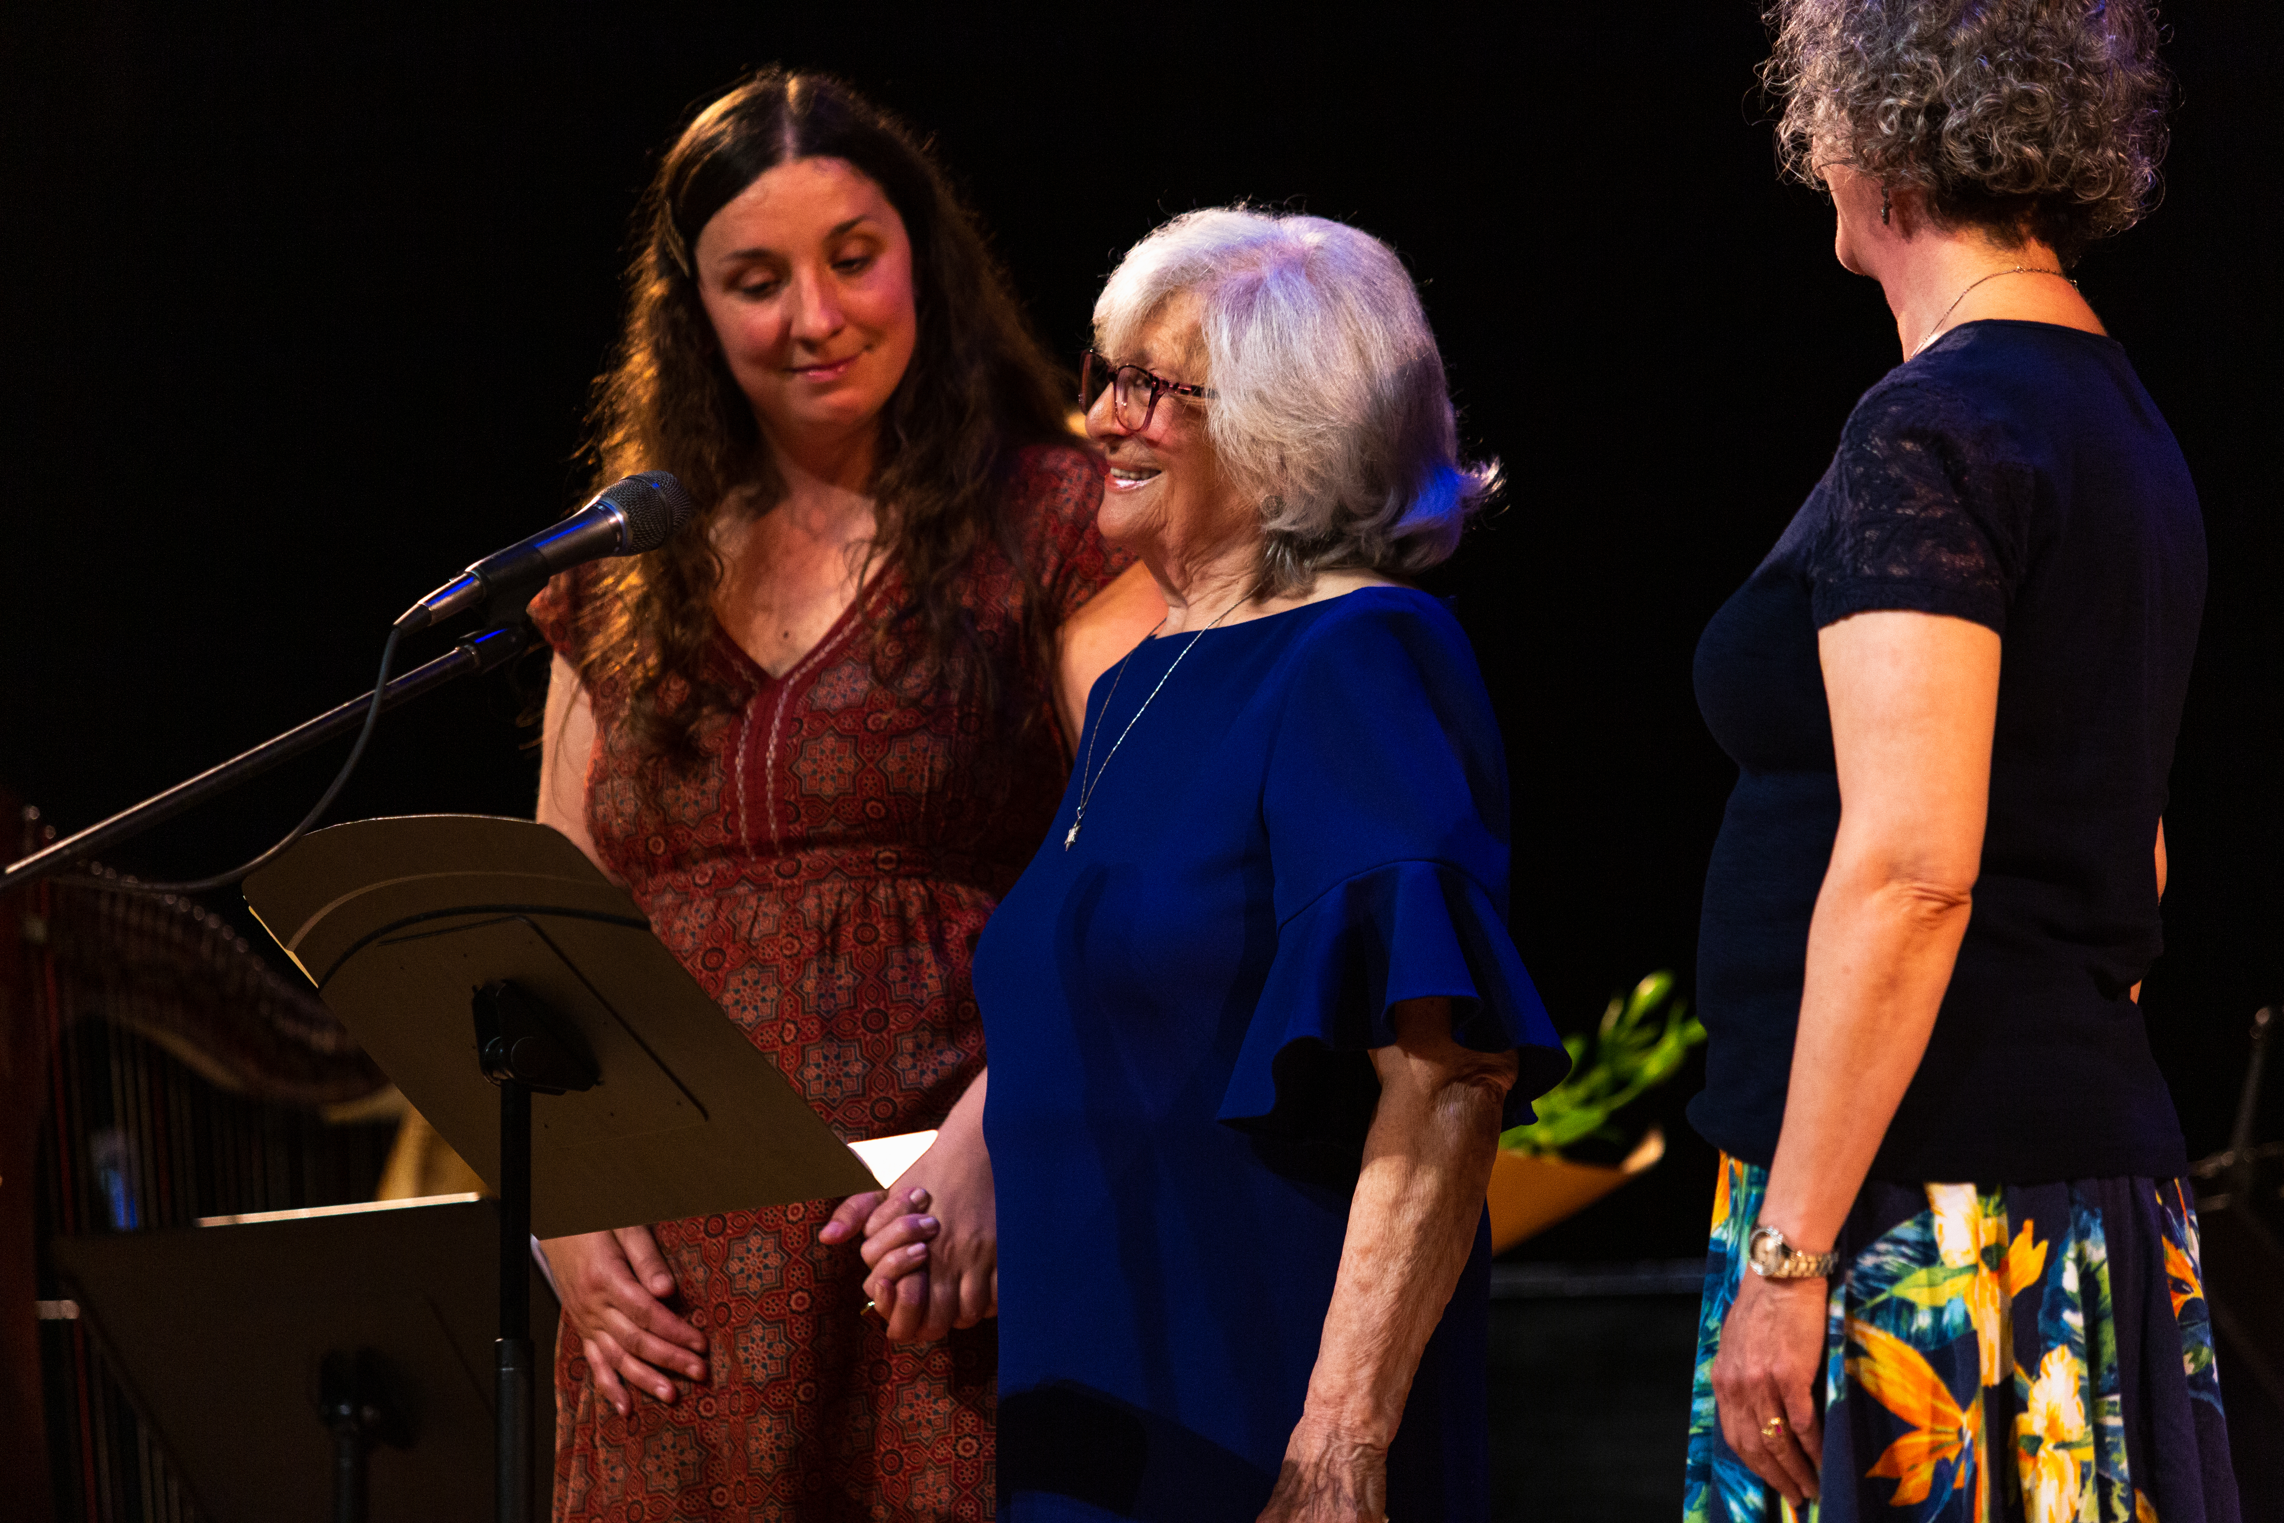
Holocaust survivor Freide Gorewitz and songwriter Elizabeth Clark receive a standing ovation at the live concert. (Credit: Whitney Martin)
ARLINGTON, VA; MARCH 9, 2022 -- PBS announces WE REMEMBER: SONGS OF SURVIVORS, a one-hour special celebrating the lives of Holocaust survivors through storytelling and music. The documentary will premiere the week of Yom HaShoah, Holocaust Remembrance Day, on Tuesday, April 26, at 8:00 p.m. ET (check local listings) on PBS, PBS.org and the PBS Video app.

WE REMEMBER: SONGS OF SURVIVORS follows four talented singer-songwriters who work for the community arts organization SageArts in New York’s Hudson Valley. Through a program offered by Jewish Family Service of Orange County, they visit local Holocaust survivors to create original songs based on their conversations. The film documents the relationships that develop and the songwriting process over many months, culminating in an emotional live concert where the survivors and songwriters are celebrated by friends, family and the community.

“At a time when the world is faced with the horrors of war and hatred, we wanted to tell this hopeful story of perseverance and love,” said Ilene Cutler, co-producer of WE REMEMBER: SONGS OF SURVIVORS.

“PBS is honored to shed light on this moving and powerful project, which illuminates the ways in which music can uniquely memorialize these stories of resiliency,” said Zara Frankel, Director of Programming and Development at PBS. “Through a collaborative songwriting process, the musicians featured in this film showcase the inspirational lives of each survivor, commemorating the full breadth of strength and joy they inspired in their lifetime.”

In-depth interviews with the survivors — Rita, Tibor, Tommy and Freide — and access to rare personal archives lead to revealing stories, many of which have been deeply buried in their memories for decades. At the same time, the songwriters — Michael, Jude, Kelleigh and Elizabeth — create video diaries to document their own thoughts and feelings about the experience of telling a Holocaust survivor’s story through song.

“Many documentaries exist about the Holocaust. However, few have taken such a unique approach to telling these horrific stories. We wanted to shed light on the devastating experiences of Holocaust survivors while celebrating the possibilities of healing through the power of music,” said Tim Miller, co-producer of WE REMEMBER: SONGS OF SURVIVORS. “Little did we know this film, with its powerful message, would change the lives of both the survivors and songwriters.”

WE REMEMBER: SONGS OF SURVIVORS will be available for streaming concurrent with broadcast on all station-branded PBS platforms, including PBS.org and the PBS Video App, available on iOS, Android, Roku, Apple TV, Android TV, Amazon Fire TV, Samsung Smart TV, Chromecast and VIZIO. PBS station members can view many series, documentaries and specials via PBS Passport. For more information about PBS Passport, visit the PBS Passport FAQ website.

Produced by Tim Miller and Ilene Cutler, WE REMEMBER: SONGS OF SURVIVORS was written and edited by Timothy Guetterman. Zara Frankel is the executive in charge for PBS.
ABOUT PBS
PBS, with more than 330 member stations, offers all Americans the opportunity to explore new ideas and new worlds through television and digital content. Each month, PBS reaches over 120 million people through television and 26 million people online, inviting them to experience the worlds of science, history, nature and public affairs; to hear diverse viewpoints; and to take front row seats to world-class drama and performances. PBS’ broad array of programs has been consistently honored by the industry’s most coveted award competitions. Teachers of children from pre-K through 12th grade turn to PBS for digital content and services that help bring classroom lessons to life. Decades of research confirms that PBS’ premier children’s media service, PBS KIDS, helps children build critical literacy, math and social-emotional skills, enabling them to find success in school and life. Delivered through member stations, PBS KIDS offers high-quality educational content on TV – including a 24/7 channel, online at pbskids.org, via an array of mobile apps and in communities across America. More information about PBS is available at www.pbs.org, one of the leading dot-org websites on the internet, or by following PBS on Twitter, Facebook or through our apps for mobile and connected devices. Specific program information and updates for press are available at pbs.org/pressroom or by following PBS Communications on Twitter.
– PBS –

CONTACTS:
PJ Feinstein, PBS, pjfeinstein@pbs.org
DKC Public Relations, DKCSongsofSurvivors@dkcnews.com

For images and additional up-to-date information on this and other PBS programs, visit PBS PressRoom at pbs.org/pressroom.

