VOCES: LATINO VOTE 2024
Summer TCA 2024 bios

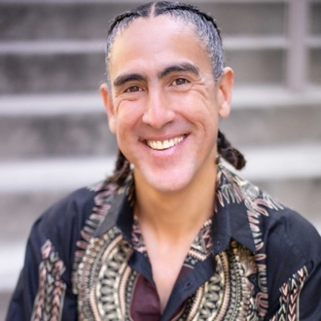
Andrés Cediel (Producer) is an Emmy-Award winning documentary filmmaker and professor at UC Berkeley’s Graduate School of Journalism. Cediel has been a frequent contributor to the PBS program FRONTLINE, including serving as a writer, director and producer of Covid’s Hidden Toll (2020), Trafficked in America (2018), and the Emmy-Award winning Kids Caught in the Crackdown (2019), which was produced in collaboration with the Associated Press. For FRONTLINE, he also produced Rape in the Fields (2013) and was a writer and producer of Rape on the Night Shift (2015), which investigated the rampant sexual assault of immigrant women at work and sparked legislative reform in California. The two films, which aired in both English and Spanish, were produced at the Investigative Reporting Program in collaboration with Univisión, the Center for Investigative Reporting and KQED. He also produced The Real CSI (2012) in collaboration with ProPublica, which examined flaws in forensic science. Cediel is currently developing a film with the Jingle Dress Project, which promotes art as healing while raising awareness for Missing and Murdered Indigenous Women.
His work has received two duPont-Columbia Journalism awards, the RFK Grand Prize for Journalism, twice been a finalist for the Goldsmith Prize in Investigative Reporting, and been nominated for a Peabody and multiple Emmys, among other awards. He received a BA in Anthropology from Brown University, and his Master’s degree in Journalism from UC Berkeley.
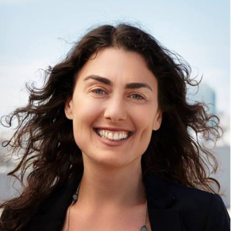
Tamara Gould (Producer) is as an award-winning documentary filmmaker, media executive and strategic partnership builder who brings a wealth of production experience and deep ties to Southern California’s flagship public media organization. Known for building strategic collaborations with both local and national partners to support independent filmmakers, she is an industry-recognized leader in the world of documentary storytelling.
At PBS SoCal, Gould leads a dynamic, creative and nationally recognized team of content producers across multiple platforms to amplify the voices and stories of the extraordinary communities within and beyond Southern California. She serves as the strategic leader and visionary in the development, production and distribution of the organization’s linear and digital content that includes existing award-winning, locally-produced series ARTBOUND, LOST LA and EARTH FOCUS, as well as national productions like ART HAPPENS HERE and ROOTS OF COMEDY.
Prior to coming to PBS SoCal, Gould has held numerous positions at ITVS during her 18-year tenure there, including most recently Head of Co-Productions and Strategic Partnerships. She served as Production Executive for multiple documentaries and series for public broadcasting and has worked closely with both journalism and media outlets as well as ITVS’ federal partners including CPB, NEH, NEA and USAID to increase opportunity and support for independent filmmakers.

Production credits include Matter of Mind (in production with Structure Films), a multi-part trilogy focused on neurodegenerative brain conditions, TED Talks Live, a three-part television series in partnership with TED Talks and PBS, Half the Sky, a four-hour television special for PBS with Show of Force based on the bestselling book by Nicholas Kristof and Sheryl Wudunn, and American Graduate Latino, a collection of bilingual television programs and digital shorts focused on the barriers to high school graduation facing Latino youth.

Gould has spearheaded ITVS’ international work, including the Global Perspectives Project, an international documentary exchange program between U.S. and global filmmakers from over 80 countries with major support from philanthropic and government partners as well as the creation of Women and Girls Lead Global, a public-private partnership to bring the power of documentary film to work for women and girls in countries around the world.
Gould also made the award-winning Hell of a Nation, a PBS documentary film which focused on the Constitutional Convention in Afghanistan post-9/11 produced with Actual Films. Prior to joining ITVS, she served as an Executive Producer of Television at KQED and as Executive Director of the Bay Area Video Coalition.
Gould holds a Bachelor’s Degree in Anthropology and Film, where she graduated with honors from Brown University. She is a Fulbright Scholar and earned a Master’s Degree from the University of California at Santa Cruz. She is a Southern California native and currently lives in the Washington, D.C. area with her family.
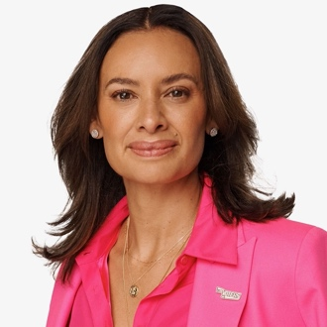
María Teresa Kumar (Film Participant) is the co-founder and President of Voto Latino Foundation, a non-profit, non-partisan 501(c)(3) organization, and its sister 501(c)(4) advocacy organization, Voto Latino. Voto Latino Foundation and Voto Latino are the largest and most effective Latino voter registration and Latino youth advocacy organizations in the country, respectively. Fast Company named Kumar one of the 100 Most Creative Minds, TIME Magazine named her one of 13 Latinos reshaping industries and the country, and the Analyst Institute recognized Voto Latino with an Expy Award for expanding the field of voter registration. A sought-after political leader and strategist, she advised President Barack Obama’s Task Force on 21st Century Policing, and she currently serves on the National Task Force on Election Crises. She is an Emmy-nominated analyst for MSNBC and serves on the boards of Steve Madden, Emily’s List, Robert F. Kennedy Human Rights and the Rockefeller Brothers Fund. Additionally, she is a lifetime member of the Council on Foreign Relations and a Young Global Leader of the World Economic Forum.

Raised in Sonoma, California, Kumar lives in Washington, DC, with her husband, Raj Kumar, and their two children. She is a first-generation graduate of the Harvard Kennedy School of Government and the University of California, Davis.

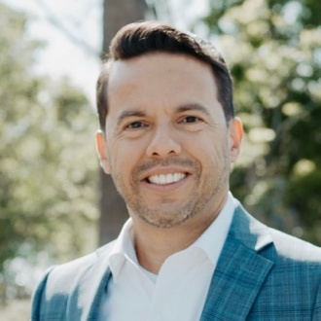
Samuel Rodriguez (Film Participant) lead pastor of New Season, one of America’s most influential megachurches according to Newsmax, is the president of the National Hispanic Christian Leadership Conference, one of the world’s largest Christian organizations. Rodriguez stands recognized by CNN, FOX News, Univision and Telemundo as America’s most influential Latino/Hispanic faithleader. Charisma Magazine named him one of the 40 leaders who changed the world. The Wall Street Journal named him one of the top 12 Latino leaders and he was the only faith leader on that list. He has been named among the “Top 100 Christian Leaders in America” (Newsmax 2018) and nominated as one of the “100 most influential people in the world” (TIME, 2013). Rodriguez has advised Presidents Bush, Obama, and Trump. He is the first Hispanic American to have participated in two different Presidential inauguration ceremonies. In 2009 he read from the Gospel of Saint Luke at President Barack Obama’s inaugural prayer service at St. John’s Episcopal church and in 2017, on the Capitol steps before a global viewing audience, Pastor Sam read and prayed from the Gospel of Matthew. He is the bestselling author of 12 books including Be Light, Persevere with Power, and Your Mess, God’s Miracle. In addition, he is the executive producer of three films including Breakthrough and Flamin’ Hot. Rodriguez is the recipient of the Martin Luther King Jr. Leadership Award presented by the Congress of Racial Equality.
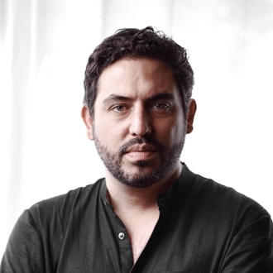
Bernardo Ruiz (Director/Producer) is an award-winning documentary producer and director based in New York. Ruiz has directed and produced both documentary films and series for a wide variety of outlets including ESPN's 30 for 30 series, numerous PBS series as well as Disney+.
Highlights of past directing work include Roberto Clemente for AMERICAN EXPERIENCE, which won the Alma award for outstanding made for television documentary. He also directed the feature documentaries Reportero, about Mexican reporters covering organized crime and political corruption in Tijuana and the Participant-financed Kingdom of Shadows, about the U.S.-Mexico drug war. Both films were nominated for News & Documentary Emmy's. Ruiz also directed the James Beard-nominated Harvest Season, about the lives of the temporary laborers, permanent residents, and multigenerational Latinos intimately connected to the production of premium wines in the Napa and Sonoma regions of Northern California.
In 2020, Ruiz created, directed and produced Latino Vote: Dispatches from the Battleground, which was filmed during the early stages of the Covid-19 pandemic. The Boston Globe called it an “absorbing and essential film.” A "deep, thoughtful...great documentary,” wrote veteran Univision anchor Jorge Ramos of the film.

