FOR IMMEDIATE RELEASE

VOCES “Almost American” PREMIERES ON PBS AND PBS.ORG
ON MONDAY, AUGUST 26, 2024

A Salvadoran-American Family Rooted in D.C. Fights to Stay Together After the Department of Homeland Security Revokes the Temporary Protected Status of El Salvador

(Los Angeles, CA/July 1, 2024) – A powerful look at a Salvadoran-American family caught up in the contentious battle over immigration, “Almost American,” produced and directed by Nina Alvarez, premieres on the PBS series VOCES on Monday, August 26, 2024, 10:00-11:30 p.m. ET (check local listings) on PBS, PBS.org and the PBS app.
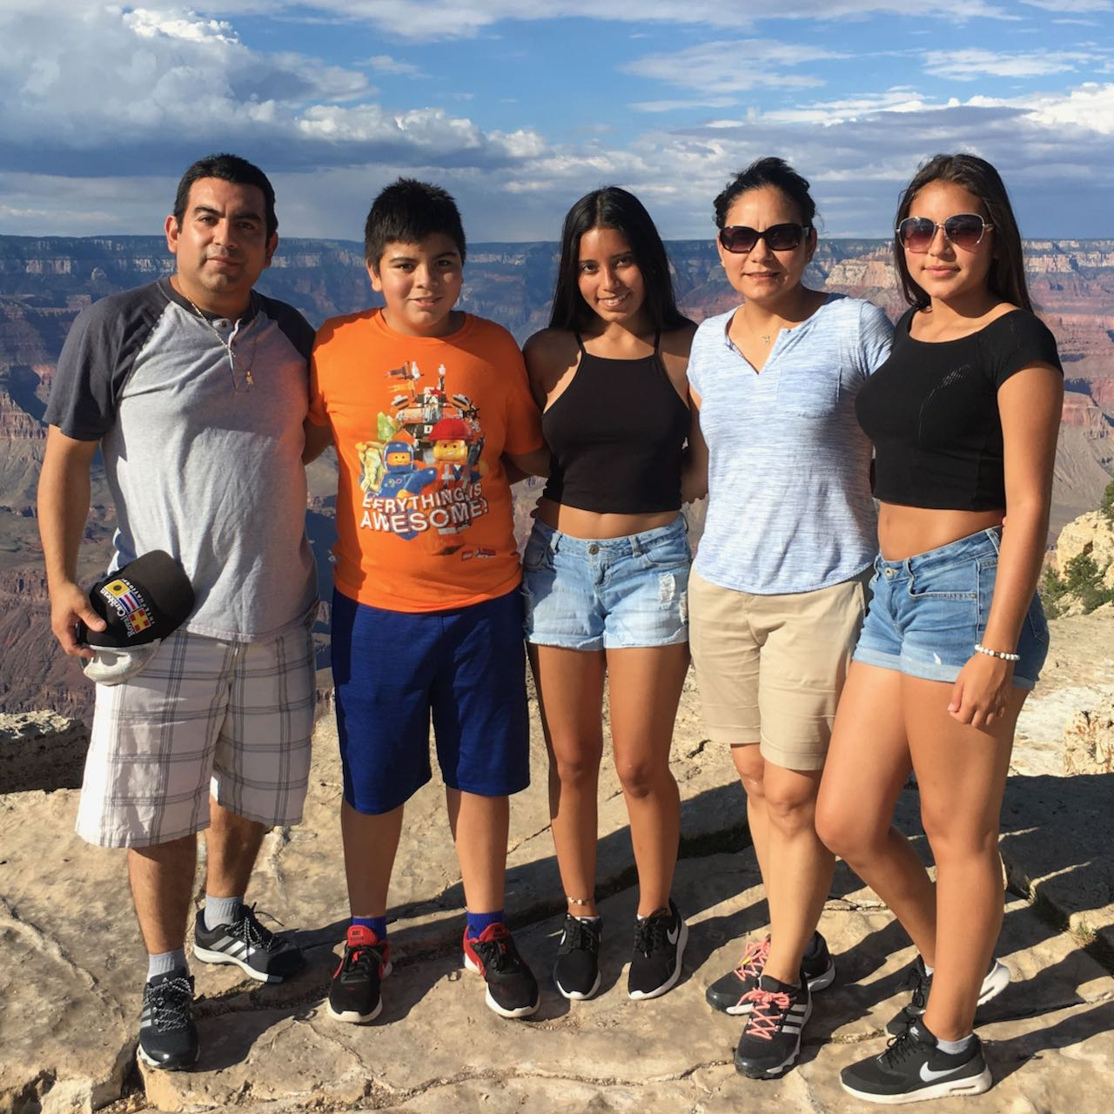
Credit: Courtesy Ayala Flores family.

In 2018, the Trump Administration’s Department of Homeland Security abruptly terminated Temporary Protected Status (TPS) for those from six countries, comprising almost all TPS holders — foreign nationals from countries beset by civil unrest, violence, or natural disasters who are permitted lawful residence in the United States. The majority of those affected were from El Salvador, a country plagued by violence, the aftermath of a civil war, and a devastating earthquake.

The decision to terminate TPS status, which is reviewed every 18 months, left thousands of American families on the brink of a separation crisis since many TPS holders have lived in the U.S. for decades and now have American-born children. “Almost American” follows the Ayala Flores family, who have lived and worked in the nation’s capital for 20 years, sheltered by the TPS status first granted under the George W. Bush administration in 2001. Like her parents, the family’s oldest daughter, Maria, was born in El Salvador but the younger children, born in the U.S., are American citizens. The termination of TPS status threatens to separate the family.

Reluctantly, the Ayala Flores family joins a class-action lawsuit, Ramos V. Neilsen, to halt the termination of TPS. The suit argues that the administration’s restrictive view of the TPS laws was unconstitutional as it was adopted to further the administration’s anti-immigrant agenda. Through surprisingly frank interviews with elected officials and former State Department and Department of Homeland Security officials, VOCES “Almost American” documents how the incoming administration’s hardline immigration sentiment brought about the termination — against the recommendation of many longtime immigration officials.

The court ruled in favor of the plaintiffs but the government appealed the decision and, in September 2020, the verdict was reversed, leaving the termination of TPS status in place. In 2023, the Biden administration reinstated protection for the TPS holders. The Ayala Flores family and hundreds of thousands of others will see their TPS up for review again in 2025, under the next president.

“‘Almost American’ puts a human face on the ongoing conversation about the country’s immigration policy. While news coverage is almost exclusively focused on the issues at the border, this film reminds us that others have been legally allowed here for humanitarian reasons and that their lives can be deeply affected by politics and policy changes,” says VOCES Executive Producer Sandie Viquez Pedlow.

VOCES “Almost American” will stream simultaneously with broadcast and be available on all station-branded PBS platforms, including PBS.org and the PBS app, available on iOS, Android, Roku, Apple TV, Amazon Fire TV, Android TV, Samsung Smart TV, Chromecast and VIZIO.

About the Filmmakers

Nina Alvarez (Producer/Director) is a journalist, documentarian and video photographer. For over 25 years, she has reported breaking news and feature stories from around the world, on broadcast and web segments, radio reports and long-form documentaries. Alvarez began her journalism career at ABC News as a production associate on the acclaimed documentary series Turning Point. She went on to work in the Miami Bureau and established the Mexico City Bureau in 1997, reporting and producing breaking news, feature and investigative stories in Latin America and the Caribbean. Her work with the network's top on-air talent was broadcast on World News Tonight with Peter Jennings, Good Morning America, Nightline and 20/20 and was recognized with three national Emmy Awards. Since 2001, she has reported and produced news and longform stories for Univision, NBC, CNN, NPR, MTV News and Al Jazeera from the Middle East, Africa, Central Asia and Latin America. From 2015 to 2017, she was also Senior Producer at the Fusion/Netflix investigative series The Naked Truth, recognized with the Alfred I. duPont Columbia Journalism Award, an Emmy nomination and the Al Neuharth Award.

An important theme in Alvarez's work has been the experience of migration, historically and today. She was a producer on the Oscar-nominated film Which Way Home (2009) and produced an episode for the landmark PBS series Latino Americans (2012), for which she received a Peabody Award and the Imagen Award. Her short film, Fields of Promise (2016), was broadcast on the WORLD Channel series America ReFramed and awarded the Alfred I. duPont Columbia Journalism Award. Alvarez is a native New Yorker, daughter of Salvadorans and mother of a Salvadoran-Irish-French-American daughter. She is an assistant professor at Columbia University’s School of Journalism.

Reuben Atlas (Producer) is an independent filmmaker and lawyer, selected for DOCNYC’s inaugural 40 Under 40 list and as an Impact Partners Producers Fellow. He recently produced Bill Russell: Legend for Netflix. His other work includes Acorn and the Firestorm, produced and directed with Sam Pollard, about the impactful and controversial community organizing group ACORN (Tribeca Film Festival/PBS's Independent Lens.) He also co-directed with Jerry Rothwell the Netflix and Arte funded Sour Grapes, about a counterfeit wine conman. His first film, Brothers Hypnotic, about the Hypnotic Brass Ensemble, which featured Prince and Damon Albarn, premiered at the SXSW Film Festival and broadcast internationally and on PBS’ Independent Lens. He previously worked at Legal Aid in Paterson, NJ, in counseling at a maximum-security prison, as a bartender in the Netherland Antilles, and for a Cuban newspaper in Costa Rica.

Brittany Huckabee (Editor) is an award-winning independent filmmaker with feature-length documentaries that have shown on PBS, Netflix, Showtime and international festivals including Sundance and Tribeca. How to Fix a Primary (2020) premiered at the Full Frame Documentary Film Festival and highlighted the system of power and money in American politics today. Her film After Fire, about the challenges facing women veterans, premiered at DOC NYC on Veterans Day 2016. She wrote, produced and edited Hot Girls Wanted (2015), an inside look at the ‘amateur’ pornography industry, which premiered at Sundance and was nominated for a primetime Emmy. She also produced and edited Sexy Baby (2012), which premiered at Tribeca and was broadcast on Showtime. Her film The Mosque in Morgantown (2009) premiered at True/False and was broadcast nationally on PBS. She is co-creator of The Secret Life of Muslims, an Emmy, IDA and Peabody-nominated Vox series that has garnered more than 65 million views to date.

About VOCES
Produced by Latino Public Broadcasting, the acclaimed PBS documentary series VOCES features the best of Latino arts, culture and history and shines a light on current issues that impact Latino Americans. Devoted to exploring the rich diversity of the Latino experience, VOCES presents new and established filmmakers and brings their powerful and illuminating stories to a national audience — on TV, online and on the PBS app. Luis Ortiz is series producer; Sandie Viquez Pedlow is executive producer. Follow us on Facebook and X. Funding for VOCES is provided by the Corporation for Public Broadcasting and PBS.

About Latino Public Broadcasting
Latino Public Broadcasting (LPB) is the leader in the development, production, acquisition and distribution of film and digital cultural media that is representative of Latino people or addresses issues of particular interest to Latino Americans. These programs are produced for dissemination to public broadcasting stations and other public media entities. Providing a voice for the diverse Latino community throughout the United States, Latino Public Broadcasting is funded by the Corporation for Public Broadcasting. LPB also produces the acclaimed PBS documentary series VOCES, exploring the rich diversity of the Latino experience. VOCES presents new and established filmmakers and brings their powerful and illuminating stories to a national audience — on TV, online and on the PBS app.

Between 2009 and 2023, LPB programs won over 135 awards, including three prestigious George Foster Peabody Awards as well as Emmys, Imagen Awards and the Sundance Film Festival Award for Best Director, Documentary. LPB has been the recipient of the Norman Lear Legacy Award and the NCLR Alma Award for Special Achievement – Year in Documentaries. Sandie Viquez Pedlow is executive director of LPB; Edward James Olmos is co-founder and chairman.
###
Contact:
CaraMar Publicity
Mary Lugo 770 851 8190 lugo@negia.net
Cara White 843 881 1480 cara.white@mac.com

For images and additional up-to-date information on this and other PBS programs, visit PBS PressRoom at pbs.org/pressroom.

