FOR IMMEDIATE RELEASE

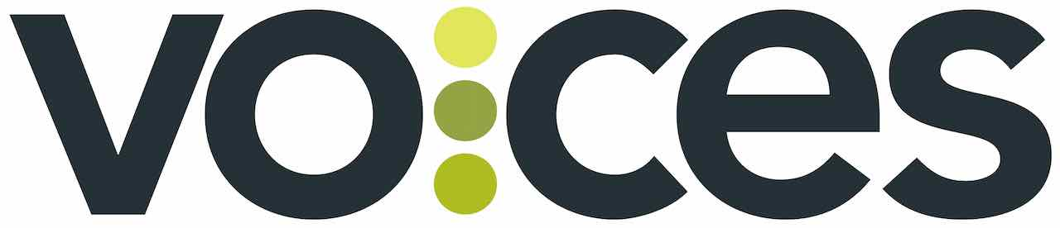

VOCES “Our Texas, Our Vote” PREMIERES ON PBS AND PBS.ORG
ON MONDAY, OCTOBER 28, 2024

New Documentary Examines the Power and Diversity of the Growing Latino Electorate in Texas

Los Angeles, CA/September 23, 2024) – On the eve of the upcoming presidential election, acclaimed filmmaker Hector Galán takes viewers inside the largest Latino voter registration mobilization effort in Texas history, led by a new generation on the frontlines of a growing state that neither political party can afford to ignore. “Our Texas, Our Vote” traces the evolution of Texas as a Latino-majority state, examines the history of efforts to disenfranchise Latino voters, and profiles both conservative and progressive activists who are determined to increase voter participation among Texas Latinos. Produced and directed by Galán and executive produced by Sandie Viquez Pedlow, “Our Texas, Our Vote” premieres on the PBS series VOCES on Monday, October 28, 2024, 10:00-11:00 p.m. ET (check local listings) on PBS, PBS.org and the PBS app.
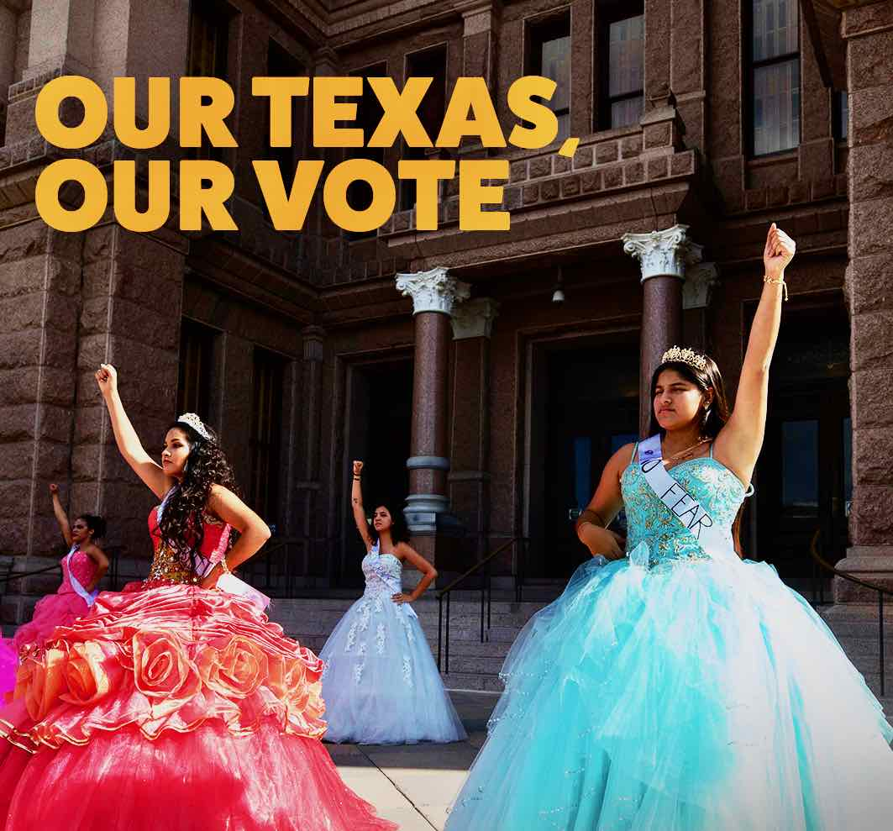

The Lone Star state has seen explosive growth; today, over 30 million people call Texas home. The 2020 US Census revealed that Latinos are now the majority demographic group in Texas – almost 12 million strong and growing. This growth is fueled in large part by young Latinos, with a quarter of a million Texans of color turning 18 each year. Now, as the election nears, both Democrats and Republicans are courting Latinos as never before, creating new strategies to reach a young electorate that no longer consumes traditional media.

“Our Texas, Our Vote” features candid interviews with several young leaders who are at the forefront of this unprecedented campaign to engage Latino voters and get them to the polls. Included is Cristina Tzintzún Ramirez, leader of NextGen America, one of the nation’s largest youth voting organizations, and the creator of Poder Quince, which harnesses the power of the state’s young Latinas; Republican Joel Castro of Alvin, Texas, the youngest city council member in the state; 21-year-old Olivia Julianna, a progressive political activist and strategist who uses the power of social media to reach her peers; Michelle Gamboa, a conservative city councilwoman from Longview, Texas; and more. Also featured are journalist/anthropologist Cecilia Ballí, who studies the voting patterns of Latinos; author/journalist John Phillip Santos; border reporter Gaige Davila; and former Congressman Beto O’Rourke, founder of the grassroots voting mobilization campaign, Powered by People.

“Our Texas, Our Vote” reports from across the state, from border towns to big cities to the state’s capitol, meeting with people across the political spectrum. As with the rest of the nation, Texas Latinos are concerned with the economy, reproductive rights, gun violence, and immigration. A recurring theme is that “demographics are not destiny” – Latino voters are not a monolith, one message does not fit all, and neither party can afford to take their support for granted. What is certain is that Latino voters in Texas are poised to have more power at the ballot box than ever before.

Says Olivia Julianna, “More and more Latinos on the ballot. More and more Latinos getting out to vote. It’s happening and it’s exciting to see and they’re not running just because they’re Latino. They’re not running because, oh, we need more representation. They’re running to win and to make political change and that’s what’s exciting.”

VOCES “Our Texas, Our Vote” will stream simultaneously with broadcast and be available on all station-branded PBS platforms, including PBS.org and the PBS app, available on iOS, Android, Roku, Apple TV, Amazon Fire TV, Android TV, Samsung Smart TV, Chromecast and VIZIO.

About the Filmmaker

Hector Galán (Producer/Director) is one of the most prolific Latino documentary filmmakers working today. He has contributed over 40 hours of programming to major television outlets, including the PBS series FRONTLINE and AMERICAN EXPERIENCE. Galán theatrically released his feature documentary, Los Lonely Boys: Cottonfields and Crossroads, in 2006. His other work includes Ancient Roads from Christ to Constantine; Children of Giant, which explored the social issues behind George Stevens’ film Giant; Porvenir, Texas, about the 1918 massacre of 15 Mexican men in a small Texas town; Willie Velasquez: Your Vote is Your Voice; and The Big Squeeze.

About VOCES
Produced by Latino Public Broadcasting, the acclaimed PBS documentary series VOCES features the best of Latino arts, culture and history and shines a light on current issues that impact Latino Americans. Devoted to exploring the rich diversity of the Latino experience, VOCES presents new and established filmmakers and brings their powerful and illuminating stories to a national audience — on TV, online and on the PBS app. Luis Ortiz is series producer; Sandie Viquez Pedlow is executive producer. Funding for VOCES is provided by the Corporation for Public Broadcasting and PBS. Follow us on Facebook and X.

About Latino Public Broadcasting
Latino Public Broadcasting (LPB) is the leader in the development, production, acquisition and distribution of film and digital cultural media that is representative of Latino people or addresses issues of particular interest to Latino Americans. These programs are produced for dissemination to public broadcasting stations and other public media entities. Providing a voice for the diverse Latino community throughout the United States, Latino Public Broadcasting is funded by the Corporation for Public Broadcasting. LPB also produces the acclaimed PBS documentary series VOCES.

Between 2009 and 2023, LPB programs won over 135 awards, including three prestigious George Foster Peabody Awards as well as Emmys, Imagen Awards and the Sundance Film Festival Award for Best Director, Documentary. LPB has been the recipient of the Norman Lear Legacy Award and the NCLR Alma Award for Special Achievement – Year in Documentaries. Sandie Viquez Pedlow is executive director of LPB; Edward James Olmos is co-founder and chairman.

###
Contact:
CaraMar Publicity
Mary Lugo 770 851 8190 lugo@negia.net
Cara White 843 881 1480 cara.white@mac.com

For images and additional up-to-date information on this and other PBS programs, visit PBS PressRoom at pbs.org/pressroom.

