FOR IMMEDIATE RELEASE:

UNITED IN SONG: CELEBRATING THE AMERICAN DREAM
Premieres New Year’s Eve, Friday, December 31 on PBS

Featuring:
DELBERT ANDERSON, DAVID ARCHULETA, JENCARLOS CANELA, JUDY COLLINS, DEBORAH COX, DREW GEHLING, AMBER MERRITT, MIDORI, SANDI PATTY, CASSADEE POPE, CHITA RIVERA,
PEPE ROMERO, LEA SALONGA, PAULO SZOT, BRANDEE YOUNGER AND THE WASHINGTON BALLET;
WITH THE AMERICAN POPS ORCHESTRA CONDUCTED BY LUKE FRAZIER

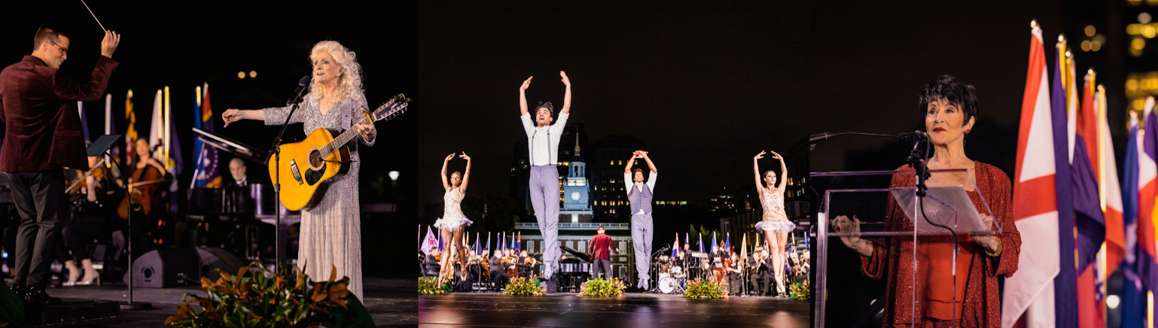

Photos by Industry and Commerce Image Works – (from Left to Right) – LUKE FRAZIER and JUDY COLLINS, THE WASHINGTON BALLET, CHITA RIVERA
at Independence Hall

WASHINGTON, D.C. (December 2, 2021) – Nouveau Productions announced today the
release of UNITED IN SONG: CELEBRATING THE AMERICAN DREAM, which premieres Friday, December 31, 2021, 9:00-10:30 p.m. and again from 10:30 p.m.-12:00 a.m. (check local listings) on PBS, PBS.org and the PBS Video App. The star-studded performance—filmed at Independence Hall in Philadelphia—celebrates the American dream and America’s irrepressible strength as we welcome the New Year. This special evening of wide-ranging music and artistic disciplines reminds us of our ever-present pursuit of uniting as one America.

Filmed in front of a live audience, UNITED IN SONG: CELEBRATING THE AMERICAN DREAM features performances by recording and touring artist Delbert Anderson; celebrated recording artist David Archuleta; award-winning Latin pop singer Jencarlos Canela; Grammy Award-winning and world-renowned artist Judy Collins; Grammy Award-nominated and multi-platinum R&B/Pop recording artist Deborah Cox; Broadway performer Drew Gehling; rising opera star Amber Merritt; UN Messenger of Peace Midori; five-time Grammy Award winner Sandi Patty; Grammy Award-nominated Cassadee Pope; internationally celebrated guitarist Pepe Romero; Tony Award winner Lea Salonga; Tony Award winner Paulo Szot; celebrated harpist Brandee Younger; alongside The American Pops Orchestra, conducted by Luke Frazier and hosted by three-time Tony Award winner Chita Rivera.

The program also features a newly commissioned performance by The Washington Ballet, led by Artistic Director Julie Kent and choreographed by celebrated choreographer Jessica Lang.

“The rich history that took place at Independence Hall reminds us of the challenges our country faced as such a young nation,” said David M. Rubinstein, co-executive producer of UNITED IN SONG: CELEBRATING THE AMERICAN DREAM. “This evening’s performance celebrates the ever-present pursuit of the American dream, and our collective hope of unity, here in America and beyond.”

UNITED IN SONG: CELEBRATING THE AMERICAN DREAM will stream simultaneously with broadcast and be available on all station-branded PBS platforms, including PBS.org and the PBS Video App, available on iOS, Android, Roku streaming devices, Apple TV, Amazon Fire TV, Android TV, Samsung Smart TV and Chromecast.

About the American Pops Orchestra
APO was founded in 2015 with a mission to breathe new life into orchestral pops programming and inspire diverse audiences to discover the wealth of the material in the Great American Songbook in dynamic new ways. Seeing an opportunity to challenge the status-quo of the repertoire an orchestra performs, Founder and Music Director, Luke Frazier, created The American Pops with the intent of breaking the mold of the traditional pops orchestra. This new, distinctly “American” orchestra brings together versatile musicians and reimagined programming focused around the Great American Songbook, and presents it with an approachable, fresh spin in order to engage diverse audiences. Through non-traditional orchestral settings, APO aims to deliver popular American classics to those who already know and love them, while also introducing these timeless pieces to younger generations in approachable settings. To learn more, visit www.TheAmericanPops.org.

About Independence Hall
First opened in 1752 to house the Pennsylvania legislature, Independence Hall is the birthplace of America. Here, George Washington was appointed Commander in Chief of the Continental Army in 1775, and our Founding Fathers debated and signed both the Declaration of Independence and the US Constitution inside this building. The legacy of the nation’s founding documents have influenced lawmakers around the world and distinguished Independence Hall as a UNESCO World Heritage Site.

About PBS
PBS, with more than 330 member stations, offers all Americans the opportunity to explore new ideas and new worlds through television and digital content. Each month, PBS reaches over 120 million people through television and 26 million people online, inviting them to experience the worlds of science, history, nature and public affairs; to hear diverse viewpoints; and to take front row seats to world-class drama and performances. PBS’s broad array of programs has been consistently honored by the industry’s most coveted award competitions. Teachers of children from pre-K through 12th grade turn to PBS for digital content and services that help bring classroom lessons to life. Decades of research confirms that PBS’s premier children’s media service, PBS KIDS, helps children build critical literacy, math and social-emotional skills, enabling them to find success in school and life. Delivered through member stations, PBS KIDS offers high-quality educational content on TV— including a 24/7 channel, online at pbskids.org, via an array of mobile apps and in communities across America. More information about PBS is available at www.pbs.org, one of the leading dot-org websites on the internet, or by following PBS on Twitter, Facebook or through our apps for mobile and connected devices. Specific program information and updates for press are available at pbs.org/pressroom or by following PBS Communications on Twitter.
###

MEDIA CONTACTS

For Nouveau Productions and APO: For PBS:
Camille Cintrón Devlin Cara White / Mary Lugo, CaraMar, Inc.
571-317-9317 843-881-1480; 770-851-8190
pr@camillcdevlin.com cara.white@mac.com; lugo@negia.net

For images and additional up-to-date information on UNITED IN SONG: CELEBRATING THE AMERICAN DREAM and other PBS programs, visit PBS PressRoom at pbs.org/pressroom.

