FOR IMMEDIATE RELEASE:

“UNITED IN SONG: CELEBRATING THE RESILIENCE OF AMERICA”
Premieres New Year’s Eve: Thursday, December 31 on PBS

Featuring:
JAMIE BARTON, JOSHUA BELL, RENÉE FLEMING, DENYCE GRAVES, JOSH GROBAN,
SOLOMAN HOWARD, MORGAN JAMES, JUANES, PATTI LABELLE, YO-YO MA,
AUDRA MCDONALD, BRIAN STOKES MITCHELL, ANNA DEAVERE SMITH,
JEAN-YVES THIBAUDET; WITH THE AMERICAN POPS ORCHESTRA CONDUCTED BY MAESTRO LUKE FRAZIER AND THE NATIONAL SYMPHONY ORCHESTRA CONDUCTED BY MAESTRA JOANN FALLETTA

Watch the First Trailer for “UNITED IN SONG: CELEBRATING THE RESILIENCE OF AMERICA”
https://www.pbs.org/video/trailer-tn9bhu/

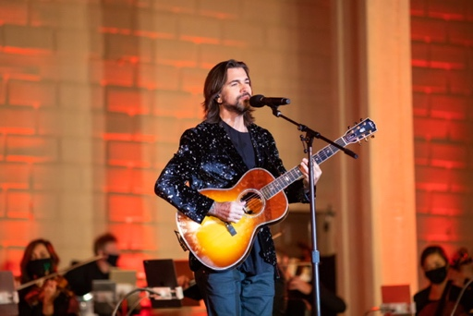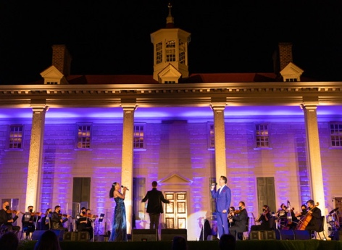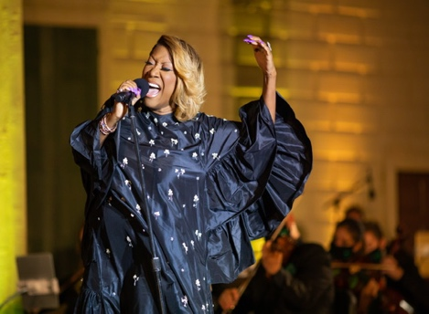

Photos by Kevin Parisi – (from Left to Right) – JUANES, AUDRA MCDONALD, BRIAN STOKES MITCHELL and PATTI LABELLE
at George Washington’s Mount Vernon

WASHINGTON, D.C. (December 3, 2020) – Nouveau Productions (Nouveau) announced today the
release of “UNITED IN SONG: CELEBRATING THE RESILIENCE OF AMERICA,” which premieres Thursday, December 31, 2020 from 8:00-9:30 p.m. ET and again from 9:30-11:00 p.m. ET (check local listings) on PBS, PBS.org and the PBS Video App. The star-studded performance—filmed at George Washington’s Mount Vernon and the John F. Kennedy Center for the Performing Arts—encourages our nation to come together and celebrate our irrepressible strength as we welcome the New Year. Despite the enormity of COVID-19 and the significant presence of social injustice, this special evening of wide-ranging music joins us in the ever-present pursuit of uniting as one America.

Filmed at George Washington’s Mount Vernon in front of a small, socially-distanced live audience and under strict COVID-19 mitigation procedures, “UNITED IN SONG: CELEBRATING THE RESILIENCE OF AMERICA” features performances by: Grammy-nominated mezzo-soprano Jamie Barton multi-Grammy Award-winning violinist Joshua Bell; world-renowned soprano Renée Fleming; celebrated mezzo-soprano Denyce Graves; multi Grammy- and Tony Award-nominated artist Josh Groban; rising opera star Soloman Howard; recording artist and Broadway star Morgan James; 26-time Grammy and Latin Grammy Award winner Juanes; Grammy Award-winning and world-renowned artist Patti LaBelle; internationally celebrated cellist Yo-Yo Ma; six-time Tony Award winner Audra McDonald; two-time Tony Award winner Brian Stokes Mitchell; celebrated actor, playwright and professor Anna Deavere Smith; world-renowned pianist Jean-Yves Thibaudet; alongside The American Pops Orchestra, conducted by Maestro Luke Frazier. Performances by the National Symphony Orchestra, conducted by Maestra JoAnn Falletta, were filmed in the Concert Hall of the Kennedy Center and are also part of this special broadcast.

In addition to the abovementioned musical appearances, interviews with artists were conducted onsite at George Washington’s Mount Vernon by David M. Rubenstein, philanthropist and host of “The David Rubenstein Show” on Bloomberg.

“Music is a universal language and has the unique power of uniting us. I suspect the majority of us will be celebrating this New Year’s with an inability to gather in-person. Ringing in 2021 with music performed by world-class artists, provides an opportunity to celebrate what makes us American,” shared Mr. Rubenstein, co-executive producer of “UNITED IN SONG: CELEBRATING THE RESILIENCE OF AMERICA.” He added, “When George Washington was leaving office to return to Mount Vernon, he asked that we look to each other and find what we share in common as opposed to what makes us different. That advice appears to be just as relevant today as it was more than 200 years ago. I am sorry that George Washington was not here to greet these extraordinary artists, but I have no doubt that he was listening from above.”

“UNITED IN SONG: CELEBRATING THE RESILIENCE OF AMERICA” will stream simultaneously with broadcast and be available on all station-branded PBS platforms, including PBS.org and the PBS Video App, available on iOS, Android, Roku streaming devices, Apple TV, Amazon Fire TV, Android TV, Samsung Smart TV and Chromecast.

About the American Pops Orchestra
APO was founded in 2015 with a mission to build community through the preservation, promotion and reimagination of American popular music. Through live and virtual performances, educational initiatives and collaborations, APO makes the highest quality art accessible to the broadest audiences. Seeing an opportunity to challenge the status-quo of the repertoire an orchestra performs, Founder and Music Director Luke Frazier created The American Pops with the intent of breaking the mold of the traditional pops orchestra. This new, distinctly “American” orchestra brings together versatile musicians and reimagined programming focused around the Great American Songbook, and presents it with an approachable, fresh spin in order to engage diverse audiences and make attending a live orchestral show fun again. Through non-traditional orchestral settings, APO aims to deliver popular American classics to those who already know and love them, while also introducing these timeless pieces to younger generations in approachable settings. To learn more, visit www.TheAmericanPops.org.

About the National Symphony Orchestra
The 2020–2021 season marks the National Symphony Orchestra’s 90th, and Gianandrea Noseda’s fourth as its music director. The Italian conductor serves as the Orchestra’s seventh music director, joining the NSO’s legacy of distinguished leaders. Its artistic leadership also includes Principal Pops Conductor Steven Reineke and Artistic Advisor Ben Folds.

Founded in 1931, the Orchestra has always been committed to artistic excellence and music education. In 1986, the National Symphony became an artistic affiliate of the John F. Kennedy Center for the Performing Arts, where it performs year-round. The NSO’s community engagement projects are nationally recognized, including NSO In Your Neighborhood, an annual week of approximately 50 performances in schools, churches, community centers, and other unexpected venues; Notes of Honor, which offers free performances for active, veteran, prior service, and retired members of the military and their families; and Sound Health, a collaboration with the National Institutes of Health (NIH) and its affiliated organizations. Career development opportunities for young musicians include the NSO Youth Fellowship Program and its tuition-free Summer Music Institute. For more information, visit nationalsymphony.org.

About Mount Vernon
Since 1860, more than 85 million visitors have made George Washington’s Mount Vernon the most popular historic home in America. Through thought-provoking tours, entertaining events, and stimulating educational programs on the estate and in classrooms across the nation, Mount Vernon strives to preserve George Washington’s place in history as “First in War, First in Peace, and First in the Hearts of His Countrymen.” Mount Vernon is owned and operated by the Mount Vernon Ladies’ Association, America’s oldest national preservation organization, founded in 1853. To learn more, visit www.mountvernon.org.

About PBS
PBS, with more than 330 member stations, offers all Americans the opportunity to explore new ideas and new worlds through television and digital content. Each month, PBS reaches over 120 million people through television and 26 million people online, inviting them to experience the worlds of science, history, nature and public affairs; to hear diverse viewpoints; and to take front row seats to world-class drama and performances. PBS’s broad array of programs has been consistently honored by the industry’s most coveted award competitions. Teachers of children from pre-K through 12th grade turn to PBS for digital content and services that help bring classroom lessons to life. Decades of research confirms that PBS’s premier children’s media service, PBS KIDS, helps children build critical literacy, math and social-emotional skills, enabling them to find success in school and life. Delivered through member stations, PBS KIDS offers high-quality educational content on TV— including a 24/7 channel, online at pbskids.org, via an array of mobile apps and in communities across America. More information about PBS is available at www.pbs.org, one of the leading dot-org websites on the internet, or by following PBS on Twitter, Facebook or through our apps for mobile and connected devices.

Specific program information and updates for press are available at pbs.org/pressroom or by following PBS Pressroom on Twitter.
###

MEDIA CONTACTS

For Nouveau Productions and APO: For PBS:
Camille Cintrón Devlin Cara White / Mary Lugo, CaraMar, Inc.
571-317-9317 843-881-1480; 770-623-8190
camiletapr@gmail.com cara.white@mac.com; lugo@negia.net

For images and additional up-to-date information on “UNITED IN SONG: CELEBRATING THE RESILIENCE OF AMERICA” and other PBS programs, visit PBS PressRoom at pbs.org/pressroom.

