PBS Sets U.S. Streaming and Broadcast Premiere Date for TRESPASSES on September 20

The Four-Part Drama Stars Lola Petticrew, Tom Cullen, Gillian Anderson and More in This Captivating Story on Love, Desire, Duty and Freedom

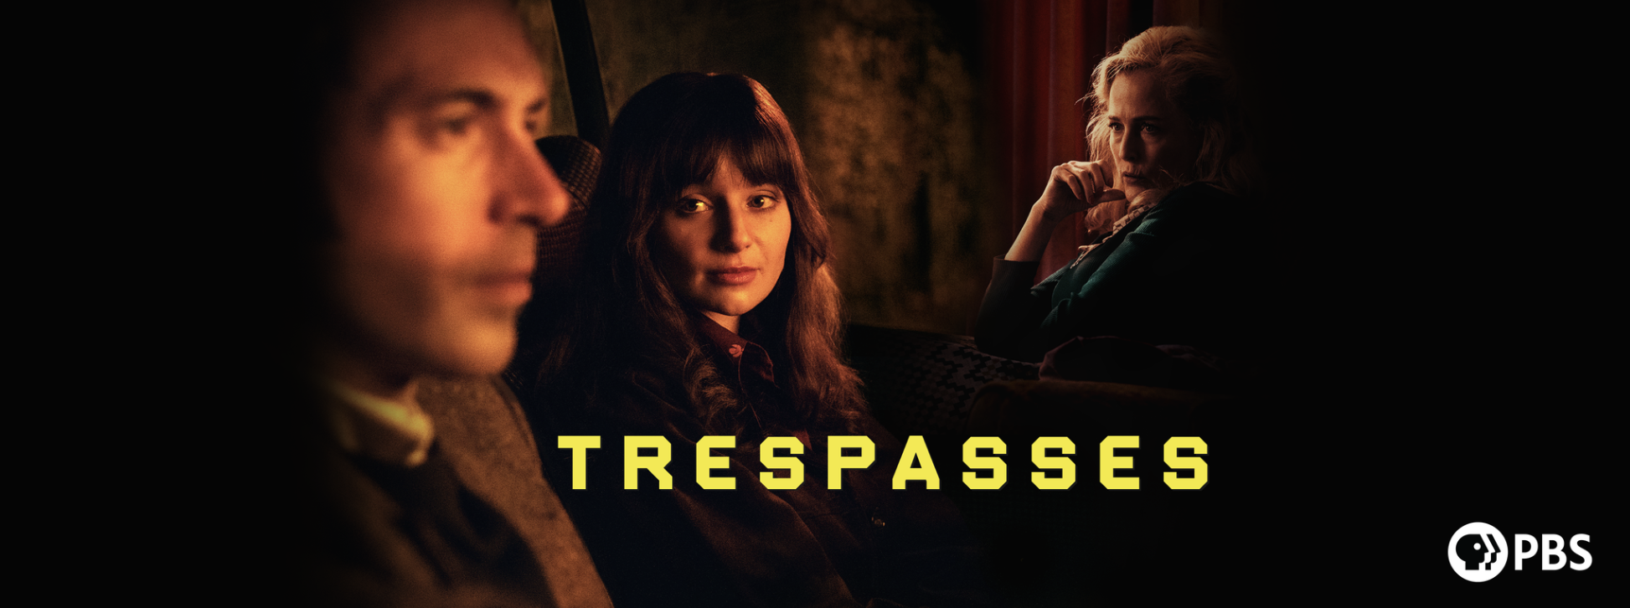
Caption: Trespasses Key Art

TRAILER
KEY ART + IMAGES

LOS ANGELES, CA / ARLINGTON, VA, August 11, 2026 – Today, PBS announced the U.S. premiere of TRESPASSES, based on Louise Kennedy’s breakout debut novel. All episodes will be available to stream beginning Sunday, September 20 on PBS Passport and with PBS Masterpiece on Prime Video. The series will broadcast, Sundays, Sept. 20 – Oct. 11, 10:00 p.m. ET on PBS (check local listings), PBS.org and the PBS app. TRESPASSES presents an unforgettable story of forbidden love set against the backdrop of the Troubles in 1970s Belfast.

TRESPASSES follows Cushla (Lola Petticrew, “Say Nothing”), a young Catholic schoolteacher whose life in 1975 Northern Ireland is shadowed by the Troubles. She meets and falls for Michael (Tom Cullen, “The Gold”) – an older, married Protestant barrister. Despite the suspicions and warnings of her glorious wreck of an alcoholic mother, Gina (Gillian Anderson “Sex Education”), Cushla and Michael are irresistibly drawn to one another. As the forbidden love between Cushla and Michael deepens, violence looms and tensions rise. Cushla is pulled between duty and desire, family and freedom.

The ensemble cast also features Martin McCann (“Blue Lights”) as Eamonn Lavery, Oisin Thompson (“My Left Nut”) as Gerry Harkin, Emily Taaffe (“The Rising”) as Betty McGeown, Barry Ward (“Bad Sisters”) as Victor McIntyre, Lisa Dwyer Hogg (“The Fall”), Lorcan Cranitch (“Bloodlands”), Frank Blake (“Normal People”), Gary Lydon (“The Banshees of Inisherin”), and Lalor Roddy (“Bodkin”).

“There wasn’t a single false moment for me in watching this poignantly beautiful series of love and heartbreak,” said Maria Bruno Ruiz, VP, Program Content Strategy & Scheduling at PBS. “The outstanding creative team behind the series and the authentic approach to Louise Kennedy’s acclaimed work, left me spellbound and I was taken away to time and place. Trespasses is an incredible addition to the PBS drama portfolio and I’m so proud that PBS viewers will see the U.S. premiere and feel its lasting impression."

Episode 1: As the passion between Cushla and Michael grows in secret, sectarian violence and
scrutiny close in, forcing her to risk everything for a love that defies the divide.

Episode 2: As Cushla’s affair deepens, tensions rise at school and home. Her kindness with her pupil backfires, her mother Gina’s drinking worsens and her love for Michael is tested by betrayal, jealousy and the dangerous politics closing in around them.

Episode 3: Cushla and Michael’s love deepens amid secrets and danger. She discovers he’s lied about his family and confronts him. Just as they commit to each other, tragedy strikes, devastating Cushla and shaking their community to its core.

Episode 4: A grieving Cushla confides in her friend Gerry and mother Gina. Cushla seeks the truth, leading to a shocking climax.

TRESPASSES will stream on all station-branded PBS platforms, including PBS Masterpiece on Prime Video, PBS.org, PBS Passport, and the PBS app, which is available on iOS, Apple TV, Android mobile and tablets, Android/Google TV, Roku, Amazon Fire TV and tablets, Comcast, Samsung Smart TV, VIZIO and LG Smart TVs.

Commissioned by the UK’s Channel 4 and produced in association with All3Media International, TRESPASSES is from Wildgaze Films (“Brooklyn,” “An Education”), the independent production company run by Oscar-nominated producing duo Finola Dwyer and Amanda Posey. Led by a line-up of stellar female talent both on-screen and off, it is directed by BAFTA winner Dawn Shadforth (“Mood,” “Adult Material”) and is based on Louise Kennedy’s breakout debut novel, which was shortlisted for the Women’s Prize for Fiction and is adapted for television by rising talent Ailbhe Keogan (“Bad Sisters”) in her first lead writing credit. TRESPASSES is produced by Maria Mulhall and executive produced by Louise Kennedy, Finola Dwyer, Dawn Shadforth, Gillian Anderson and Amanda Posey. All3Media International, part of media and entertainment group Banijay Entertainment, handles international distribution for TRESPASSES while PBS Distribution handles North American distribution.

About All3Media International
All3Media International distributes popular, award-winning TV programmes to over 1,000 broadcasters and media platforms around the world and manages FAST and AVOD channels. The company has been celebrated for producing, marketing and distributing high-quality, ground-breaking and pioneering shows to a global audience from All3Media Group producers and leading third-party producers. All3Media International has consistently topped the Broadcast and Televisual annual Indies Surveys and received the Queen’s Award for Enterprise in recognition of its growth – twice. Its catalogue contains over 35,000 hours of content across all genres.

As well as one of Britain’s top-selling drama series MIDSOMER MURDERS, All3Media International’s quality scripted content includes returning favourites such as ALL CREATURES GREAT AND SMALL and TRIGGER POINT, celebrated classics SKINS, FLEABAG and IT’S A SIN and star-studded dramas such as THE ENGLISH and THE TOURIST, in addition to THE ASSASSIN starring Keeley Hawes and Freddie Highmore, TRESPASSES featuring Gillian Anderson and upcoming series SECRET SERVICE led by Gemma Arterton.

The distributor’s expansive format slate includes global phenomenon THE TRAITORS. Named K7’s format of the year in 2024, over 30 territories have commissioned local versions, over 50 territories have broadcast episodes via tape sales and All3Media International also handles ancillary rights. Other celebrated formats include RACE ACROSS THE WORLD, LINGO and CASH CAB.

Scripted formats from All3Media International’s catalogue include LIAR, the global hit thriller commissioned in 15 territories, INFORMER, BLOOD and CHEAT as well as more lighthearted series such as QUEER AS FOLK, LAID and STEP DAVE.

About PBS Masterpiece on Prime Video
PBS Masterpiece on Prime Video consists of binge-worthy British and international drama series and movies from MASTERPIECE, Walter Presents and other critically acclaimed producers. The subscription rate for PBS Masterpiece on Prime Video is $6.99/month in the US and CAN$6.99/month in Canada with an Amazon Prime or Prime Video subscription. Every purchase helps support public television for all. The content available on the service varies between the U.S. and Canada as rights permit. Follow PBS Masterpiece on Prime Video on Facebook.

About PBS Passport
PBS Passport is one of many member benefits from participating PBS stations that gives eligible donors and supporters extended access to an on-demand library of quality public television programming online or within the PBS app. For more information about PBS Passport, visit the PBS Passport FAQ website.

About PBS
PBS, with more than 330 member stations, offers all Americans the opportunity to explore new ideas and new worlds through television and digital content. Each month, PBS reaches over 36 million adults on linear primetime television, 16 million users on PBS-owned streaming platforms, 56 million viewers on YouTube, and 10 million followers on social media, inviting them to experience the worlds of science, history, nature, and public affairs and to take front-row seats to world-class drama and performances. PBS’s broad array of programs has been consistently honored by the industry’s most coveted award competitions. As the number one educational media brand, PBS KIDS helps children 2-8 build critical skills, enabling them to find success in school and life. Delivered through member stations, PBS KIDS offers high-quality content on TV — including a PBS KIDS channel — and streaming free on pbskids.org and the PBS KIDS Video app, games on the PBS KIDS Games app, and in communities across America. Teachers of children from pre-K through 12th grade turn to PBS LearningMedia for digital content and services that help bring classroom lessons to life. More information about PBS is available at PBS.org, one of the leading dot-org websites on the internet, Facebook, Instagram, or through our apps for mobile and connected devices. Specific program information and updates for press are available at pbs.org/pressroom or by following PBS Communications on X.

About PBS DISTRIBUTION
PBS Distribution is a leading distributor of public media content around the world, entertaining audiences across platforms and formats. The company, a joint venture of PBS and GBH Boston, provides premium content through multiple digital channels and video services. PBS Distribution operates seven subscription streaming channels — PBS Masterpiece (US and CA), PBS KIDS, PBS Living, PBS Documentaries (US and CA) and PBS America (U.K.) as well as numerous Free Advertising-Supported Streaming TV (FAST) Channels in the U.S. and U.K. In addition, the company reaches viewers through Transactional Video On Demand (TVOD), Subscription Video On Demand (SVOD) licensing, Advertising-Supported Video on Demand (AVOD), DVD and Blu-ray, theatrical releasing, educational platforms, non-theatrical and inflight sales, and serves broadcasters and producers providing program sales and co-production financing.

PBS Distribution offers consumers and educators the highest quality factual, scripted, and children’s programming including films from Ken Burns, hit series from MASTERPIECE and foreign language dramas from Walter Presents, entertaining and educational PBS KIDS series, and award-winning documentaries from NOVA, FRONTLINE, AbloMERICAN MASTERS, NATURE, AMERICAN EXPERIENCE, and many independent producers. For over 15 years, the company has extended the reach of programming beyond broadcast while generating revenue for the public media system, stations, and producers. Follow PBS Distribution on Facebook.

###

Media Contacts:
BECK Media & Marketing
pbsd@beckmedia.com

Chelsie Pope, PBS
cepope@pbs.org

