SOUTHERN STORYTELLERS, a New Documentary Series Exploring Southern Identity Through the Eyes of Contemporary Creatives, Premieres July 18 on PBS

Billy Bob Thornton, Jesmyn Ward, Jason Isbell, Jericho Brown, Amanda Shires, Lyle Lovett, Angie Thomas, Qui Nguyen, and Mary Steenburgen Among Featured Writers From the Worlds of Literature, Music, Film, and Television

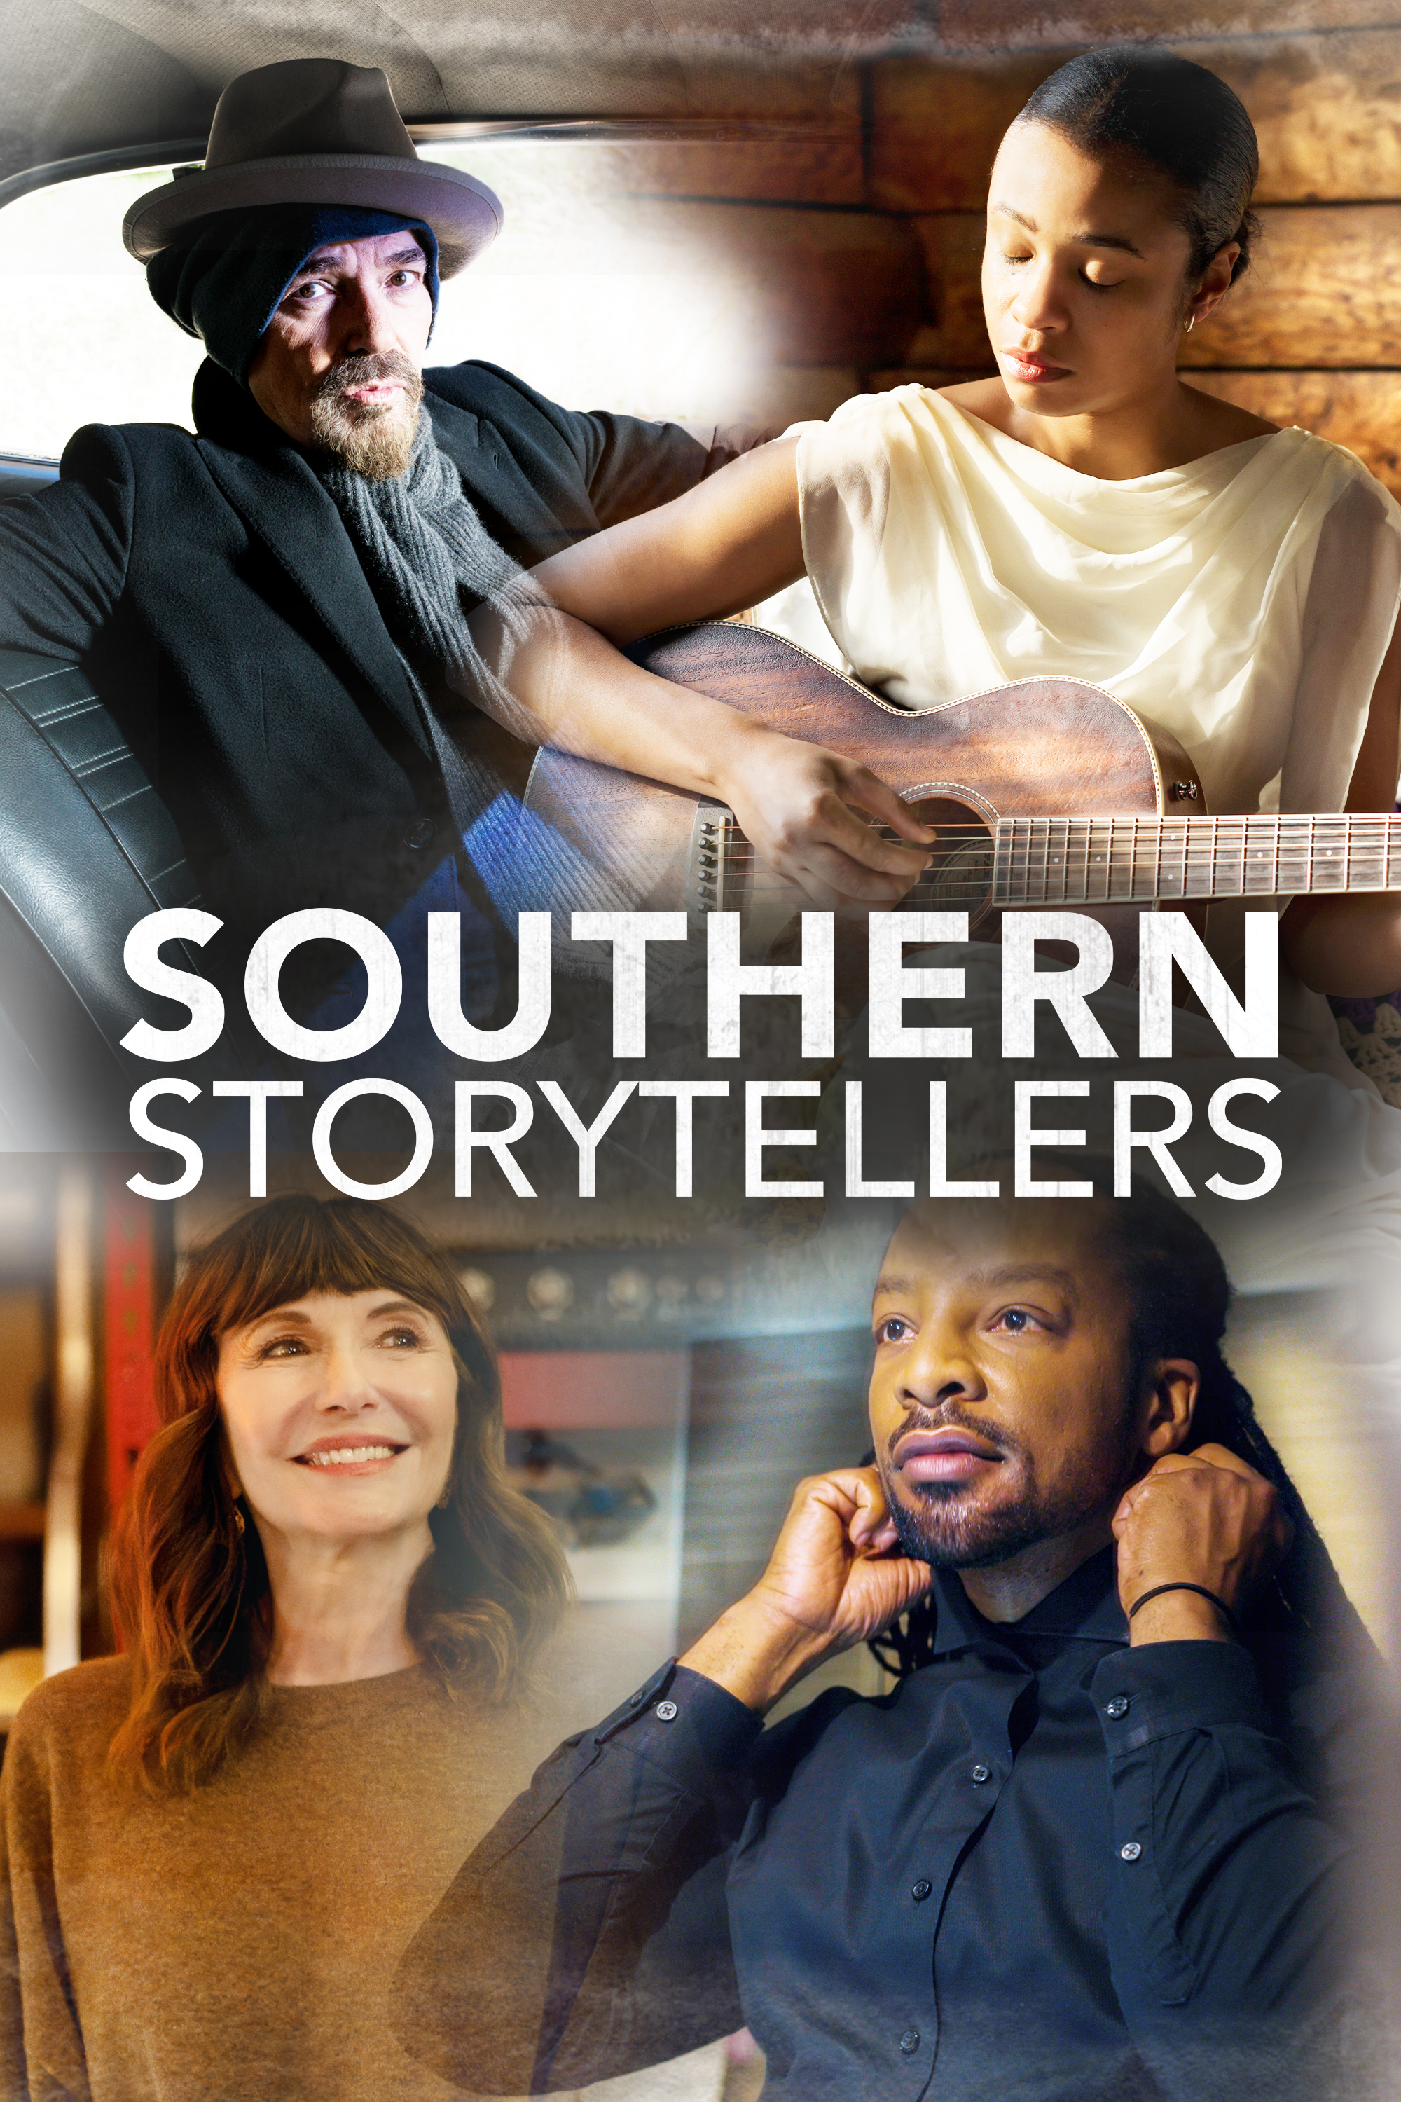
ARLINGTON, VA; JUNE XX, 2023 – The American South is known for its boundless creativity, absorbing personalities and evocative landscapes. SOUTHERN STORYTELLERS, a new three-episode series from PBS, Arkansas PBS, and Peabody Award-winning filmmaker Craig Renaud, follows some of the region’s most compelling and influential contemporary creators to the places they call home — the communities that fertilize the stories they tell in books, songs, poems, plays, and on screens large and small. The documentary series premieres Tuesdays, July 18-August 1, 9-10 p.m. ET (check local listings) on PBS, PBS.org, and the PBS App.

“SOUTHERN STORYTELLERS comes from our desire, as native Southerners, to show the South in an authentic light,” says Courtney Pledger, executive director and CEO of Arkansas PBS. “And we can think of no better way to do that than through the experiences of the region’s writers and creators who are able to engage us, move us, and take us to a deeper understanding of such a dynamic place and its people.”
SOUTHERN STORYTELLERS Key Art
(Credit: PBS)

With major funding from the Corporation for Public Broadcasting (CPB), SOUTHERN STORYTELLERS traverses the South, from the mountains of Appalachia to the Gulf of Mexico, revealing a vivid patchwork of diverse American stories that celebrate the resilience and joy of Southern people — and the magnitude of gifts from the region’s writers. Among the featured creatives are some of the most recognized storytellers from the worlds of literature, music, television, and film, including authors Jesmyn Ward, Michael Twitty, Angie Thomas, and David Joy; poets Jericho Brown and Natasha Trethewey; songwriters Jason Isbell, Thao Nguyen, Lyle Lovett, Tarriona “Tank” Ball, Adia Victoria, Amanda Shires and Justin Moore; songwriter/screenwriter/actor Billy Bob Thornton; songwriter/actor Mary Steenburgen; and screenwriters Qui Nguyen and Michael Waldron.

“We are thrilled to partner with Arkansas PBS and Craig Renaud, a talented and deep-rooted storyteller himself, to explore the breadth and depth of Southern art and culture,” says Bill Gardner, vice president of multiplatform programming and head of development at PBS. “SOUTHERN STORYTELLERS gives our audiences the opportunity to hear creators from across the region as they share, in their uniquely Southern voices, the places and histories that inspire them to honor and preserve traditions and to create new ones for the future.”

“As dialogue and connections across differences become ever more essential to our democracy, we are excited about how SOUTHERN STORYTELLERS gives voice to Southerners to reveal Southern culture in its diversity and complexity,” said Kathryn Washington, Senior Vice President, Television Content, for the Corporation for Public Broadcasting. “Besides the multiplatform series, CPB is also funding a local storytelling series for Instagram in which 12 public media stations in the South will bring even more local voices from their communities to the conversation.”

In addition to the three-part broadcast series, SOUTHERN STORYTELLERS includes a six-part companion series from PBS Digital Studios called SOUTHERN SOUNDS. The digital series explores the intersection of music and story, with a distinctly Southern perspective. Directed and produced by Keith Maitland (“Dear Mr. Brody,” “Tower”) and Terry Lickona (AUSTIN CITY LIMITS), the series offers both a front-row seat and backstage pass to the storytelling process. In each episode, Series Host Thao Nguyen invites audiences to see a new Southern Artist at work — each a unique voice reflecting the character and culture of their home community — and to explore that artist’s relationship to their hometown through the lyrics of their songs. The digital series will launch on PBS’s flagship YouTube channel on July 11.

Descriptions and broadcast dates for each of the three episodes are provided below:

SOUTHERN STORYTELLERS “Episode 1”
Premieres: Tuesday, July 18 at 9 p.m. ET
In the first of a three-part series, Southern creators of literature, music, and film explore deep ties to their native South: Billy Bob Thornton reflects on a life of writing songs and screenplays; Adia Victoria celebrates her music and marriage near Nashville; David Joy laments the disappearance of the Appalachian culture he loves; Jericho Brown reveals the South as essential to his creativity; and Mary Steenburgen remembers her Arkansas childhood in song.

SOUTHERN STORYTELLERS “Episode 2”
Premieres: Tuesday, July 25 at 9 p.m. ET
Six of the South’s most influential creators take us home to the places that define them: Mississippi’s Angie Thomas as she writes to change young lives; Jason Isbell remembers his roots in Muscle Shoals while Amanda Shires invites us home to the Tennessee farm the couple shares; Michael Twitty uncovers his roots in Alabama; Lyle Lovett traces his love of stories back to his childhood; Qui Nguyen reveals the small town that showed him the power of personal stories.

SOUTHERN STORYTELLERS “Episode 3”
Premieres: Tuesday, August 1 at 9 p.m. ET
In this third and final episode, some of the South’s most compelling and influential contemporary creators take us home to the places that fertilize the stories they tell in books, songs, poems, and on screens large and small: Mississippi author Jesmyn Ward and poet Natasha Trethewey; Georgia screenwriter and series creator Michael Waldron; Arkansas songwriter Justin Moore; songwriter Tarriona “Tank” Ball from New Orleans; and Virginia songwriter Thao Nguyen.

SOUTHERN STORYTELLERS was created by filmmaker Craig Renaud and Courtney Pledger of Arkansas PBS, who also executive produce. Renaud, known for his intimate approach to documentary subjects, has spent the last two decades telling human-centered, verité stories from around the globe, often in partnership with his late brother, Brent Renaud. The partnership between the Renaud brothers and Arkansas PBS began in 2018 with the PBS documentary STATE OF THE ART, capturing the personal stories of artists at Crystal Bridges Museum of American Art who are redefining the aesthetic of contemporary art in America. Renaud has won numerous major awards, including a Peabody and multiple duPont-Columbia Awards.

A diverse team of filmmakers and producers join Renaud Brothers Films and Arkansas PBS in the overall effort, including Keith Maitland, Terry Lickona, Juan Arredondo, Nathan Willis, Jamal Hodge, Denise Godoy, Andy Sarjahani, Stephen Bailey and Héctor Tapia. Bill Gardner is the executive in charge for PBS.

Major Funding for SOUTHERN STORYTELLERS was provided by the Corporation for Public Broadcasting. Additional funding was provided by the Rosalind P. Walter Foundation, the Willard and Pat Walker Charitable Foundation, Inc., and Moses Tucker Partnership.

About Arkansas PBS
For more than 50 years, Arkansas PBS has served as Arkansas’s statewide public media network. An inventive and award-winning multiplatform producer of local and national public media content, Arkansas PBS empowers learners of all ages and drives conversations, inspiring people and communities to reach their full potential. Arkansas PBS creates and celebrates Arkansas stories, informs through in-depth public affairs content and shares valued PBS programs as an essential service to all Arkansans, deepening connections to communities and the larger world, and changing lives for the better. More information about Arkansas PBS’s broadcast, online, educational, and on-demand services and resources is available at myarkansaspbs.org.

About Renaud Brothers Films
Renaud Brothers Films is led by Craig Renaud, best known for his character-driven, cinema verité documentaries such as “Dope Sick Love,” “Last Chance High,” “Off to War” and “Meth Storm.” In 2018, Renaud Brothers Films produced STATE OF ART for PBS. Renaud’s work has often been in partnership with his brother Brent Renaud, who died in 2022 while documenting the refugee crisis in the Ukraine, the first American journalist killed in that conflict. The Renaud Brothers’ work has won a Peabody Award, two du-Pont-Columbia Awards, two Overseas Press Club Awards, an IDA Documentary Award, a Webby Award and an Edward R. Murrow Award.

About PBS Digital Studios
PBS Digital Studios produces original, digital programming for YouTube and Facebook, designed to engage, enlighten, and entertain online audiences. The PBS Digital Studios network has more than 29 million subscribers, generating an average of 50 million views a month and has acquired more than three billion lifetime views. Currently, the Studio has 20 original series streaming online, including eight series from PBS member stations. Series include the Webby Award-winning IT’S OKAY TO BE SMART, SOUND FIELD and CRASH COURSE, the Daytime Emmy-award winning PRIDELAND, as well as popular series such as TWO CENTS, EONS and PBS SPACE TIME.

About PBS
PBS, with more than 330 member stations, offers all Americans the opportunity to explore new ideas and new worlds through television and digital content. Each month, PBS reaches over 42 million adults on linear primetime television, more than 15 million users on PBS-owned streaming platforms, and 56 million people view PBS content on social media, inviting them to experience the worlds of science, history, nature, and public affairs; to hear diverse viewpoints; and to take front-row seats to world-class drama and performances. PBS’s broad array of programs has been consistently honored by the industry’s most coveted award competitions. Teachers of children from pre-K through 12th grade turn to PBS LearningMedia for digital content and services that help bring classroom lessons to life. As the number one educational media brand, PBS KIDS helps children 2-8 build critical skills, enabling them to find success in school and life. Delivered through member stations, PBS KIDS offers high-quality content on TV — including a PBS KIDS channel — and streaming free on pbskids.org and the PBS KIDS Video app, games on the PBS KIDS Games app, and in communities across America. More information about PBS is available at PBS.org, one of the leading dot-org websites on the internet, Facebook, Instagram, or through our apps for mobile and connected devices. Specific program information and updates for press are available at pbs.org/pressroom or by following PBS Communications on Twitter.

– PBS –

Media Contacts:

Chelsie Pope, PBS, cepope@pbs.org, 703-405-8280

Jordan Lawrence, DKC, jordan_lawrence@dkcnews.com, 201-396-6529

For images and additional up-to-date information on this and other PBS programs, visit PBS PressRoom at pbs.org/pressroom.

