SING DEMOCRACY 250
Premieres September 25, 2026 on PBS and PBS.org

Concert Commemorating 250 Years of Democracy Through Song Invites All Americans to Active Citizenship

ARLINGTON, VA; August 6, 2026 – PBS announced today that SING DEMOCRACY 250 will premiere Friday, September 25, 2026, at 9:00 p.m. ET (check local listings) on PBS, PBS.org and the PBS app. Produced by Together In Hope Project in association with Thirty-Fifth Productions and Foreground Productions, this soaring choral concert is a timely call to Americans to become actively involved in renewing our democratic ideals as the nation celebrates its 250th anniversary.
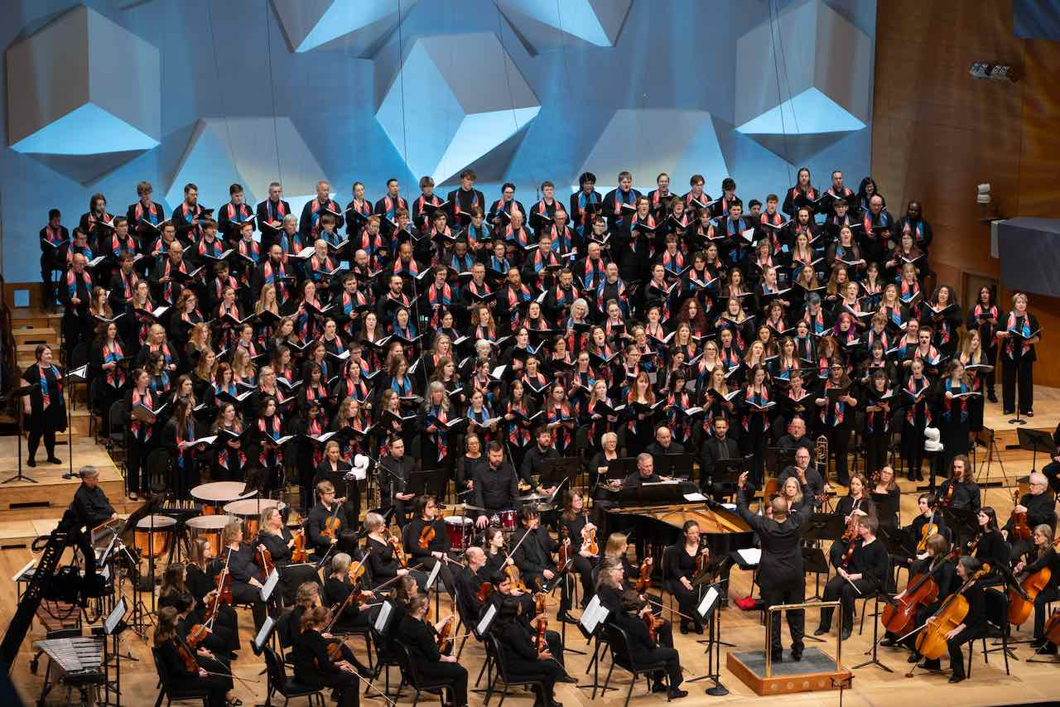
Credit: Lee Clifford

Filmed on April 12, 2026 at Orchestra Hall in Minneapolis, the concert opens with the world premiere of “Fanfare: Democracy 250” by Steven Amundson, an energetic, brass-forward fanfare that weaves fragments of “America the Beautiful” throughout with the full melody finally emerging. Two newly commissioned works are also included: “Redeem the Dream,” by Brandon A. Boyd and “US,” by Michael Bussewitz-Quarm. Reflecting on the gap between the ideals of the American dream and the reality experienced by many, “Redeem the Dream” opens with the words of the Declaration of Independence, then moves to the Langston Hughes’ 1935 poem “Let America Be America Again.” “US” is based on Richard Haass’ 2023 book The Bill of Obligations: The Ten Habits of Good Citizens. “US” unpacks each of the ten obligations through 31 quotations from a diverse group of Americans and ends with a call to participate — a reminder that democracy is in our hands.

These compositions deliver a powerful message of hope for democracy, expressed through the voices of nearly 200 singers from high school, college, and community choirs, anchored by the Together In Hope Choir and a 60-piece orchestra. The concert also includes “The Star-Spangled Banner” and “Lift Every Voice and Sing,” both arranged by conductor G. Phillip Shoultz, III. Performers include Minnesota-based ensembles the Together In Hope Choir (Minneapolis/St. Paul), St. Scholastica Chamber Choir (Duluth), Minnesota State University Moorhead Dragon Choir, Choral Arts Ensemble (Rochester), young singers of the Honors Choirs of SE Minnesota, and the Metropolitan Symphony Orchestra, all led by conductor G. Phillip Shoultz, III.

The Minneapolis concert was the second in a series of four Sing Democracy 250 signature concerts nationwide. Past concerts include the world premiere in Philadelphia at Marian Anderson Hall (October 2025); New York City at Lincoln Center's David Geffen Hall (May 2026) and at DAR Constitution Hall in Washington, D.C. (June 2026).
Beyond the signature concerts, the initiative expands through the All-America Program, a call for choirs nationwide to perform these works in their own communities. More than 100 choirs have committed to more than 75 performances across 25 states and the District of Columbia in 2026.

SING DEMOCRACY 250 is part of PBS America @ 250, a multiyear celebration of U.S. history, culture, and children’s programming, which began in spring 2025 and continues through America’s Semiquincentennial in 2026 and beyond.

“This concert was born out of a deep desire to bring people together to honor the 250th anniversary of our country,” said conductor G. Phillip Shoultz, III. “We are living in a time when division too often defines our public life. Music has a unique power to gather us in the same space, to help us listen to one another, and to remind us of our shared humanity. When we sing together, we practice the very act of community.”

“Sing Democracy 250 is an invitation to gather through music, to reflect on the fundamental values expressed in the Declaration of Independence — that all are equal before the law, that all share the same rights of life, liberty, and the pursuit of happiness,” said SD250 co-founders Gary Aamodt and Celia Ellingson. “The music also reminds us what We, the People can and must do to fulfill our duties as citizens. It is now our turn — and our opportunity — to do all we can to ensure that our democracy is not just remembered but renewed for the next 250 years.”

SING DEMOCRACY 250 will stream simultaneously with broadcast and be available on all station-branded PBS platforms, including PBS.org and the PBS app, which is available on iOS, Apple TV, Android mobile and tablets, Android/Google TV, Roku, Amazon Fire TV and tablets, Comcast, Samsung Smart TV, VIZIO and LG Smart TVs.

SING DEMOCRACY 250 is a co-production of Thirty-Fifth Productions and Foreground Productions. Directed by Kristin Fosdick and Cody McLeod Rogers. Executive produced by Cody McLeod Rogers and Jacob Leftwich. Consulting Producer is Justin Ellis. Zara Frankel is Executive in Charge for PBS.

About Together In Hope Project
Together In Hope Project, whose mission is changing lives through “music with a purpose,” was established in 2018 to focus the transformative power of music on issues of our shared humanity. Together In Hope Project has created and delivered two major music projects on the world stage: the first marked the 500th anniversary of the Reformation in 2017-2018 by bringing Protestants and Catholics together for healing and reconciliation, with performances in the U.S. in 2017 and in Rome at the invitation of the Vatican in 2018. In 2022, the second project “The Stranger,” done in collaboration with USA for UNHCR (the UN refugee agency) focused on welcoming refugees, immigrants, and displaced persons, with the world premiere in Trondheim, Norway, and the U.S. premiere in the Twin Cities. The Together In Hope Choir, a community of 50 premier artists primarily from the Minneapolis/St. Paul area, serves as the anchor choir for the four Sing Democracy 250 Signature Concerts.

About Sing Democracy 250
Sing Democracy 250, founded by Gary Aamodt and Celia Ellingson, is a nationwide nonpartisan musical initiative commemorating the 250th anniversary of the signing of the Declaration of Independence: a movement of resilience, a chorus of hope, and a celebration of the values that define us as Americans. Sing Democracy 250 unfolds through four signature choral concerts across cities important to the founding of America: Philadelphia and Washington, D.C. for their foundational roles in democratic history; New York City, today's modern cultural capital; and Minnesota, widely regarded as a leading choral center of the United States. All four concerts are rooted in local partnerships with community voices and celebrate the beginnings of our nation through meaningful texts and musical compositions.

Sing Democracy 250 is a project of Players Philanthropy Fund, a Texas nonprofit corporation recognized by the IRS as a tax-exempt public charity under Section 501(c)(3) of the Internal Revenue Code (Federal Tax ID: 27-6601178, ppf.org/pp). Contributions to Sing Democracy 250 qualify as tax-deductible to the fullest extent of the law.

About Thirty-Fifth Productions
Named in tribute to the legacy of American cultural leadership, Thirty-Fifth Productions is dedicated to building the future of live performance — boldly, collaboratively, and with purpose. Founded by Justin Ellis and Matthew Winer, the company brings more than two decades of leadership experience from the Kennedy Center and the National Symphony Orchestra, where they produced nationally broadcast events, major cross-genre collaborations, and large-scale cultural initiatives. Today, Thirty-Fifth operates at the intersection of the performing arts and the broader entertainment industry, helping institutions, artists, and partners create work that resonates with contemporary audiences while sustaining long-term artistic vitality. We develop original projects, forge strategic partnerships, and advise cultural organizations on how to thrive in a rapidly changing landscape — expanding audiences, generating new revenue, and redefining what live performance can be in the 21st century.

About Foreground Productions
Foreground Productions is an independent studio built to champion bold storytellers in a rapidly evolving entertainment industry. As traditional studio systems shift and independent filmmaking becomes increasingly competitive, we believe great stories deserve the resources and support to thrive. We partner with artists at every stage of the creative process — from story development and IP acquisition to production, post-production, and distribution. By combining traditional filmmaking with innovative digital revenue and distribution strategies, we have created a sustainable model that prioritizes artistic integrity over box office pressures. Whether producing feature films, television, or live-performance captures, our mission is simple: keep the soul of every project in the foreground while empowering the creators behind it and bringing distinctive, meaningful stories to audiences.

About PBS
PBS, with more than 330 member stations, offers all Americans the opportunity to explore new ideas and new worlds through television and digital content. Each month, PBS reaches over 36 million adults on linear primetime television, 16 million users on PBS-owned streaming platforms, 56 million viewers on YouTube, and 10 million followers on social media, inviting them to experience the worlds of science, history, nature, and public affairs and to take front-row seats to world-class drama and performances. PBS’s broad array of programs has been consistently honored by the industry’s most coveted award competitions. As the number one educational media brand, PBS KIDS helps children 2-8 build critical skills, enabling them to find success in school and life. Delivered through member stations, PBS KIDS offers high-quality content on TV — including a PBS KIDS channel — and streaming free on pbskids.org and the PBS KIDS Video app, games on the PBS KIDS Games app, and in communities across America. Teachers of children from pre-K through 12th grade turn to PBS LearningMedia for digital content and services that help bring classroom lessons to life. More information about PBS is available at PBS.org, one of the leading dot-org websites on the internet, Facebook, Instagram, or through our apps for mobile and connected devices. Specific program information and updates for press are available at pbs.org/pressroom or by following PBS Communications on X.

– PBS –

CONTACTS:

Meredith Tiger, PBS, mjtiger@pbs.org, 516-551-8511

Amanda Sweet, Bucklesweet, amanda@bucklesweet.com, 347-564-3371

For images and additional up-to-date information on this and other PBS programs, visit PBS PressRoom at pbs.org/pressroom.

