SHAMROCK TENORS: LIVE FROM BELFAST,

A Musical Journey Through Ireland’s Most Beloved

Classic Songs, Premieres on PBS Stations

Beginning November 29

Harmonic Renditions of Irish Classics Transport Viewers to the Emerald Isle Through Song

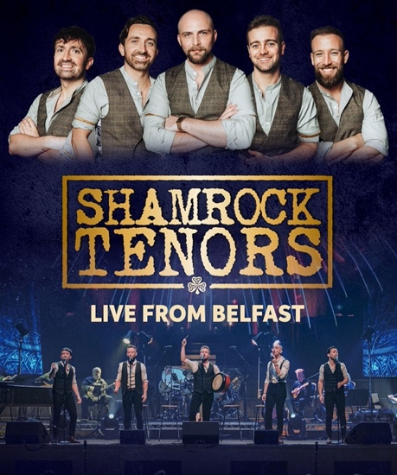
Credit: Sam Kwan

Shamrock Tenors are Ireland’s most exciting new artists who are shaping the future of Celtic music. Through SHAMROCK TENORS: LIVE FROM BELFAST, viewers experience a musical journey through the Emerald Isle’s most beloved classic songs — all in perfect five-part harmony. With favorites like “Danny Boy,” “Whiskey in the Jar,” “The Parting Glass,” and “Wild Rover,” SHAMROCK TENORS: LIVE FROM BELFAST is a show for all ages, performed with that cheeky Irish charm! The concert premieres on PBS stations beginning Friday, November 29, 2024 (check local listings) and will be available for streaming for PBS station members with PBS Passport.

Hailing from Ulster — a historic province in the North of Ireland — the Shamrock Tenors represent both sides of their native home community and celebrate the progress and peace that Northern Ireland has found since the Good Friday Agreement. Their powerful and smooth vocals and the best multi-instrumentalists Ireland has to offer integrate a unique blend of guitar, flute, fiddle, Celtic whistle, and the ancient bodhrán drum.

The band is comprised of five multi-talented performers:

- Tom Brandon trained at the Royal Academy of Music, London, and Trinity Laban Conservatoire of Music & Dance. A fluent Gaelic speaker, the actor and singer is an original cast member of the Olivier-nominated The Choir of Man and is its associate director. He most recently performed the production at its premiere in London, prior to which he performed in two US National Tours after three sell-out seasons with the show at the Sydney Opera House.
- Matthew Campbell has toured and performed extensively with the Shamrock Tenors as singer, arranger, and multi-instrumentalist (guitar, whistle, flute, fiddle, drums, bodhran) since 2018. He also recently joined Tom in The Choir of Man for their month-long Melbourne residency. He studied Music at Queens University Belfast, and his Masters focused on Musical Theatre in Northern Ireland.
- Jimmy Johnston has performed all over the world, singing and dancing for audiences and proudly representing his country. The silky smooth vocalist and champion Irish dancer is responsible for writing the group's original songs, including “Mary” and “Climbing Over the Mountain,” with many more to be recorded and released soon.
- Jack Walsh earned his Bachelor of Fine Arts in Filmmaking from the New York Film Academy in Los Angeles. During this time, the tenor vocalist composed the soundtracks for all his projects and wrote, directed, composed, choreographed, and starred in a musical short film, Not Another High School Musical. He also spent time working with Oscar-nominated composer John Debney. Walsh’s film, Grace, set in troubled 1979 Northern Ireland, was accepted into the Cannes Film Festival Court Métrage in 2016.
- Raymond Walsh, older brother of fellow Shamrock Tenor Jack, formed the Shamrock Tenors in 2018 to showcase the most talented lads he knew in Northern Ireland. Winner of the William Lloyd Webber singing trophy, he trained in Musical Theatre at the Guildford School of Acting. He spent eight years performing in musicals across the world, including two years in the original version of Les Misérables in London and was featured in the All-Star Concert version alongside Alfie Boe and Michael Ball.

“We’re so excited to be part of the PBS family and share this special performance,” says band creator and director Raymond Walsh. “This show was created with our audience in mind — to give them a true flavor of Ireland’s classics with our own spin on them, to get them moving and get them excited about our country’s rich musical history.”

The concert begins with one of the oldest and liveliest Celtic classics, “Wild Rover,” then moves to a heartfelt rendition of the inspiring anthem “Ireland’s Call.” Each song has the crowd swaying in appreciation, often jumping to their feet to dance along. From Irish reels to fan favorites, SHAMROCK TENORS: LIVE FROM BELFAST weaves traditional Irish folk songs, such as “Red Is the Rose,” “Belfast,” and “Dirty Old Town,” with emotive Irish ballads, like “The Fields of Athenry” — a velvety duet with Mairéad Carlin from Celtic Woman — to dynamic renditions of “Black Velvet Band,” the popular tavern tune, “Whiskey in the Jar” and the Scottish Irish folk song, “Wild Mountain Thyme.”

The Shamrock Tenors headlined their first-ever Northern Irish national tour in 2024. Starting with a sold-out show at the Grand Opera House in Belfast, they continued to sell out the entire tour, including a return to the Grand Opera House for another sold-out performance. Their tour culminated with a sold-out show at the Adelphi Theatre in London’s West End. They also headlined the BBC’s 2024 St Patrick’s Day coverage across the entire UK and Ireland with the launch of their debut concert special.

The group’s first two singles shot straight to Number 1 on the iTunes World Music Charts, while their performances online have received over seven million views. They’ve traveled to over 30 countries as a group, including Irish festivals in the US and sold-out shows in iconic venues such as the Ulster Hall, Belfast, and Birmingham Symphony Hall in England.

Following the group’s first-ever national special on PBS, select markets across America will get to experience the Shamrock Tenors live as they launch their first US tour starting in the spring of 2025.

PBS special programming invites viewers to experience the worlds of science, history, nature and public affairs; hear diverse viewpoints; and take front-row seats to world-class drama and performances. Viewer contributions are an important source of funding, making PBS programs possible. PBS and public television stations offer all Americans from every walk of life the opportunity to explore new ideas and new worlds through television and online content.

- PBS –

CONTACT: Cara White, CaraMar, Inc., cara.white@mac.com

For images and additional up-to-date information on this and other PBS programs, visit PBS PressRoom at pbs.org/pressroom.

