SARAH BRIGHTMAN: A CHRISTMAS SYMPHONY
Premieres on PBS Stations Beginning October 2021

Celebrate the Holiday Season with the Soprano’s First-Ever
Christmas Special

A CHRISTMAS SYMPHONY TOUR Set To Kick Off This December!

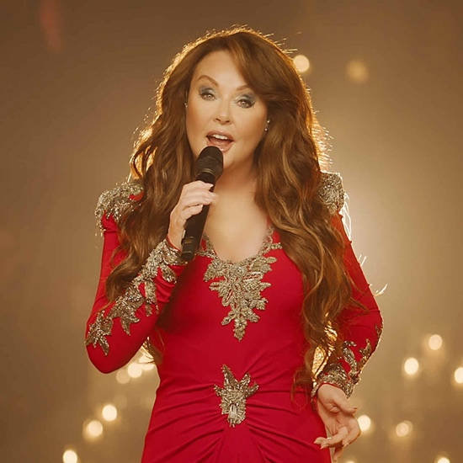
Credit: Oliver Sommers

In celebration of the holidays, the world’s best-selling soprano and legendary Grammy® Award-nominated artist performs her first-ever Christmas special from the beautiful Christ Church Spitalfields in London. Transforming the iconic and historic setting into an intimate winter wonderland, SARAH BRIGHTMAN: A CHRISTMAS SYMPHONY is part of special programming premiering on PBS stations beginning October 2021 (check local listings). A CHRISTMAS SYMPHONY TOUR is set to kick off this December.

Please click HERE to view the trailer for SARAH BRIGHTMAN: A CHRISTMAS SYMPHONY

Sarah breathes new life into a bevy of holiday classics and festive fan favorites for the season. She handpicked the set, which explores various eras of the Christmas canon, and performs “Silent Night,” “I Believe In Father Christmas,” “Ave Maria,” “Colder Than Winter,” “Amazing Grace” and more.

And since it wouldn’t be the holidays without friends, Sarah is joined by special guests Aled Jones (the voice of “The Snowman”) and choir Gregorian. She also reunites with very special guest Andrew Lloyd Webber for a beautiful new arrangement of “Christmas Dream,” a holiday classic written by Lloyd Webber and Tim Rice. Additional songs featured include “Coventry Carol,” the Nutcracker overture, “Walking in the Air” and “Pie Jesu.”

PBS special programming invites viewers to experience the worlds of science, history, nature and public affairs; hear diverse viewpoints; and take front-row seats to world-class drama and performances. Viewer contributions are an important source of funding, making PBS programs possible. PBS and public television stations offer all Americans from every walk of life the opportunity to explore new ideas and new worlds through television and online content.

TOUR DATES:

11/26 Bethlehem, PA Wind Creek Event Center
11/27 Newark, NJ New Jersey Performing Arts Center
11/28 Staten Island, NY St. George Theatre
12/1 Worcester, MA The Hanover Theatre for the Performing Arts
12/3 Greenvale, NY Tilles Center for the Performing Arts
12/4 Atlantic City, NJ Ocean Casino Resort
12/6 North Bethesda, MD The Music Center at Strathmore
12/7 North Bethesda, MD The Music Center at Strathmore
12/10 Chicago, IL Auditorium Theatre
12/11 Nashville, TN Ryman Auditorium
12/13 Atlanta, GA Fox Theatre
12/14 Sarasota, FL Van Wezel Performing Arts Hall
12/15 Clearwater, FL Ruth Eckerd Hall
12/18 Sugar Land (Houston), TX Smart Financial Centre
12/19 San Antonio, TX Majestic Theatre
12/20 Dallas, TX Winspear Opera House
12/21 New Orleans, LA Saenger Theatre

ABOUT SARAH BRIGHTMAN:
Known for her three-octave range and for pioneering the classical-crossover music movement, Sarah Brightman has amassed global sales of more than 30 million units. The only artist to have simultaneously topped Billboard’s dance and classical music charts, Brightman has racked up more than 180 gold and platinum awards in over 40 countries. She is also known for her iconic star turn in The Phantom of the Opera, whose soundtrack has sold more than 40 million copies worldwide. Her duet with Bocelli, “Time To Say Goodbye,” became an international success selling 12 million copies worldwide. Brightman’s albums Eden, La Luna, Harem, and Symphony were each chart-topping Billboard hits and accompanied by world tours. Additionally, Brightman has performed at such prestigious events as the 2007 Concert for Diana, the 1992 Barcelona Olympic Games and the 2008 Beijing Olympic Games. Her latest studio album HYMN was released in 2018 and debuted at #1 on the Classical and Classical crossover Billboard charts. Sarah’s HYMN world tour began in South America in September 2018 and concluded in her hometown of London, England in November 2019. Together with orchestra and choir, Sarah will take “A Christmas Symphony” on the road for the very first time, as part of a 17-date US tour beginning late November 2021.

Underwriters: Public Television Viewers and PBS
Production Company: Harmonic Instinct LTD

- PBS –

CONTACT FOR PBS: Cara White, CaraMar, Inc., cara.white@mac.com
CONTACT FOR SARAH BRIGHTMAN: Carleen@theoriel.co
CONTACT FOR PBS BROADCAST INQUIRIES: Hope Reed, hope@hopereedmarketing.com

For images and additional up-to-date information on this and other PBS programs, visit PBS PressRoom at pbs.org/pressroom.

