SALUTE TO SERVICE: A VETERANS DAY CELEBRATION Honors Members of the Military with Host Jon Stewart and a Star-Studded Line-Up of Musical Guests

New Veterans Day Special with the United States Army Field Band Premieres Friday, Nov. 10 on PBS

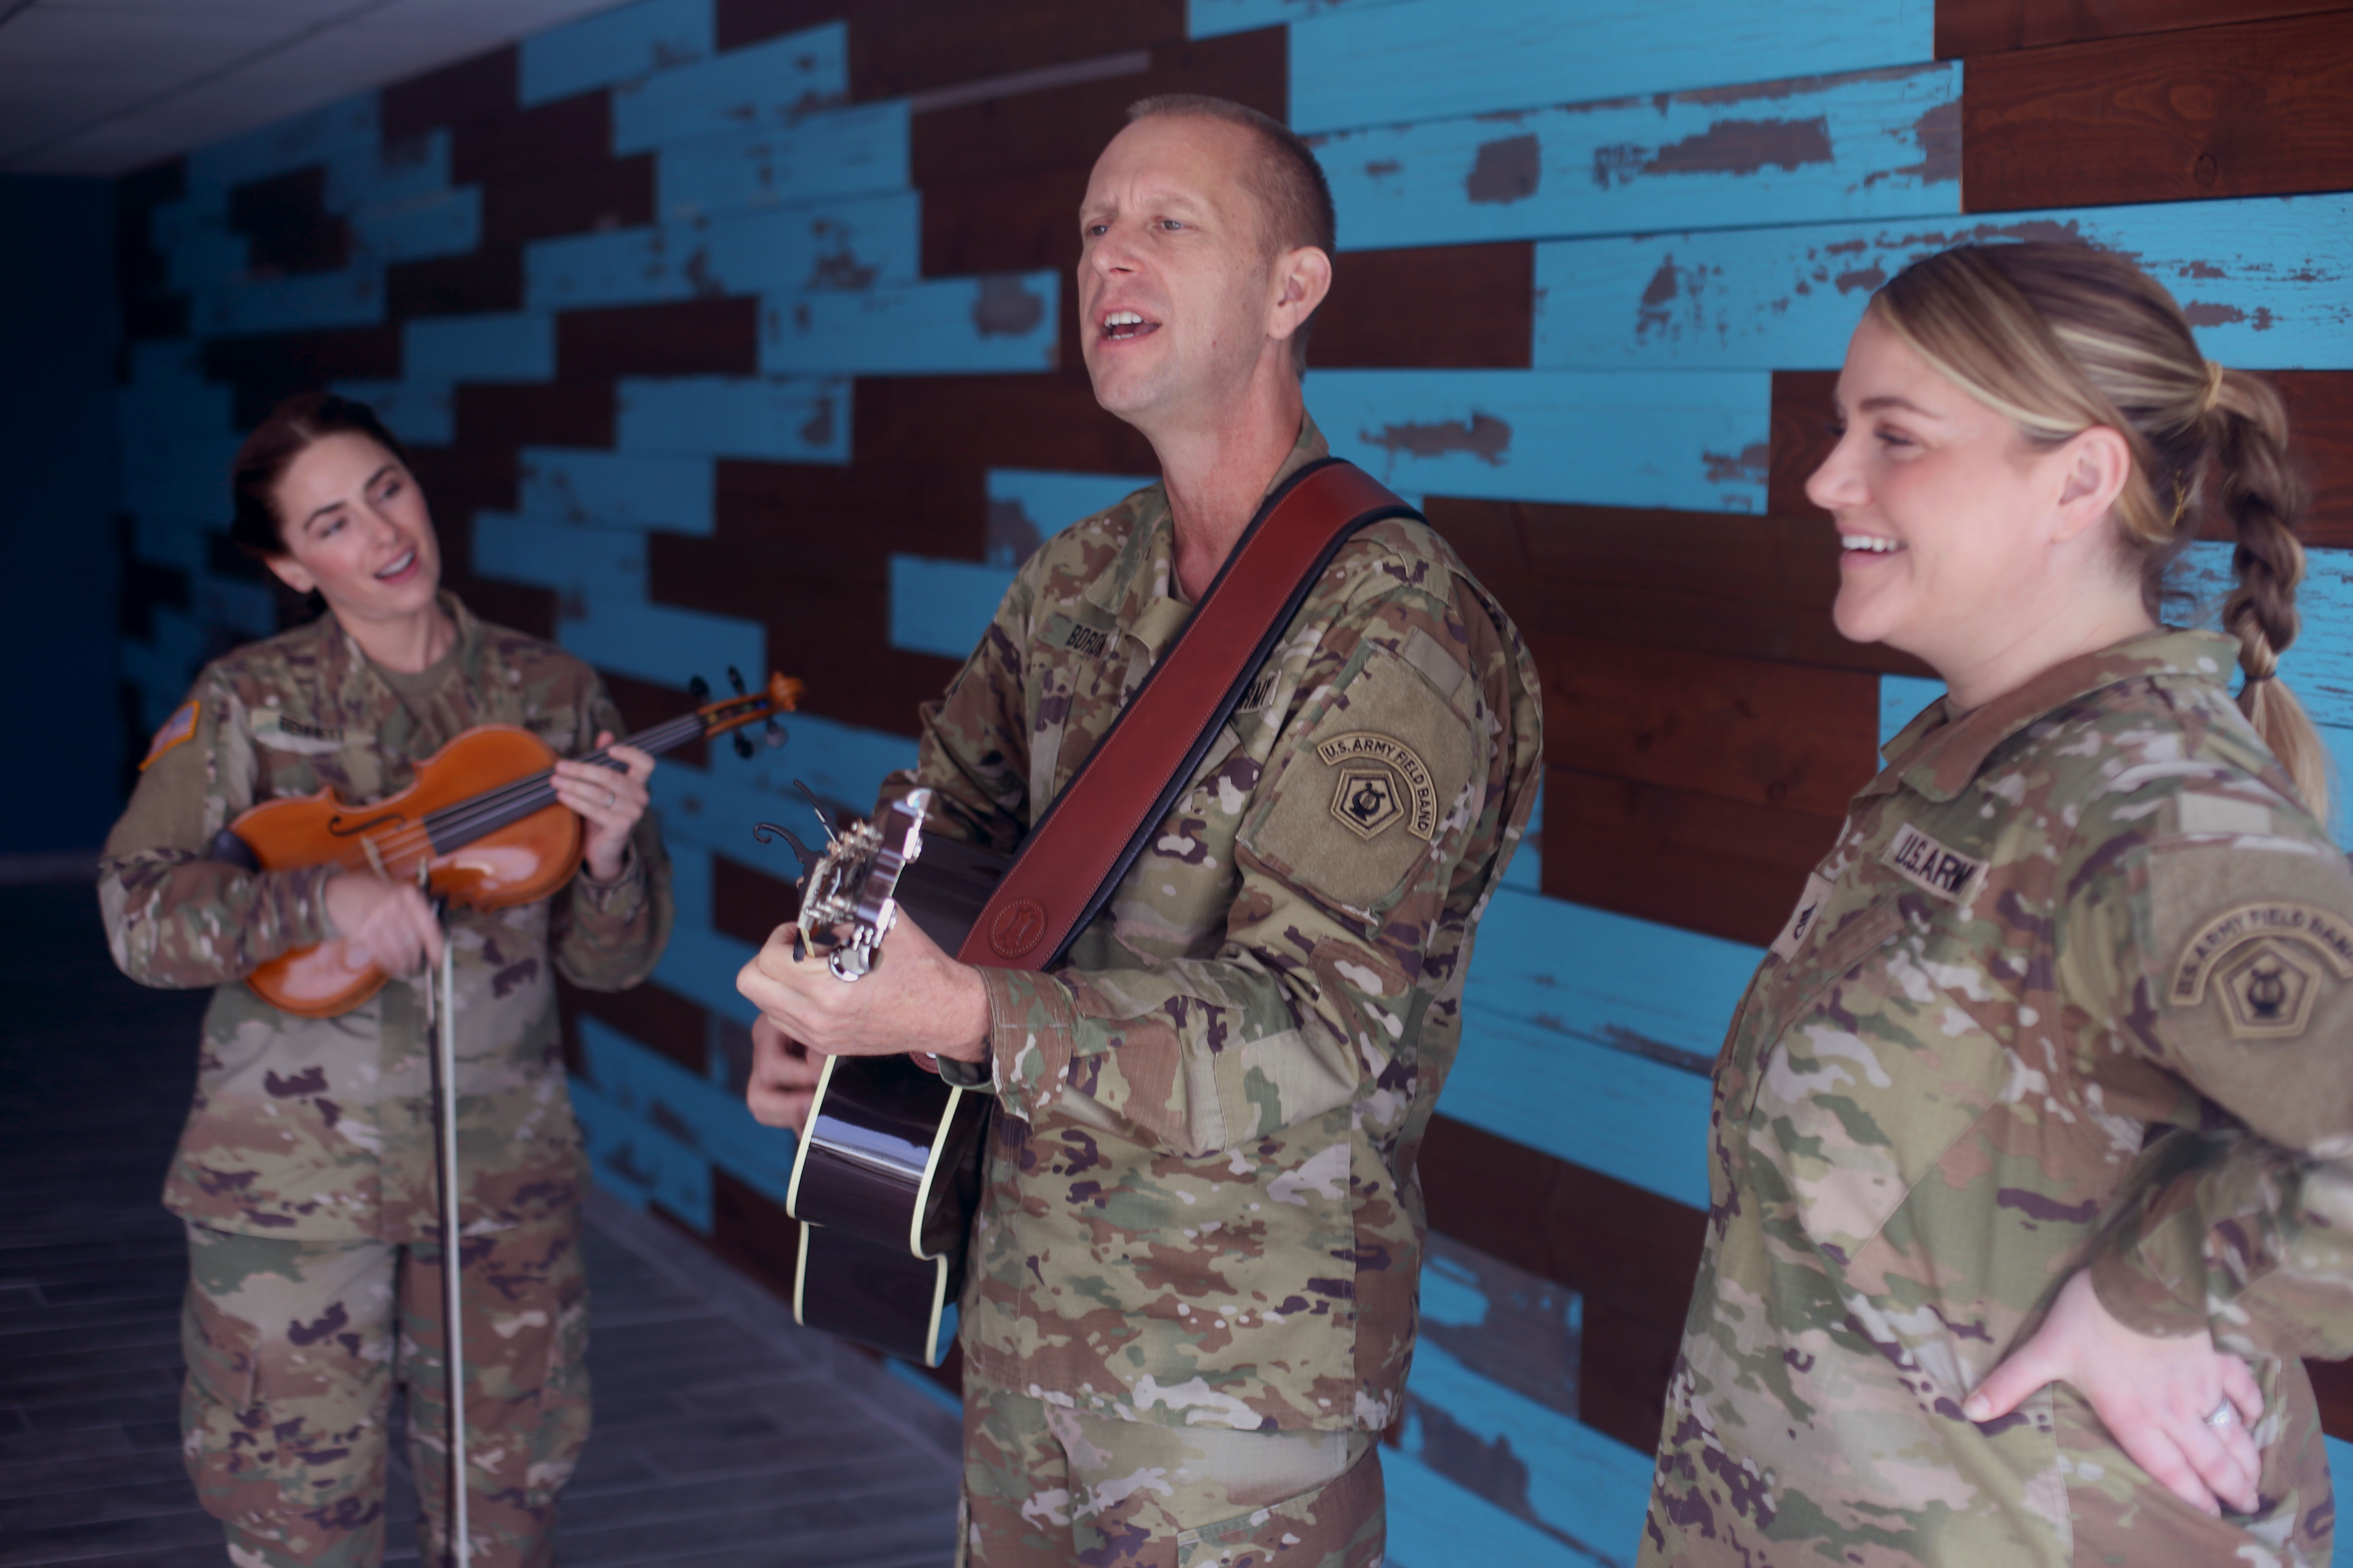
Caption: The U.S. Army Field Band Six-String Soldiers
Credit: SPC Justin Card (Photographer)

ARLINGTON, VA; Oct. 10, 2023 – SALUTE TO SERVICE: A VETERANS DAY CELEBRATION, a special with the U.S. Army Field Band, will premiere Friday, Nov. 10, at 9 p.m. ET (check local listings) on PBS, PBS.org, and the PBS App. Jon Stewart, comedian and recent recipient of the Kennedy Center Mark Twain Prize for American Humor, hosts the celebration alongside a stellar lineup of performers, including country music artist Mickey Guyton, singer/songwriter Amanda Shires, and Broadway star Mandy Gonzalez.

The special is a heartfelt showcase of musical diversity and award-winning singing talent. The special will also introduce real-life heroes like Medal of Honor recipient and Green Beret Colonel Paris Davis – a Vietnam War Veteran – and trailblazer Evelyn Kandel, a 90-year-old Korean War-era veteran who paved a way for women to serve their country. Stewart sits down with veterans of all service branches and generations to explore stories of courage and camaraderie.

Through inspiring music, the soldiers of the U.S. Army Field Band will lead a collective salute to the many heroes who have served, sacrificed, and protected the nation, as well as inspire a new generation of America’s defenders, as all reflect on the enduring spirit of America for Veterans Day.

“The U.S. Army Field Band is one of the finest ensembles of its kind, and it is an honor to bring its sound to America in this special,” said executive producer and director Habib Azar. “With Jon Stewart as our host, we honor our veterans and their service to our country in a program which is celebratory and entertaining.”

PBS’s Senior Director, Arts Programming & Development Christopher Farley said, “It’s important to honor people who have served this country, and it’s great to have the support of the incredible artists in this show. SALUTE TO SERVICE: A VETERANS DAY CELEBRATION is a deeply moving special that will not only explore the experiences of those who have served but will connect family and friends and provide an opportunity to celebrate ahead of Veterans Day.”

SALUTE TO SERVICE: A VETERANS DAY CELEBRATION comes from Snap Snap productions with Habib Azar as executive producer and director and written by Ken Kaissar. Master Sgt. Lauren Urquhart, Master Sgt. Teresa Alzadon, and Sgt. 1st Class Pamela Daniels serve as U.S. Army Field Band producers. Christopher Farley is executive in charge for PBS.

About Snap Snap Productions
Snap Snap Productions is led by 8-time Emmy Award-winning director Habib Azar. One of the world's leading multi-camera directors and a specialist in filming music for TV, Habib Azar's work spans popular and classical music styles. Snap Snap Productions regularly films the world's leading artists at Carnegie Hall and David Geffen Hall. Habib directs the annual July 4th Boston Pops Fireworks Spectacular, which has featured artists including Jon Batiste, Mavis Staples, Chaka Khan, and En Vogue. For PBS he has directed for series including The Met: Live in HD, Live from Lincoln Center, The All-Star Orchestra, and Great Performances. His feature film Armless was an official selection of the Sundance Film Festival.

About PBS
PBS, with more than 330 member stations, offers all Americans the opportunity to explore new ideas and new worlds through television and digital content. Each month, PBS reaches over 42 million adults on linear primetime television, more than 15 million users on PBS-owned streaming platforms, and 56 million people view PBS content on social media, inviting them to experience the worlds of science, history, nature, and public affairs; to hear diverse viewpoints; and to take front-row seats to world-class drama and performances. PBS’s broad array of programs has been consistently honored by the industry’s most coveted award competitions. Teachers of children from pre-K through 12th grade turn to PBS LearningMedia for digital content and services that help bring classroom lessons to life. As the number one educational media brand, PBS KIDS helps children 2-8 build critical skills, enabling them to find success in school and life. Delivered through member stations, PBS KIDS offers high-quality content on TV — including a PBS KIDS channel — and streaming free on pbskids.org and the PBS KIDS Video app, games on the PBS KIDS Games app, and in communities across America. More information about PBS is available at PBS.org, one of the leading dot-org websites on the internet, Facebook, Instagram, or through our apps for mobile and connected devices. Specific program information and updates for press are available at pbs.org/pressroom or by following PBS Communications on Twitter.

– PBS –

Media Contact:

Chelsie Pope, PBS, cepope@pbs.org, 703-405-8280

For images and additional up-to-date information on this and other PBS programs, visit PBS PressRoom at pbs.org/pressroom.

