RIVERDANCE 25TH ANNIVERSARY SHOW
Premieres August 2020 on PBS Stations

– Fall in Love With the Magic All Over Again With This Powerful Reinvention of the Groundbreaking Show –

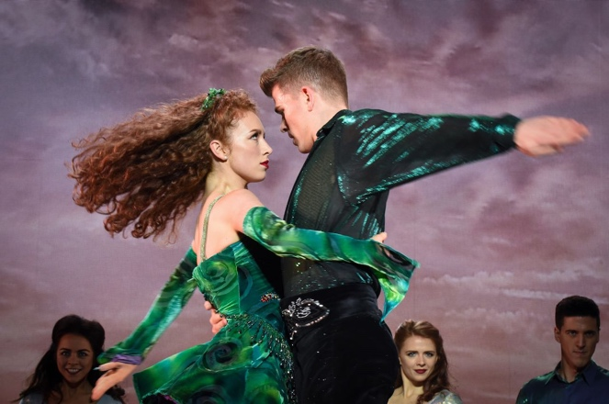
Credit: © Tyrone Productions

Filmed on the 25th anniversary of its first full performance at the 3Arena in Dublin — the spot where it all began — the RIVERDANCE 25TH ANNIVERSARY SHOW is a powerful and stirring reinvention of this beloved family favorite. Catapulting Riverdance into the 21st century, this new cinematic experience immerses viewers in the extraordinary and elemental power of music and dance. Celebrated the world over for its Grammy® Award-winning score, Riverdance brings thrilling energy and passion to Irish and international dance. RIVERDANCE 25TH ANNIVERSARY SHOW is part of special programming premiering on PBS stations beginning Saturday, August 29, 2020 (check local listings).

Twenty-five years ago, seven minutes changed the face of Irish dancing forever. The Eurovision Song Contest interval act performance by Riverdance gave millions of people a new and exciting glimpse of the future of Irish dance. Now composer Bill Whelan has re-recorded his mesmerizing soundtrack while producer Moya Doherty and director John McColgan have re-imagined the groundbreaking show with innovative and spectacular lighting, projection, stage and costume designs.
New and extraordinarily evocative video backdrops call forth the beauty and mystery of the island and enhance the show’s central theme, chronicling the emotional upheaval of the migration to a new Irish life in America. An incredible new generation of dancers and musicians, including a fantastic 17-year-old fiddler from New Jersey, brings fresh energy to the production.
PBS special programming invites viewers to experience the worlds of science, history, nature and public affairs; hear diverse viewpoints; and take front-row seats to world-class drama and performances. Viewer contributions are an important source of funding, making PBS programs possible. PBS and public television stations offer all Americans from every walk of life the opportunity to explore new ideas and new worlds through television and online content.

Underwriters: Public Television Viewers and PBS
Producer: Stagescreen Limited/Pop Twist Entertainment/Tyrone Productions/Abhann Productions

- PBS –

CONTACT: Cara White, CaraMar, Inc. 843-881-1480; cara.white@mac.com

For images and additional up-to-date information on this and other PBS programs, visit PBS PressRoom at pbs.org/pressroom.

