RISE OF THE BOLSONAROS
Premieres Tuesday, August 30 on PBS and
Streaming on PBS.org

New Documentary Explores a Family Dynasty’s Ascent to Political Power Led by Brazil’s Controversial President Jair Bolsonaro

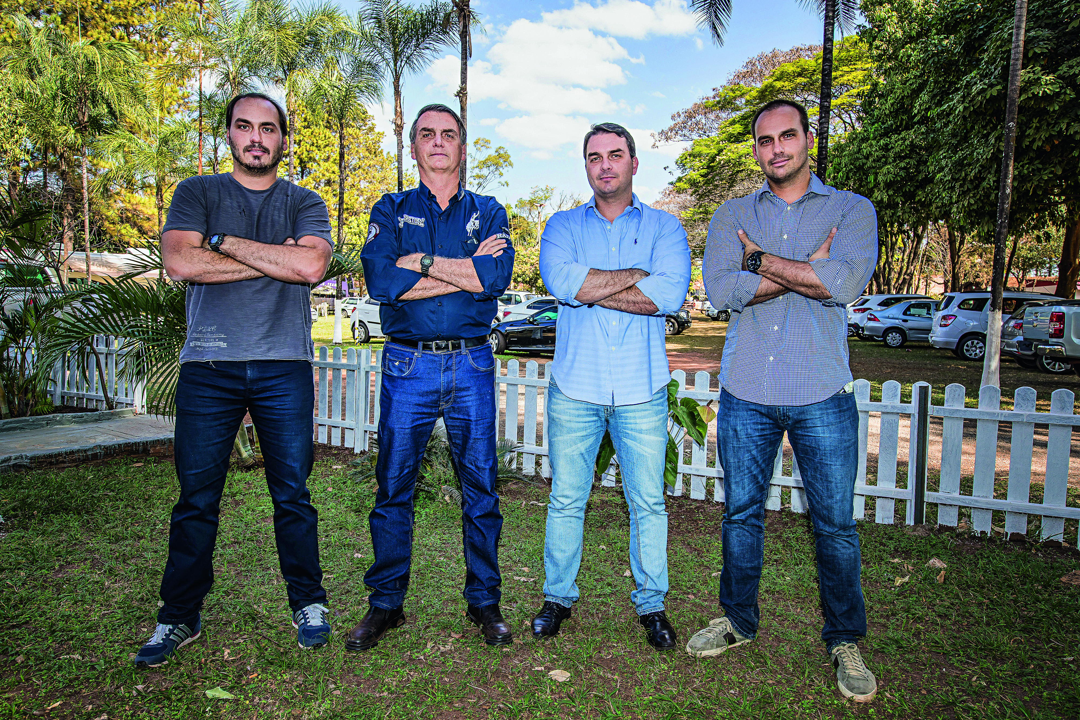
Jair Bolsonaro with his children Eduardo Bolsonaro, Flávio Bolsonaro, Carlos Bolsonaro in 2017.
Credit: Antonio Milena
ARLINGTON, VA – Since his surprise landslide victory in 2018, Brazil's President Jair Bolsonaro has rarely been out of the headlines. Despite his combative manner and controversial views — pro-military, anti-feminist, anti-gay and determined to exploit the Amazon’s riches despite the outraged pleas of global environmentalists — he continues to have tens of millions of avid supporters. Told through revealing interviews with some of those closest to him, including family members as well as opponents, RISE OF THE BOLSONAROS is the story of a family’s remarkable rise from obscurity to the ultimate seat of power. As Bolsonaro faces re-election in October, this story has consequences not just in Brazil but around the world. RISE OF THE BOLSONAROS premieres Tuesday, August 30, at 9:00-11:00 p.m. ET (check local listings) on PBS, PBS.org and the PBS Video app.

RISE OF THE BOLSONAROS charts the rise of Jair Bolsonaro and his three sons, also politicians, who together wield enormous power in modern Brazil. Born into a poor family south of São Paolo, Bolsonaro attended a military academy and then joined the army, becoming a career soldier. In 1985, following years of dictatorship and military rule, the civilian president Jose Sarney took office, and a new era of societal freedom began. Disapproving of this new Brazil, Bolsonaro entered politics, becoming a deputy in the national congress in 1991. Although polarizing and controversial, Bolsonaro’s star continued to rise as his pro-military and pro-family values conservatism struck a chord with a large segment of the nation’s population.

When he ran for president in 2018, the Brazilian media dismissed his chances. Despite his family values stance, Bolsonaro has been married three times, fathered a child by his mistress (who became his second wife), convinced one of his sons to run for office against his former first wife, and made homophobic and sexist statements that pundits assumed would be career-ending. But by orchestrating a vast social media army to vilify his opponents with fake news and secret groups on WhatsApp, openly courting the country’s evangelicals and surviving a near-fatal stabbing on the campaign trail, Bolsonaro stunned the nation by winning the election.

Once he became president, Bolsonaro relied on the advice of his three closest advisors: sons Flávio, Carlos and Eduardo. Since taking office, his presidency has been rocked by controversy, including his handling of the COVID-19 pandemic, the curtailing of Indigenous rights and the rapid acceleration of the Amazon’s deforestation. In August 2019, the burning of the rainforest was so intense that the skies of São Paolo, 1600 miles away, were darkened by smoke.

This October, the eyes of the nation and the world will be on Brazil as Bolsonaro faces re-election. His main opponent will be the left-leaning former President Luiz Inácio Lula da Silva. Declining in popularity, Bolsonaro is being investigated for corruption and spreading fake news, and his defense has been to cast doubt on the validity of the election process in Brazil. "I have three alternatives for my future: being arrested, killed or victory,” Bolsonaro said.

Featured in the special are Bolsonaro’s son Flávio, several political allies and adversaries, U.S. supporter Steve Bannon (who refers to Bolsonaro as “Trump to the 10th power”) and Brazilian-based journalists, including former Reuters bureau chief Brian Winter, Terry McCoy of The Washington Post, Katy Watson of the BBC, former Bloomberg correspondent Shannon Sims, and more.

RISE OF THE BOLSONAROS will be available to stream on all station-branded PBS platforms, including PBS.org and the PBS Video app, available on iOS, Android, Roku, Apple TV, Amazon Fire TV, Android TV, Samsung Smart TV, Chromecast and VIZIO.

RISE OF THE BOLSONAROS is produced for BBC Two, commissioned by Patrick Holland and Jack Bootle. It is a BBC Studios Productions’ Documentary Unit series; the executive producer is Ricardo Pollack, the series producer is Raquel Toniolo, the edit director is Richard Max and the series director is Matt Hill. Diana El-Osta is the executive in charge for PBS.

About PBS
PBS, with more than 330 member stations, offers all Americans the opportunity to explore new ideas and new worlds through television and digital content. Each month, PBS reaches over 120 million people through television and 26 million people online, inviting them to experience the worlds of science, history, nature and public affairs; to hear diverse viewpoints; and to take front row seats to world-class drama and performances. PBS’s broad array of programs has been consistently honored by the industry’s most coveted award competitions. Teachers of children from pre-K through 12th grade turn to PBS for digital content and services that help bring classroom lessons to life. Decades of research confirms that PBS’s premier children’s media service, PBS KIDS, helps children build critical literacy, math and social-emotional skills, enabling them to find success in school and life. Delivered through member stations, PBS KIDS offers high-quality educational content on TV – including a 24/7 channel, online at pbskids.org, via an array of mobile apps and in communities across America. More information about PBS is available at www.pbs.org, one of the leading dot-org websites on the internet, or by following PBS on Twitter, Facebook or through our apps for mobile and connected devices. Specific program information and updates for press are available at pbs.org/pressroom or by following PBS Communications on Twitter.

– PBS –
CONTACTS:

PJ Feinstein, PBS, pjfeinstein@pbs.org

Cara White / Mary Lugo, CaraMar, Inc.
cara.white@mac.com; lugo@negia.net

For images and additional up-to-date information on this and other PBS programs, visit PBS PressRoom at pbs.org/pressroom.

