PBS Showcases One of America’s Greatest Comics in RICHARD PRYOR: ICON

New Documentary Premieres Sunday, November 23, 2014,
10:00-11:00 p.m. ET on PBS

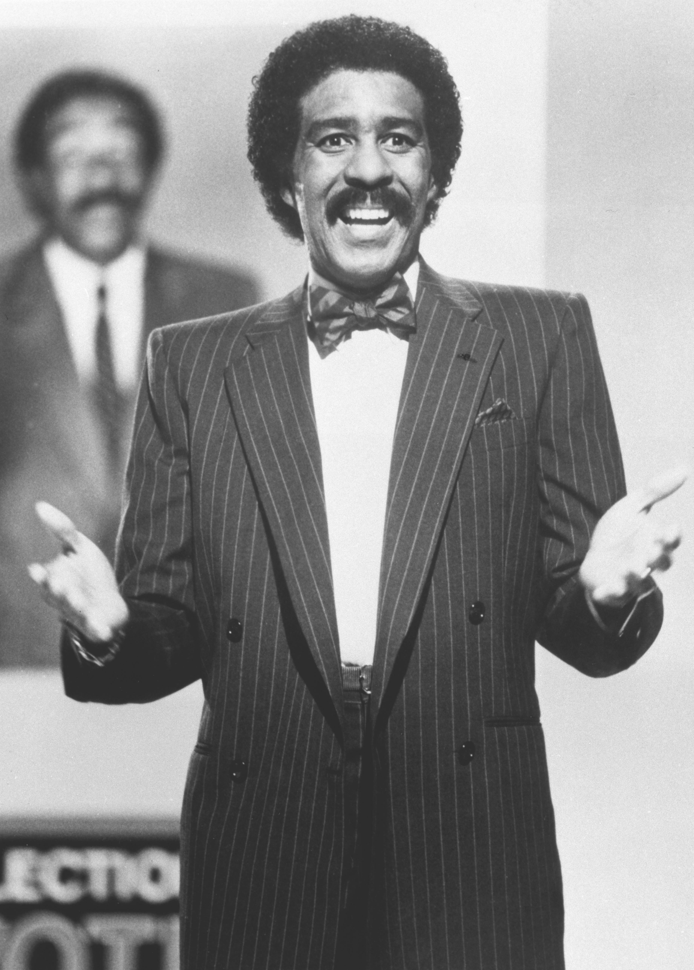
Richard Pryor
Credit: Photoshot

ARLINGTON, VA – PBS announced today the broadcast of RICHARD PRYOR: ICON Sunday, November 23, 2014, 10:00-11:00 p.m. ET. The program tells the story of the groundbreaking entertainer who changed the rules of comedy.

From his troubled upbringing in the slums of Peoria, Illinois, to his brave battle against multiple sclerosis, from performing on the “Ed Sullivan Show” to being banned by the networks, RICHARD PRYOR: ICON examines the roller coaster life and times of this comedic trailblazer. Though he was one of the most successful and influential entertainers of his generation, Pryor wrestled with self-destructive behaviors that threatened his life.

“Richard Pryor is an important figure in modern American cultural history. He is one of the most influential performers of our time and PBS is excited to show our audience why,” says Bill Gardner, Vice President, Programming and Development, PBS. “These types of stories should be told — stories that are both challenging and thought-provoking.”

The special explores Pryor’s transformation from a straight-laced comedian to one of the most controversial and thought-provoking acts of his time. After walking off stage during a sold-out Las Vegas show, fed up with being forced to limit his self-expression, Pryor took a two-year sabbatical. He returned to the comedy scene a raw and unfiltered performer — and changed comedy forever. Sex, drugs, race…nothing was off limits. As he was more honest with himself, and his audience, the laughs grew even bigger.

Pryor opened the door for other comedians to inject social commentary and other once-verboten topics into their humor. RICHARD PRYOR: ICON features interviews with close personal friends and comedians he influenced, including Tracy Morgan and George Lopez. The program is produced by Outpost Entertainment (part of Leftfield Entertainment, an ITV Studios company).

About PBS
PBS, with its over 350 member stations, offers all Americans the opportunity to explore new ideas and new worlds through television and online content. Each month, PBS reaches nearly 109 million people through television and over 28 million people online, inviting them to experience the worlds of science, history, nature and public affairs; to hear diverse viewpoints; and to take front row seats to world-class drama and performances. PBS’ broad array of programs has been consistently honored by the industry’s most coveted award competitions. Teachers of children from pre-K through 12th grade turn to PBS for digital content and services that help bring classroom lessons to life. PBS’ premier children’s TV programming and its website, pbskids.org, are parents’ and teachers’ most trusted partners in inspiring and nurturing curiosity and love of learning in children. More information about PBS is available at www.pbs.org, one of the leading dot-org websites on the Internet, or by following PBS on Twitter, Facebook or through our apps for mobile devices. Specific program information and updates for press are available at pbs.org/pressroom or by following PBS PressRoom on Twitter.

– PBS –

For additional information, photos, interviews and more, contact Goodman Media or PBS:

Meghan Newton / Nisa Kiang, Goodman Media International for PBS: 212-576-2700; PBSProgramming@goodmanmedia.com

Lara Davidson, PBS: 703-739-5115; lkdavidson@pbs.org

For images and additional up-to-date information on this and other PBS programs, visit PBS PressRoom at pbs.org/pressroom.

