PRESS RELEASE

JULY 9 2024

‘POV’ Presents the National Broadcast Premiere of One of the World’s Most Famous Dissidents Fighting for Democracy Against a Dominant Superpower in Who’s Afraid of Nathan Law?

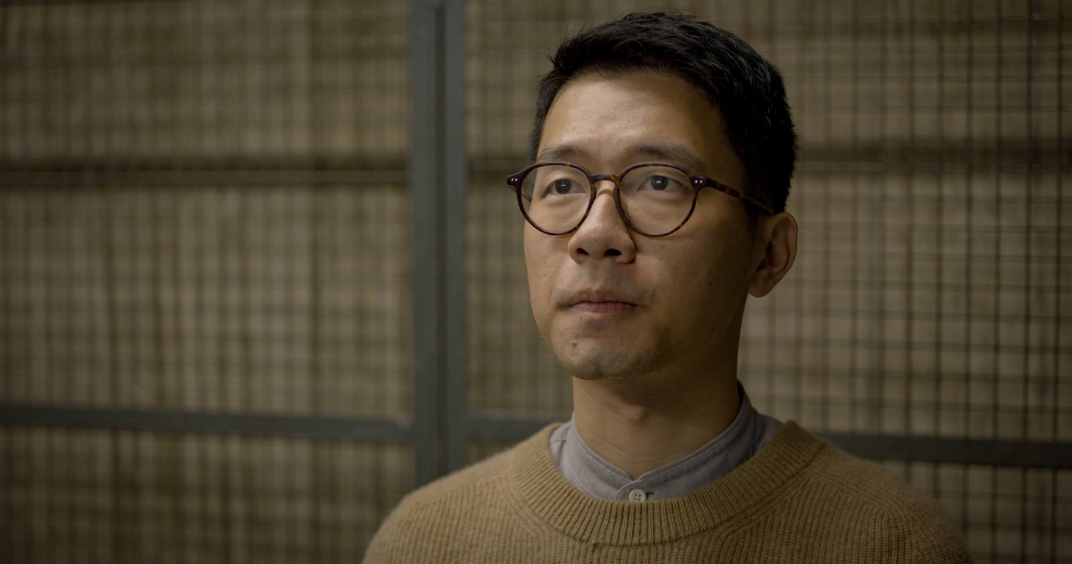

Brooklyn, N.Y. — June 9, 2024 — POV, the multi Emmy® and Peabody award-winning documentary series, spotlights courage, resilience, and youthful idealism, in Who’s Afraid of Nathan Law?, directed by Joe Piscatella, and produced by Mark Rinehart and Matthew Torne. At 21, Nathan Law was a leader of Hong Kong's Umbrella Revolution. By 23, he became Hong Kong's youngest elected lawmaker. At 26, he was “Most Wanted” under the National Security Law. Who’s Afraid of Nathan Law?, a co-presentation with Preserving Democracy, a public media initiative from The WNET Group, offers a close look at the city's most famous dissident to uncover what happens to freedom when an authoritarian power goes unchecked.
Winner of the “Top 10 Audience Favorite Award” at its World Premiere at the 2023 Hot Docs Canadian International Documentary Festival, Who’s Afraid of Nathan Law?, will make its national broadcast premiere on POV Monday, September 23, 2024 at 10pm/9C (check local listings) and available to stream until November 22, 2024 at pbs.org, and the PBS App. In addition to standard closed captioning for the film, POV, in partnership with audio description serviceDiCapta, provides real time audio interpretations for audiences with sensory disabilities. Now in its 37th season, POV continues to mark its place as America’s longest running non-fiction series.
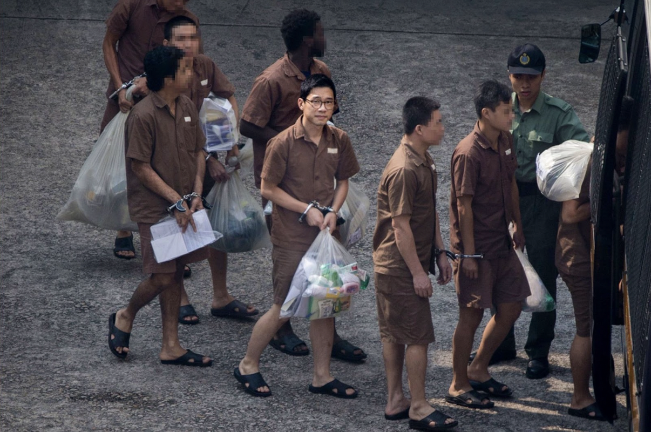
In Who’s Afraid of Nathan Law? shy college freshman, Nathan Law, discovers an identity in activism. As one of the organizers of a student strike demanding that Hong Kong be allowed to elect their own leader (something promised to them back in 1998), Nathan leads five days of student boycotts with a message of peaceful civil disobedience. When the strike suddenly becomes the Umbrella Revolution, Nathan is unexpectedly thrust into a leadership role that shuts down Hong Kong for 79 days and captures the attention of the world.
When the movement falters, Nathan is charged for his role in the Umbrella Revolution, and his entire generation in Hong Kong has been awoken. Riding the enthusiasm of the student movement he helped spark, Nathan makes the impossible transition from protest leader to elected official, becoming the youngest lawmaker in Hong Kong’s history where he continues his fight for democracy from inside the government.
Fearful of Nathan’s message gaining traction beyond students, the government disqualifies Nathan on a technicality and sends him to jail. As Hong Kong continues to see the erosion of its freedom, a new movement is launched. Whereas the Umbrella Revolution was driven by hope, this new movement is driven by desperation. Nathan’s message of civil disobedience is overshadowed by a new generation of protestors who no longer feel that peaceful demonstrations can save Hong Kong. As Hong Kong descends into the biggest political crisis in modern Chinese history, Nathan must decide his role and his future.

“Who’s Afraid of Nathan Law?, is more than just the story of Hong Kong’s fight for freedom and democracy they’ve been promised,” said Joe Piscatella, director of Who’s Afraid of Nathan Law?. “It’s the story of how a group of teenagers, led by Nathan Law, are willing to risk everything to save their home. It is also a great example of what it means to fight for democracy and how quickly freedoms can disappear if we don’t safeguard them.”
"In countries around the world, democracy is under attack," said Chris White, Executive Producer, POV. "In Who's Afraid of Nathan Law?, Joe Piscatella presents a cautionary tale of how quickly unchecked governments can take away our autonomy." The Umbrella Revolution in Hong Kong is just one compelling example of citizens trying to reclaim their power."

Who’s Afraid of Nathan Law?, is written and directed by Joe Piscatella (#chicagoGirl: The Social Network Takes on a Dictator; Joshua: Teeanger vs. Superpower). The film is produced by Matthew Torne, Mark Rinehart, Joe Piscatella and Andrew Duncan. The editor is Matthew Sultan. The executive producers are Elizabeth H. Weatherman, and Erika Dilday and Chris White for American Documentary | POV. Hong Kong-based DPs, producers and all crew have chosen to remain anonymous to protect their safety.

Download Who’s Afraid of Nathan Law? photos here.
Click here to access the theatrical Who’s Afraid of Nathan Law? Press Notes.

