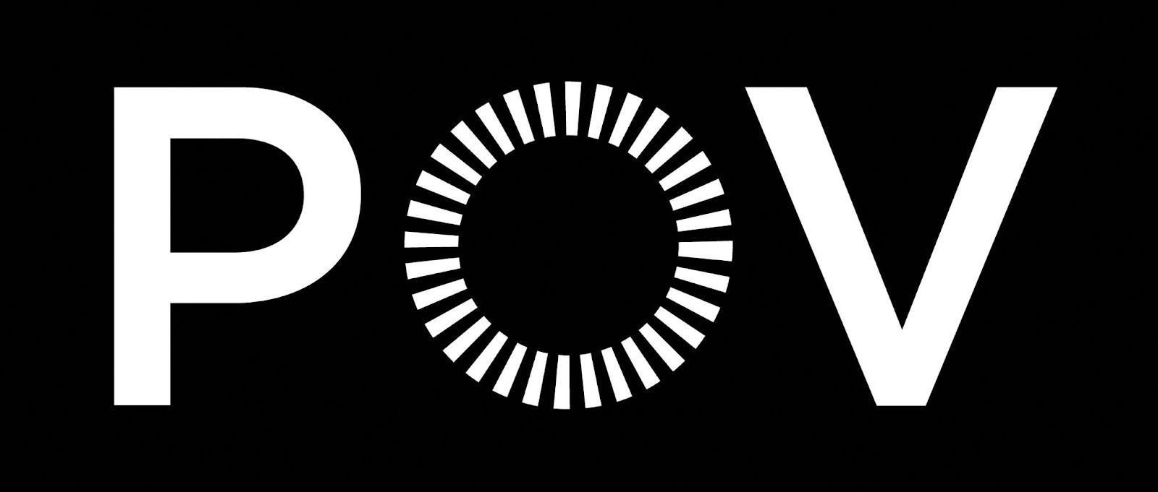

‘POV’ Examines the Symbiotic Relationship Between A Buddhist Midwife and Her Muslim Apprentice At A Health Clinic in Myanmar in Midwives
Debuts on PBS Television Nationwide Monday, November 21, 2022 and Free Streaming on PBS.org Until December 21, 2022
Download Press Photos • #MidwivesFilmPBS
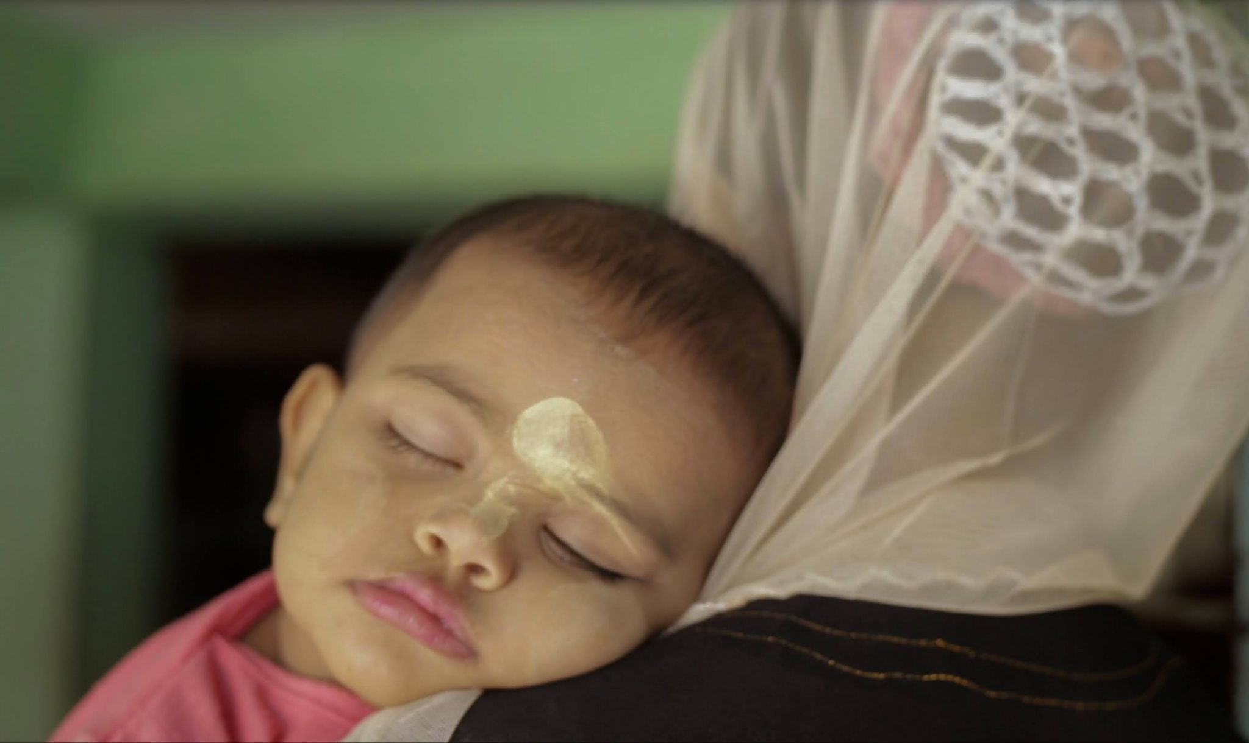

New York, N.Y. — October 13, 2022 — POV delves into the lives of two midwives – one a Buddhist and one a Muslim, who defy strict ethnic divisions to work side by side at a health clinic in western Myanmar, in the absorbing documentary, Midwives. Directed by Snow Hnin Ei Hlaing and produced by Snow, Emmy Award® winner Mila Aung-Thwin (Up the Yangtze), Bob Moore (Last Train Home) and Ulla Lehmann (Wood and Water), Midwives makes its national broadcast premiere on POV Monday, November 21, 2022 (check local listings) and will be available to stream with no PBS Passport membership necessary until December 21, 2022 at pbs.org, and the PBS Video app.

In addition to standard closed captioning for the film, POV, in partnership with audio description service DiCapta, provides real time audio interpretations for audiences with sensory disabilities. POV, currently celebrating its 35th anniversary season, is America’s longest running non-fiction series.

Midwives, director Snow’s feature film debut, chronicles Hla and Nyo Nyo, two courageous women who unite to bring forth life at a makeshift medical clinic in western Myanmar. Hla, the owner of the clinic, is a Buddhist in the western region of the country, where the Rohingya of Rakhine State (a Muslim minority community) are persecuted and denied basic rights. Nyo Nyo is a Muslim and an apprentice midwife who acts as an assistant and translator at the clinic. Her family has lived in the area for generations, yet they’re still considered intruders.

Encouraged and challenged by Hla, who risks her own safety daily by helping Muslim patients, Nyo Nyo is determined to become a steady health care provider for her community. Hlaing followed the pair over five turbulent years and witnessed their struggles amid an increasingly dangerous environment.

“Be true to your story and your story will be true to you. Making creative documentary films can sometimes be lonely. We have to believe in what we are doing; deeply believe in our story. That means a lot of hard work and knowing what we really want to capture. Every woman's story you tell and every success you have as a filmmaker is a footprint for other women,” said Midwives Director/Producer Snow Hnin Ei Hlaing.

“Midwives, director Snow Hnin Ei Hlaing’s remarkable feature debut, offers a rare insight into the complex reality of Myanmar and its people. Her gentle, impartial gaze grants unique access to these fearless women who are committed to helping women in the region. We are honored to bring this powerful film to American audiences,” said Erika Dilday, executive producer of POV and America ReFramed and executive director of American Documentary.

Midwives premiered at the 2022 Sundance Film Festival and won the Excellence In Verité Filmmaking World Cinema Documentary Special Jury Award. The documentary took the Best Film Award at the 2022 One World Human Rights Film Festival in Prague, and won the Asian Competition Grand Prize and Next Award at the DMZ International Documentary Film Festival.

Midwives is an EyeSteelFilm, AMA FILM, Snow Films and American Documentary co-production. Snow Hnin Ei Hlaing is the director/producer, and Mila Aung-Thwin, Bob Moore and Ulla Lehmann are the producers. Erika Dilday, Chris White, Justine Nagan are the executive producers for American Documentary | POV and Bob Moore for EyeSteelFilm. “POV” has previously collaborated with Montreal-headquartered EyeSteelFilm on a number of award-winning films, including Up the Yangtze, Last Train Home, Still Tomorrow and Softie.

###

Credits

Director/Producer/Editor: Snow Hnin Ei Hlaing
Producers: Mila Aung-Thwin, Bob Moore, Ulla Lehmann
Co-Producer: Katie McKay
Cinematographers Soe Kyaw Htin Tun
Editor: Mila Aung-Thwin, Ryan Mullins
Music By: Olivier Alary, Johannes Malfatti
Associate Producer: David Magdael, Vince Johnson
Post Production Supervisor: Samantha Neboschizkij
Executive Producers: Erika Dilday, Chris White, Justine Nagan, Daniel Cross, Andrea Roggon, Ken Pelletier, Shizuka Asakawa, Vijay Vaidyanathan, Inmaat Productions

###

Photos

Download Midwives photos here.

About the Filmmakers

Snow Hnin Ei Hlaing, Director/Producer, Midwives
Snow has worked as a freelance filmmaker in Myanmar since 2006, acting as director, producer, editor and sound recordist after attending film schools in both Myanmar and Germany. Her short, Burmese Butterfly played festivals in over 20 countries, and Period@Period won for best short at the Wathan Film Festival. Midwives is her feature documentary debut. Midwives premiered at the 2022 Sundance Film Festival and won the Excellence In Verité Filmmaking World Cinema Documentary Special Jury Award. Midwives won the best film award at the 2022 One World Human Rights Film Festival in Prague. Midwives won the Asian Competition Grand Prize and Next Award in DMZ International Documentary Film Festival.

Ulla Lehmann, Producer, Midwives
Lehmann was born in Berlin and has lived in Germany and France. Together with film director Andrea Roggon, she founded AMA FILM. The company focuses on the development and production of films of artistic and social relevance, e.g. Midwives by Snow Hnin Ei Hlaing (Sundance Film Festival, CPH:Dox), Wood and Water by Jonas Bak (Berlinale, New Directors/New Films N.Y.) and The Inner Light by Stefan Sick (Berlinale, Shanghai IFF). AMA FILM also acted as distributor and released The Inner Light to over 70 German cinemas.

Mila Aung-Thwin, Producer/Editor, Midwives
Aung-Thwin is co-founder of the Montreal documentary production company
EyeSteelFilm. He has produced more than 40 feature documentaries including Last Train Home (winner of 2 Emmy Awards); Up the Yangtze (Independent Spirit Award Nominee; Golden Horse Award winner); Rip: A Remix Manifesto (Webby Award Honoree; IDFA audience choice prize winner); and I Am the Blues (Canadian Screen Award winner). He is the executive producer and editor of Softie (Sundance World Cinema Documentary Special Jury Award winner for Editing). He directed, produced, and edited Let There Be Light (Big Sky Film Fest’s Artistic Vision award winner) about mankind’s epic quest for fusion energy. He has worked with broadcasters around the world, including National Geographic, BBC, ZDF/ARTE, NHK Japan, PBS, etc. He served for five years as President of RIDM, Montreal's international documentary festival and has served on the juries of the Sundance Film Festival, the International Emmy Awards, and the New Zealand Screen Awards. He frequently mentors and gives documentary storytelling seminars to upcoming filmmakers - recent workshops include Guangzhou, China; Ouagadougou, Burkina Faso; and Yangon, Myanmar.

Bob Moore, Producer, Midwives
Moore is Co-President and Creative Producer at EyeSteelFilm in Montreal where he has produced over 40 feature documentaries since 2008. Together with his talented partners and collaborators, he has been the recipient of over 100 international awards, including Emmys, Cinema Eyes, Golden Horses, Owls, Phoenixes, and a variety of other celebratory animal-themed prizes. He’s been the subject of a Producer’s Spotlight at the Cannes Marché du Film, is currently an advisor and mentor working with the Sundance Film Festival, IDFA, DMZ Docs South Korea, QUMRA, Tokyo Docs, Dhaka DocLab Bangladesh, Hot Docs, and RIDM.
###

About POV
Produced by American Documentary, POV is the longest-running independent documentary showcase on American television. Since 1988, POV has presented films on PBS that capture the full spectrum of the human experience, with a long commitment to centering women and people of color in front of, and behind, the camera. The series is known for introducing generations of viewers to groundbreaking works like Tongues Untied, American Promise and Minding The Gap and innovative filmmakers including Jonathan Demme, Laura Poitras and Nanfu Wang. In 2018, POV Shorts launched as one of the first PBS series dedicated to bold and timely short-form documentaries. All POV programs are available for streaming concurrent with broadcast on all station-branded PBS platforms, including PBS.org and the PBS Video app, available on iOS, Android, Roku streaming devices, Apple TV, Android TV, Amazon Fire TV, Samsung Smart TV, Chromecast and VIZIO. For more information about PBS Passport, visit the PBS Passport FAQ website.

POV goes “beyond the broadcast” to bring powerful nonfiction storytelling to viewers wherever they are. Free educational resources accompany every film and a community network of thousands of partners nationwide work with POV to spark dialogue around today’s most pressing issues. POV continues to explore the future of documentary through innovative productions with partners such as The New York Times and The National Film Board of Canada and on platforms including Snapchat and Instagram.

POV films and projects have won 46 Emmy Awards, 27 George Foster Peabody Awards, 15 Alfred I. duPont-Columbia University Awards, three Academy Awards and the first-ever George Polk Documentary Film Award. Learn more at pbs.org/pov and follow @povdocs on social media.

About American Documentary, Inc.
American Documentary, Inc. (AmDoc) is a multimedia company dedicated to creating, identifying and presenting contemporary stories that express opinions and perspectives rarely featured in mainstream media outlets. AmDoc is a catalyst for public culture, developing collaborative strategic engagement activities around socially relevant content on television, online and in community settings. These activities are designed to trigger action, from dialogue and feedback to educational opportunities and community participation.

Major funding for POV is provided by PBS, the Open Society Foundations, The John D. and Catherine T. MacArthur Foundation, the Wyncote Foundation, Reva & David Logan Foundation, Park Foundation, and Perspective Fund. Additional funding comes from the National Endowment for the Arts, New York State Council on the Arts, public funds from the New York City Department of Cultural Affairs in partnership with the City Council, Sage Foundation, Nancy Blachman and David desJardins, Chris and Nancy Plaut, Abby Pucker, Ann Tenenbaum and Thomas H. Lee and public television viewers. POV is presented by a consortium of public television stations, including KQED San Francisco, WGBH Boston and THIRTEEN in association with WNET.ORG.

###

