‘POV’ Announces Acquisition of An Act of Worship Following Premiere at 2022 Tribeca Film Festival

Added to Historic 35th Season of American TV’s Longest-Running and Award-Winning Documentary Series; Will Debut this October on PBS
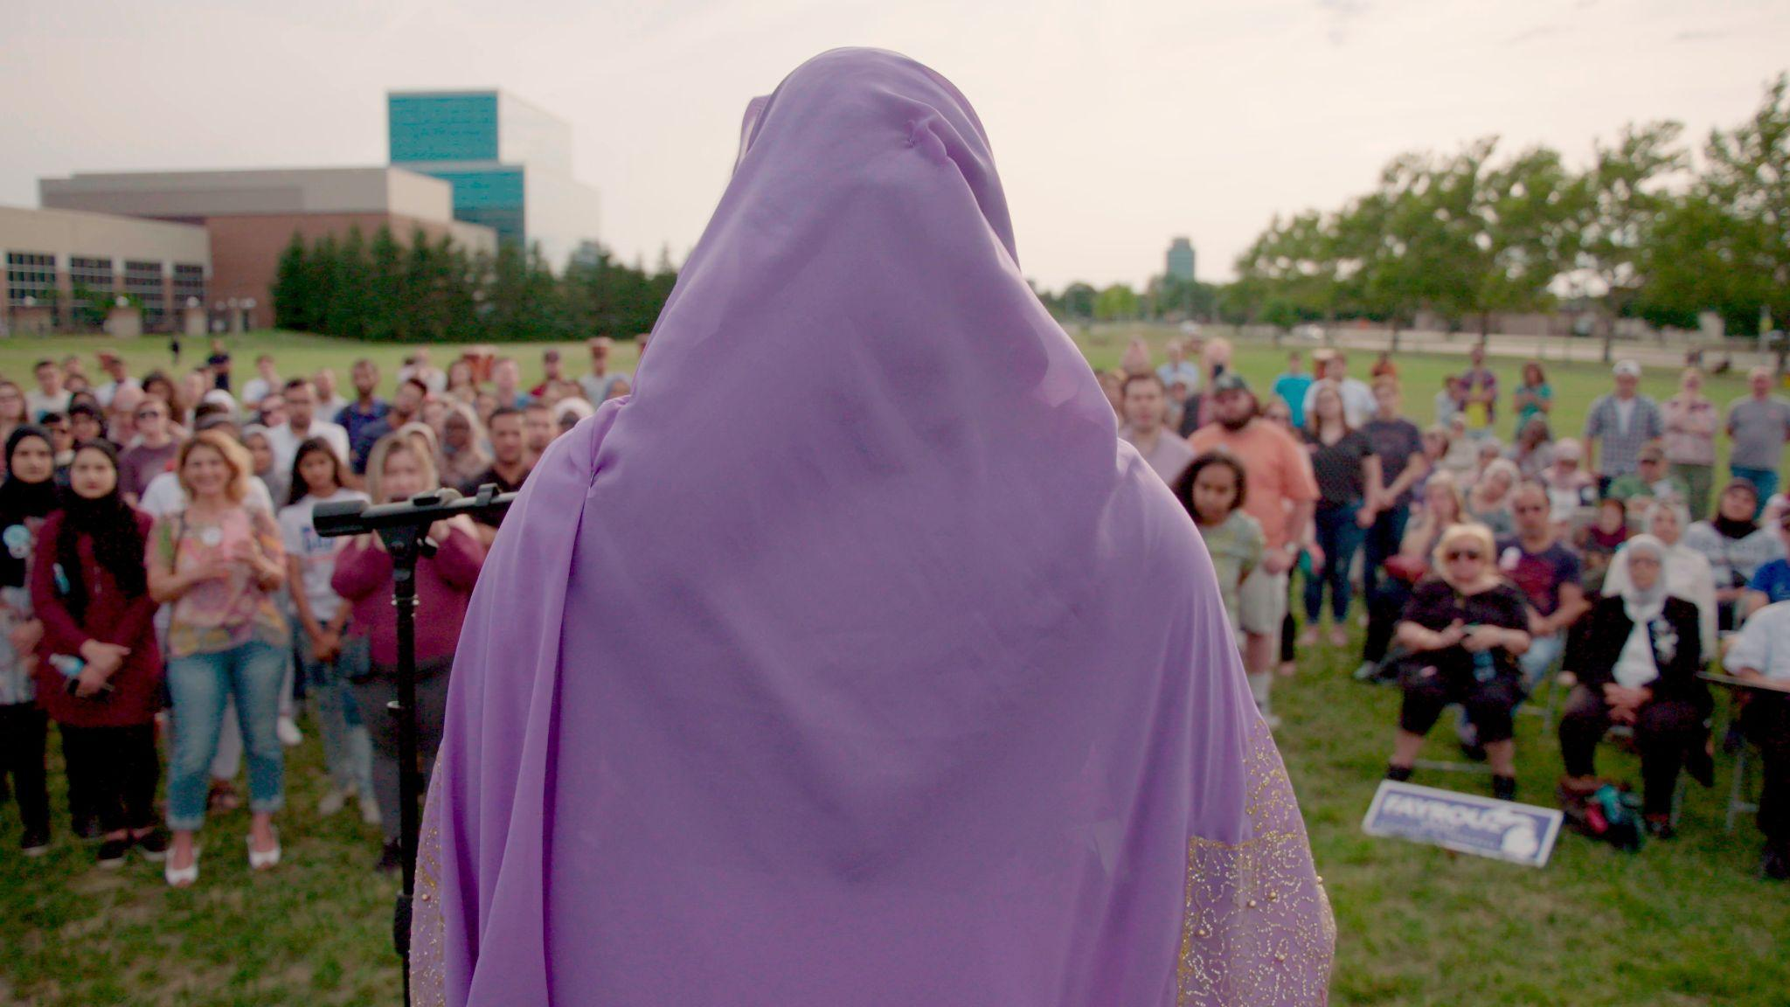

Director Nausheen Dadabhoy’s Poignant Film Captures 30 Years of Muslim Life in America, As Told By Muslims

New York, N.Y. — June 10, 2022 — POV, the critically acclaimed PBS documentary series, announced today the acquisition of An Act of Worship as part of its 35th season. The film by Pakistani-American director Nausheen Dadabhoy and produced by DuPont-Crichton Award-winner Heba Elorbany, Emmy® Award-winner Kristi Jacobson, and Emmy-nominated Sofian Khan is a counter-narrative of the last 30 years of Muslim life in America. An Act of Worship made its world premiere June 9th at the 2022 Tribeca Festival and will make its national broadcast premiere on Monday, October 17, 2022 on POV.

In An Act of Worship, a diverse range of Muslim Americans recount the past 30 years of pivotal moments in U.S. history and policy from their own perspectives. The film weaves together observational footage of activists who came of age after 9/11, community-sourced home videos, and evocative recollections from individuals impacted by incidents of Islamophobia. Due to the filmmaking team’s first-hand knowledge and intimate access to the Muslim community, Dadabhoy is able to marry various voices of the account, which previously had been shaped largely by outsiders.

American Documentary | POV Executive Director Erika Dilday said: “We’re very pleased to include An Act of Worship in our Season 35 slate. This film dispels the idea of Muslim Americans as a monolith and contextualizes each specific story and voice in the mosaic that is America.”

“Through intimate home video archival and a tapestry of community voices that narrate the film, we hope to regain authorship of our community’s story. It’s a way to replace images of violence so that our community can see itself through its own gaze. Our partnership with POV is so meaningful, as it expands our film’s reach as we’d always hoped – reaching our community, through impact and engagement screenings, and via broadcast, the private, quotidian, and communal moments that are rarely portrayed in stories about Muslim Americans will be televised into homes across the United States” said An Act of Worship filmmaker Nausheen Dadabhoy.

The An Act of Worship deal was negotiated by Chris White and Erika Dilday for American Documentary | POV and Nausheen Dadabhoy, Heba Elorbany, Kristi Jacobson, and Sofian Khan for the filmmaking team.

In addition to An Act of Worship screenings during the festival, Tribeca Festival and The Blackhouse Foundation, with co-hosts Firelight Media, Brown Girls Doc Mafia, and Pillars are holding a special panel event featuring An Act of Worship. Panelists will discuss the importance of storytellers from marginalized communities, providing perspectives through lived experience and disrupting harmful narratives that impact their communities.

POV episodes premiere Monday nights and are available for streaming concurrent with broadcast on all station-branded PBS platforms, including PBS.org, and the PBS Video app, available on iOS, Android, Roku streaming devices, Apple TV, Android TV, Amazon Fire TV, Samsung Smart TV, Chromecast and VIZIO. For more information about PBS Passport, visit the PBS Passport FAQ website. In addition to standard closed captioning, POV, in partnership with audio description service DiCapta, provides real time audio interpretations for audiences with sensory disabilities.

An Act of Worship is a co-presentation of the Center for Asian American Media (CAAM), and American Documentary | POV, directed by Nausheen Dadabhoy and produced by Heba Elorbany, Kristi Jacobson and Sofian Khan. The Executive Producers for American Documentary | POV are Erika Dilday and Chris White.

###

Credits

Director/Producer: Nausheen Dadabhoy
Producers: Heba Elorbany, Kristi Jacobson, Sofian Khan
Executive Producers: Erika Dilday, Chris White
Editor: Ben Garchar
Mentor: Jonathan Duffy

###

About the Filmmakers

Nausheen Dadabhoy, Director, An Act of Worship
Nausheen Dadabhoy is a Pakistani-American director and cinematographer whose work spans fiction and documentary. As a cinematographer she has lensed an Oscar® nominated live action short film and an Emmy® winning feature documentary. Her films have screened at festivals worldwide including Sundance, TIFF, Tribeca, Locarno and have appeared on Netflix, Amazon, HBO and PBS. The Ground beneath Their Feet (2014) — her directorial debut following two Pakistani women who were paralyzed after an earthquake — premiered at IDFA in the first appearance competition. Nausheen has been a Film Independent Project:Involve Fellow, Berlin Talents participant, Firelight Fellow, Chicken & Egg Eggcelerator Lab Fellow, newportFILM Documentary Cinematography Fellow, Soros Equality Fellow and she is currently a Pillars Artist Fellow. She was part of DOCNYC’s inaugural “40 Under 40.” Nausheen is based in NYC, LA and Karachi, Pakistan. She received her MFA in Cinematography from the American Film Institute.
Follow Nausheen (@naushero) on Twitter and Instagram.

Heba Elorbany, Producer, An Act of Worship
Heba Elorbany is an Egyptian-American journalist and filmmaker based in Los Angeles. Her first documentary film, Lifehouse (2017), earned her a DuPont-Crichton Award. She was a researcher and assistant editor on Oscar-nominated short documentary film St. Louis Superman and has collaborated with award-winning directors, including Lana Wilson (The Departure, After Tiller) and Smriti Mundhra (A Suitable Girl). In addition to making documentary films, she produces audio stories and live shows. She’s worked on productions for The New York Times, Viacom, BBC, Gimlet Media, PRX, Radio Ambulante and more. Heba earned her master’s degree in 2017 from Columbia University’s Graduate School of Journalism and is currently a senior producer at The Los Angeles Times.

Kristi Jacobson, Producer, An Act of Worship
Kristi Jacobson is an Emmy-winning documentary filmmaker. Her films include Solitary HBO), which won the Emmy Award for Outstanding Investigative Documentary, the critically acclaimed Toots (Tribeca Film Festival), and A Place at the Table (2012 Sundance Film Festival). Her episodic work includes Dirty Money: Cartel Bank (Netflix Original), Dogs: The Protectors (Netflix Originals), and Through Our Eyes: Homefront (HBO/Max and Sesame Workshop) and the short film “I Am Not Going To Change 400 Years in Four”, co-directed with Angela Tucker (ITVS/ Independent Lens). She is a member of AMPAS, the Directors Guild of America, and has received grant support and/or fellowships from Tribeca Film Institute, Sundance Institute, Ford Foundation, Chicken & Egg Pictures.

Sofian Khan, Producer, An Act of Worship
Sofian Khan is an Emmy-nominated filmmaker and founder of Capital K Pictures. He directed, produced and shot The Interpreters, a feature-length documentary following Afghan and Iraqi interpreters targeted for their work helping American forces that made its broadcast premiere on the 2019 season of Independent Lens. His episode of the PBS American Masters series In the Making (2021) received a Webby Award and an NAACP Image nomination. Most recently, Sofian directed an episode of the new series Takeout With Lisa Ling (2022) on HBOMax, and is currently in production on several new projects under the Capital K Pictures banner.

You can follow @anactofworship on Twitter and Instagram, and here on Facebook.

###

About POV
Produced by American Documentary, POV is the longest-running independent documentary showcase on American television. Since 1988, POV has presented films on PBS that capture the full spectrum of the human experience, with a long commitment to centering women and people of color in front of, and behind, the camera. The series is known for introducing generations of viewers to groundbreaking works like Tongues Untied, American Promise and Minding The Gap and innovative filmmakers including Jonathan Demme, Laura Poitras and Nanfu Wang. In 2018, POV Shorts launched as one of the first PBS series dedicated to bold and timely short-form documentaries. All POV programs are available for streaming concurrent with broadcast on all station-branded PBS platforms, including PBS.org and the PBS Video app, available on iOS, Android, Roku streaming devices, Apple TV, Android TV, Amazon Fire TV, Samsung Smart TV, Chromecast and VIZIO. For more information about PBS Passport, visit the PBS Passport FAQ website.

POV goes “beyond the broadcast” to bring powerful nonfiction storytelling to viewers wherever they are. Free educational resources accompany every film and a community network of thousands of partners nationwide work with POV to spark dialogue around today’s most pressing issues. POV continues to explore the future of documentary through innovative productions with partners such as The New York Times and The National Film Board of Canada and on platforms including Snapchat and Instagram.

POV films and projects have won 45 Emmy Awards, 27 George Foster Peabody Awards, 15 Alfred I. duPont-Columbia University Awards, three Academy Awards and the first-ever George Polk Documentary Film Award. Learn more at pbs.org/pov and follow @povdocs on social media.

About PBS
PBS, with more than 330 member stations, offers all Americans the opportunity to explore new ideas and new worlds through television and digital content. Each month, PBS reaches over 120 million people through television and 26 million people online, inviting them to experience the worlds of science, history, nature and public affairs; to hear diverse viewpoints; and to take front row seats to world-class drama and performances. PBS’s broad array of programs has been consistently honored by the industry’s most coveted award competitions. Teachers of children from pre-K through 12th grade turn to PBS for digital content and services that help bring classroom lessons to life. Decades of research confirm that PBS’s premier children’s media service, PBS KIDS, helps children build critical literacy, math and social-emotional skills, enabling them to find success in school and life. Delivered through member stations, PBS KIDS offers high-quality educational content on TV – including a 24/7 channel, online at pbskids.org, via an array of mobile apps and in communities across America. More information about PBS is available at www.pbs.org, one of the leading dot-org websites on the internet, or by following PBS on Twitter, Facebook or through our apps for mobile and connected devices. Specific program information and updates for press are available at pbs.org/pressroom or by following PBS Communications on Twitter.

About American Documentary, Inc.
American Documentary, Inc. (AmDoc) is a multimedia company dedicated to creating, identifying and presenting contemporary stories that express opinions and perspectives rarely featured in mainstream media outlets. AmDoc is a catalyst for public culture, developing collaborative strategic engagement activities around socially relevant content on television, online and in community settings. These activities are designed to trigger action, from dialogue and feedback to educational opportunities and community participation.
Major funding for POV is provided by PBS, the Open Society Foundations, The John D. and Catherine T. MacArthur Foundation, the Wyncote Foundation, Reva & David Logan Foundation, Park Foundation, and Perspective Fund. Additional funding comes from the National Endowment for the Arts, New York State Council on the Arts, public funds from the New York City Department of Cultural Affairs in partnership with the City Council, Sage Foundation, Chris and Nancy Plaut, Ann Tenenbaum and Thomas H. Lee and public television viewers. POV is presented by a consortium of public television stations, including KQED San Francisco, WGBH Boston and THIRTEEN in association with WNET.ORG.

