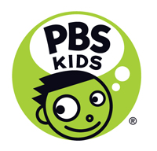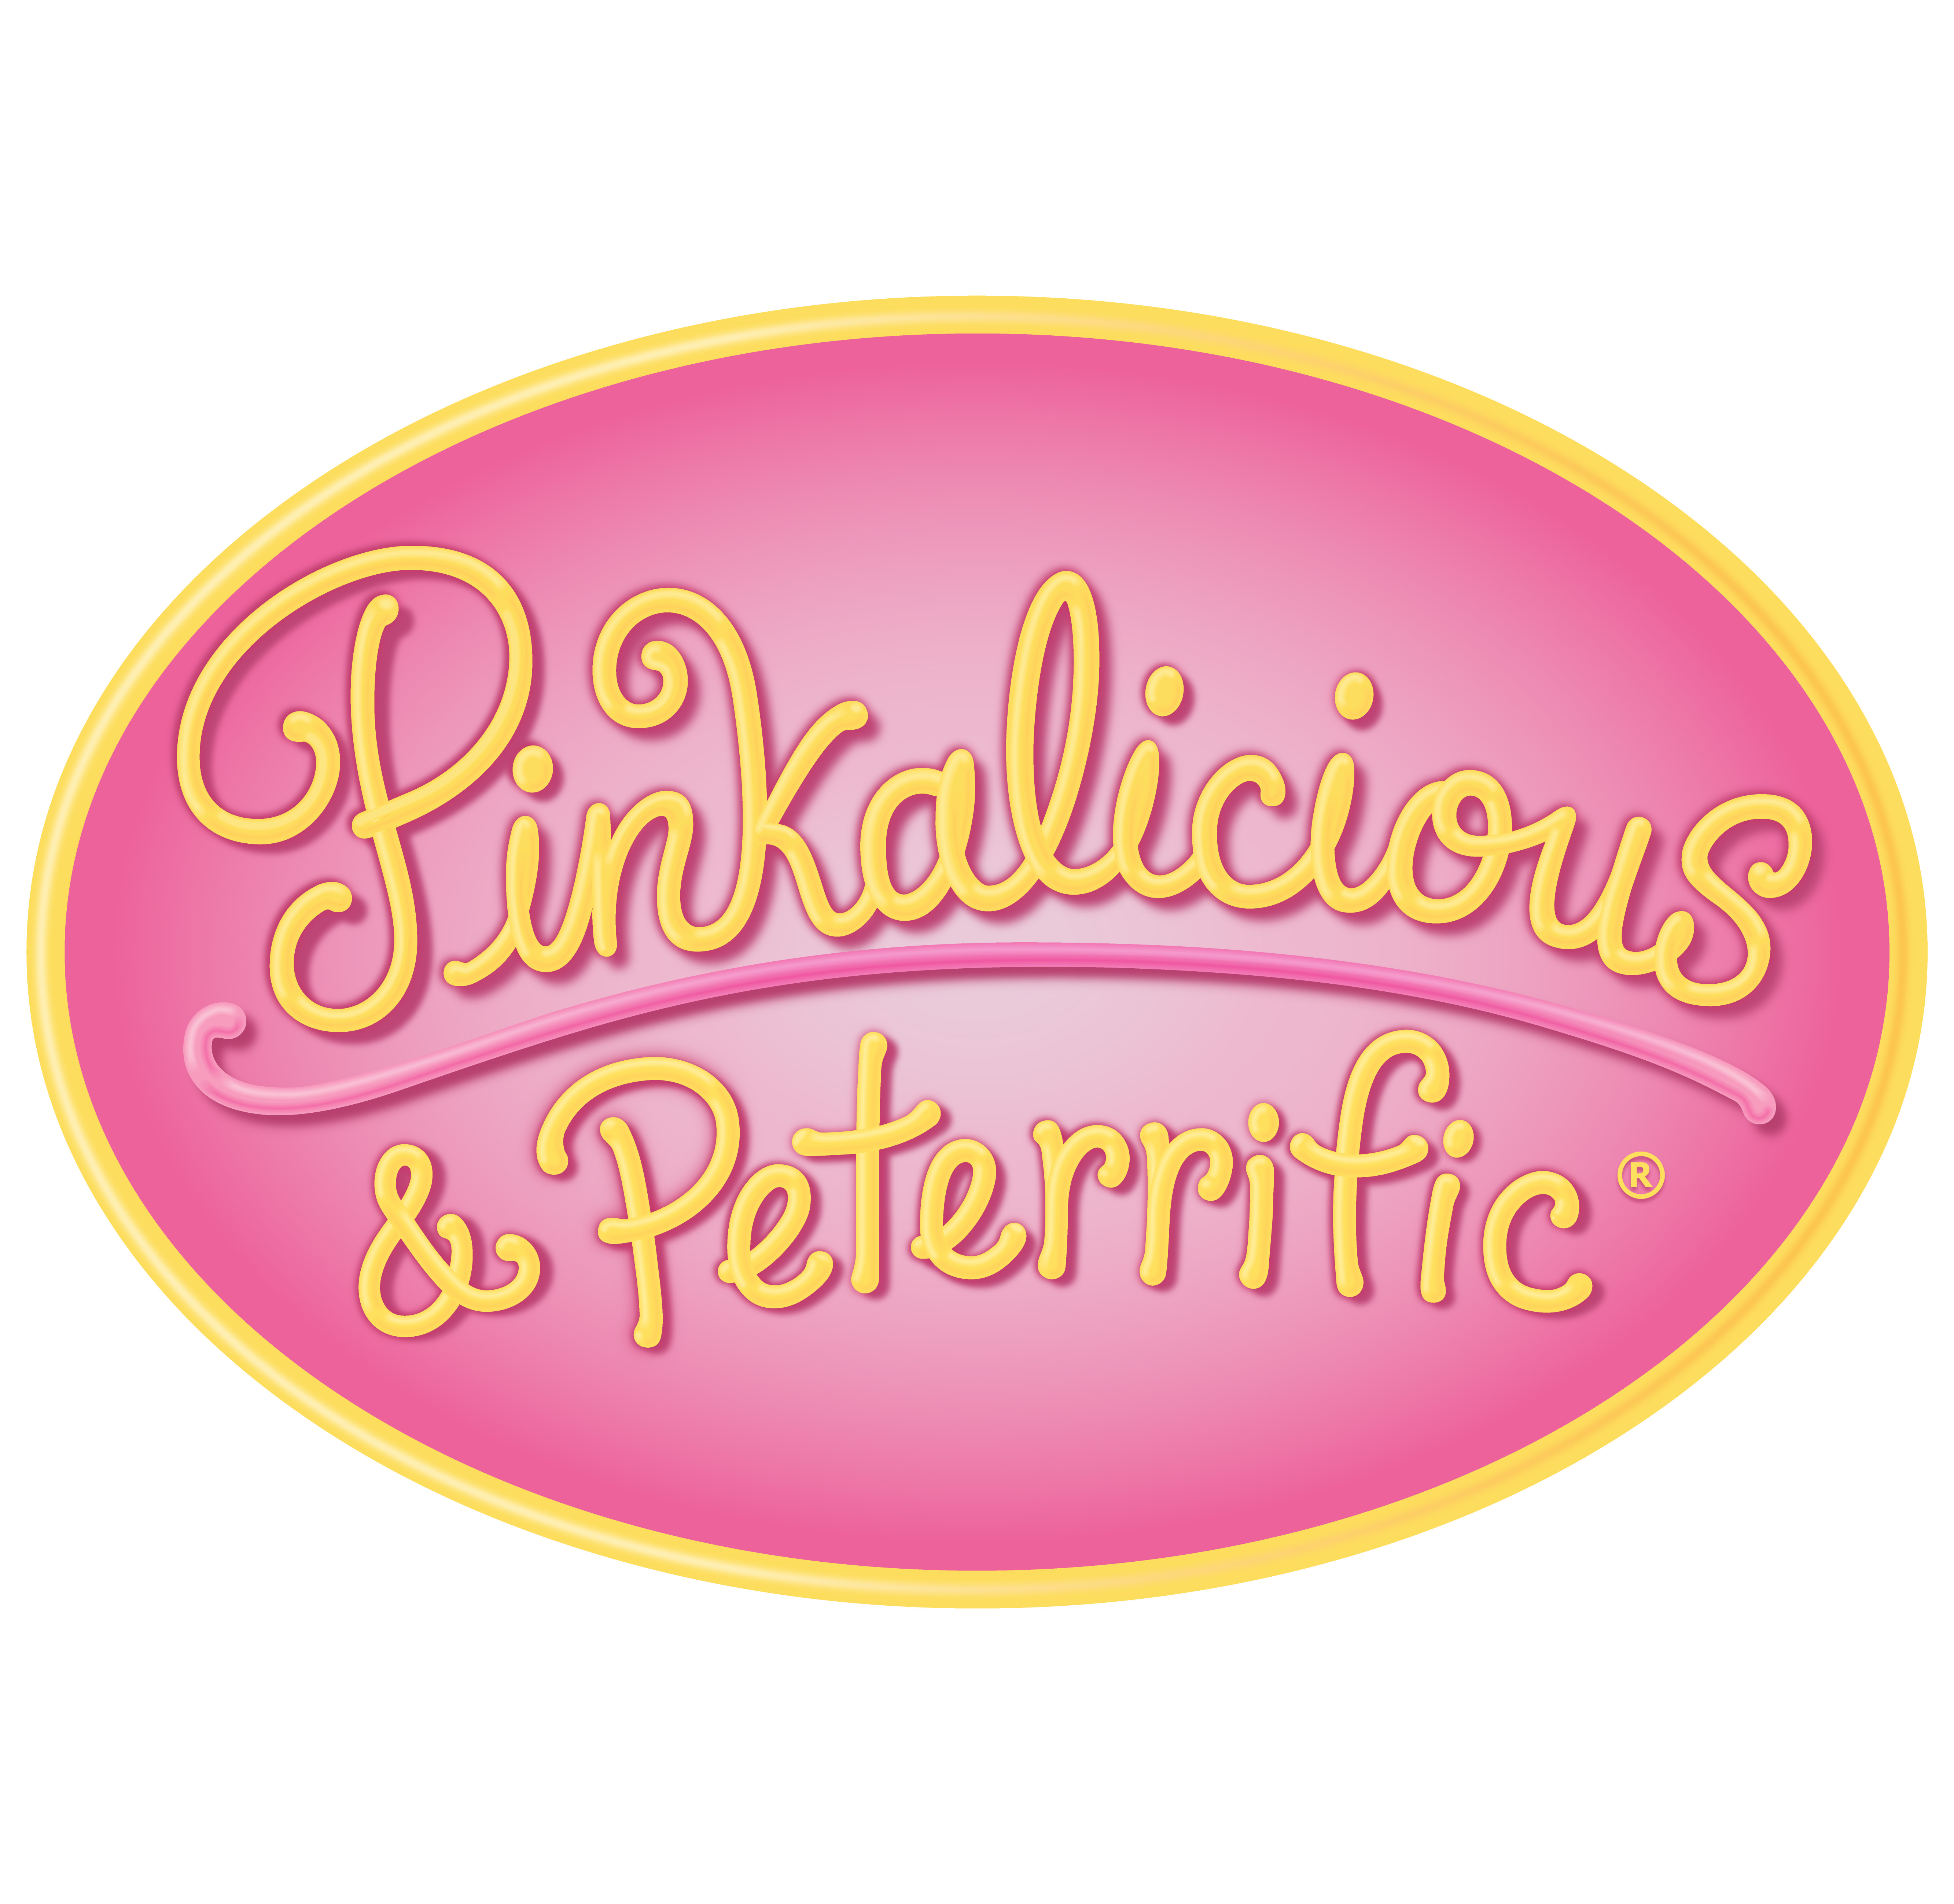

Pinkalicious & Peterrific

Episode Descriptions

EPISODE 201

“A Birthday Party for Kendra”
Pinkalicious is shocked to hear Kendra has never celebrated a birthday before so she decides to throw her a surprise party with the help of their friends! But a pinkaperfect party isn’t what Kendra had in mind.

Curriculum: (Visual Arts) Different people react differently to colors and visual styles.

“Norman Plans a Playdate”
Norman the Gnome is really excited — his friend Edna is coming over to play! Pinkalicious and Peter put their gnome-thinking caps on to help Norman plan the perfect playdate.

Curriculuum: (Theatre / Visual Arts) - Use role play to experiment with interacting with different types of people (and to help understand different types of personalities).

Interstitial: Kids meet comic book creator LJ Baptiste and learn how choosing different color palettes can convey a variety of feelings.

EPISODE 202

“A Fairy Thanksgiving”

When Pinkalicious and Peter accidentally damage Fairyanna’s Thanksgiving table, they are determined to make things right and give the fairies the most pinkamazing Fairy Thanksgiving yet!

Curriculum: (Visual Arts) - Create art from found objects in nature.

“Pinkfoot Playdate”

Pinkfoot is back and is eager to spend the day with Pinkalicious and her friends. But Pinkalicous struggles to find something that’s pinkaperfect for her giant pink furry monster friend.

Curriculum: (Dance) Using movement, explore contrasts in force, e.g. hard/soft, strong/light.

Interstitial: Kids use elements from nature to create a fairy house in their backyard.

EPISODE 203

“Aqualicious”
While at the beach, Pinkalicious and Peter meet Aqua, a merminnie! The three become friends and play together until it’s time for Aqua to go home. But Aqua’s home isn’t quite what Pinkalicious is expecting – it’s even more pinkamazing!

Curriculum: (Visual Arts) A color can come in many different shades (focus on blue).

“Sing in the Spring”
Spring has come to Pinkville but none of the flowers have bloomed. Turns out all the Springtime fairies have the flu. But with a little fairy dust and a lot of singing, Pinkalicious and Peter make the flowers bloom and help bring in the Spring.

Curriculum: (Music) Sing songs that use gestures to illustrate or substitute for words.

Interstitial: Kids observe the same lake from different angles and paint their perspectives with watercolors; using different colors and different painting techniques.

EPISODE 204

“Mr. Socko”
Peter is missing one of his favorite lucky socks! To help her brother out, Pinkalicious creates a sock puppet with the remaining sock. Pinkalicious and Peter then use the puppet, Mr. Socko, to retrace Peter's steps to find its other pair.

Curriculum: (Visual Arts) An introduction to creating a puppet through found objects and learning to manipulate (or operate) it to create its character and show emotion.

“A Pinkapurrfect Pet”
The Pinkertons discover a cat on their front doorstep! Pinkalicious and Peter realize that while taking care of a cat is tough, things can get even hairier when they wake up to find three new kittens.

Curriculum: (STEAM) Explore the design thinking aspect of STEAM.

Interstitial: Kids build puppets with Sarah Nolen and learn how to bring character and movement to puppet performances.

EPISODE 205

“Yodelahee Goat”
Flora’s goat Greta has escaped her farm, and Pinkalicious and Peter help track it down. After running all over Pinkville they find the goat on top of Town Hall! How in the world are they going to get Greta down?

Curriculum: (Music) Introducing the singing form of yodeling, with a focus on using both high and low pitches.

“Pink Mascot”
The Pinksters have a new mascot – the pinkatoo. Pinkalicious and friends make a mascot costume, but who will wear it and help cheer the soccer team on?

Curriculum: (Theatre) To create a character and embody that character when putting on a costume.

Interstitial: Kids learn how to create a variety of different sounds using just their mouths with the help of beatboxer Nate Ball.

EPISODE 206

“The Sparkle Kart”
Pinka and Peter spot Kendra in a flashy store-bought go kart! With some help from Mommy, they make a homemade kart, the Sparkle Speedster, but is it fast enough to beat Kendra?

Curriculum: (Visual Arts) Construct Assemblages; (STEAM) Engingeering – creating something out of existing materials.

“The Pinkville Merry-Go-Round”
The new Pinkville merry-go-round has…one bench? That’s no fun to ride. Pinkalicious and friends search all over Pinkville to find ways to make the merry-go-round more pinkamazing.

Curriculum: (Visual Arts) Model flexible thinking as part of creative problem solving.

Interstitial: Kids accessorize their bikes with robot-inspired decorations to ride in a parade.

EPISODE 207

“Invasion of the Flutterbugs”
The Pinkertons are shocked to find their house is suddenly swarming with Flutterbugs! What could possibly be drawing them in and more importantly, how can Pinkalicious and Peter get them to leave?

Curriculum: (Music) Exploring the musical concept of a repeat song as a means to communicate, connect and make music.

“Ballet of the Bells”
Pinkalicious and Peter find a box of handbells and their playing attracts the fairy, Bellerina! She tells them that if they continue practicing, even more fairies will come dance to their music. But can the show go on when Peter accidentally breaks one of the bells?

Curriculum: (Music) Bell music; bells make higher or lower pitches depending on their size.

Interstitial: Kids from the Boston City Singers discuss the fundamentals of singing.

EPISODE 208

“Treasure Hunt”
Pinkalicious and Peter are thrilled to meet a real life Pirate, Captain Toothy McSquint! It’s not long before Toothy has his new mateys walkin’ and talkin’ like pirates, as the three search for Toothy’s long lost buried treasure.

Curriculum: (Theater) Use your body and voice to create a character using evidence based observations, prior knowledge, and inquiry.

“Cheer Up, Archie”
Pinkalicious and Jasmine are worried that Archie the pinkfish is bored in his fishbowl so they take him outside to play. When that doesn’t cheer him up, they go to Aqua the merminnie for help!

Curriculum: (Visual Arts) Experiment with different materials, tools, and techniques to make art. Introducing the concept of creating an installation.

Interstitial: Kids watch funny woman Marcy Goldberg-Sacks perform and create characters by using her voice, body, and a few helpful props. Then the kids create and perform their own fun characters.

EPISODE 209

“PinkaPolka Dotty”
Inspired by Dame Nostrella’s pinkcredible polka dot art exhibit, Pinkalicious decides to create polka dot art of her own, but she gets a little too carried away! Soon, the entire Pinkerton household is covered with polka dots!

Curriculum: (Visual Arts) Creating art with polka dots; discussing how a work of art makes you feel.

“Lila Gets Glasses”
Lila’s a little embarrassed to wear her new glasses, even when she needs them to play soccer. So Pinkalicious comes up with a creative solution to help Lila see in style.

Curriculum: (Visual Arts) Experiment with different materials, tools and techniques to make art that expresses an individual's style.

Interstitial: Kids use recycled bottle caps of different sizes and colors to create unique works of art.

EPISODE 210

“Invisible Ink”
It’s Indigo’s first time babysitting and she’s brought a fun activity for Pinkalicous and Peter…Invisible Ink! But what will happen when Peter suddenly turns himself invisible?!

Curriculum: (Music) Expressing ourselves musically in dialogue with others, through call and response and improvisation, is joyful and a means of personal expression.

“Rusty’s Doghouse”
When Rusty refuses to go inside, Pinkalicious, Peter, Rafael and Frida decide to build Rusty his very own doghouse! It turns out so pinkcredible that a few other animals use it as their own home.

Curriculum: (STEAM) Introducing design as a part of the engineering process.

Interstitial: Kids study the innerworkings of a kazoo and use everyday objects to create and decorate their own.

EPISODE 211

“Gingerbread House”
Pinkalicious and Peter build a pinkamazing gingerbread house that attracts Sarafina, a holiday fairy. But as pieces of the house begin to go missing, it’s up to Pinkalicious to find the sneaky snacker before all that’s left are crumbs.

Curriculum: (Visual Arts) Working collaboratively to make a work of art out of edible materials.

“Christmas Tree Trouble”
It’s time to decorate the Pinkerton’s Christmas Tree! But when the box of all of the family’s ornaments break hours before the holiday party, it will take some creativity and pinkamagination to bring back the family’s Christmas spirit.

Curriculum: (Visual Arts) Experiment with different tools and materials to make art (Christmas tree ornaments)

Interstitial: Kids decorate for the holidays by creating snowpeople made out of socks and other art materials.

EPISODE 212

“Petercadabra”
Peter is determined to become a great magician after finding Daddy’s book of magic tricks. And with a fancy hat, a wand, and a little bit of magic, Peter is well on his way to becoming “The Great Peterini.”

Curriculum: (Theater) Use costumes props and your imagination to take on a persona.

“Sleepless in Pinkville”
Pinkalicious and Peter have to get up early for a very special sunrise, but are too excited to sleep. Perhaps Goldie the unicorn can help them finally get some shut-eye?

Curriculum: (Theater) Experiment with the imagination and creative movement as a way to release energy and play together.

Interstitial: Kids learn about “living art” from a performer who uses costumes and creative movement to look and act like a tree.

EPISODE 213

“Spoon Sounds”
Pinkalicious sets out to collect all the spoons in Pinkville to create a one-of-a-kind giant wind chime! Sounds like a pinkamazing plan, right?

Curriculum: (Music / Visual Arts) Making wind chimes with spoons.

“Robotta the Artiste”
Dame Nostrella invites Pinkalicious to create one hundred line drawings for a new exhibit at the art museum. There is no humanly way Pinkalicious can make all those paintings in time. Pherhaps her robot can help?

Curriculum: (Visual Arts) To bring awareness to the beauty of simple shapes in art.

Interstitial: Kids meet artist Ken Butler, and explore the playful, interactive musical instruments he creates!

