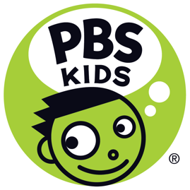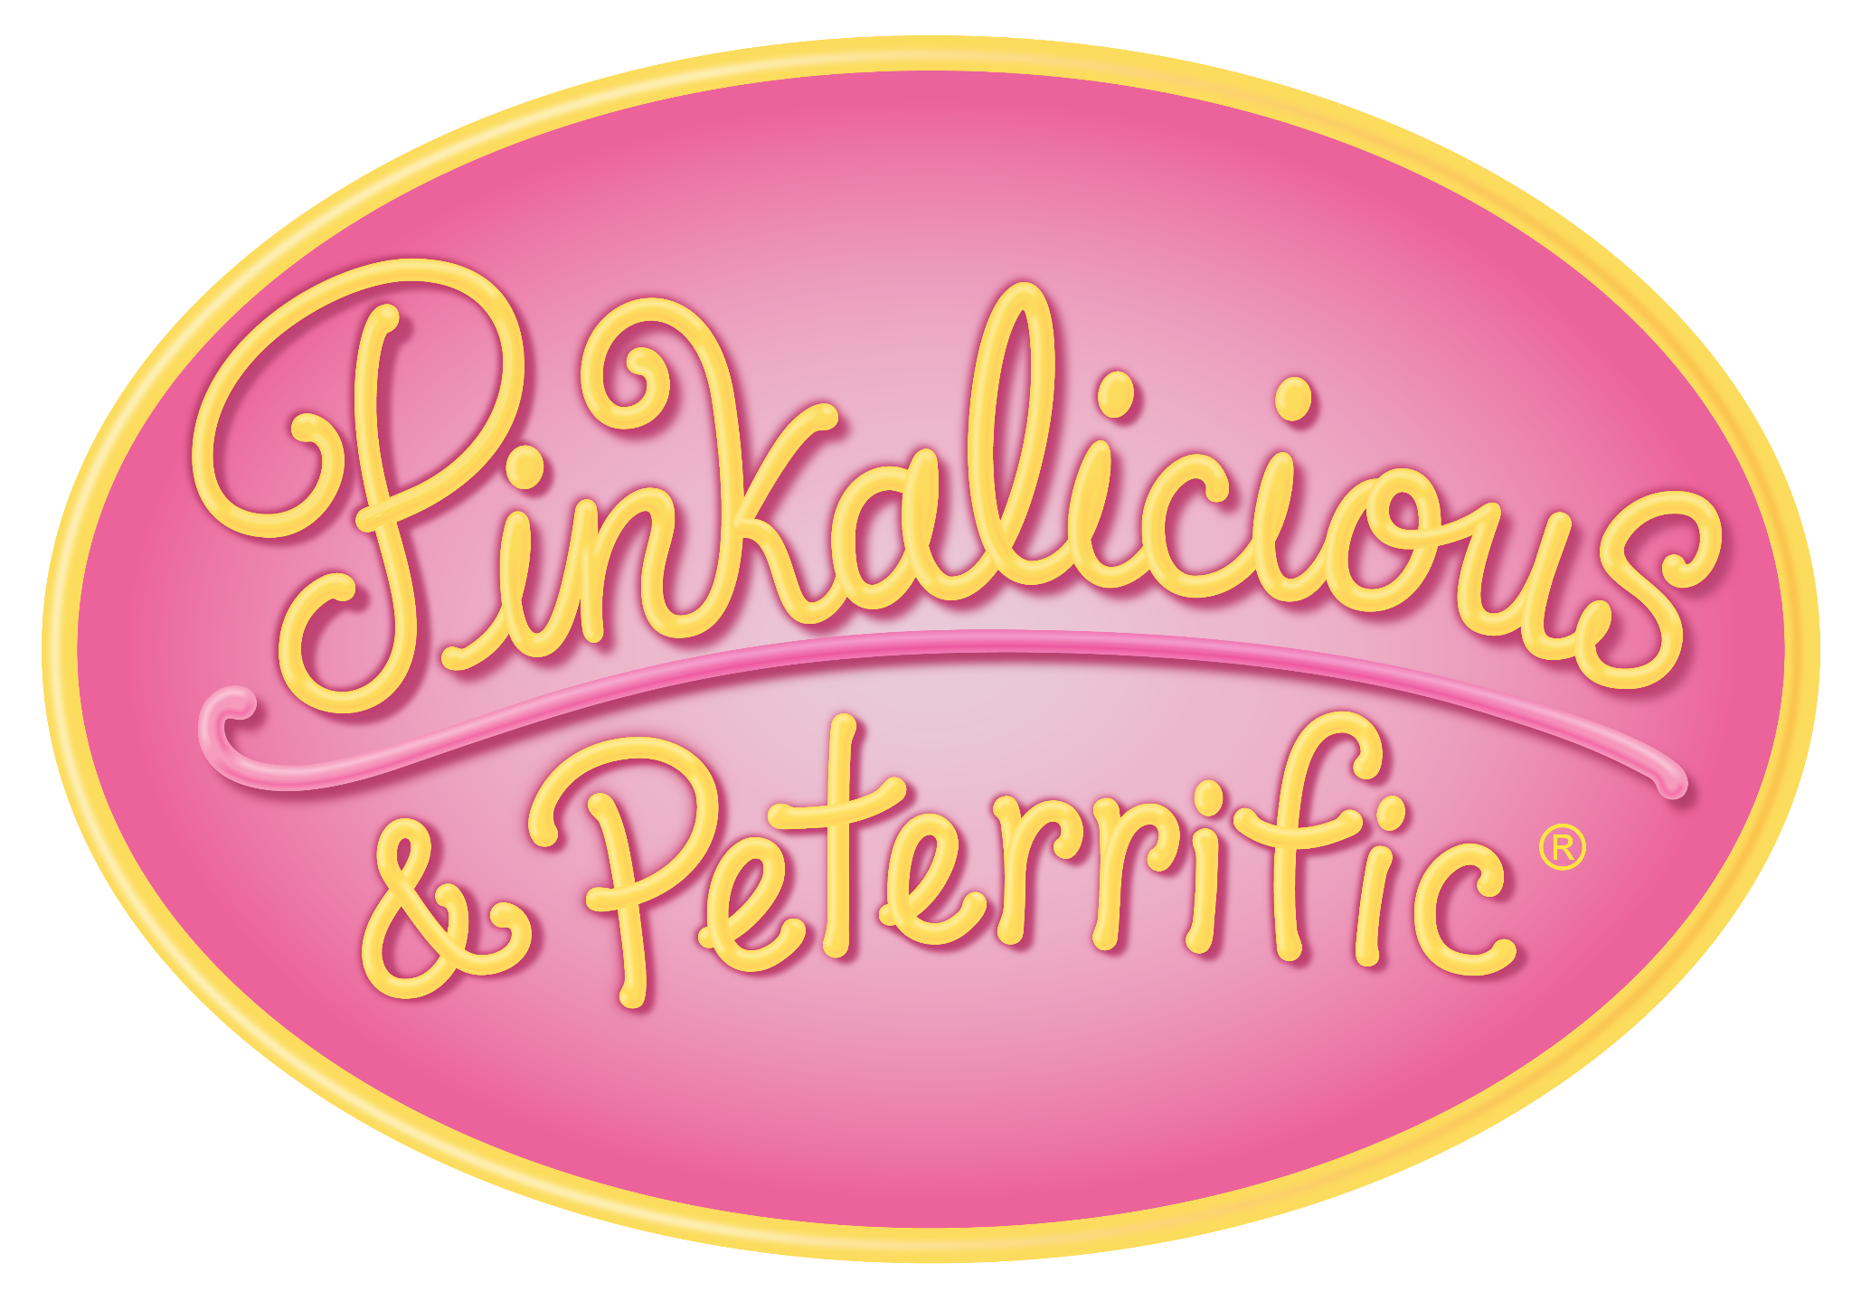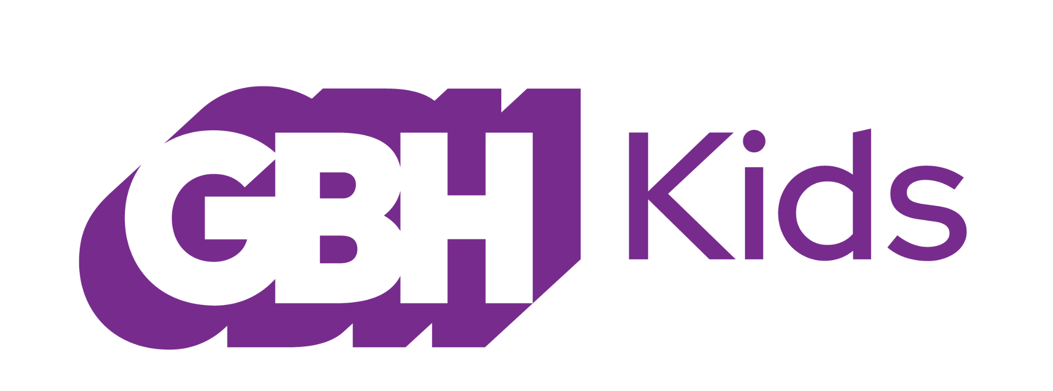

Hit PBS KIDS Series PINKALICIOUS & PETERRIFIC Launches Season 2 Podcast and New Game, Produced by GBH Kids

BOSTON (May 4, 2022) – GBH Kids today announces the second season of The Pinkalicious & Peterrific Podcast and a new original game for the PBS KIDS animated preschool series PINKALICIOUS & PETERRIFIC, a program that inspires children to explore the arts and express themselves creatively.

The new season of the popular The Pinkalicious & Peterrific Podcast kicks off today (listen to the trailer), just in time for any Memorial Day travel. The new season will include eight new episodes available on the PBS KIDS Video app, the PBS KIDS YouTube channel and pbskids.org, and free across all major podcast listening platforms. The podcast is distributed by PRX. Each week, listeners will embark on a Pinkatastic adventure and interact with podcast hosts, Pinkalicious and her brother Peter. In the new season fans can dance and sing along to songs while exploring the importance of friendships, creating fun ideas for playdates, spending time at the beach, and learning more about Pinkalicious and Peter’s favorite things. At the end of each episode, Pinkalicious creator and author Victoria Kann will answer questions from young fans.

“At GBH Kids, we recognize that more and more kids and families are turning to podcasts for fun and to support learning,” said Dorothea Gillim, creative director and executive producer, GBH Kids. “Pinkalicious and the entire Pinkville community encourages kids to be their most creative and expressive selves through the arts – whether that’s singing, dancing, or through imaginative play.”

A Podcast Activity Guide is available as a companion to The Pinkalicious & Peterrific Podcast, providing kids and their caregivers with activities tied to the themes found in each episode of the podcast. Each guide offers a PINKALICIOUS & PETERRIFIC activity or worksheet related to a podcast episode, book or video recommendations, and additional podcast recommendations. Visit wgbh.org/pinkalicious to receive an email with the guide.

Later this month, PINKALICIOUS & PETERRIFIC fans will be heading to the beach in a new original game “Splashtastic Beach Day.” Launching May 26, players will join Pinkalicious and her friend Rafael on a trip to the beach where they have the opportunity to build sandcastles, embark on a treasure hunt, reimagine a tide pool and dance with fish. The new game ties with the beach-themed podcast episode that will also air that week.

Production for Season 2 of The Pinkalicious & Peterrific Podcast is made possible by GBH Kids in partnership with HOThead Creative Studios and PRX. Corporate funding for the second season of The Pinkalicious & Peterrific Podcast was provided by IKEA Retail U.S. and Kiddie Academy®. Additional series content in the Season 2 podcast is from Seasons 1 and 2 of the PINKALICIOUS & PETERRIFIC series.®

PINKALICIOUS & PETERRIFIC is the animated preschool series that inspires children to explore the arts and express themselves creatively. Based on the best-selling picture books by Victoria Kann, the series brings music, dance, theater and visual arts to life through the adventures of Pinkalicious, her brother Peter, and their many friends. Together, they find creative opportunities and imaginative solutions to problems, encouraging young viewers to do the same.

PINKALICIOUS & PETERRIFIC® is produced by GBH Kids and Sixteen South Studios. Funding for PINKALICIOUS & PETERRIFIC® is provided by the Corporation for Public Broadcasting, and public television viewers. Produced with the participation of Northern Ireland Screen. Corporate funding is provided by IKEA Retail U.S. and Kiddie Academy®

About PBS KIDS
PBS KIDS believes the world is full of possibilities, and so is every child. As the number one educational media brand for kids, PBS KIDS helps children ages 2-8 learn lessons that last a lifetime. Through media and community-based programs, PBS KIDS wants children to see themselves uniquely reflected and celebrated in lovable, diverse characters who serve as positive role models, and to explore their feelings and discover new adventures along the way. Families can stream PBS KIDS for free anytime, no subscription required. A large collection of mobile apps and pbskids.org provide accessible content that spark kids’ curiosity. PBS KIDS and local stations across the country support the entire ecosystem in which children learn and grow – including their teachers and caregivers, parents, and community – providing resources accessible anytime and anywhere. For more information, visit pbs.org/pressroom, or follow PBS KIDS on Twitter, Facebook and Instagram.

About GBH Kids
​​GBH Kids is one of the top producers for public media, creating educational content for kids, parents, caregivers and teachers, including iconic PBS Kids programs such as the award-winning Arthur and Molly of Denali, digital series such as Scribbles and Ink, games, apps and podcasts. GBH Kids, based in Boston, also works closely with PBS LearningMedia, providing digital curricula for more than 2 million teachers across all 50 states. GBH Kids is committed to equity and access to educational media and the healthy development of all children. As the inventor of closed captioning and audio description, GBH is dedicated to making media accessible and inclusive. Find more information at gbh.org/kids

HOThead Creative Studios
HOThead Creative Studios is an award-winning multimedia production company delivering top notch content to its clients. Setting the tone for many networks and platforms, HOThead was instrumental in the development of Nickelodeon, Nick Jr, Noggin and MTV brands. Other clients of note include PBS, GBH, Sprout, Acamar Films, Discovery Kids, Audible, HBO, NJ Hall of Fame, Blue Sky and Pinna. HOThead is the recipient of many prestigious awards including ProMaxBDAs, Clio, Manny Awards, Annie, Emmys, Parents’ Choice, and Webby.
We love storytelling and bringing ideas to life! https://hothead.tv

About PRX
PRX is a non-profit public media company specializing in audio journalism and storytelling. PRX serves independent producers and organizations by helping them connect to their most engaged, supportive audiences. One of the world’s leading podcast publishers, PRX works in partnership with TED, PBS, the Smithsonian, Futuro Media, GBH, Religion of Sports, and more. PRX is also home to Radiotopia, known as one of the most creative and successful podcast networks. In addition, PRX distributes trusted and treasured public radio programming to hundreds of stations nationwide, including “The World,” “The Moth Radio Hour,” “This American Life,” “Snap Judgment,” “Reveal,” “The Takeaway,” and “Latino USA.” PRX programs have been recognized by the Peabody Awards, the duPont-Columbia Awards, the IDA Documentary Awards, and the Pulitzer Prizes. Visit PRX.org for more.

