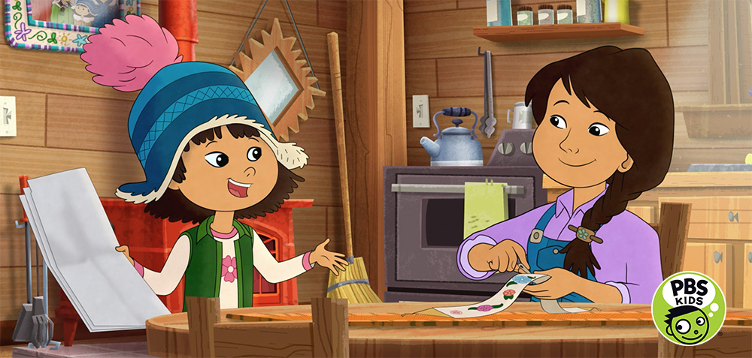
© 2018 WGBH Educational Foundation

wgbh bOSTON Creates OPPORTUNITY FOR Alaska Native WRITERS
TO CONTRIBUTE TO NEW PBS KIDS SERIes

Molly of Denali Screenwriting Fellowship Now Accepting Applications

Boston, MA September 21, 2018 – WGBH Boston is breaking new ground with the upcoming PBS KIDS series, Molly of Denali, the first nationally distributed children’s programming to feature an Alaska Native lead character. As part of WGBH’s commitment to creating opportunities for Alaska Native voices throughout all aspects of series production, a screenwriters’ fellowship is being launched, open only to Alaska Native writers. Applications are now being accepted for Fellowships at:
https://www.wgbh.org/foundation/molly-of-denali-scriptwriting-fellowship

Molly of Denali, premiering Summer 2019, is an animated, action-adventure, comedy featuring the adventures of Molly Mabray, a 10-year-old Alaska Native girl who runs a store called the Denali Trading Post with her family. Each episode follows Molly, her friends, and family on their daily adventures in Alaska. The series’ educational component is rooted in informational text: in each episode, Molly’s life and adventures are enhanced and broadened by informational texts (books, online resources, field guides, historical archives, indigenous knowledge from elders, maps, charts, posters, photos, and more) designed to convey information.

For the Screenwriting Fellowship, WGBH will review submissions and ultimately identify six writers to participate in the initiative, starting with a week-long intensive workshop in early November 2018. Working closely with a head writer distinguished in children’s programming, Fellows will hear from guest lecturers, develop story ideas, and leave the workshop with a completed episode outline for Molly of Denali. Following the intensive workshop, Fellows will continue writing and being mentored over a three-month period to complete an 11-minute script that may become part of the series.

While no prior screenwriting experience is necessary, it is preferred.

Applications are now being accepted for Fellowships at:
https://www.wgbh.org/foundation/molly-of-denali-scriptwriting-fellowship

Applications close on October 19, 2018 at 5pm ET.

--more--

Press contacts:

Kayla Springer
kmspringer@pbs.org
703-739-5351

Bara Levin
bara_levin@wgbh.org
617-300-5391

About WGBH
WGBH Boston is America’s preeminent public broadcaster and the largest producer of PBS content for TV and the Web, including Masterpiece, Antiques Roadshow, Frontline, Nova, American Experience, Arthur, Pinkalicious & Peterrific, and more than a dozen other primetime, lifestyle and children’s series. WGBH’s television channels include WGBH 2, WGBX 44, and the digital channels World and Create. WGBH TV productions focusing on the region’s diverse community include Greater Boston, Basic Black and High School Quiz Show. WGBH Radio serves listeners across New England with 89.7 WGBH, Boston’s Local NPR®; 99.5 WCRB Classical Radio Boston; and WCAI, the Cape and Islands NPR® Station. WGBH also is a major source of programs for public radio (among them, PRI’s The World®), a leader in educational multimedia (including PBS LearningMedia™, providing the nation’s educators with free, curriculum-based digital content), and a pioneer in technologies and services that make media accessible to deaf, hard of hearing, blind and visually impaired audiences. WGBH has been recognized with hundreds of honors: Emmys, Peabodys, duPont-Columbia Awards and Oscars. Find more information at wgbh.org.

About PBS KIDS
PBS KIDS, the number one educational media brand for kids, offers children ages 2-8 the opportunity to explore new ideas and new worlds through television, digital media and community-based programs. PBS KIDS and local stations across the country support the entire ecosystem in which children learn, including their teachers, parents and community. Provided by stations, the free PBS KIDS 24/7 channel and live stream is available to more than 95% of U.S. TV households. Kidscreen- and Webby Award-winning pbskids.org provides engaging interactive content, including digital games and streaming video. PBS KIDS offers mobile apps to help support young children’s learning, including the PBS KIDS Video app, which is available on a variety of mobile devices and on platforms such as Roku, Apple TV, Amazon Fire TV, Android TV and Chromecast. PBS KIDS also offers parent and teacher resources to support children’s learning anytime and anywhere. For more information on PBS KIDS content and initiatives supporting school readiness and more, visit pbs.org/pressroom, or follow PBS KIDS on Twitter, Facebook and Instagram.

