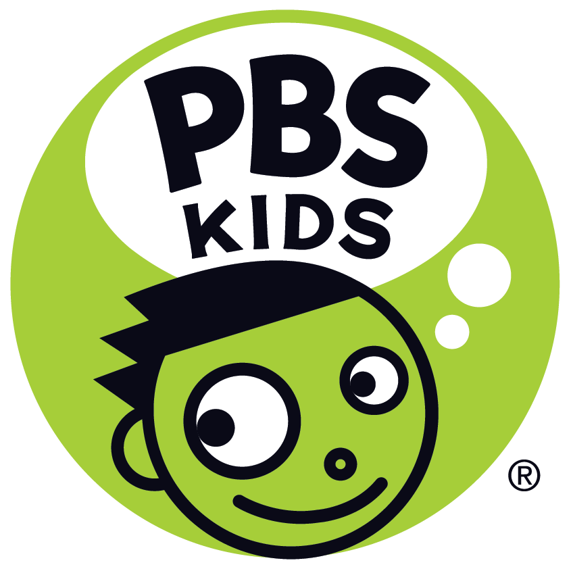
ALMA’S WAY, New PBS KIDS Series From Fred Rogers Productions, Created by Beloved Children’s TV Icon Sonia Manzano, Premieres October 4
Set in the Bronx, Animated Show Helps Kids Recognize Their Own Power to Think Things Through
Original Theme Song Written and Produced By Lin-Manuel Miranda and Bill Sherman
Arlington, VA, August 10, 2021 – Today at the Television Critics Association Press Tour, PBS KIDS announced ALMA’S WAY, a new animated series from Fred Rogers Productions, will premiere on October 4, 2021. The series is created by Sonia Manzano, beloved by generations as “Maria” on Sesame Street, who broke new ground as one of the first Latino characters on national TV.
Inspired by Manzano’s own childhood, ALMA’S WAY centers on 6-year-old Alma Rivera, a proud, confident Puerto Rican girl who lives in the Bronx with her family among a diverse group of close-knit friends and community members. Infused with Manzano’s humor and grounded in a social and emotional curriculum, the series will give children ages 4-6 the tools to find their own answers, express what they think and feel, and recognize and respect the unique perspective of others.
“I am so excited to be working with PBS KIDS and Fred Rogers Productions to introduce Alma, a strong and positive Puerto Rican girl who will empower young viewers,” said Manzano. “Alma's way is to think things through, and we hope the new series will show kids that their thought processes are valid and give them the confidence to think critically."
The engaging modern-day series stars Alma, along with her parents, Mami and Papi; younger brother, Junior; her Abuelo; and their lovable little dog, Chacho. In every episode, Alma speaks directly to young viewers with asides and her “Think Through” moments, where she stops, thinks, and processes. She models optimism and determination, showing that if she puts her mind to a problem, she can ﬁgure it out. Young viewers will tag along with Alma as she learns to speak up for herself, make tough decisions, figure out how to help friends, and so much more.
“The stories on ALMA’S WAY are designed to help kids learn to think for themselves and take into consideration the perspectives of those around them,” said Ellen Doherty, Chief Creative Officer, Fred Rogers Productions. “As Alma thinks things through, she models self-advocacy, empathy and social awareness. She’s a smart kid with a big heart — we hope young viewers will think she’s way, way, way fun to watch!”
Each episode showcases different aspects of Latino cultures through language, food, music, and customs. All viewers will see how other families are both alike and different from their own. Music is the “backbeat” of the series and includes traditional Puerto Rican styles like Plena, Bomba, and salsa along with other Latino genres such as Cuban son and Colombian cumbia. The original theme song, written and produced by Lin-Manuel Miranda and Bill Sherman, is performed by Flaco Navaja and Summer Rose Castillo, who plays Alma. The series music is composed by Asher Lenz, Stephen Skratt, and Fabiola M. Mendez. The series will be available for viewers in both English and Spanish on all PBS KIDS platforms.
“We’re thrilled to welcome Alma and her family to PBS KIDS this fall,” said Linda Simensky, Head of PBS KIDS Content. “Alma’s unique humor and spirit are rooted in the everyday stories of her neighborhood. All children across America deserve to see themselves represented in stories that celebrate and give voice to their lived experiences. That philosophy is at the heart of PBS KIDS.”
ALMA’S WAY is produced, written, and directed by a diverse team, and Latino voices are imbued throughout the series, both on screen and behind the scenes. The series is created by Lifetime Achievement Emmy®-winner Sonia Manzano and produced by Fred Rogers Productions. Ellen Doherty and Sonia Manzano are executive producers. Jorge Aguirre (Goldie & Bear) is head writer. The series is animated by Pipeline Studios (Elinor Wonders Why).
Building on this commitment to authentic representation in PBS KIDS content, JELLY, BEN & POGO, a series of funny and engaging animated shorts from Primal Screen, will debut this fall, following episodes of ALMA’S WAY. Created by Jalysa Leva, each short follows the adventures of the intrepid Jelly, her brainy little brother, Ben, and Pogo, a young sea monster who is always ready to get the party started. Jelly and Ben’s family are of Filipino heritage, and the show is infused with Filipino culture throughout, including the Tagalog language and food and music from the Philippines. Jelly, Ben, and Lola (their grandmother) are voiced by Filipino and Filipino American talent. The three best friends help their neighbors – and each other – by identifying a problem and working together to find a solution, often using STEAM concepts and always understanding the unique perspectives and needs of those they are helping.
ALMA’S WAY will debut on PBS stations and begin streaming free on PBS KIDS October 4. Launching in tandem with the show, digital content for kids, parents and teachers will further the messages and goals of ALMA’S WAY. Series-inspired games will be available in English and Spanish on pbskids.org and on the free PBS KIDS Games App. Spanish and English language parent resources, including tips and hands-on activities to extend the learning at home, will be available on the PBS KIDS for Parents site, and PBS LearningMedia will offer tools for teachers, including video excerpts, games, teaching tips, and printable activities.
About PBS KIDS
PBS KIDS believes the world is full of possibilities, and so is every child. As the number one educational media brand for kids, PBS KIDS helps children ages 2-8 learn lessons that last a lifetime. Through television, digital media, and community-based programs, PBS KIDS wants children to see themselves uniquely reflected and celebrated in lovable, diverse characters who serve as positive role models, and to explore their feelings and discover new adventures along the way. Families can watch PBS KIDS anytime on the free PBS KIDS 24/7 channel and the PBS KIDS Video app, available on mobile and connected-TV devices, no subscription required. PBS KIDS’ large collection of mobile apps and pbskids.org provide accessible content, including digital games and streaming video to spark kids’ curiosity. PBS KIDS and local stations across the country support the entire ecosystem in which children learn and grow – including their teachers, parents, and community – providing resources to support children’s learning, anytime and anywhere. For more information, visit pbs.org/pressroom, or follow PBS KIDS on Twitter, Facebook and Instagram.
About Fred Rogers Productions
Fred Rogers Productions was founded by Fred Rogers in 1971 as the non-profit producer of Mister Rogers’ Neighborhood for PBS. In the years that followed, it created hundreds of episodes of this much-loved program and extended Fred’s values and approach to other efforts in promoting children’s social, emotional, and behavioral health while supporting parents, caregivers, teachers, and other professionals in their work with children. Fred Rogers Productions continues to build on Fred’s legacy in innovative ways through a wide variety of media and engages new generations of children and families with his timeless wisdom. The company’s highly-rated children’s series, including Daniel Tiger’s Neighborhood, Peg + Cat, Odd Squad, and Through the Woods, have earned 30 Emmy® Awards among other important honors. Newly launched in 2021 on PBS KIDS is Donkey Hodie, the innovative puppet series inspired by characters from Mister Rogers’ Neighborhood; and coming this fall is Alma’s Way, an animated series created by Sonia Manzano, known to generations of children and adults as “Maria” on Sesame Street. For more information, visit www.fredrogers.org or follow us on Twitter, Facebook, Instagram, and LinkedIn.

Media Contacts:
PBS | Lubna Abuulbah | labuulbah@pbs.org
Grand Communications | Gabrielle Torello | gab@grandcommunications.com
Hispanic Communications Network | Alicia Vigil Blanco | alicia.vigilblanco@hcnmedia.com

