POMPEII: THE NEW DIG TO AIR ON PBS MAY 15-29

PBS Joins BBC Two and Arte France as Co-Producer and All3Media International on Premium Documentary Series, also Acquiring US/Canadian Broadcast Rights

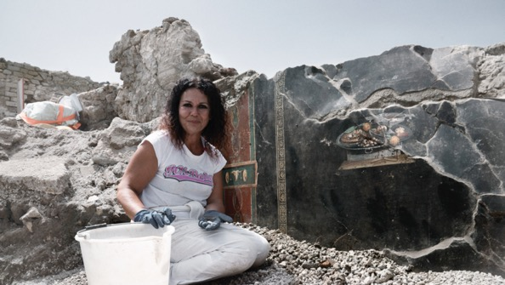

ARLINGTON, VA; APRIL 9, 2024 – POMPEII: THE NEW DIG is a new three-part, three-hour documentary from Lion Television and independent distributor All3Media International, commissioned by BBC Two in a co-production with Arte France and PBS.
The series will premiere on Wednesday, May 15, 10:00-11:00 p.m. ET (check local listings) on PBS, PBS.org, and the PBS App. Additional episodes will air on May 22 and 29.

From the renowned creators of “Secrets of the Saqqara Tomb” and “Saving Venice,” POMPEII: THE NEW DIG follows the most extensive archaeological excavation in Pompeii for a generation. Nearly two years in the making, with exclusive access to the dig and the all-Italian team of archaeologists, the series follows the excavation of an entire city block, unearthing what life was like in Pompeii before the eruption and the horror faced by the victims, and those who survived when Vesuvius erupted in AD 79.

Remarkably, in the excavation, archaeologists uncovered a fresco that looked like a pizza. This artwork, dating back 2,000 years, was discovered in the Regio IX section of Pompeii’s archeological park, near Naples, where pizza originated. It was found on a wall in what seems to have been a hallway of a house, possibly connected to a bakery.

“We’re thrilled to continue our relationship with the accomplished teams at both Lion Television and All3Media International and collaborate on such a captivating show,” said Diana El-Osta, Senior Director, Multiplatform Programming and Development, PBS. “The recent excavation is unveiling valuable insights into Pompeii, showcasing there’s still much to discover. PBS viewers will get to join in on an intriguing 2,000-year journey, spanning from Pompeii’s ancient homes to the present day, and we can’t wait for them to watch.”

“We’re delighted to welcome PBS onboard as co-producer and broadcaster for US/Canada on Lion Television’s latest project,” said Jennifer Askin, SVP North America at All3Media International. “Infused with Lion Television’s trademark cinematic values and immersive storytelling, POMPEII: THE NEW DIG will take us right to the heart of a moment in history that has always fascinated audiences around the world. And by ensuring local experts play a central role, Lion Television is bringing true authenticity to the series, giving viewers a unique opportunity to join the archaeologists as they unearth more thrilling finds and add even more depth to the incredible story of Pompeii and its people.”

ABOUT PBS
PBS, with more than 330 member stations, offers all Americans the opportunity to explore new ideas and new worlds through television and digital content. Each month, PBS reaches over 42 million adults on linear primetime television, more than 15 million users on PBS-owned streaming platforms, and 56 million people view PBS content on social media, inviting them to experience the worlds of science, history, nature, and public affairs; to hear diverse viewpoints; and to take front-row seats to world-class drama and performances. PBS’s broad array of programs has been consistently honored by the industry’s most coveted award competitions. Teachers of children from pre-K through 12th grade turn to PBS LearningMedia for digital content and services that help bring classroom lessons to life. As the number one educational media brand, PBS KIDS helps children 2-8 build critical skills, enabling them to find success in school and life. Delivered through member stations, PBS KIDS offers high-quality content on TV — including a PBS KIDS channel — and streaming free onpbskids.org and the PBS KIDS Video app, games on the PBS KIDS Games app, and in communities across America. More information about PBS is available at PBS.org, one of the leading dot-org websites on the internet, Facebook, Instagram, or through our apps for mobile and connected devices. Specific program information and updates for press are available at pbs.org/pressroom or by following PBS Communications on X (formerly Twitter).

About All3Media International
All3Media International distributes popular, award-winning TV programmes to over 1,000 broadcasters and media platforms around the world. The company has been celebrated for producing, marketing and distributing high-quality, ground-breaking and pioneering shows to a global audience, consistently topping the Broadcast and Televisual annual Indies Surveys and receiving the Queen’s Award for Enterprise in recognition of its growth – twice. Its catalogue contains over 30,000 hours of content across all genres.

As well as one of the top-selling drama series MIDSOMER MURDERS, All3Media International’s quality scripted content includes FLEABAG, ALL CREATURES GREAT AND SMALL, IT'S A SIN, TRIGGER POINT, THE TOURIST, MYSTERY ROAD, VAN DER VALK and THE ENGLISH. Its non-scripted content slate includes premium factual documentaries such as WHO IS GHISLAINE MAXWELL? and FEVER PITCH: THE RISE OF THE PREMIER LEAGUE as well as various factual entertainment titles including ESCAPE TO THE CHATEAU, GREAT BRITISH MENU and FOUR IN A BED. The company also represents brands featuring some of television's most beloved names including Monty Don, Alan Titchmarsh, Gordon Ramsay, Mary Beard and Grayson Perry. All3Media International’s celebrated formats include THE TRAITORS, GOGGLEBOX, UNDERCOVER BOSS, THIS IS YOUR LIFE, LINGO, THE DOG HOUSE and RACE ACROSS THE WORLD, and it also represents an extensive list of successful scripted formats including LIAR, BLOOD, CHEAT and QUEER AS FOLK.

Media Contacts:

PBS
Meredith Tiger, PBS, mjtiger@pbs.org

ALL3MEDIA INTERNATIONAL
Rachel Glaister, rachel.glaister@all3media.com

For images and additional up-to-date information on this and other PBS programs, visit PBS PressRoom at pbs.org/pressroom.

– PBS –

