PAVLO: LIVE IN SANTORINI
Premieres on PBS Stations Beginning November 27

The Mediterranean Guitarist Performs From The Mystical Island

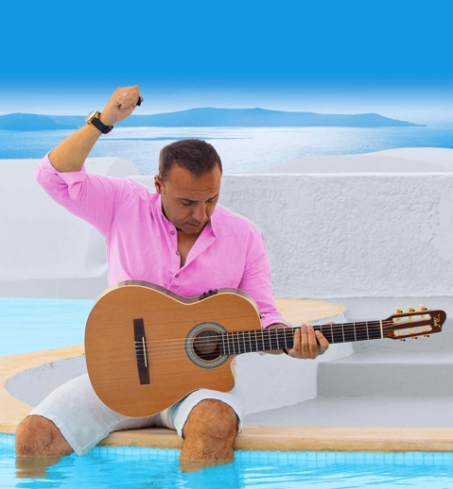
Credit: Courtesy of Pavlo Simtikidis

Mediterranean guitarist Pavlo brings the wondrous beauty of Greek’s most famous island to life through his Santorini-inspired compositions in this new special. Breathtaking sunsets and panoramic views of the iconic white and blue structures built along Santorini’s steep cliffs—calderas—form the backdrop as Pavlo becomes the first artist to bring a concert film to North American television from this mystical island. PAVLO: LIVE IN SANTORINI is part of special programming premiering on PBS stations beginning Saturday, November 27, 2021 (check local listings).

Joining Pavlo are a stellar band and special guests, including America’s Got Talent finalist Daniel Emmet, who sings “Nights In White Satin,” and Benise, “The Prince of Spanish Guitar,” who adds his signature touch to “My Life Is Going On”/”Bella Ciao.”

Pavlo serenades viewers with new music accented with a few special classics, including an unforgettable arrangement of Bon Jovi’s, “Make A Memory” and the most romantic song ever written, “Love Story.”

PBS special programming invites viewers to experience the worlds of science, history, nature and public affairs; hear diverse viewpoints; and take front-row seats to world-class drama and performances. Viewer contributions are an important source of funding, making PBS programs possible. PBS and public television stations offer all Americans from every walk of life the opportunity to explore new ideas and new worlds through television and online content.

Underwriters: Public Television Viewers and PBS
Producer: Pavlo Simtikidis

- PBS –

CONTACT: Cara White, CaraMar, Inc., cara.white@mac.com

For images and additional up-to-date information on this and other PBS programs, visit PBS PressRoom at pbs.org/pressroom.

