PAIN SECRETS: THE SCIENCE OF EVERYDAY PAIN, Hosted by Award-winning ABC News Journalist Deborah Roberts,
Premieres on PBS Stations Beginning November 27

Explores the Latest Research on Pain and Offers Ways to Help Minimize and Resolve It

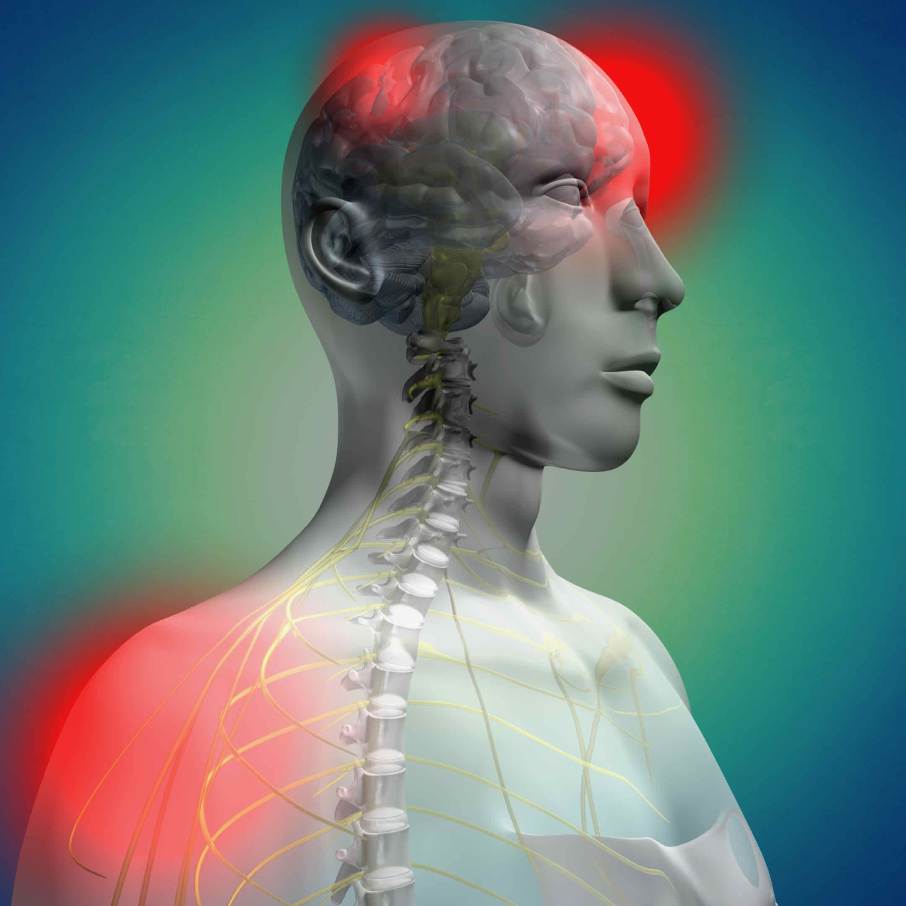
Top: ABC News journalist Deborah Roberts. Credit: Courtesy ABC News. Bottom: Graphic from PAIN SECRETS. Credit: Inky Dinky Worldwide, Inc.

Exploring the latest research and scientific origins of common, everyday pain, PAIN SECRETS: THE SCIENCE OF EVERYDAY PAIN provides viewers with proactive steps they can take to help minimize or resolve many kinds of chronic pain. Featuring interviews with leading experts in pain and pain management—neuroscientists, physicians, researchers and others—the program uses state-of-the-art computer animations to clearly illustrate how pain works and then explains many cutting-edge modalities of treatment that have proven to be powerful ways to help minimize it. Hosted by award-winning ABC News journalist Deborah Roberts, PAIN SECRETS: THE SCIENCE OF EVERYDAY PAIN is part of special programming premiering on PBS stations beginning Saturday, November 27, 2021 (check local listings).

Most people think of pain in terms of an injury or inflammation. This type of pain serves a useful purpose, because when we are hurt, we protect ourselves to prevent further injury and allow healing. But neuropathic pain—which occurs because of an abnormal function of the nervous system—does not have the same benefit. This kind of pain includes a wide variety of disorders affecting any part of the nervous system—from the brain to the spinal cord to the smallest nerves in the toes. In some cases, the brain can receive a signal even if there is no painful stimulus. In other cases, sensory signals get crossed and are "misread" as pain.

Understanding the variety and complexity of our body’s expression of chronic pain leads us toward a pathway toward improved non-pharmaceutical and non-surgical treatment options.
Revealing a revolutionary new way of understanding pain through the Pain-Brain Connection, PAIN SECRETS: THE SCIENCE OF EVERYDAY PAIN explores these treatment modalities that can help to resolve, manage and in some cases correct for chronic everyday pain. Viewers are reminded that they need to consult their health care provider for any serious or persistent, painful condition.

PBS special programming invites viewers to experience the worlds of science, history, nature and public affairs; hear diverse viewpoints; and take front-row seats to world-class drama and performances. Viewer contributions are an important source of funding, making PBS programs possible. PBS and public television stations offer all Americans from every walk of life the opportunity to explore new ideas and new worlds through television and online content.

Underwriters: Public Television Viewers and PBS
Producer: Inky Dinky Worldwide, Inc.
Executive Producers: Bob Marty & Eli Brown

- PBS –

CONTACT: Cara White, CaraMar, Inc., cara.white@mac.com

For images and additional up-to-date information on this and other PBS programs, visit PBS PressRoom at pbs.org/pressroom.

