NOVA “WHAT ARE UFOs?”
SUMMER 2024 TCA PRESS TOUR PANELIST BIOS

(IN ALPHABETICAL ORDER):

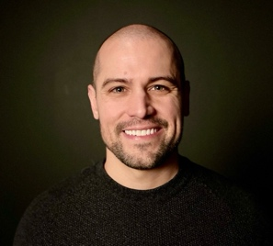
RYAN GRAVES
Former Lt. U.S. Navy and F/A-18F Pilot
First active-duty pilot to come forward publicly about regular sightings of UAPs
Ryan Graves is a former Lt. U.S. Navy and F/A-18F pilot who deployed twice in support of Operation Enduring Freedom and Operation Inherent Resolve. Graves was the first active duty pilot to come forward publicly about regular sightings of UAP and has been featured in “60 Minutes,” The New York Times, and The Joe Rogan Experience.

Graves serves as co-founder and Executive Director of Americans for Safe Aerospace (ASA), a military pilot led nonprofit dedicated to aerospace safety and national security with focus on UAP.

Graves volunteers as the first Chair of the AIAA UAP Integration and Outreach Committee (UAPIOC). The UAPIOC serves as a neutral, scientifically focused group enabling greater aerospace safety.

TERRI RANDALL
Producer, Director, and Writer, NOVA "What are UFOs?"
For the last 15 years, Terri has written, produced, and directed many hours about space exploration for NOVA, including "The Pluto Files" with Neil deGrasse Tyson, "Chasing Pluto," the story of the Pluto flyby, "Death Dive to Saturn" the end of the Cassini Mission, "Touching the Asteroid" the story of the OSIRIS-REx mission, "Looking for Life on Mars" the tale of Perseverance, NASA’s latest Mars rover, and "Ultimate Space Telescope” the construction and launch of the James Webb Space Telescope- nominated for an Emmy in 2023.

She also produced two personal independent films about her family; "Daughter of the Bride" was nominated for an Academy Award for Best Short Subject Documentary. “What Kids Want to Know about Sex and Growing," produced for CTW (now known as Sesame Workshop), was nominated for a Primetime Emmy for Outstanding Children's Programming.

She directed several dramatic shorts for History Channel that are on permanent exhibition at George Washington’s Mt. Vernon and Independence Hall in Philadelphia.

https://terrirandallproductions.com/

CHRIS SCHMIDT
Co-Executive Producer, NOVA
Chris is an award-winning producer and director of documentaries and factual television series. Along with Co-Executive Producer Julia Cort, Chris oversees NOVA’s development team in creating new multi-hour projects in collaboration with U.S. filmmakers and international co-producers. Since joining NOVA in 2012 he has developed and guided more than 100 ground-breaking films and series, including “The Planets,” “Black Hole Apocalypse,” “Great Math Mystery,” “Einstein’s Quantum Riddle,” “Hunting The Elements,” “Human Nature,” “Arctic Sinkholes,” “Alaskan Dinosaurs,” and “Zero to Infinity.” Prior to working full-time at NOVA Chris was an independent filmmaker and executive producer making programs for factual networks including Discovery, National Geographic, History, Animal Planet and PBS. In love with stories of human ingenuity and discovery, Chris’s curiosity and persistence have led him up Chinese construction cranes, into the Sahara Desert in search of whale skeletons, catapulted him off an aircraft carrier and made it possible to hang out with some of the world’s most dedicated scientists, mathematicians, and engineers. His work has received the prestigious Alfred I. DuPont-Columbia University Award, the AAAS Gold Kavli Science Journalism award, the Cine Golden Eagle, and many nominations for the News and Documentary Emmy Award.

A graduate of Northwestern University and University of Chicago, Chris currently lives in Concord, Massachusetts.
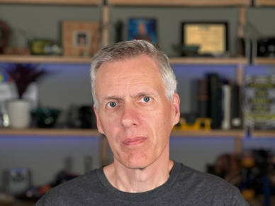
MICK WEST
Author, Software developer, UFO analyst, and Conspiracy Debunker
Founder, Metabunk
Mick West is an author, software developer, and UFO analyst with a rich background in the video game industry, notably as the Technical Director of the Tony Hawk's Pro Skater series. He founded Metabunk, a website dedicated to investigating conspiracy theories and unusual claims through crowdsourcing and public data. Mick authored the book "Escaping the Rabbit Hole: How to Debunk Conspiracy Theories Using Facts, Logic, and Respect." Additionally, he developed the Sitrec suite of tools, which are used for the technical analysis and recreation of UFO videos.

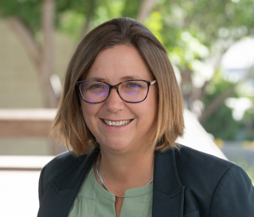
SHELLEY WRIGHT
Professor in Astronomy and Astrophysics, University of California, San Diego
Shelley Wright is a Professor in Astronomy & Astrophysics at UC San Diego. Her research focuses on developing innovative astronomical instrumentation and observations using some of the world's largest optical telescopes. Shelley specializes in optical and near-infrared cameras and spectrographs and studying distant galaxies and supermassive black holes. Shelley is the Principal Investigator of new instrumentation at W. M. Keck Observatory and the Project Scientist of first-light instrument for the Thirty Meter Telescope. Shelley has been an active researcher and instrumentalist in the Search for Extraterrestrial Intelligence (SETI) field for over two decades.

ADDITIONAL ON-SITE PRODUCER (MAKING OPENING REMARKS):

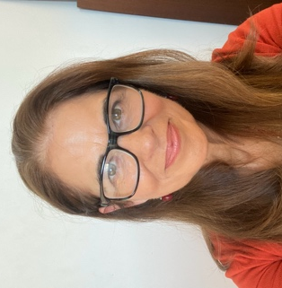
JULIA CORT
Co-Executive Producer, NOVA
(she/her)
Julia Cort, together with Co-Executive Producer Chris Schmidt, oversees the long-running PBS science series NOVA, produced by GBH. Since joining NOVA, Julia has contributed to more than two hundred films and digital videos, covering everything from quantum mechanics and neuroscience to climate change and space exploration. She has developed and overseen some of NOVA’s most popular episodes, mini-series, and digital content, including “Your Brain,” “Great American Eclipse,” “Ice Age Footprints, Ultimate Space Telescope,” “The Cannabis Question,” “Polar Extremes,” “NOVA Wonders,” and “Antarctic Extremes.” In her quest to make complex science engaging for all, Julia has traveled deep underground to investigate the hunt for dark matter, waded into leech-infested swamps, and attempted to re-create the technological feats of ancient engineers. Her work has been honored with the George Foster Peabody Award, the National Academies Keck Communication Award, the AAAS Science Journalism Award, the Alfred I. duPont-Columbia Award, and the News & Documentary Emmy. Prior to coming to GBH and NOVA, Julia worked on the production teams of more than two dozen feature films and TV series, including “Dirty Dancing” and the original “Hairspray.”

###
Press Contacts:
Jordan Lawrence
DKC Public Relations
jordan_lawrence@dkcnews.com
212.981.5220

Jennifer Welsh
NOVA/GBH
jennifer_welsh@wgbh.org
978.985.9835

