Press Contacts: Chelsey Saatkamp, The WNET Group, 513-266-1748 saatkampc@wnet.org,
Press Materials: pbs.org/pressroom or thirteen.org/pressroom

Websites:
pbs.org/nature, facebook.com/PBSNature, @PBSNature, instagram.com/pbsnature, youtube.com/naturepbs, tiktok.com/@pbsnature, #NaturePBS

San Diego: America’s Wildest City
Talent Biographies

Fred Kaufman
Executive Producer, NATURE
@kaufman_fred
For more than 40 years, Fred Kaufman has been a leader in the natural history genre and one of the longest tenured executive producers in PBS history. As the executive producer of the acclaimed PBS series NATURE, Kaufman has won eight Emmys and two Peabody Awards. He has worked on NATURE since its beginning in 1982 and has overseen it since 1991. During his tenure, NATURE has been honored with hundreds of industry awards. In 2012, Kaufman was named the recipient of the International Wildlife Film Festival’s Lifetime Achievement Award for Media. In 2010, NATURE earned the Outstanding Achievement Award from the prestigious Wildscreen Festival in Bristol, England. It was the first time in the 20-year history of the festival that the award was presented to an American wildlife series. Kaufman is a board member of the Jackson Hole Wildlife Film Festival and the Bronx Children’s Museum.

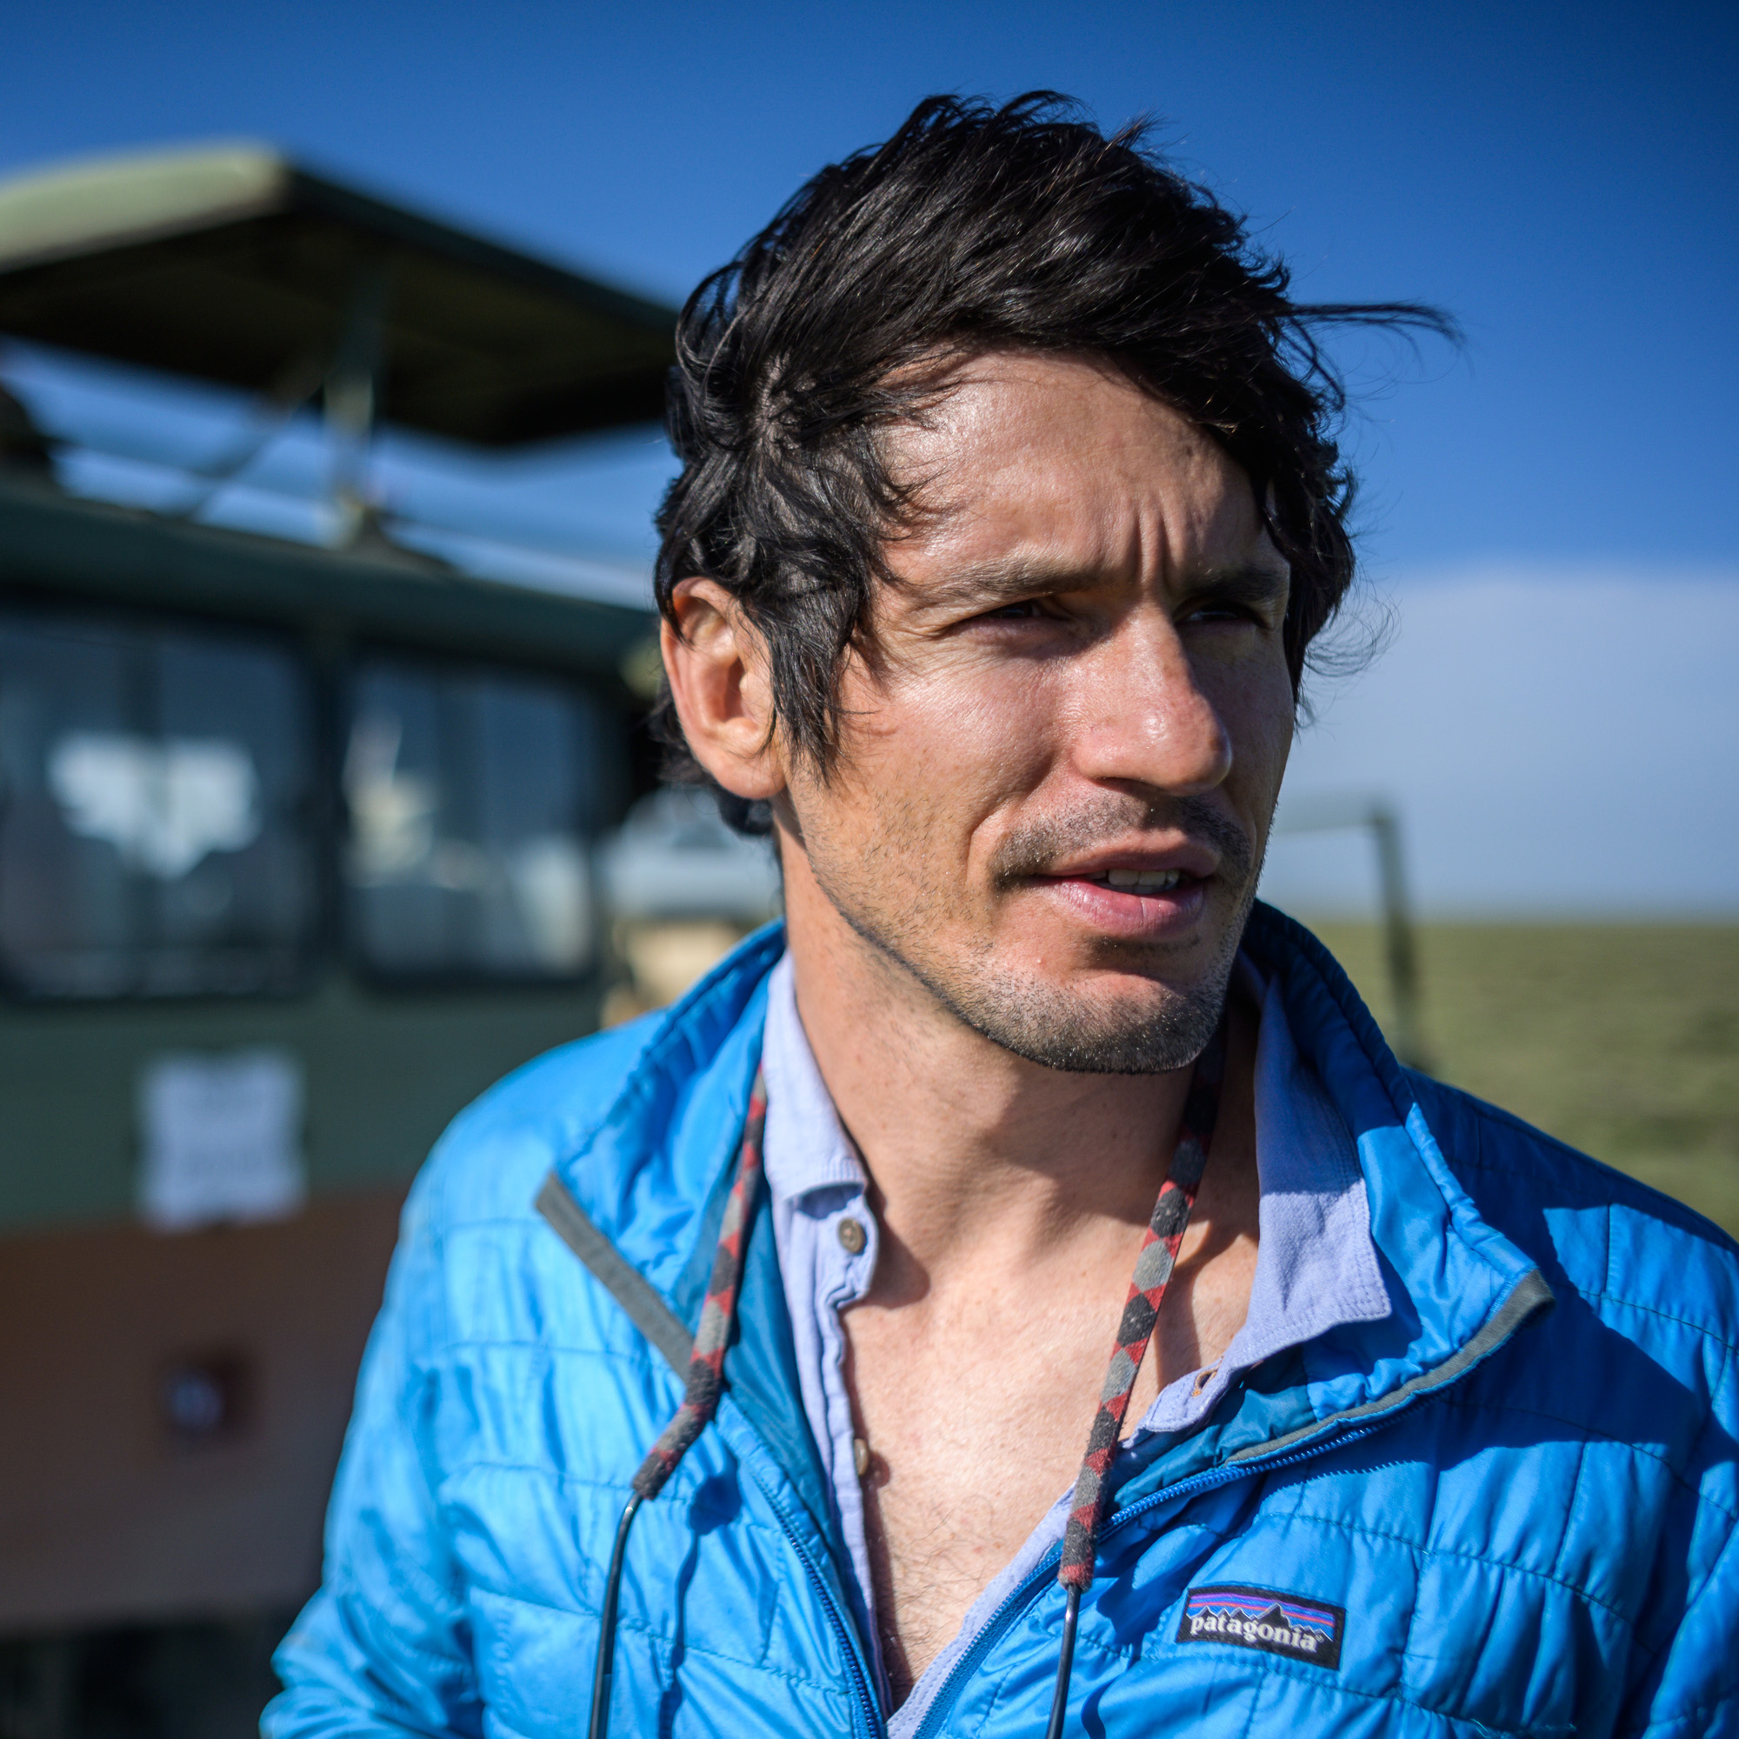
Nate Dappen
Director and Producer
@daysedge @natedappen
Nate Dappen is a biologist and filmmaker based in San Diego, CA. Before going into documentaries, Nate earned his Ph.D. in Evolution and Animal Behavior from The University of Miami in 2012. The same year, Nate cofounded Day's Edge Productions with Neil Losin. Since then, he has been making science and natural history documentaries full-time. He is the director, writer, and DP of SAN DIEGO: AMERICA'S WILDEST CITY as well as the series director and senior producer of the award-winning PBS Primetime science series HUMAN FOOTPRINT. Nate is a Fellow of the Explorers Club and an Affiliate of the International League of Conservation Photographers.

