Celebrate the Holiday Season With
THE NUTCRACKER AND THE MOUSE KING,
A Reimagining of the Classic Tale Featuring Alan Cumming

Premieres Tuesday, December 14 on PBS and PBS.org

ARLINGTON, VA (DECEMBER 1, 2021) – Conceived by Grammy, Emmy and Tony Award winner John Mauceri, THE NUTCRACKER AND THE MOUSE KING is a delightful reimagining of Tchaikovsky's perennial holiday favorite, The Nutcracker. Based on the original E.T.A. Hoffmann novella published in 1816, this new musical production features Alan Cumming recounting the three-part tale: the Nutcracker’s origin story, the well-known events on Christmas Eve, and what happens to the girl and the prince after the beloved ballet ends. Music from Tchaikovsky’s tone poems, orchestral suites, and the magical score for The Nutcracker ballet help tell this cherished—and now complete—tale. Performed by the Royal Scottish National Orchestra under the musical direction of Mauceri, with Cumming narrating the story live on stage, THE NUTCRACKER AND THE MOUSE KING premieres Tuesday, December 14, 2021, 9:00-10:30 p.m. ET (check local listings) on PBS, PBS.org, and the PBS Video app.
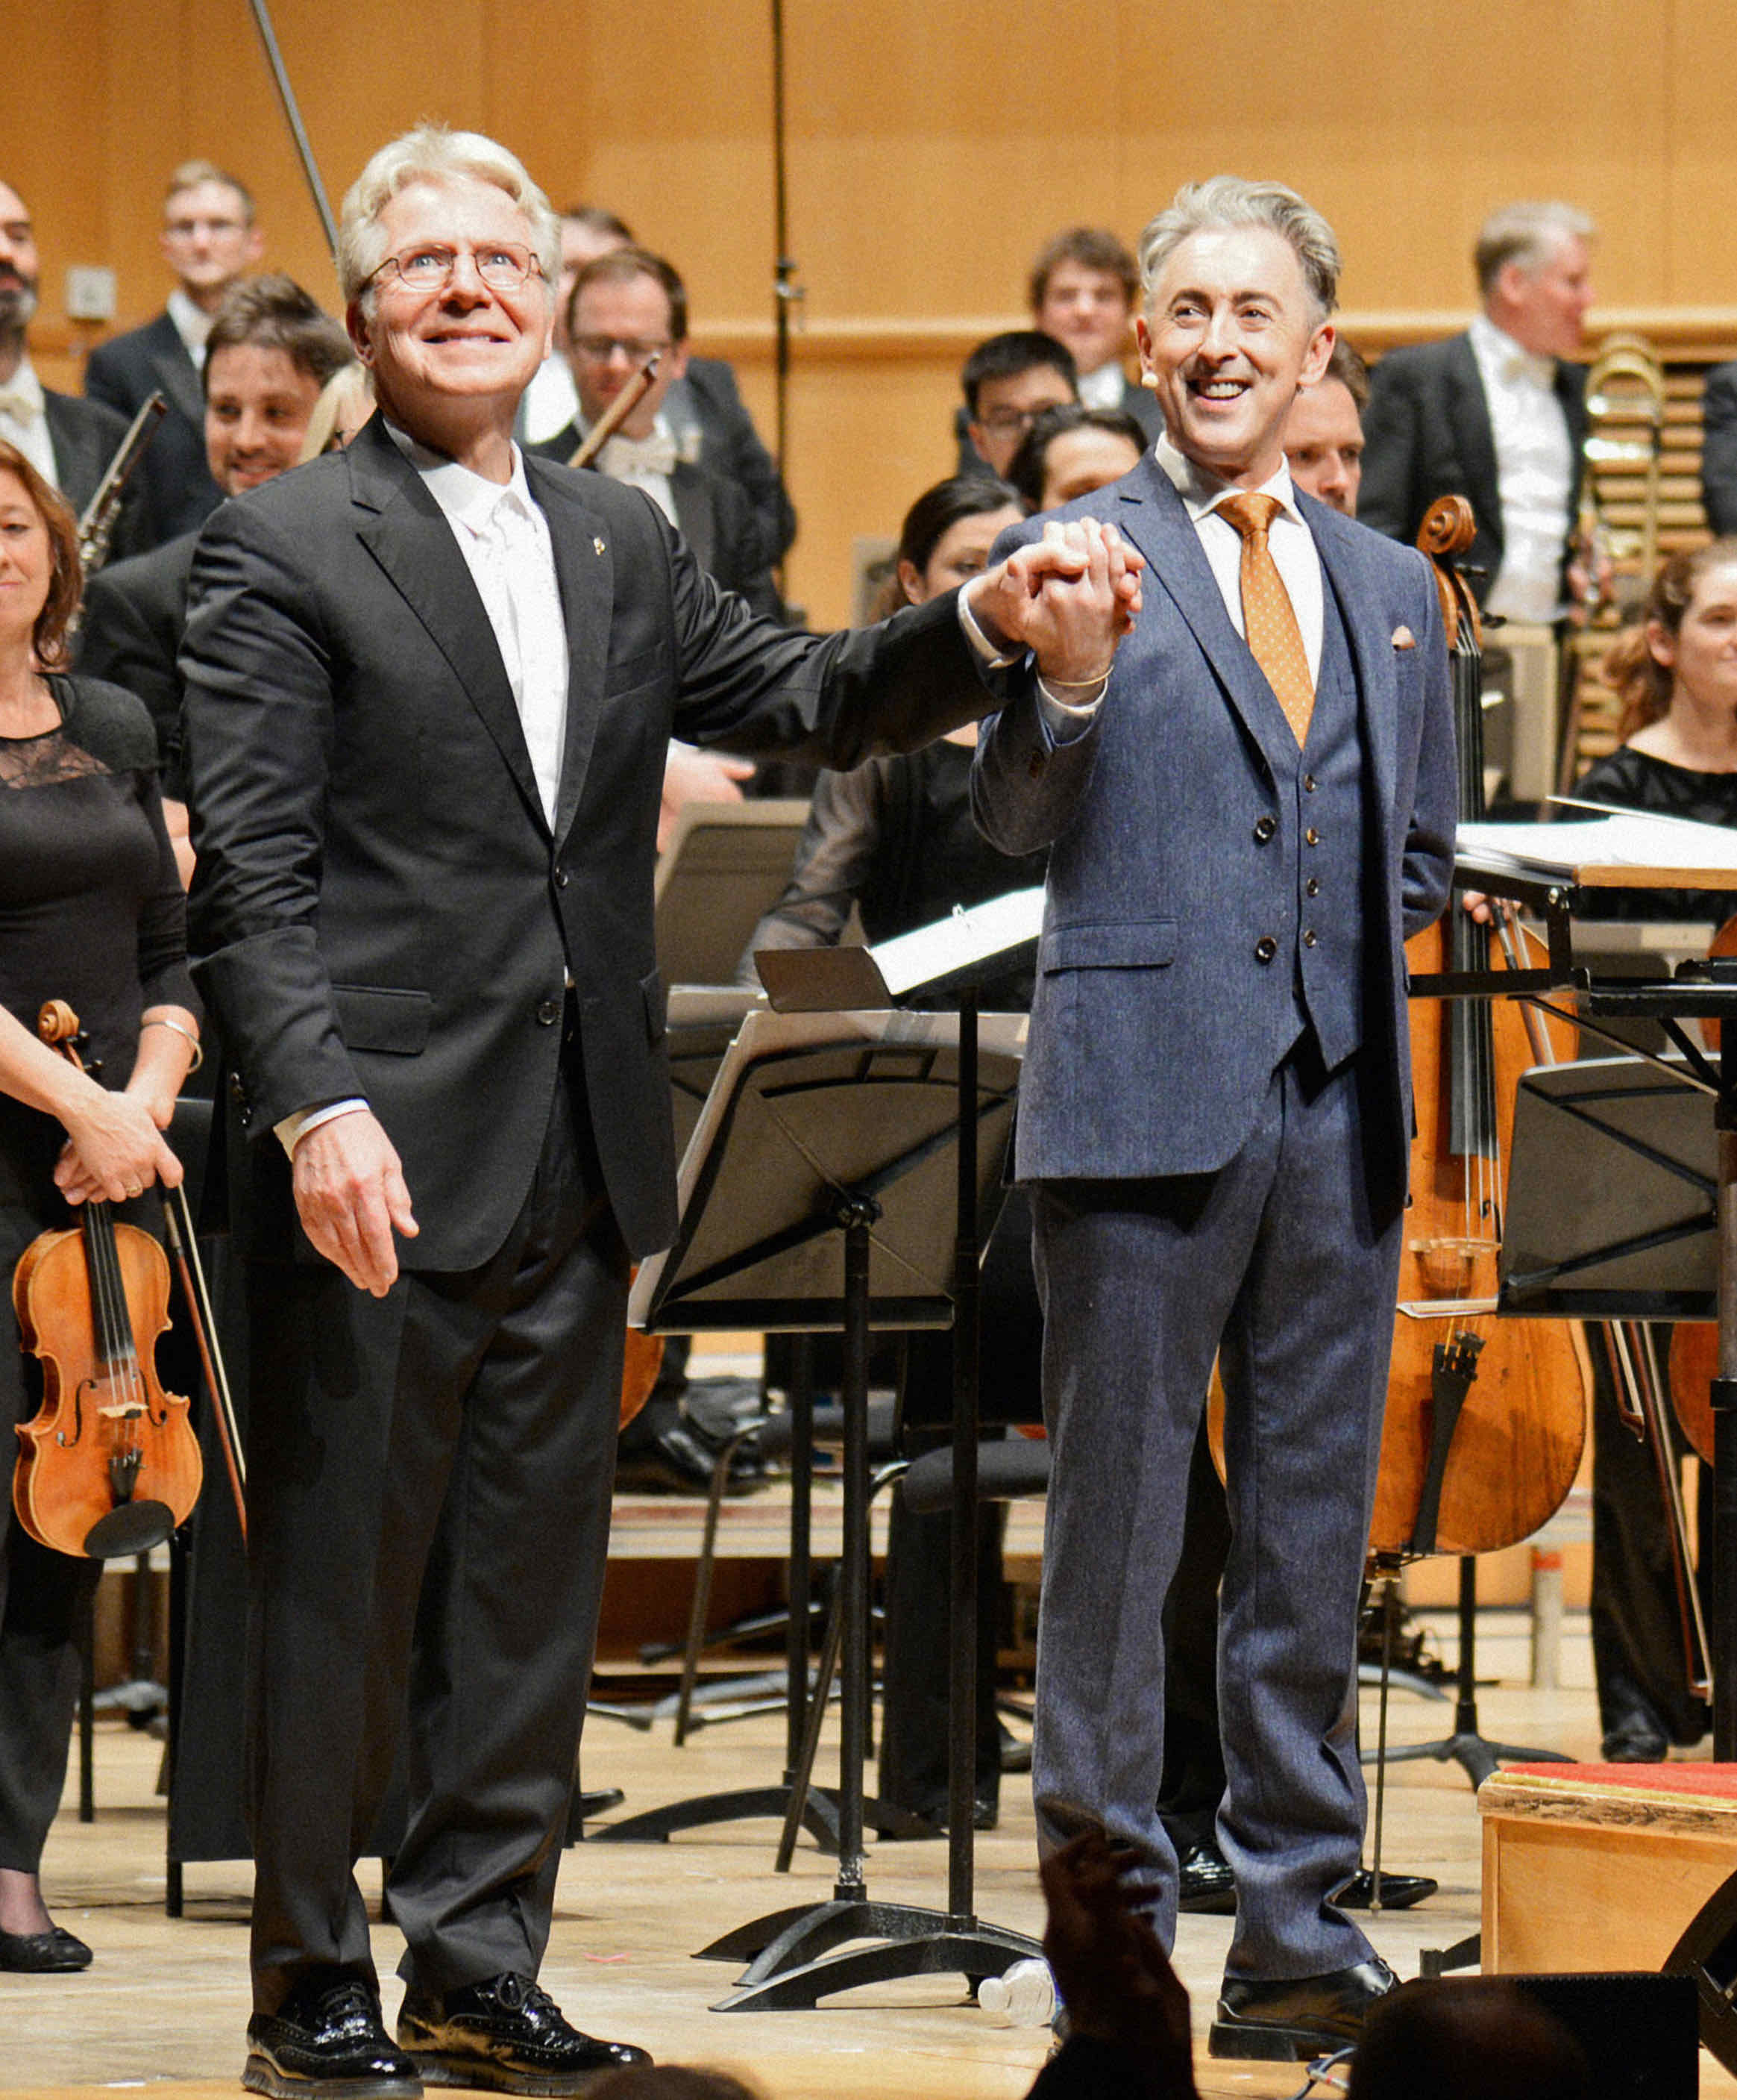
Left to right: John Mauceri and Alan Cumming.
Credit: Andrew Young

Commentary from Mauceri provides additional context for the history behind this classic, pointing out that Hoffmann’s original narrative is about a young girl who saves a prince—the opposite of Cinderella, Sleeping Beauty, and Snow White. Carved wooden nutcrackers dressed as soldiers first appeared in Germany in the early 1800s, providing inspiration for Hoffmann. Alexander Dumas, the most successful French author of the 19th century, translated Hoffmann’s work in 1845. Mauceri believes that Dumas, the grandson of a French aristocrat and an African Haitian slave, was drawn to a story where the young girl grows up to become the queen of a land of tolerance and imagination. It was the version by Dumas that was adapted by Tchaikovsky in 1892. The composer was actually writing the score when he travelled to New York City to conduct the grand opening concert of Carnegie Hall in 1891.

“It makes for a great tale, one that is both familiar and unknown,” said Mauceri. “Perhaps it can do what Hoffmann intended: encourage children to follow their dreams and never stop believing in the power of imagination and the possibility that we can all live together in raucous harmony and understanding.”

THE NUTCRACKER AND THE MOUSE KING will stream simultaneously with broadcast on all station-branded PBS platforms, including PBS.org and the PBS Video app, available on iOS, Android, Roku, Apple TV, Amazon Fire TV, Android TV, Samsung Smart TV, Chromecast, and VIZIO.

THE NUTCRACKER AND THE MOUSE KING is based on the 1816 story by E.T.A. Hoffmann. Music by Pyotr Ilyich Tchaikovsky. Story and music adapted and retold by John Mauceri. Narrated by Alan Cumming. Featuring the Royal Scottish National Orchestra, Maya Iwabuchi, Leader. Conducted by John Mauceri. Associate Producer is Thiago Tiberio. Produced for television by John Mauceri and Andrew Young. Recorded at the Glasgow Royal Concert Hall, December 7, 2019.

About PBS
PBS, with more than 330 member stations, offers all Americans the opportunity to explore new ideas and new worlds through television and digital content. Each month, PBS reaches over 120 million people through television and 26 million people online, inviting them to experience the worlds of science, history, nature and public affairs; to hear diverse viewpoints; and to take front row seats to world-class drama and performances. PBS’s broad array of programs has been consistently honored by the industry’s most coveted award competitions. Teachers of children from pre-K through 12th grade turn to PBS for digital content and services that help bring classroom lessons to life. Decades of research confirms that PBS’s premier children’s media service, PBS KIDS, helps children build critical literacy, math and social-emotional skills, enabling them to find success in school and life. Delivered through member stations, PBS KIDS offers high-quality educational content on TV— including a 24/7 channel, online at pbskids.org, via an array of mobile apps and in communities across America. More information about PBS is available at pbs.org, one of the leading dot-org websites on the internet, or by following PBS on Twitter, Facebook or through our apps for mobile and connected devices. Specific program information and updates for press are available at pbs.org/pressroom or by following PBS Communications on Twitter.

– PBS –
CONTACTS:

PJ Feinstein, PBS: pjfeinstein@pbs.org

Cara White / Mary Lugo, CaraMar, Inc.
843-881-1480; 770-851-8190
cara.white@mac.com; lugo@negia.net

For images and additional up-to-date information on this and other PBS programs, visit PBS PressRoom at pbs.org/pressroom.

