PBS Sets Premiere Date for Third Episode of New Performing Arts Series, NEXT AT THE KENNEDY CENTER,
With Hip Hop Legends The Roots
Friday, Jan. 27, 2023
9-10 p.m. ET on PBS

NEXT AT THE KENNEDY CENTER “The Roots Residency” Explores Grammy-Winning Band’s Musical and Cultural Impact

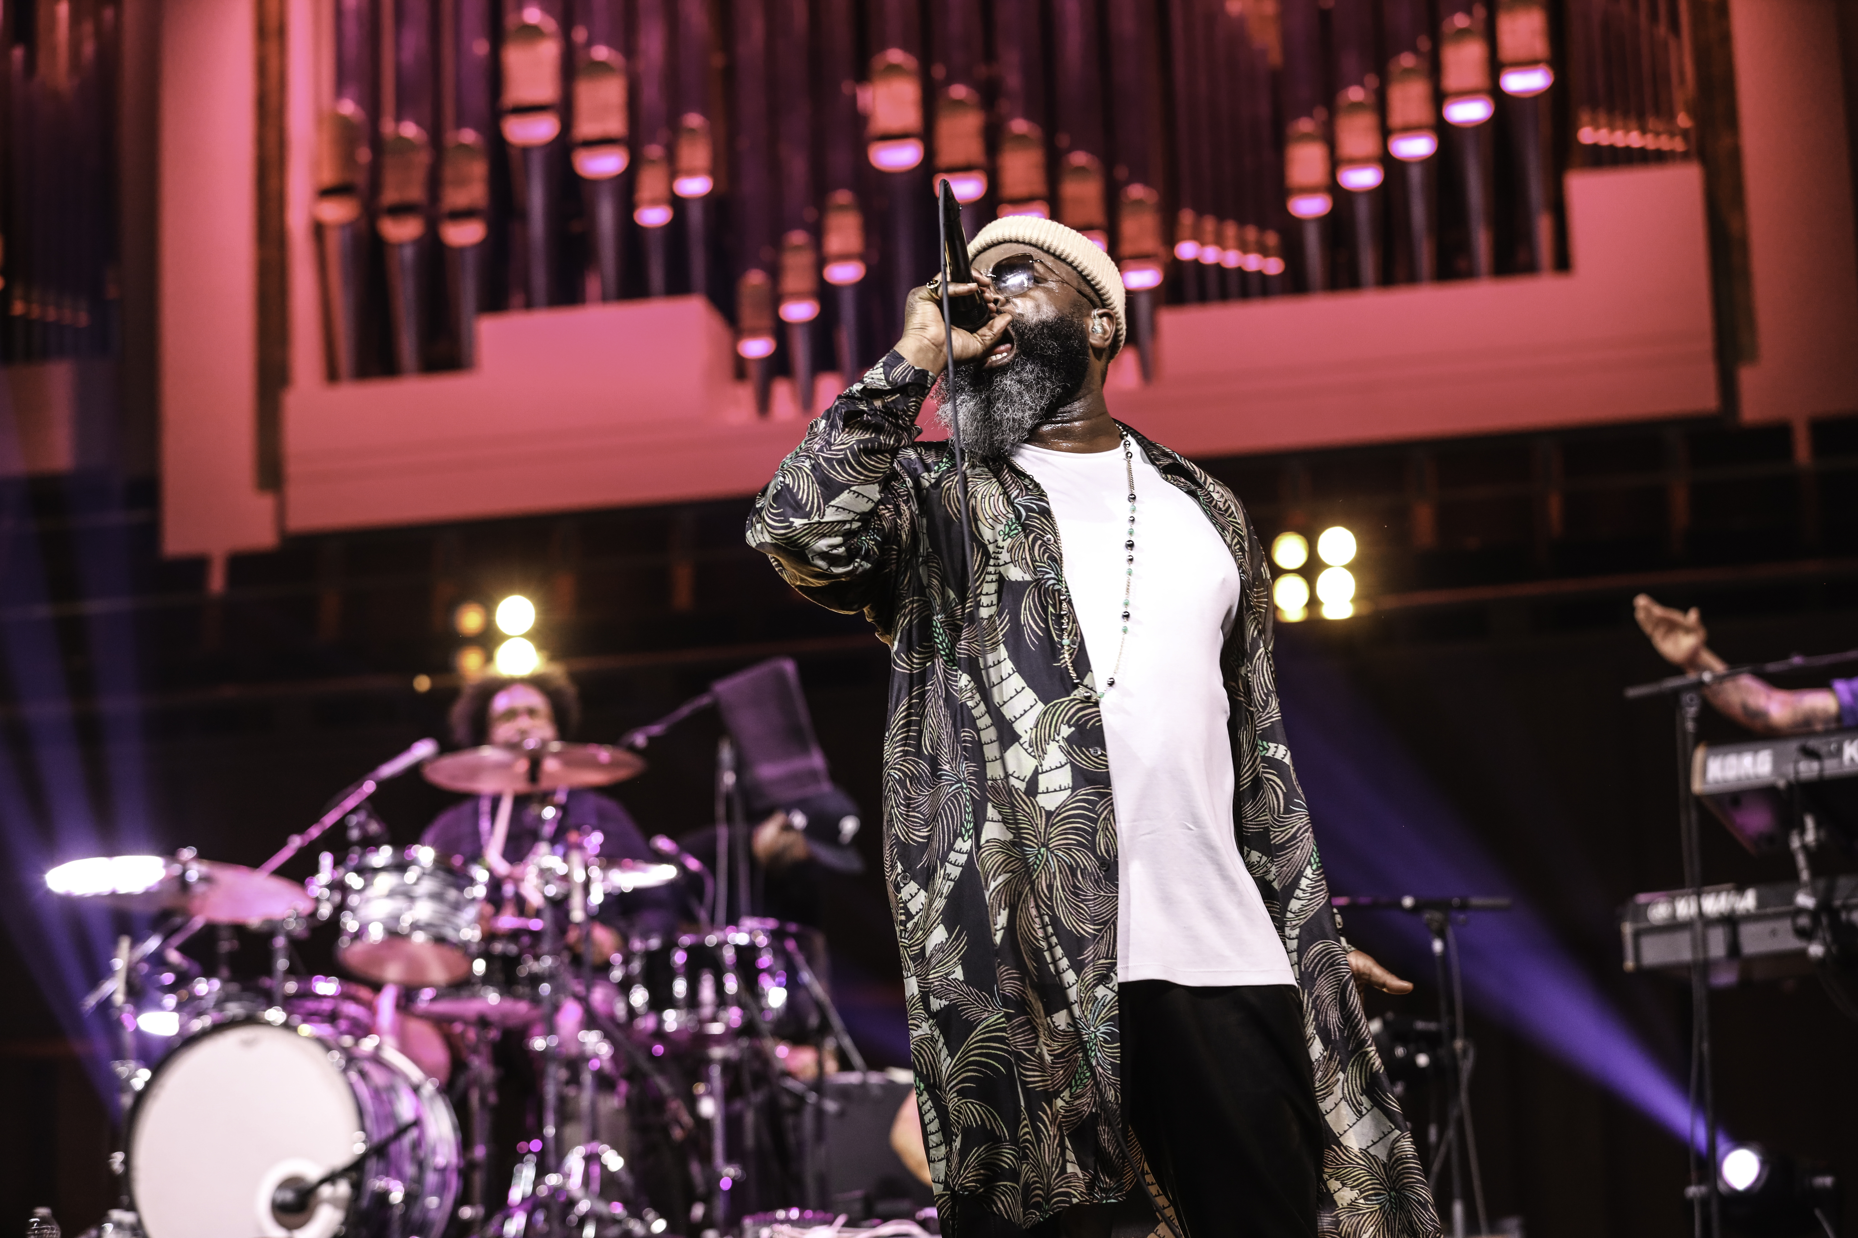
The Roots: Tariq “Black Thought” Trotter and Ahmir “Questlove” Thompson (Courtesy of The Kennedy Center)
ARLINGTON, VA, Nov. 1, 2022 – PBS today announced that the third episode of NEXT AT THE KENNEDY CENTER, a series from the pubcaster’s first multi-year collaboration with the John F. Kennedy Center for the Performing Arts, will feature the Grammy Award-winning hip hop group The Roots. Anchored by an unforgettable concert in the Kennedy Center’s Concert Hall, the special explores how The Roots continue to push the boundaries of their art form while using their platform as the inaugural artist-in-residence of the Center’s Hip Hop Culture Program to foster the next generation of cultural leaders. NEXT AT THE KENNEDY CENTER “The Roots Residency” premieres Friday, Jan. 27, 2023, at 9 p.m. ET (check local listings) on PBS, PBS.org, and the PBS Video app.

“For more than 50 years, PBS and the Kennedy Center have shared a joint mission to bring the best of the performing arts to the American public,” said Sylvia Bugg, chief programming executive and general manager of general audience programming at PBS. “NEXT AT THE KENNEDY CENTER showcases the richness of the nation’s stage, helping to contextualize the cultural impact of contemporary artists like The Roots who are not only extraordinary musicians but passionate community leaders. As the series continues, we look forward to sharing a diversity of genres and stories.”

Known for electrifying live performances that blend hip hop, jazz, rap, soul and funk, The Roots regularly sell out concert venues when they’re not serving as the house band for “The Tonight Show Starring Jimmy Fallon.” “The Roots Residency” takes music fans beyond the stage, coupling live concert footage with a look at the band's curatorial endeavors, masterclasses and humanitarian activities from their residency at the Kennedy Center. Respected cultural trailblazers, frontmen Ahmir “Questlove” Thompson and Tariq “Black Thought” Trotter are committed to inspiring and educating rising artists.

Viewers will meet EZY Truth, a Washington, D.C.-based hip hop artist and member of Black Thought’s “School of Thought,” a mentoring program for aspiring emcees. They’ll hear from Durrand Bernarr, an emerging R&B artist who participated in “The Road to the Roots Picnic,” a series of curated live performances that launched virtually during the pandemic. The episode also includes moments from “Music is History,” Questlove’s discussion with Reverend Al Sharpton about the drummer’s latest book, as well as Black Thought’s “Streams of Thought” conversation with photographer David Allen.
“The Roots have existed at the forefront of culture for over three decades. They are deeply committed to ensuring that generations of artists and communities see themselves powerfully reflected through their work and at venerable institutions like the Kennedy Center,” said Simone Eccleston, the Center’s director of hip hop culture and contemporary music. “‘The Roots Residency’ is a testament to their capacity to not only change the lives of individuals but also to transform institutions. The impact of our partnership is that we are forever changed as an organization. Through their residency, The Roots have created powerful platforms for the celebration of multihyphenates, cultural leaders and emerging artists. We hope that viewers experience their genius as performers, curators and cultural catalysts.”

NEXT AT THE KENNEDY CENTER, a new series of primetime performance specials, shines a spotlight on the Center’s contemporary culture program, bringing the best of the nation’s stage to viewers across the country. Captured to match the unique style of the artists, each episode of NEXT AT THE KENNEDY CENTER weaves together performances filmed live at the Kennedy Center with intimate off-stage moments and first-person commentary. The series premiere, “Let My Children Hear Mingus,” can be streamed on PBS.org and the PBS Video app. The second episode, “A Joni Mitchell Songbook,” premieres Friday, Nov. 18, at 9 p.m. ET (check local listings) and will be available to stream the same day.

NEXT AT THE KENNEDY CENTER is a production of the John F. Kennedy Center for the Performing Arts. Matthew Winer is the showrunner and executive producer for the Kennedy Center. Kristin Fosdick directs the series with her team in the Kennedy Center’s multimedia department. Elizabeth O’Neil is the associate director of content and strategy for PBS.

NEXT AT THE KENNEDY CENTER was made possible, in part, by The Rosalind P. Walter Foundation and by contributions from public television viewers.

About the Kennedy Center
The John F. Kennedy Center for the Performing Arts is America’s living memorial to President John F. Kennedy, attracting millions of visitors each year to more than 2,000 performances, events, and exhibits. With its artistic affiliates, the National Symphony Orchestra and Washington National Opera, the Center is one of the nation’s busiest performing arts centers dedicated to providing world-class art, powerful education, and outstanding memorial experiences to the broadest possible constituency. Across all its offerings, the Kennedy Center is committed to increasing accessible, inclusive opportunities for all people to participate in, and learn through the arts, including more than 400 free performances each year and a variety of specially priced ticket programs for students, seniors, persons with disabilities, and others. On Sept. 7, 2019, the Kennedy Center inaugurated the REACH, its first-ever major expansion. Designed by Steven Holl Associates, the REACH provides visitors with new opportunities to interact and engage with the Center as the nation’s premier nexus of arts, learning, and culture. On Sept. 8, 2022, the Kennedy Center unveiled Art and Ideals: President John F. Kennedy, a new 7,500-square-foot permanent exhibit exploring Kennedy’s presidency and his commitment to the arts.

About PBS
PBS, with more than 330 member stations, offers all Americans the opportunity to explore new ideas and new worlds through television and digital content. Each month, PBS reaches over 120 million people through television and 26 million people online, inviting them to experience the worlds of science, history, nature, and public affairs; to hear diverse viewpoints, and to take front-row seats to world-class drama and performances. PBS’s broad array of programs has been consistently honored by the industry’s most coveted award competitions. Teachers of children from pre-K through 12th grade turn to PBS for digital content and services that help bring classroom lessons to life. Decades of research confirm that PBS’s premier children’s media service, PBS KIDS, helps children build critical literacy, math, and social-emotional skills, enabling them to find success in school and life. Delivered through member stations, PBS KIDS offers high-quality educational content on TV – including a 24/7 channel, online at pbskids.org, via an array of mobile apps, and in communities across America. More information about PBS is available at pbs.org, one of the leading dot-org websites on the internet, or by following PBS on Twitter, Facebook, or through our apps for mobile and connected devices. Specific program information and updates for press are available at pbs.org/pressroom or by following PBS Communications on Twitter.

– PBS –

CONTACTS:

PJ Feinstein, PBS
pjfeinstein@pbs.org

Brendan Padgett, The John F. Kennedy Center for the Performing Arts
bepadgett@kennedy-center.org

Brandii Toby-Leon, Bullseye Communications
brandii.leon@bullseyecomm.com

For images and additional up-to-date information about the NEXT AT KENNEDY CENTER and other PBS programs, visit PBS PressRoom at pbs.org/pressroom.

