New PBS Performing Arts Series, NEXT AT THE KENNEDY CENTER “Continuum: Jason Moran & Christian McBride” Elevates and Upholds the Jazz Tradition

Music Icons’ Electrifying Performance at The Kennedy Center
Premieres on PBS, Friday, April 21, 10-11 p.m. ET

Screener and Images Available on PBS PressRoom
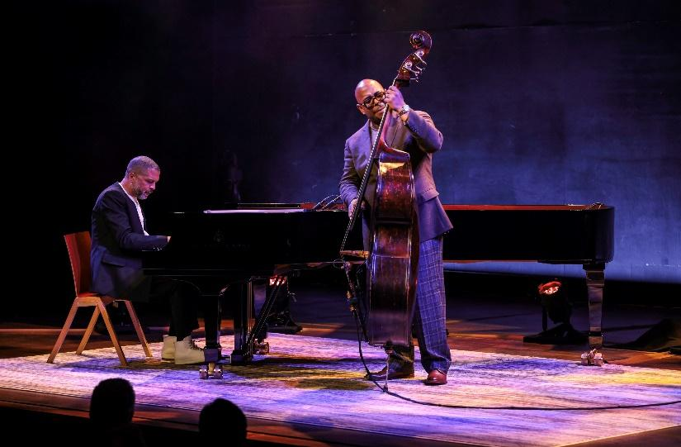
ARLINGTON, Va. – March X, 2023 – With six Grammys and a MacArthur Genius Award between them, pianist Jason Moran and bassist Christian McBride are two of the most sought-after artists alive. In a new PBS installment of NEXT AT THE KENNEDY CENTER, a series from PBS’s multi-year collaboration with the John F. Kennedy Center for the Performing Arts, these music icons are partnering together at The Kennedy Center for an electrifying performance elevating the jazz tradition. In the one-hour program, Moran and McBride will also share stories about their legendary teachers and introduce viewers to their remarkable protégés. NEXT AT THE KENNEDY CENTER “Continuum: Jason Moran & Christian McBride” premieres Friday, April 21 at 10-11 p.m. ET (check local listings) on PBS, PBS.org, and the PBS app.

Taking inspiration from America’s diverse artistic landscape, Moran and McBride’s collaboration is infused with a distinctive soul which illuminates their reverence of the past, and commitment to make every note feel relevant to modern times. These elements are felt through performances of music composed by legends Thelonious Monk, Wes Montgomery, Charles Mingus, Wayne Shorter, Geri Allen and Louis Armstrong.

Whether it’s taking inspiration from the text of Toni Morrison or their love of Hip Hop and Funk, in both their musical sensibilities and as ambassadors for the jazz community, they hold a deep appreciation for the entire tradition of Jazz - each as links in a chain dedicated to the preservation and evolution of America’s original musical art form. From a young age, each sought out their heroes to absorb knowledge, wisdom, and take lessons in temperament, collaboration, and musicianship. Moran and McBride have learned by the side of countless legends including Jaki Byard, Betty Carter, Geri Allen, and Freddie Hubbard. Lessons from these individuals informed how they approach their work, inspired their future roles as artistic ambassadors, and instilled a commitment to paying it forward by mentoring the next generation of jazz greats - ensuring the rich legacy of jazz is preserved and is given freedom for evolution.

While Moran’s role as artistic director of Betty Carter’s Jazz Ahead program at The Kennedy Center and McBride’s role as artistic director of Jazz House Kids in New Jersey are formal encapsulations of their leadership in the field, they continuously strive to identify and offer opportunities to the next generation of musicians who follow in their footsteps. In service of paying forward learnings from their mentors, Moran and McBride have taken emerging musicians Sequoia “REDWOOD” Snyder (piano) and Liany Mateo (bass) under their respective wings to offer opportunity and carry the torch. In this spirit, REDWOOD and Mateo perform and contextualize their places in this storied continuum. In the tradition of the Bill Evans/Eddie Gomez duets, The Moran/McBride Session focuses on a night of great music and the importance of America's musical legacy as it is passed from generation to generation.

NEXT AT THE KENNEDY CENTER, a new series of primetime performance specials, shines a spotlight on the Kennedy Center’s contemporary culture program, bringing the best of the nation’s stage to viewers across the country. Captured to match the unique style of the artists, each episode weaves together performances filmed live at the Kennedy Center with intimate off-stage moments and first-person commentary.

Previous installments of NEXT AT THE KENNEDY CENTER “Let My Children Hear Mingus,” “A Joni Mitchell Songbook” and “The Roots Residency” are currently available for streaming on PBS Passport. Upcoming episodes premiering on PBS (check local listings) include “Ballet Hispánico’s Doña Perón” (April 14 at 10 p.m. ET) and “Continuum: Jason Moran & Christian McBride” (April 21 at 10 p.m. ET).

NEXT AT THE KENNEDY CENTER is a production of the John F. Kennedy Center for the Performing Arts. Matthew Winer and Steve Holtzman serve as executive producers for the Kennedy Center. Kristin Fosdick directs the series with her team in the Kennedy Center’s multimedia department. Elizabeth O’Neil is the associate director of content and strategy for PBS.

NEXT AT THE KENNEDY CENTER was made possible, in part, by The Rosalind P. Walter Foundation and by contributions from public television viewers.

About the Kennedy Center
The John F. Kennedy Center for the Performing Arts is America’s living memorial to President John F. Kennedy, attracting millions of visitors each year to more than 2,000 performances, events, and exhibits. With its artistic affiliates, the National Symphony Orchestra and Washington National Opera, the Center is one of the nation’s busiest performing arts centers dedicated to providing world-class art, powerful education, and outstanding memorial experiences to the broadest possible constituency. Across all its offerings, the Kennedy Center is committed to increasing accessible, inclusive opportunities for all people to participate in, and learn through the arts, including more than 400 free performances each year and a variety of specially priced ticket programs for students, seniors, persons with disabilities, and others. On Sept. 7, 2019, the Kennedy Center inaugurated the REACH, its first-ever major expansion. Designed by Steven Holl Associates, the REACH provides visitors with new opportunities to interact and engage with the Center as the nation’s premier nexus of arts, learning, and culture. On Sept. 8, 2022, the Kennedy Center unveiled Art and Ideals: President John F. Kennedy, a new 7,500-square-foot permanent exhibit exploring Kennedy’s presidency and his commitment to the arts.

About PBS
PBS, with more than 330 member stations, offers all Americans the opportunity to explore new ideas and new worlds through television and digital content. Each month, PBS reaches over 120 million people through television and 26 million people online, inviting them to experience the worlds of science, history, nature, and public affairs; to hear diverse viewpoints, and to take front-row seats to world-class drama and performances. PBS’s broad array of programs has been consistently honored by the industry’s most coveted award competitions. Teachers of children from pre-K through 12th grade turn to PBS for digital content and services that help bring classroom lessons to life. Decades of research confirm that PBS’s premier children’s media service, PBS KIDS, helps children build critical literacy, math, and social-emotional skills, enabling them to find success in school and life. Delivered through member stations, PBS KIDS offers high-quality educational content on TV – including a 24/7 channel, online at pbskids.org, via an array of mobile apps, and in communities across America. More information about PBS is available at pbs.org, one of the leading dot-org websites on the internet, or by following PBS on Twitter, Facebook, or through our apps for mobile and connected devices. Specific program information and updates for press are available at pbs.org/pressroom or by following PBS Communications on Twitter.

– PBS –

PHOTO CAPTION: Pianist Jason Moran and Bassist Christian McBride perform on stage at The Kennedy Center in Washington, D.C. as captured in the PBS and John F. Kennedy Center for the Performing Arts’ program, NEXT AT THE KENNEDY CENTER “Continuum: Jason Moran & Christian McBride.” (Photo Courtesy: Jati Lindsay)

EDITORIAL NOTE: For images and additional up-to-date information about the NEXT AT KENNEDY CENTER and other PBS programs, visit PBS PressRoom at pbs.org/pressroom. Executives and talent from PBS and the John F. Kennedy Center for the Performing Arts are also available for interviews upon request.

MEDIA CONTACTS:

PBS
Meredith Wohl, mawohl@pbs.org
Brandii Toby-Leon, brandii.leon@bullseyecomm.com

The John F. Kennedy Center for the Performing Arts
Brendan Padgett, bepadgett@kennedy-center.org

