CYNTHIA ERIVO CELEBRATES THE NEW YEAR IN SONG
WITH NEXT AT THE KENNEDY CENTER
“CYNTHIA ERIVO & FRIENDS: A NEW YEAR’S EVE CELEBRATION”

Featuring Multi-Hyphenate Artists Ben Platt and Joaquina Kalukango

Premiering Sunday, Dec. 31 on PBS and Streaming on PBS.org, and the PBS App

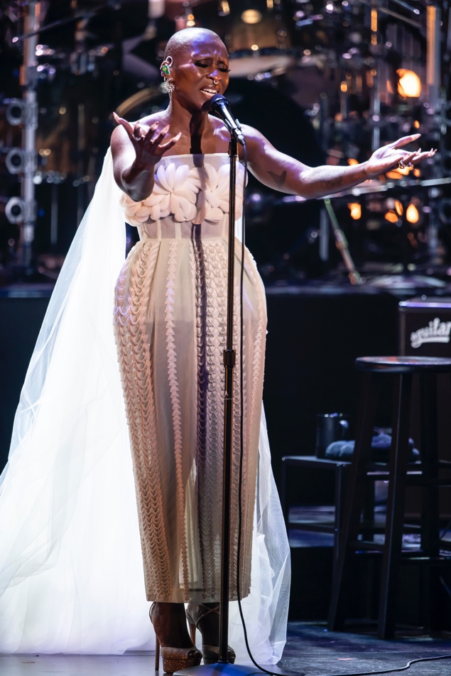
ARLINGTON, Va. – Dec. 18, 2023 — This New Year’s Eve, join enchanting star of the stage and screen, Cynthia Erivo, for a musical celebration that hits all the right notes. Since bursting onto the scene in her breakthrough role in “The Color Purple,” which earned her a Tony as well as an Emmy and Grammy, Erivo continues to prove herself as a force to be reckoned with, captivating audiences with her powerhouse performances and musical prowess. The evening features a collection of deeply personal songs that helped to shape Erivo’s career and artistic sensibility and span a wide range of genres, from showtunes to hip-hop. Joining Oscar-nominated Erivo are Tony, Grammy, and Emmy Award–winning actor and recording artist, Ben Platt (Parade, Dear Evan Hansen), and Tony, Drama Desk Award, and Outer Critics Circle Award winner, Joaquina Kalukango (Paradise Square, Slave Play), in a joyous celebration perfect for ringing in the New Year, under the direction of Emmy-Award Winning music director and producer Rickey Minor. NEXT AT THE KENNEDY CENTER “Cynthia Erivo & Friends: A New Year’s Eve Celebration” premieres Sunday, Dec. 31 at 8-9 p.m. ET on PBS (check local listings), PBS.org, and the PBS App.

Throughout the concert special, Erivo takes the audience on a musical journey through a diverse repertoire which traverses various genres, including Broadway, Motown, Soul, Rock, Folk, Blues, and R&B, and shares her personal reflections and stories behind the music. Throughout the evening, friends Platt and Kalukango join her, bringing their powerful voices and favorite songs to the Kennedy Center stage. In a dynamic showcase of the breadth and range of Erivo’s artistry, viewers will be treated to a celebration of music in its purest form in an uplifting performance that will leave audiences inspired and ready to embrace the possibilities of the year ahead.
Cynthia Erivo during the special.
Photo courtesy of Scott Suchman.

Cythia Erivo has taken the world by storm since bursting onto the West End and Broadway stages in “The Color Purple.” An actress, singer, author, and producer, Erivo has received worldwide critical acclaim for her work, including Grammy, Emmy, and Tony Awards as well as Academy Award, Golden Globe, and SAG nominations.

Erivo has starred in “Harriet”, “Genius: Aretha,” “Luther: The Fallen Sun,” and is set to star as Elphaba in the upcoming John M. Chu film adaptation of the hit musical “WICKED.” Erivo also starred in, executive produced, and co-wrote and sang a feature song for her upcoming film “Drift,” which premiered at the 2023 Sundance Film Festival and will be released this February.

NEXT AT THE KENNEDY CENTER, in its second season of primetime performance specials, shines a spotlight on the Kennedy Center’s contemporary culture program, bringing the best of the nation’s stage to viewers across the country. Captured to match the unique style of the artists, each episode weaves together performances filmed live at the Kennedy Center with intimate off-stage moments and first-person commentary.

NEXT AT THE KENNEDY CENTER will be available to stream on all station-branded PBS platforms, including PBS.org and the PBS App, available on iOS, Android, Roku, Apple TV, Amazon Fire TV, Android TV, Samsung Smart TV, Chromecast and VIZIO.

Previous installments of NEXT AT THE KENNEDY CENTER are currently available for streaming with PBS Passport including: “Let My Children Hear Mingus”, “A Joni Mitchell Songbook”, “The Roots Residency,” “Ballet Hispánico’s Doña Perón,”“Continuum: Jason Moran & Christian McBride, “Robert Glasper’s Black Radio”, and “Embracing Duality: Modern Indigenous Culture.”

NEXT AT THE KENNEDY CENTER is a production of the John F. Kennedy Center for the Performing Arts. Matthew Winer, Steve Holtzman and Kristin Fosdick serve as executive producers for the Kennedy Center. Christopher John Farley is the executive in charge for PBS.

For more information on NEXT AT THE KENNEDY CENTER, including clips and episode previews, visit www.pbs.org. Viewers are also encouraged to engage in online conversation about the series by tagging @PBS and using #KenCenNextPBS on Facebook, Twitter and Instagram.

About the Kennedy Center
The John F. Kennedy Center for the Performing Arts is America’s living memorial to President John F. Kennedy, attracting millions of visitors each year to more than 2,000 performances, events, and exhibits. With its artistic affiliates, the National Symphony Orchestra and Washington National Opera, the Center is one of the nation’s busiest performing arts centers dedicated to providing world-class art, powerful education, and outstanding memorial experiences to the broadest possible constituency. Across all its offerings, the Kennedy Center is committed to increasing accessible, inclusive opportunities for all people to participate in, and learn through the arts, including more than 400 free performances each year and a variety of specially priced ticket programs for students, seniors, persons with disabilities, and others. On Sept. 7, 2019, the Kennedy Center inaugurated the REACH, its first-ever major expansion. Designed by Steven Holl Associates, the REACH provides visitors with new opportunities to interact and engage with the Center as the nation’s premier nexus of arts, learning, and culture. On Sept. 8, 2022, the Kennedy Center unveiled Art and Ideals: President John F. Kennedy, a new 7,500-square-foot permanent exhibit exploring Kennedy’s presidency and his commitment to the arts.

About PBS
PBS, with more than 330 member stations, offers all Americans the opportunity to explore new ideas and new worlds through television and digital content. Each month, PBS reaches over 42 million adults on linear primetime television, more than 15 million users on PBS-owned streaming platforms, and 56 million people view PBS content on social media, inviting them to experience the worlds of science, history, nature, and public affairs; to hear diverse viewpoints; and to take front-row seats to world-class drama and performances. PBS’s broad array of programs has been consistently honored by the industry’s most coveted award competitions. Teachers of children from pre-K through 12th grade turn to PBS LearningMedia for digital content and services that help bring classroom lessons to life. As the number one educational media brand, PBS KIDS helps children 2-8 build critical skills, enabling them to find success in school and life. Delivered through member stations, PBS KIDS offers high-quality content on TV — including a PBS KIDS channel — and streaming free on pbskids.org and the PBS KIDS Video app, games on the PBS KIDS Games app, and in communities across America. More information about PBS is available at PBS.org, one of the leading dot-org websites on the internet, Facebook, Instagram, or through our apps for mobile and connected devices. Specific program information and updates for press are available at pbs.org/pressroom or by following PBS Communications on Twitter.

– PBS –

EDITORIAL NOTE: For images and additional up-to-date information about the NEXT AT KENNEDY CENTER and other PBS programs, visit PBS PressRoom at pressroom.pbs.org. Executives and talent from PBS and the John F. Kennedy Center for the Performing Arts are also available for interviews upon request.

MEDIA CONTACTS:

PBS
Meredith Wohl, mawohl@pbs.org
Brandii Toby-Leon, brandii.leon@bullseyecomm.com

The John F. Kennedy Center for the Performing Arts
Campbell Slavin, CJSlavin@kennedy-center.org

