Biographical Notes - TOM JONES

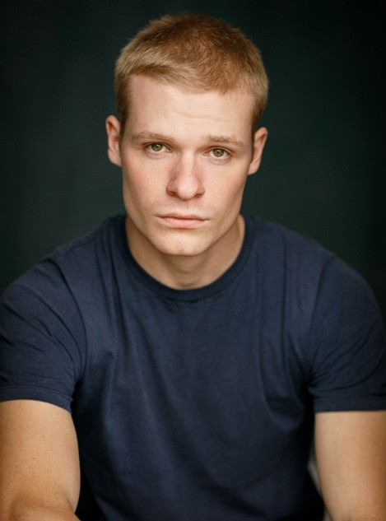
Solly McLeod
Tom Jones, Tom Jones
Solly McLeod is currently filming a starring role in
The Dead Don’t Hurt, alongside Viggo Mortensen, who is directing and starring. He most recently wrapped on the indie film Jericho Ridge alongside Nikki Amuka-Bird, Michael Socha and Zack Morris, directed by BAFTA Award winner Will Gilbey. Solly played a principal role in
the high-profile HBO fantasy series House of the Dragon alongside Matt Smith, Paddy Considine and Olivia Cooke. Before that he played the lead role in Sky Studios’ new supernatural thriller The Rising alongside Clara Rugaard.
Written by Peter McTighe and based on the Belgian series Hotel Beau Séjour, The Rising was chosen for the 2022 Berlin International Film Festival (Berlinale) as an official festival selection for their TV strand. Solly can be seen in Aml Ameen’s directorial debut film Boxing Day starring Aja Naomi King, Leigh-Anne Pinnock and Marianne Jean-Baptiste. He will soon be seen playing a guest role in an episode of Starz’s Outlander.

Sophie Wilde
Sophia Western, Tom Jones
Sophie hails from Australia and graduated from NIDA in 2019. She immediately made her stage debut at The Sydney Opera House playing the role of Ophelia in Bell Shakespeare’s Hamlet. She then went on to book the lead in Eden, an eight-part series directed by John Curran and Mirrah Foulkes for the Australian streaming service Stan. Her domestic success and flawless U.K. accents afforded her the opportunity to work in the U.K., quickly booking the lead in the BBC drama You Don’t Know Me opposite Samuel Adewunmi and the
female lead in Tom Jones. Her films include The Portable Door for the Henson company and Talk to Me for Causeway Films. She has recently wrapped playing the lead role in The F**k It Bucket for Netflix, written by Ripley Parker, and is now shooting Boy Swallows Universe, also for Netflix.

– more –

Winter 2023 TCA Biographies, Page 2

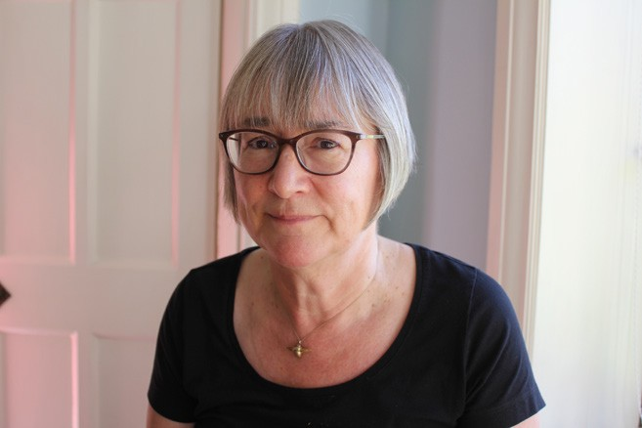
Gwyneth Hughes
Writer, Executive Producer, Tom Jones
Gwyneth Hughes was born in London, the daughter of a police constable from North Wales, and a hospital clerk from the East End. She graduated in Russian at Sussex University, before moving to the north of England to train as a newspaper reporter on the Sheffield Morning Telegraph. Gwyn’s first job in television was on the Yorkshire Television regional news desk; from there she became a BAFTA-
nominated documentary director, specializing in history and true crime. She began her move from factual programmes into drama, writing episodes of The Bill and Silent Witness. Her original thriller miniseries Five Days and her Tippi Hedren biopic The Girl were both nominated for the BAFTA and Golden Globes®. Her classic dramatizations include The Mystery of Edwin Drood, Vanity Fair, and Miss Austen Regrets. Gwyn is currently writing about the most widespread miscarriage of justice in British history, affecting the lives of hundreds of village postmasters. She lives with her husband near Skipton in North Yorkshire.

James Gandhi
Executive Producer, Tom Jones
James Gandhi is an Executive Producer at Mammoth Screen. In addition to Tom Jones, he has worked on the upcoming Noughts + Crosses 2 for the BBC, and is developing a range of projects. He previously worked at Studio Lambert as Head of Scripted Development, where he developed a slate with a variety of writers. Prior to Studio Lambert, James script edited several shows, including The City & the City for the BBC, and Fearless and Vanity Fair for ITV.

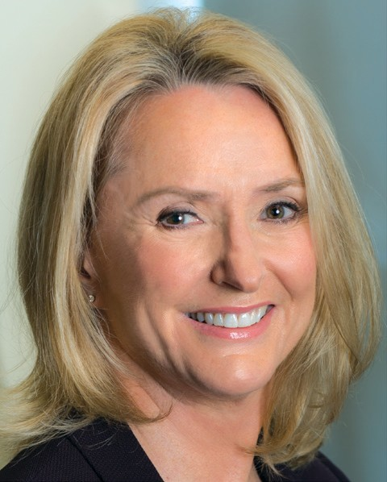
Susanne Simpson
Executive Producer, MASTERPIECE
As executive producer of MASTERPIECE, the iconic PBS drama series,
Susanne Simpson commissions original U.K. productions, including the
upcoming Tom Jones with Hannah Waddingham, and Moonflower Murders, written by Anthony Horowitz and starring Lesley Manville. Simpson
coproduces many U.K. programs such as All Creatures Great and Small, Around the World in 80 Days, and the long-running detective series
Endeavour and Unforgotten. She is currently developing Miss Austen,
adapted by Andrea Gibb for Bonnie Productions, as well as other series. Simpson is a two-time Academy Award® nominee and two-time Emmy®-
winner for documentary and dramatic films. As an executive producer of Downton Abbey,
Simpson was in charge of all aspects of the U.S. broadcast of the most watched drama in PBS history and recipient of 59 Emmy® nominations and 12 wins. She also oversaw co-productions such as Sherlock, Wolf Hall, and Victoria. She is a member of the Academy of Motion Pictures Arts & Sciences, the Television Academy, and a lifetime member of WGA, East. Simpson is the executive producer of MASTERPIECE Studio, a podcast with more than 22 million downloads since 2016.

– more –

Winter 2023 TCA Biographies, Page 3

pbs.org/masterpiece MASTERPIECE Press Contacts
Ellen Dockser, 617-300-5338, ellen_dockser@wgbh.org
Laura Garvey, 617-300-5342, laura_garvey@wgbh.org
About MASTERPIECE
Winner of 83 Primetime Emmys® and 18 Peabody Awards, MASTERPIECE has been essential Sunday night viewing for millions of fans since 1971. Susanne Simpson is the executive producer and Rebecca Eaton is the executive producer-at-large for the series. Funding for MASTERPIECE is provided by Viking and Raymond James with additional support from public television viewers and contributors to The MASTERPIECE Trust. Produced for PBS by GBH Boston, MASTERPIECE is known for hits such as All Creatures Great and Small, Sherlock, Downton Abbey and Victoria, and beloved classics such as Upstairs Downstairs, Prime Suspect, The Forsyte Saga and Poldark.

FUNDING FOR MASTERPIECE PROVIDED BY

