Ring in the Holidays With
MARY BERRY’S HIGHLAND CHRISTMAS
Premiering Monday, December 18 on PBS and
Streaming on PBS.org and the PBS App

Join The Beloved Home Cook In Her Mother’s Homeland, Scotland,
As She Prepares Favorite Christmas Dishes with Scottish Friends
Andy Murray, Iain Stirling, and Emeli Sandé

ARLINGTON, VA – In her latest holiday special, Dame Mary Berry travels to her mother’s homeland, Scotland, for a magical winter adventure. Inspired by her own family holidays, Mary cooks up an array of sumptuous dishes, joined by three special friends: former world number one tennis player and US Open champion Andy Murray; BAFTA Award-winning comedian, writer and Love Island narrator Iain Stirling; and singer/songwriter Emeli Sandé. Together they’ll share stories, memories and indulgent Christmas dishes that can be enjoyed anytime during the holidays. MARY BERRY’S HIGHLAND CHRISTMAS premieres Monday, December 18, 2023, 9:00-10:00 pm ET (check local listings) on PBS, PBS.org and the PBS App.
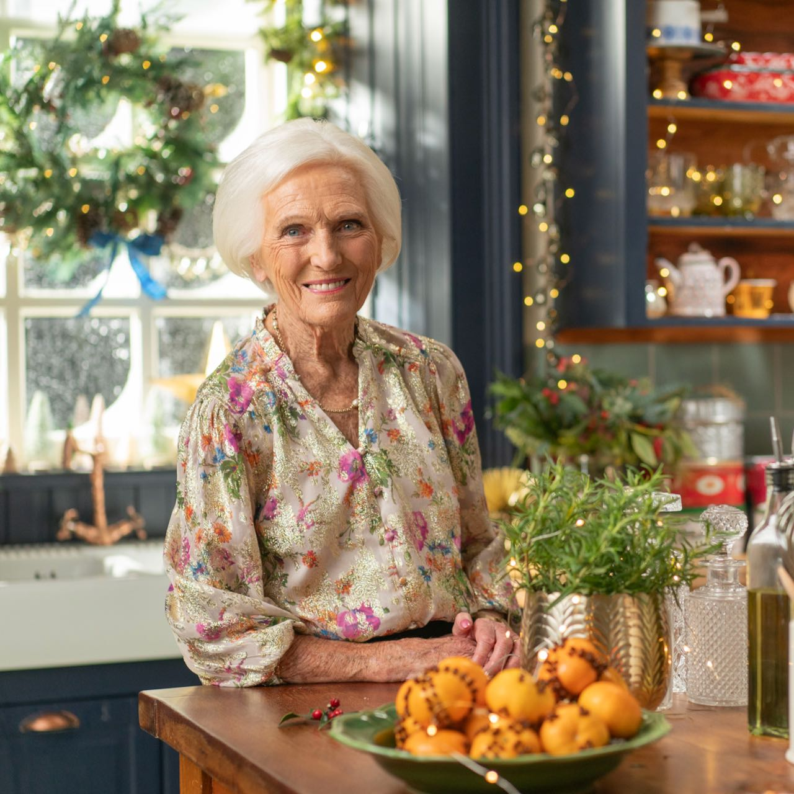
Credit: Mark Mainz.

“I’ve always been incredibly proud of my Scottish heritage, so where better to get cozy and cook for the holidays than in the Scottish Highlands,” says Dame Mary. This new special finds Mary preparing favorite holiday dishes, many of which are inspired by her family’s roots in Scotland. On the menu is a spectacular Christmas Cranachan Pavlova Wreath, combining the traditional Scottish dessert made from oats, fruit and cream with a pavlova twist. And during a visit to tennis legend Andy Murray’s hotel in Dunblane, Mary, Andy and his grandmother cook up the classic breakfast dish Kedgeree.

The holidays are meant for entertaining and Mary shares her festive Smoked Salmon and Guacamole canape recipe, followed by a Fennel and Onion Tarte Tatin. Iain Stirling attempts to herd some reindeer while Mary rustles up an indulgent Christmas fondue with a surprising twist.

Mary shares her iconic ‘Highland Beef Pie,’ made with Aberdeen Angus beef and pickled walnuts, and then it’s off to a traditional Scottish celebration known as a ceilidh, where she makes her classic mulled wine for the revelers. Aberdeenshire-raised singer Emeli Sandé pops in to help Mary make her classic Bûche du Noël before surprising her with some special visitors — a choir of carolers performing outside the cottage in the snow. It’s the perfect end to a delightful Scottish holiday with the Queen of British cookery.

Dame Mary Berry is the author of over 70 books, including the bestselling Mary Berry Cooks, Mary Berry's Absolute Favorites, Mary Berry At Home, and Mary Berry's Baking Bible. She was the much-loved judge on the BBC's The Great British Bake Off (which aired for five seasons on PBS as The Great British Baking Show) and has been teaching the world to cook for over four decades. Following her training at the Cordon Bleu in Paris, Mary began her career as a magazine cookery editor before publishing her first cookbook in 1966. In 2009, Mary was awarded the highly coveted Guild of Food Writers Lifetime Achievement Award and in 2012 she was made a CBE (Commander of the Order of the British Empire) in the Queen's Birthday Honours list.

MARY BERRY’S HIGHLAND CHRISTMAS will be available to stream on all station-branded PBS platforms, including PBS.org and the PBS App, available on iOS, Android, Roku, Apple TV, Amazon Fire TV, Android TV, Samsung Smart TV, Chromecast and VIZIO.

MARY BERRY’S HIGHLAND CHRISTMAS is a 1x60’ series for PBS and BBC One, produced by Rumpus Media and commissioned by Catherine Catton, Head of Commissioning, Factual Entertainment and Events. The Commissioning Editor is Ricky Cooper. The Director is Katy Fryer and the Executive Producers are Emily Hudd and Kelly Sparks for Rumpus Media. Zara Frankel is the Executive in Charge for PBS.

About PBS
PBS, with more than 330 member stations, offers all Americans the opportunity to explore new ideas and new worlds through television and digital content. Each month, PBS reaches over 42 million adults on linear primetime television, more than 15 million users on PBS-owned streaming platforms, and 56 million people view PBS content on social media, inviting them to experience the worlds of science, history, nature, and public affairs; to hear diverse viewpoints; and to take front-row seats to world-class drama and performances. PBS’s broad array of programs has been consistently honored by the industry’s most coveted award competitions. Teachers of children from pre-K through 12th grade turn to PBS LearningMedia for digital content and services that help bring classroom lessons to life. As the number one educational media brand, PBS KIDS helps children 2-8 build critical skills, enabling them to find success in school and life. Delivered through member stations, PBS KIDS offers high-quality content on TV — including a PBS KIDS channel — and streaming free on pbskids.org and the PBS KIDS Video app, games on the PBS KIDS Games app, and in communities across America. More information about PBS is available at PBS.org, one of the leading dot-org websites on the internet, Facebook, Instagram, or through our apps for mobile and connected devices. Specific program information and updates for press are available at pbs.org/pressroom or by following PBS Communications on Twitter.

– PBS –

CONTACTS:

Atiya Frederick, PBS, anfrederick@pbs.org

Cara White / Mary Lugo, CaraMar, Inc.
cara.white@mac.com; lugo@negia.net

For images and additional up-to-date information on this and other PBS programs, visit PBS PressRoom at pbs.org/pressroom.

