Escape to Versailles With
MARIE ANTOINETTE
Premiering March 19 on PBS

The captivating new series about one of history’s most influential rulers launches across all PBS platforms this spring

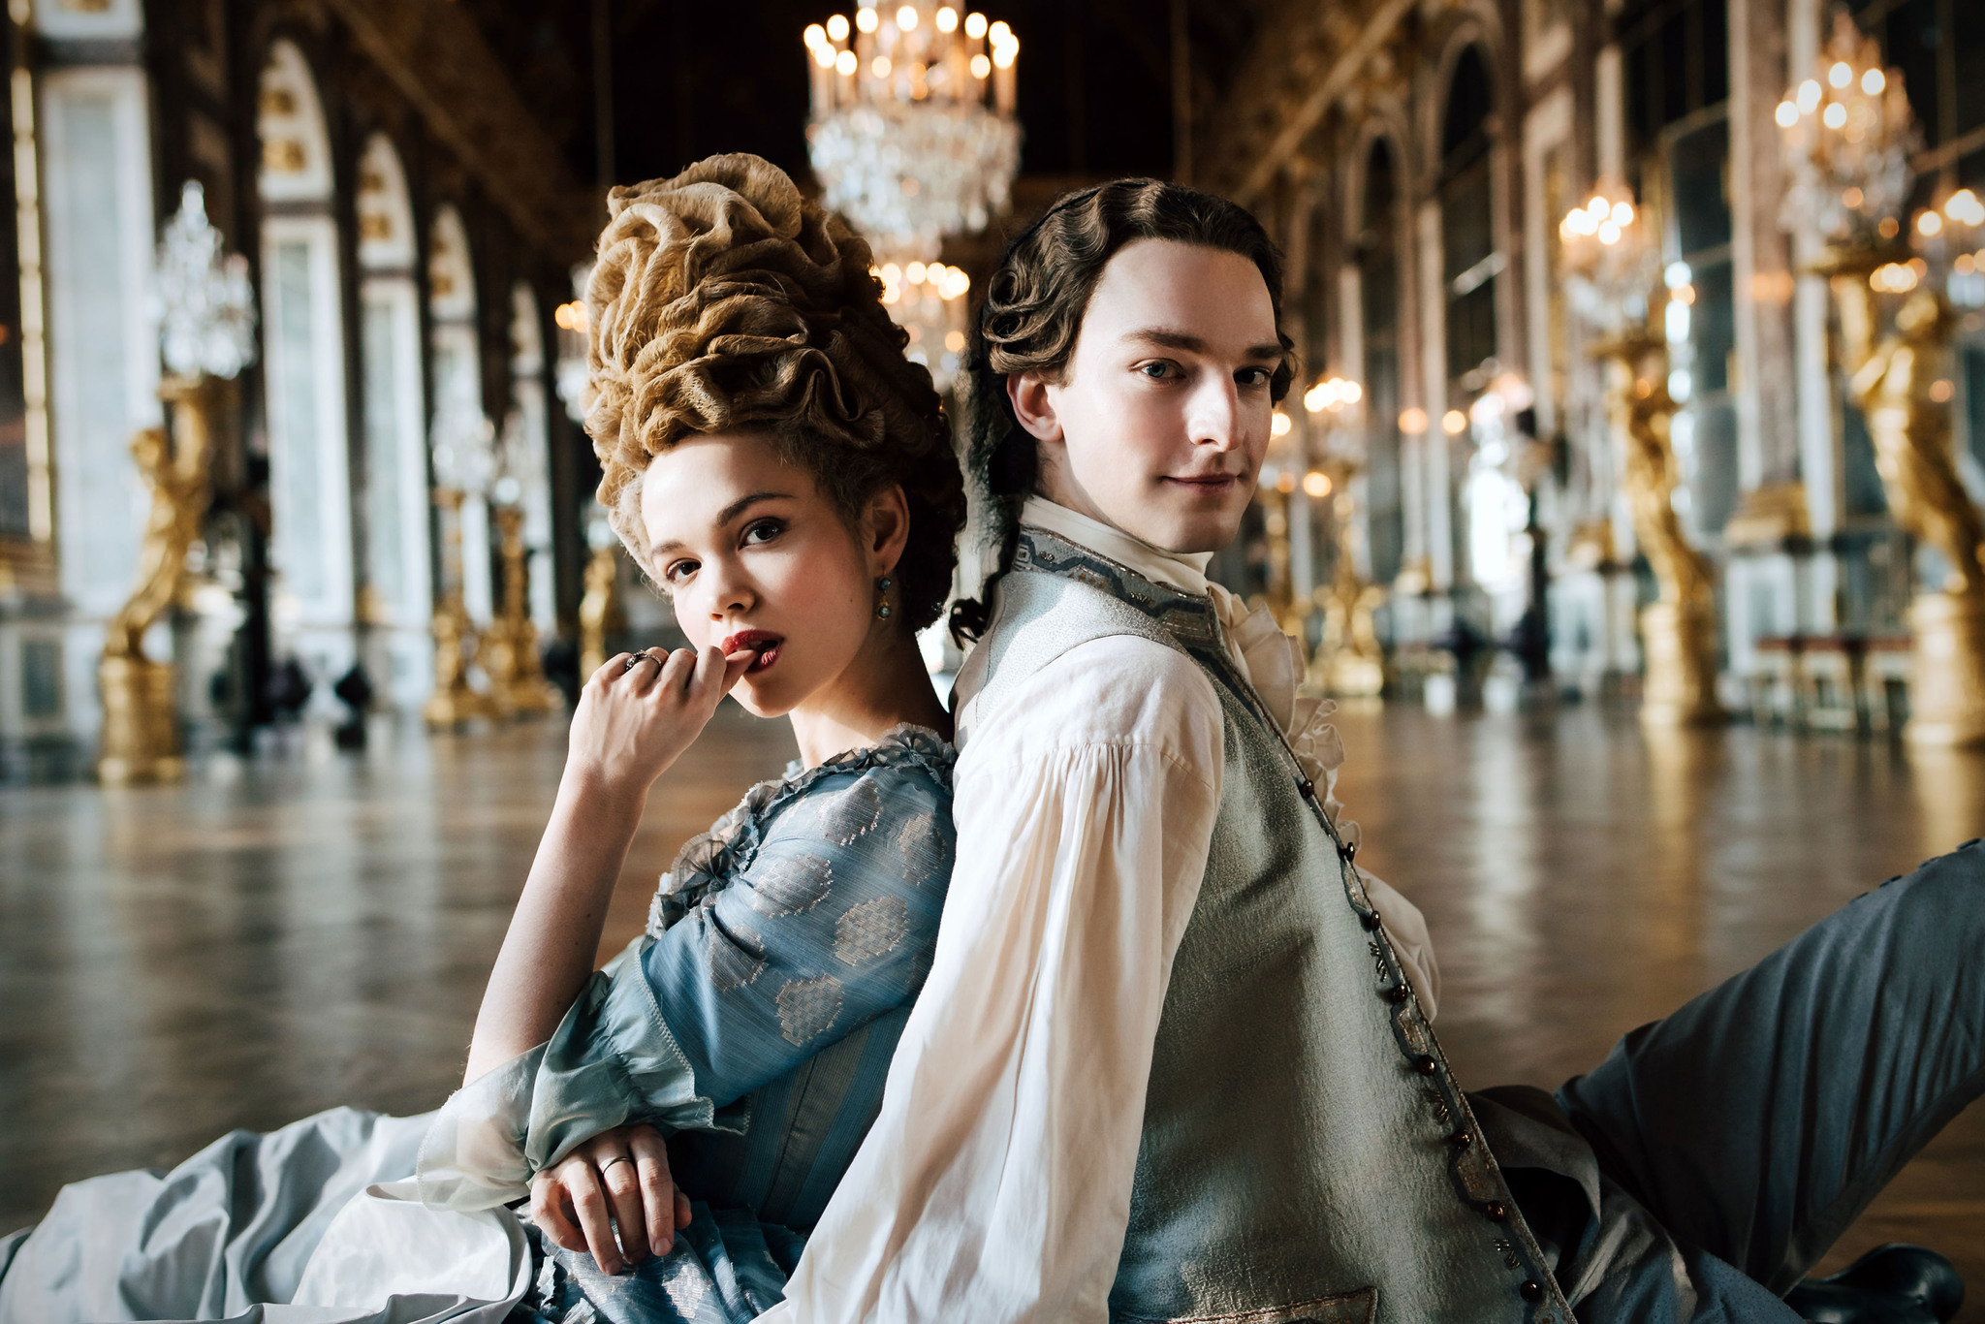
Caption: Marie Antoinette (Emilia Schüle) and Louis XVI (Louis Cunningham)
Credit: © Caroline Dubois – CAPA Drama / Banijay Studios France / Les Gens / Canal +

LOS ANGELES, January 12, 2023 – This March, the period drama series MARIE ANTOINETTE, which chronicles the infamous historical figure’s beginnings from a young dauphine to the last queen of France, will launch on all PBS platforms. The new series follows a young Marie Antoinette as she learns the rules and secrets of the court and attempts to recreate Versailles in her image: free, independent and feminist. But her successes provokes jealousy and rivalry, and her royal enemies will do everything they can to bring her down. The eight-episode series stars Emilia Schüle (“Berlin Dance School”) as the title character, with Louis Cunningham (“Bridgerton”) as the dauphin of France, Louis XVI.

MARIE ANTOINETTE premieres Sunday, March 19, 10-11 p.m. ET on PBS (check local listings) and will be available to stream on all station-branded PBS platforms including PBS.org, the PBS App, available on iOS, Android, Roku streaming devices, Apple TV, Android TV, Amazon Fire TV, Samsung Smart TV, Chromecast and VIZIO. MARIE ANTOINETTE will also be available to stream on PBS Passport and the PBS MASTERPIECE Prime Video Channel.

MARIE ANTOINETTE is just a teenager when she leaves Austria to marry the dauphin of France. When she arrives at Versailles, she must obey the numerous and complex rules of the French court. The princess quickly suffers from not being able to live her life the way she wants, while her mother, the empress of Austria (Marthe Keller, “Marathon Man”), keeps pushing her to continue the Bourbon line and thus secure the alliance between the two countries. However, faced with Louis’ avoidant and solitary character, the mission turns out to be more complicated than expected. As defamatory pamphlets and persistent rumors about her private life undermine her status, her opponents within the royal family will do everything they can to bring her down.

Rounding out the ensemble cast are Gaia Weiss (“Vikings”), James Purefoy (“Rome”), Jack Archer (“Call the Midwife”), Jasmine Backborow (“Shadow and Bone”), Oscar Lesage (“Dangerous Liaisons”), Crystal Shepherd-Cross (“Chronicles of the Sun”), Roxane Duran (“Mrs. Harris Goes to Paris”), Caroline Piette (“Beats Per Minute”) and others.

Offering a rare glimpse into how the young princess turned into one of history’s most iconic leaders, MARIE ANTOINETTE, delivers breathtaking costumes and set design that take viewers to the Palace of Versailles at the height of the “ancien régime.”

Episode One: “The Slap”
Marie Antoinetee is just a teenager when she’s forced to leave Austria to marry the dauphin. She must produce a Bourbon heir to secure the alliance between France and Austria. But she’s as unprepared for her job as her awkward teenage husband. How will this free spirit react to Versailles with its ridiculous rules of etiquette?

Episode Two: “Rival Queens”
When Louis refuses to share his bed with her, Marie Antoinette realizes that producing an heir will not be straightforward. She turns to Madame du Barry for support. But the favorite begins to see the dauphine as a rival for the king’s affections. There can’t be two queens at Versailles, and du Barry isn’t about to disappear.

Episode Three: “Pick a Princess”
The royal family goes on holiday at Fontainebleau to escape stifling Versailles. Marie Antointette discovers du Barry’s plan to welcome Provence’s betrothed. Will the spare to the French throne deliver a son before she and Louis perform their duty? Marie Antoinette’s escalating hostilities with du Barry threaten her relationship with the king.

Episode Four: “Queen of France”
Marie Antoinette and Louis are about to make their first official visit to Paris. But when the king becomes seriously ill, the succession suddenly becomes a reality. Du Barry knows that if she doesn’t protect herself from the future queen of France, her time at Versailles will be over.

Episode Five: “Rebel Queen”
Louis may now be king, but Marie Antoinette is determined to launch her reign as the queen of France. First steps: organize a glittering Inauguration Ball and convince Louis to choose her pro-Austrian candidate as his new prime minister. But their marriage hits the rocks when Louis isn’t prepared to let his Austrian wife dabble in French politics.

Episode Six: “Deus Ex Machina”
Surprisingly, the person who comes to Versailles to save the royal marriage is Marie Antoinette’s brother, Joseph, who realizes he will have his work cut out if he’s going to unite this estranged couple. Time is running out to save the Franco-Austrian alliance.

Episode Seven: “The Ostrich Bitch”
Marie Antoinette is pregnant at last! But her reputation is attacked when pornographic pamphlets challenging the legitimacy of her unborn child appear at Versailles. Louis locks down the château and demands a full-blown investigation to nail the seditious traitors.

Episode Eight: “Queen of Hearts”
Louis becomes increasingly confident in his position as king as he throws himself into supporting the American War of Independence. Meanwhile, Marie Antoinette embraces life at the Petit Trianon where she becomes enamored by a familiar face—Count Axel von Fersen.

MARIE ANTOINETTE was created and written by Deborah Davis (“The Favourite”) and directed by Pete Travis (episodes 1-4) and Geoffrey Enthoven (episodes 5-8). The series is a CANAL+ Creation Originale in association with CAPA Drama, Banijay Studios France and Les Gens. MARIE ANTOINETTE is executive produced by Claude Chelli, Stéphanie Chartreux, Margaux Balsan and Deborah Davis. Banijay Rights handles international distribution for Marie Antoinette and secured the agreement with PBS Distribution for the series.
About Banijay Studios France (A Banijay Company) (Translation)
Banijay Studios France relies on a team of renowned producers who develop and produce content for French and international audiences. The company has built up a reputation over the years thanks to major brands such as Versailles (Canal+), Mouche (Canal+), Germinal (France TV), Skam (France.tv slash) and many others, and is continuing its productions with Marie-Antoinette and Les disparus de la Forêt-Noire, a police drama (TF1).
About Banijay Rights
Leading global distributor, Banijay Rights, represents a world-class, multi-genre portfolio of 160,000 hours of standout programming. Handling the distribution for content powerhouse, Banijay, the division specialises in the exploitation of premium scripted and non-scripted brands to broadcasters worldwide.
Representing quality, excellence and experience in the business of linear and non-linear television and ancillary activity across all platforms, Banijay Rights’ catalogue encompasses a host of top titles from Banijay’s 120+ in-house labels, and a number of third-party producers, spanning drama, comedy, entertainment, factual, reality, family, formats and theatrical.
Delivering high-quality IP, which was born locally and travels globally, the distributor offers the best stories told the best way. Its landmark brands include Survivor, Big Brother, MasterChef, Peaky Blinders, Rogue Heroes, Marie Antoinette, Temptation Island, Grantchester, Deal or No Deal, Biggest Loser, Home and Away, Love Triangle, Mr Bean and Black Mirror.
Built on independence, creative freedom, entrepreneurialism and commercial acumen, Banijay Rights operates under the direction of Chief Executive Officer, Cathy Payne.
About CAPA Drama (A Newen Company)
CAPA Drama was created in the early 1990s as an extension of the famous press agency with the aim of creating and producing ground-breaking films and TV series.
In over 25 years, CAPA Drama has asserted its tone and identity by exploring all genres and styles of storytelling as demonstrated by its series of political films such as S.A.C Des Hommes dans l’Ombre (Canal+) or L’Ecole du Pouvoir (Canal+), as well as its successful police drama series such as Braquo (4 seasons for Canal+ – winner of the International Emmy Award for best series in 2012).
Over the last few years, CAPA Drama has expanded and continued to explore various genres with all French networks and platforms. Recent productions include the true-crime drama series Un Homme Ordinaire (4 x 52’ for M6 – inspired by the unsolved mystery of Xavier Dupont De Ligonnès), the critically acclaimed spy miniseries Thanksgiving (3 x 52’ for Arte), and the futuristic drama series Osmosis (8 x 52’ for Netflix). In addition to local productions, CAPA Drama has developed an expertise in international co-productions, as reflected by Its successful period drama series Versailles (3 seasons for Canal+). Today, Capa Drama is fully engaged in the development of Marie Antoinette (season 2)
About PBS MASTERPIECE Prime Video Channel
MASTERPIECE has been setting the standard for exceptional British drama in the U.S. for 50 years and the PBS MASTERPIECE Prime Video Channel continues this legacy and has expanded to include award-winning TV series from around the world. Streamers can subscribe to the PBS MASTERPIECE Prime Video Channel for $5.99 a month, in addition to an Amazon Prime Membership subscription. Follow the PBS Masterpiece Prime Video Channel on Facebook.

About PBS Passport
PBS Passport is a member benefit from participating PBS stations that gives eligible donors and supporters extended access to an on-demand library of quality public television programming online or within the PBS Video app. For more information about PBS Passport, visit the PBS Passport FAQ website.

About PBS
PBS, with more than 330 member stations, offers all Americans the opportunity to explore new ideas and new worlds through television and digital content. Each month, PBS reaches over 120 million people through television and 26 million people online, inviting them to experience the worlds of science, history, nature and public affairs; to hear diverse viewpoints; and to take front row seats to world-class drama and performances. PBS’s broad array of programs has been consistently honored by the industry’s most coveted award competitions. Teachers of children from pre-K through 12th grade turn to PBS for digital content and services that help bring classroom lessons to life. Decades of research confirms that PBS’s premier children’s media service, PBS KIDS, helps children build critical literacy, math and social-emotional skills, enabling them to find success in school and life. Delivered through member stations, PBS KIDS offers high-quality educational content on TV – including a 24/7 channel, online at pbskids.org, via an array of mobile apps and in communities across America. More information about PBS is available at pbs.org, one of the leading dot-org websites on the internet, or by following PBS on Twitter, Facebook or through our apps for mobile and connected devices. Specific program information and updates for press are available at pbs.org/pressroom or by following PBS Communications on Twitter.

About PBS DISTRIBUTION

PBS Distribution is a leading distributor of public media content around the world, entertaining audiences across platforms and formats. The company, a joint venture of PBS and GBH Boston, provides premium content through multiple digital channels and video services. PBS Distribution operates six subscription streaming channels — PBS Masterpiece (US and CA), PBS KIDS, PBS Living, PBS Documentaries and PBS America (U.K.) as well as numerous Free Ad-supported Streaming TV (FAST) Channels in the U.S and U.K. In addition, the company reaches viewers through Transactional Video-on-Demand (TVOD), Subscription Video-on-Demand (SVOD) licensing, Advertising-based Video on Demand (AVOD), DVD and Blu-ray, theatrical releasing, educational platforms, non-theatrical and inflight sales, and serves broadcasters and producers providing program sales and co-production financing.

PBS Distribution offers consumers and educators the highest quality factual, scripted, and children’s programming including films from Ken Burns, hit series from MASTERPIECE and foreign language dramas from Walter Presents, entertaining and educational PBS KIDS series, and award-winning documentaries from NOVA, FRONTLINE, AMERICAN MASTERS, NATURE, AMERICAN EXPERIENCE, and many independent producers. For over 10 years, the company has extended the reach of programming beyond broadcast while generating revenue for the public television system, stations, and producers.

Follow PBS Distribution on Facebook and Twitter.

###

Media Contacts:
Ryan Bender, MPRM Communications
rbender@mprm.com

Caitlin Jaynes, MPRM Communications
cjaynes@mprm.com

PJ Feinstein, PBS
pjfeinstein@pbs.org

For images and additional up-to-date information on this and other PBS programs, visit PBS PressRoom at pbs.org/pressroom.

