Making Black America: Through the Grapevine
Panelist Bios
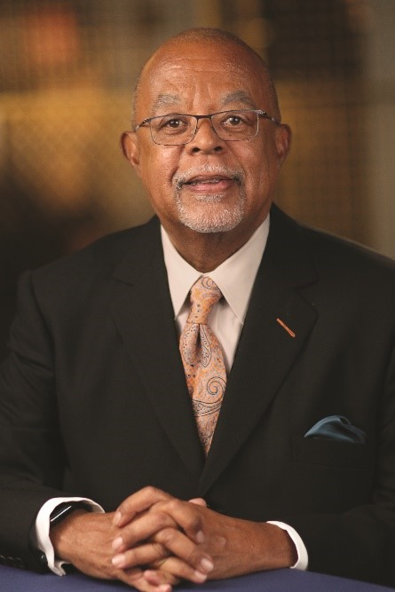
Henry Louis Gates, Jr., executive producer, host and writer, is the Alphonse Fletcher University Professor and Director of the Hutchins Center for African & African American Research at Harvard University. Emmy Award-winning filmmaker, literary scholar, journalist, cultural critic, and institution builder, Professor Gates has authored or co-authored 24 books and created 21 documentary films, including Wonders of the African World, African American Lives, Faces of America, Black in Latin America, Black America since MLK: And Still I Rise, and Africa’s Great Civilizations. Finding Your Roots, his groundbreaking genealogy series now in its sixth season on PBS, has been called “one of the deepest and wisest series ever on television,” leveraging “the inherent entertainment capacity of the medium to educate millions of Americans about the histories and cultures of our nation and the world.”
Professor Gates’s six-part PBS documentary series, The African Americans: Many Rivers to Cross (2013), which he wrote, executive produced and hosted, earned the Emmy Award for Outstanding Historical Program—Long Form, as well as the Peabody Award, Alfred I. duPont-Columbia University Award, and NAACP Image Award. His latest projects are the history series, Reconstruction: America after the Civil War (PBS, 2019), winner of the Alfred I. duPont-Columbia University Award, and the related books, Dark Sky Rising: Reconstruction and the Dawn of Jim Crow, with Tonya Bolden (Scholastic, 2019), and Stony the Road: Reconstruction, White Supremacy, and the Rise of Jim Crow (Penguin Random House, 2019), a New York Times Notable Book of 2019.
Having written for such leading publications as The New Yorker, The New York Times and Time, Professor Gates serves as chairman of TheRoot.com, a daily online magazine he co-founded in 2008, and chair of the Creative Board of FUSION TV. He oversees the Oxford African American Studies Center, the first comprehensive scholarly online resource in the field, and has received grant funding to develop a Finding Your Roots curriculum to teach students science through genetics and genealogy. In 2012, The Henry Louis Gates, Jr. Reader, a collection of his writings edited by Abby Wolf, was published.
The recipient of 56 honorary degrees and numerous prizes, Professor Gates was a member of the first class awarded “genius grants” by the MacArthur Foundation in 1981, and in 1998, he became the first African American scholar to be awarded the National Humanities Medal. He was named to Time’s 25 Most Influential Americans list in 1997, to Ebony’s Power 150 list in 2009, and to Ebony’s Power 100 list in 2010 and 2012. He earned his B.A. in History, summa cum laude, from Yale University in 1973, and his M.A. and Ph.D. in English Literature from Clare
College at the University of Cambridge in 1979. In 2018, he was one of 15 alumni of African descent honored in the exhibition Black Cantabs: History Makers at the Cambridge University Library. He also is an Honorary Fellow, Clare College, at the University of Cambridge.
Professor Gates has directed the W. E. B. Du Bois Institute for African and African American Research—now the Hutchins Center—since arriving at Harvard in 1991, and during his first 15 years on campus, he chaired the Department of Afro-American Studies as it expanded into the Department of African and African American Studies with a full-fledged doctoral program. He is a member of the American Academy of Arts and Letters and serves on a wide array of boards, including the New York Public Library, the NAACP Legal Defense Fund, the Aspen Institute, Jazz at Lincoln Center, the Whitney Museum of American Art, Library of America, and the Brookings Institution. In 2017, the Organization of American States named Gates a Goodwill Ambassador for the Rights of People of African Descent in the Americas. In 2011, his portrait, by Yuqi Wang, was hung in the National Portrait Gallery in Washington, D.C.

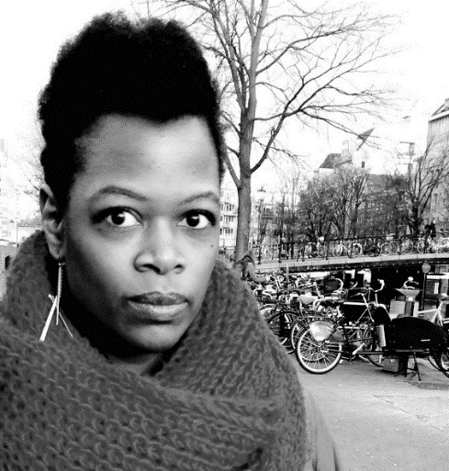
Shayla Harris is an award-winning independent director and producer based in New York. She recently produced and directed 2 episodes of 4-part series on the history of the black church with Dr. Henry Louis Gates Jr. that will air on PBS in February 2021. She was also a producer on “Who Killed Malcolm X?” a 6-part documentary series for Fusion/Netflix that was nominated for an Emmy.
Previously, she was a senior producer for digital video at Frontline PBS. Before joining Frontline, she managed the production of enterprise videos and web series at The New York Times and won numerous awards, including an Emmy for “Life, Interrupted,” a documentary series about a young woman with cancer that she shot, edited, and produced. In nearly a decade with the Times, she earned a National Magazine Award, a George Foster Peabody, an Overseas Press Club Award, and several Emmy nominations for her work. Before that, she worked on award-winning documentaries for Dateline NBC, including as the producer of “The Education of Ms. Groves," which won both an Alfred I. DuPont-Columbia University Award and a Peabody. She was also an associate producer on “Pattern of Suspicion,” a DuPont-Columbia, Silver Baton investigation of racial profiling in Cincinnati and “Children of War,” an Emmy winning story on Ugandan child soldiers.
Harris has been honored as an IDA Enterprise Documentary Fund Grantee, an IWMF African Great Lakes Reporting Fellow, a Next Generation Leadership Fellow, French American Foundation Young Leaders Fellow, and a Pew International Journalism Fellow. She has served on the Board of Screeners for the Alfred I. DuPont-Columbia University Awards and the Filmmaker Advisory Committee for the IDA’s Enterprise Documentary Fund and has judged multimedia and short documentaries for contests and film festivals like POYi, POY LatAm, World Press Photo and DocNYC. In addition, Harris has taught graduate journalism classes and lectured at conferences at NYU, CUNY, Columbia University, Missouri School of Journalism, and many others. She is a graduate of Williams College and Columbia University’s Graduate School of Journalism.

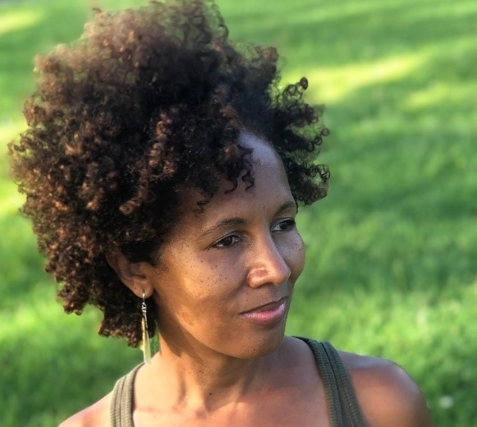
Stacey L. Holman is a Harlem-based filmmaker who’s directed/produced several award-winning projects including episode three of the 2018 PBS series Reconstruction: America After the Civil War hosted by Henry Louis Gates, Jr. She was a producer on the critically acclaimed documentary Tell Them We Are Rising: The Story of Black Colleges and Universities and served as Associate Producer on the Emmy award-winning film Freedom Riders produced/directed by Stanley Nelson. Additionally, Stacey was Coordinating Producer for Nelson’s Peabody Award-winning documentary Freedom Summer, and she was Co-Producer on Mary Lou Williams: The Lady Who Swings the Band. Stacey’s short film Dressed Like Kings garnered the Tribeca Film Festival All Access Award and aired on the WORLD Channel as part of the AfroPoP Shorts Program. She was the Series Producer/Director of Henry Louis Gates, Jr’s Black Church series The Black Church: This Is Our Story. This Is Our Song scheduled to broadcast on PBS February 16th and 17th from 8:00 – 10:00 p.m. (EST). Currently, she’s one of the producers/directors on Gates’ Making Black America: African American Social Networks airing on PBS in 2022.

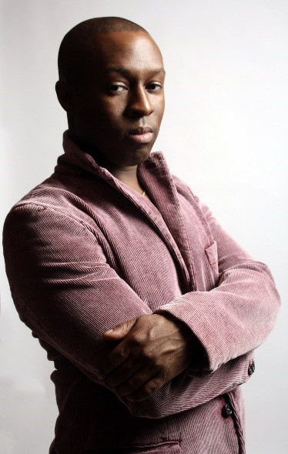
Jason King is the Chair of New York University’s Clive Davis Institute of Recorded Music, a training program at the Tisch School of the Arts for music industry leaders and creative entrepreneurs. Jason is a musician, performer, producer, songwriter, scholar, curator, journalist, and a widely published scholar, writing on the cultural politics of artists like Beyonce, Drake, Roberta Flack, and Luther Vandross. He is a regular contributor to publications like Pitchfork, Billboard, Slate, Los Angeles Times, Spin, NPR Music; and he is the author of The Michael Jackson Treasures, a Barnes and Noble exclusive biography. Jason has hosted and produced video and radio series, as well as podcasts, for media platforms like NPR Music and CNN: those series have featured artists like Dua Lipa, Alicia Keys, Moses Sumney, and Miguel. In 2021, he created and wrote a four-part radio documentary series with Meshell Ndegeocello on The Beatles and Black Music. He is currently the host and co-producer of Sound Barrier, a new podcast on Spotify: season 1 focuses on the life and work of R&B and disco artist Sylvester. Jason has been an expert witness in high-profile legal cases for Drake, Katy Perry, Jay Z, Timbaland, Lady Gaga, and Madonna. He is currently working on a biography of Freddie Mercury and producing and directing documentaries.

