PBS Explores the Enduring Artistry and Uncertain Future of American Craftsmanship in MADE IN THE WEST

Narrated by Country Music Icon Tanya Tucker, the One-Hour Film Premieres Friday, September 4, at 9 p.m. ET on PBS

View MADE IN THE WEST Trailer

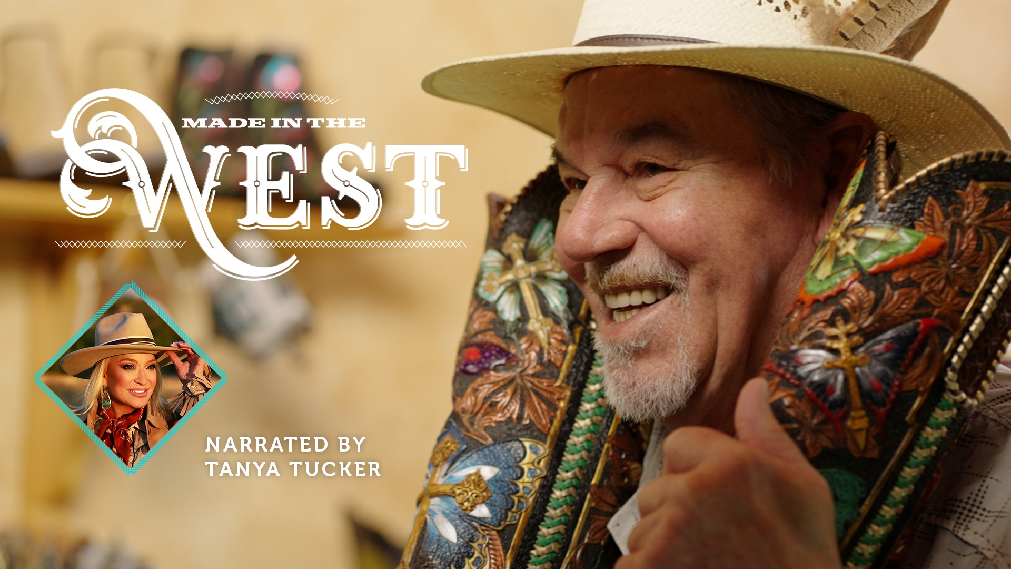
Photo Credit: PBS Key Art

Arlington, VA; (Aug. 24, 2026) – PBS announced today the new one-hour film MADE IN THE WEST, premiering Friday, September 4, 2026, at 9 p.m. ET on PBS, PBS.org and the PBS app (check local listings). Narrated by country music icon Tanya Tucker, the film celebrates the functional art and enduring craftsmanship of the American West while exploring what is at stake as many of today’s master artisans age out of their crafts.

A coproduction of Nashville PBS and Wyoming PBS, MADE IN THE WEST examines a tradition of creating objects designed not merely to be admired, but to be used, valued and passed down for generations. These are functional works of art that people can sit on, drink from or wear, all influenced by the landscapes, wildlife, materials and culture of the West.

At a time of fast fashion and fast furniture, MADE IN THE WEST invites viewers to slow down and appreciate the patience, skill and attention to detail behind something made by hand. Through intimate portraits of contemporary craftspeople, the film reveals how practical objects become enduring works of art.

The film also celebrates the impact of Indigenous artists and influential figures of the past who helped define the Western aesthetic, including William F. Cody as Buffalo Bill and designer Thomas Molesworth. Their influence can still be seen in the materials, imagery and traditions embraced by Western artisans today.

But the future of this uniquely American art form is uncertain. As master artisans grow older, questions remain about whether their knowledge, techniques and creative legacies will be preserved, and who will carry them forward. MADE IN THE WEST encourages future generations of artisans to explore the pride that comes from skilled handiwork and the fulfillment of creating something lasting with their own hands.

"The American West isn't just a place I sing about — it's in my bones,” said country music icon Tanya Tucker. “Narrating Made in the West let me celebrate the artisans who are keeping that spirit alive with their own two hands, and I'm proud to have been part of telling their story.”

MADE IN THE WEST will stream Friday, September 4, 2026, and be available on all station-branded PBS platforms, including PBS.org and the PBS app, available on iOS, Android, Roku streaming devices, Apple TV, Android TV, Amazon Fire TV, Samsung Smart TV, Chromecast, VIZIO and LG Smart TVs. PBS station members can view many series, documentaries, and specials via PBS Passport. For more information about PBS Passport, visit the PBS Passport FAQ website or contact your local station.

MADE IN THE WEST is a coproduction of Nashville PBS and Wyoming PBS in association with PBS and with Tanya Tucker as narrator. The film was made possible by Carlene Lebous, Thomas and Elizabeth Grainger, Naoma Tate, AllianceBernstein, Wyoming Cultural Trust Fund, Carolyn and Scott Heppel, PacifiCorp Foundation (aka Rocky Mountain Power Foundation), and First Horizon Foundation.
About PBS
PBS, with more than 330 member stations, offers all Americans the opportunity to explore new ideas and new worlds through television and digital content. Each month, PBS reaches over 36 million adults on linear primetime television, 16 million users on PBS-owned streaming platforms, 56 million viewers on YouTube, and 10 million followers on social media, inviting them to experience the worlds of science, history, nature, and public affairs and to take front-row seats to world-class drama and performances. PBS’s broad array of programs has been consistently honored by the industry’s most coveted award competitions. As the number one educational media brand, PBS KIDS helps children 2-8 build critical skills, enabling them to find success in school and life. Delivered through member stations, PBS KIDS offers high-quality content on TV — including a PBS KIDS channel — and streaming free on pbskids.org and the PBS KIDS Video app, games on the PBS KIDS Games app, and in communities across America. Teachers of children from pre-K through 12th grade turn to PBS LearningMedia for digital content and services that help bring classroom lessons to life. More information about PBS is available at PBS.org, one of the leading dot-org websites on the internet, Facebook, Instagram, or through our apps for mobile and connected devices. Specific program information and updates for press are available at pbs.org/pressroom or by following PBS Communications on X.

– PBS –

CONTACTS:

PBS
Chelsie Pope, cepope@pbs.org

Bullseye Communications
Lisa Dyer, lisa.dyer@bullseyecomm.com
Heather Marohn, heather.marohn@bullseyecomm.com

For images and additional up-to-date information on this and other PBS programs, visit PBS PressRoom at pbs.org/pressroom.

