PBS Announces
LUCY WORSLEY’S HOLMES VS. DOYLE,
New Three-Part Series Premiering Sundays, December 8-22

The Popular British Historian Investigates the Love-Hate Relationship Between Sherlock Holmes, the Greatest Detective Who Never Lived, and the Complex Man who Created Him – Arthur Conan Doyle

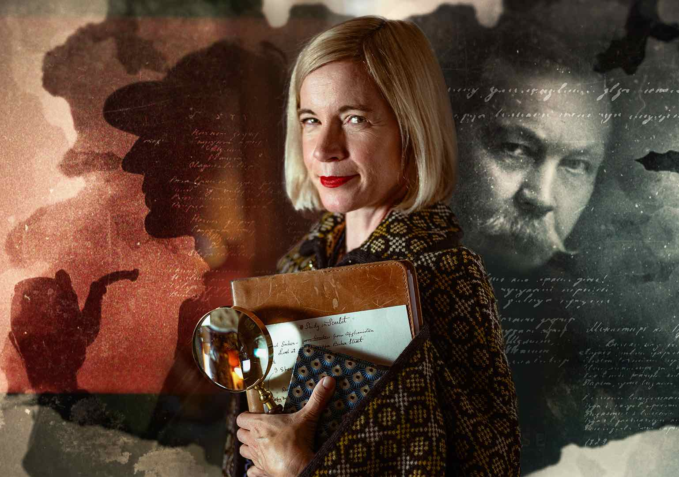
Pasadena, CA; July 15, 2024 – PBS today announced LUCY WORSLEY’S HOLMES VS. DOYLE, a new three-part series featuring the popular British historian and lifelong Sherlock Holmes fan who seeks to answer why author Arthur Conan Doyle came to despise the character that made him rich and famous. Throughout the series, Worsley explores the parallel lives of Doyle and Holmes in the historical context of their times. From the dying years of Victorian England, through the imperial crisis of the Boer war, the optimism of the early Edwardian years, to the trauma of the First World War, Arthur and Sherlock lived through them all. LUCY WORSLEY’S HOLMES VS. DOYLE premieres Sundays, December 8-22, 2024, 8:00-9:00 p.m. ET (check local listings) on PBS, PBS.org and the PBS app.

Featured in over 60 original stories and countless film and television adaptions, Sherlock Holmes has intrigued and excited fans with his intellect and powers of deduction for more than a century. Over the course of three episodes, Worsley investigates the curious relationship between detective and author.

In Episode 1, “Doctor and Detective” (December 8), Lucy unearths Holmes’ origins in Doyle’s early life as a medical student in Edinburgh. She unpacks the early stories, revealing the dark underbelly of late Victorian Britain, from drug use to true crime. She explores how Doyle infused his stories with cutting-edge technological developments and traces the author’s growing disenchantment with his detective, heading to Switzerland to visit the site of one of the most famous deaths in literature.

In Episode 2, “Fact and Fiction” (December 15), Lucy explores Doyle’s desire to distance himself from Sherlock after the detective’s apparent death at the Reichenbach Falls. From the delights of the ski slopes to the horrors of the Boer War, she reveals how far Doyle went to make himself the hero of his own story. He even took on the role of detective himself in one of the most important legal cases of the 20th century.

In the finale, “Shadows and Sleuths” (December 22), Lucy investigates the return of Sherlock. Doyle began the Edwardian age delighting in all it had to offer, but as the First World War approached, the darkness of the later stories mirrored the reality of Doyle’s life. After losing his eldest son, he became an evangelist for spiritualism, and his star declined after a public spat with a famous magician. Sherlock Holmes, in contrast, found a life beyond his author on stage and screen.

LUCY WORSLEY’S HOLMES VS. DOYLE will stream simultaneously with broadcast and be available on all station-branded PBS platforms, including PBS.org and the PBS app, available on iOS, Android, Roku, Apple TV, Amazon Fire TV, Android TV, Samsung Smart TV, Chromecast and VIZIO.

LUCY WORSLEY’S HOLMES VS. DOYLE is a 3x60’ BBC Studios production for
BBC Two, BBC iPlayer and PBS. The producers are Rachel Jardine and Laura Blount, the series producer is Linda Sands and the executive producer is Amanda Lyon. The commissioning editor for BBC Arts is Mark Bell. Zara Frankel is the Executive in Charge for PBS. BBC Studios is handling global distribution.

About Lucy Worsley
Lucy Worsley is the Chief Curator at Historic Royal Palaces in the U.K. and the author of numerous historical publications, including biographies of Queen Victoria, Jane Austen, and most, recently, Agatha Christie: An Elusive Woman. She is the host of several popular PBS specials and series including AGATHA CHRISTIE: LUCY WORSLEY ON THE MYSTERY QUEEN, LUCY WORSLEY’S ROYAL MYTHS AND SECRETS, A VERY BRITISH ROMANCE WITH LUCY WORSLEY, 12 DAYS OF TUDOR CHRISTMAS, VICTORIA & ALBERT: THE WEDDING, TALES FROM THE ROYAL BEDCHAMBER, and many more.

About PBS
PBS, with more than 330 member stations, offers all Americans the opportunity to explore new ideas and new worlds through television and digital content. Each month, PBS reaches over 36 million adults on linear primetime television, more than 16 million users on PBS-owned streaming platforms, 53 million viewers on YouTube, and 60 million people view PBS content on social media, inviting them to experience the worlds of science, history, nature, and public affairs and to take front-row seats to world-class drama and performances. PBS’s broad array of programs has been consistently honored by the industry’s most coveted award competitions. Teachers of children from pre-K through 12th grade turn to PBS LearningMedia for digital content and services that help bring classroom lessons to life. As the number one educational media brand, PBS KIDS helps children 2-8 build critical skills, enabling them to find success in school and life. Delivered through member stations, PBS KIDS offers high-quality content on TV — including a PBS KIDS channel — and streaming free on pbskids.org and the PBS KIDS Video app, games on the PBS KIDS Games app, and in communities across America. More information about PBS is available at PBS.org, one of the leading dot-org websites on the internet, Facebook, Instagram, or through our apps for mobile and connected devices. Specific program information and updates for press are available at pbs.org/pressroom or by following PBS Communications on X.

– PBS –

CONTACTS:
Atiya Frederick, PBS, PR@pbs.org

Cara White / Mary Lugo, CaraMar, Inc.
cara.white@mac.com; lugo@negia.net

For images and additional up-to-date information on this and other PBS programs, visit PBS PressRoom at pbs.org/pressroom.

