Two New Episodes of LUCY WORSLEY INVESTIGATES
Premiere Sundays, September 25 and October 2, on PBS and Streaming on the PBS Video App and PBS.org

Historian Lucy Worsley Turns Detective,
Following New Clues and Bringing Modern Perspectives to Shed Light on Britain’s 16th-Century Witch Hunts and the Deadly Black Death

ARLINGTON, VA – Popular British historian Lucy Worsley continues to explore some of British history’s most haunting mysteries in two new installments of LUCY WORSLEY INVESTIGATES. In each episode, Lucy uses historical and contemporary evidence and expert testimony to reframe the past and deepen her analysis. Lucy also reveals how the attitudes of the time towards gender politics and class often helped obscure the truth, uncovering new victors and victims, challenging perceptions and providing fresh insights. The series concludes with its two final episodes: “The Black Death” on Sunday, September 25, followed by “The Witch Hunts” on Sunday, October 2. Both episodes premiere 8:00-9:00 p.m. ET (check local listings) on PBS and will stream on PBS.org and the PBS Video app.
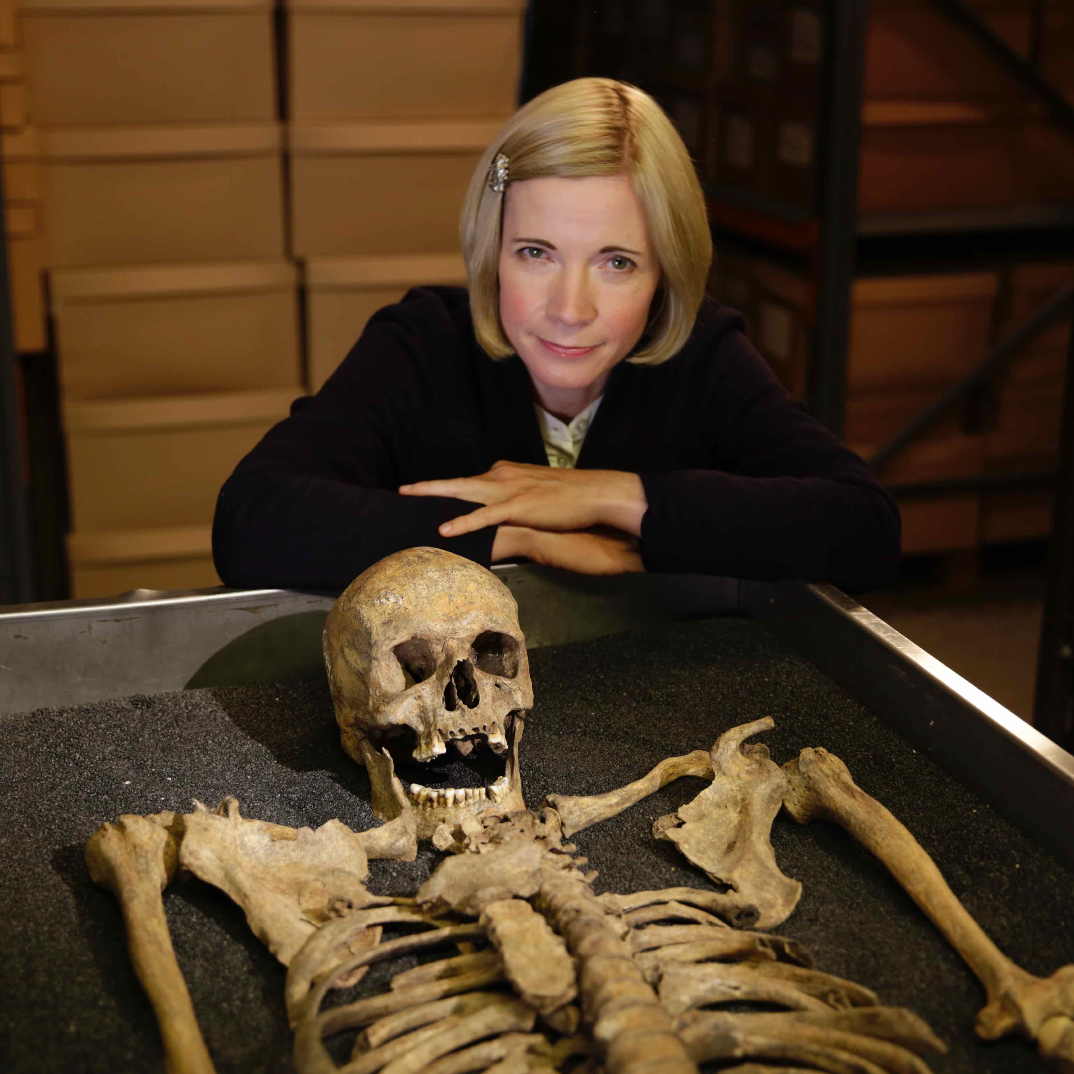
Credit: Tom Hayward © BBC Studios 2021.

“The Black Death” – Sunday, September 25
Lucy re-examines Britain’s deadliest pandemic, the Black Death, which struck in 1348 and killed an astonishing three million people — half of the country’s population. Scientists, historians and other experts help Lucy explore the wide-ranging effects of this unprecedented calamity on British society.

For centuries, no one could be certain what caused the 1348 plague. Then, in the 1980s, a vast mass grave containing the skeletons of 600 victims was uncovered in London. Lucy learns how DNA extracted from the teeth of these skeletons enabled scientists to finally identify the cause of the Black Death, a bacteria called yersinia pestis — a pathogen to which the population had no immunity. Lucy then travels to a small Suffolk village where rare court rolls reveal how the plague affected the lives of ordinary people. These fragile documents provide a unique window into the epidemic’s social, political and psychological impacts, revealing how the enormous death toll transformed religious beliefs, class structure, work and women.

“The Witch Hunts” – Sunday, October 2
The series concludes with a harrowing look at the events that sparked a craze for witch hunts across Britain and America more than 400 years ago. Lucy uncovers the extraordinary story of one supposed witch, a midwife and folk healer from rural Scotland named Agnes Sampson, who was caught up in King James’ determination to prove himself a just and godly king and figurehead of the Reformation. While Christianity and a belief in the supernatural had co-existed for centuries, the new puritanical Christianity of Scotland’s John Knox began targeting women who had an exalted role in society. Agnes’s trial and execution lit the fuse for the state-sanctioned torture and murder of thousands more like her across Britain and in America’s Salem Witch Trials. Lucy examines how the upheaval of the Reformation, the ambitions of the King and a suspicion of women in authority and female sexuality set the stage for these brutal killings.

LUCY WORSLEY INVESTIGATES is a 4x60’ series for BBC Two and PBS and is being made by BBC Studios’ The Documentary Unit. It was commissioned by Patrick Holland, Controller BBC Two. The Commissioning Editor is Abigail Priddle and the Executive Producer is Julia Harrington. Bill Gardner is Executive in Charge for PBS. BBC Studios is handling global distribution.

About Lucy Worsley
Lucy Worsley is the Chief Curator at Historic Royal Palaces in the U.K. and the author of numerous historical publications, including biographies of Queen Victoria and Jane Austen. She is the host of several popular PBS specials and series including LUCY WORSLEY’S ROYAL MYTHS AND SECRETS, A VERY BRITISH ROMANCE WITH LUCY WORSLEY, 12 DAYS OF TUDOR CHRISTMAS, VICTORIA & ALBERT: THE WEDDING, TALES FROM THE ROYAL BEDCHAMBER, and more.

About PBS
PBS, with more than 330 member stations, offers all Americans the opportunity to explore new ideas and new worlds through television and digital content. Each month, PBS reaches over 120 million people through television and 26 million people online, inviting them to experience the worlds of science, history, nature and public affairs; to hear diverse viewpoints; and to take front row seats to world-class drama and performances. PBS’ broad array of programs has been consistently honored by the industry’s most coveted award competitions. Teachers of children from pre-K through 12th grade turn to PBS for digital content and services that help bring classroom lessons to life. Decades of research confirms that PBS’ premier children’s media service, PBS KIDS, helps children build critical literacy, math and social-emotional skills, enabling them to find success in school and life. Delivered through member stations, PBS KIDS offers high-quality educational content on TV – including a 24/7 channel, online at pbskids.org, via an array of mobile apps and in communities across America. More information about PBS is available at www.pbs.org, one of the leading dot-org websites on the internet, or by following PBS on Twitter, Facebook or through our apps for mobile and connected devices. Specific program information and updates for press are available at pbs.org/pressroom or by following PBS Communications on Twitter.

– PBS –
CONTACTS:

Chelsie Pope, PBS
cepope@pbs.org

Cara White / Mary Lugo, CaraMar, Inc.
cara.white@mac.com; lugo@negia.net

For images and additional up-to-date information on this and other PBS programs, visit PBS PressRoom at pbs.org/pressroom.

