Celebrate the Holidays with
LUCY WORSLEY’S 12 DAYS OF TUDOR CHRISTMAS
Wednesday, December 25, 2019 on PBS

New Special Hosted by the Popular British Historian Recreates the Lavish Christmas Festivities of Henry VIII

ARLINGTON, VA – Join the popular royal historian and TV personality Lucy Worsley as she brings to life a magnificent Tudor Christmas, exploring the rituals and riches of the 12-day holiday as it was celebrated during the reign of King Henry VIII. With Lucy as our guide — in lavish period costume — we discover that many of our current traditions, from carols to Christmas cake, from gift-giving to mulled wine, have surprising Tudor origins. Enjoy a fun-filled and revelatory extravaganza that combines the sacred and the secular into an unforgettable time filled with entertainment, feasting, drinking and traditions both strange and familiar. LUCY WORSLEY’S 12 DAYS OF TUDOR CHRISTMAS premieres Wednesday, December 25, 2019, 8:00-9:00 p.m. ET (check local listings) on PBS, pbs.org and the PBS App.
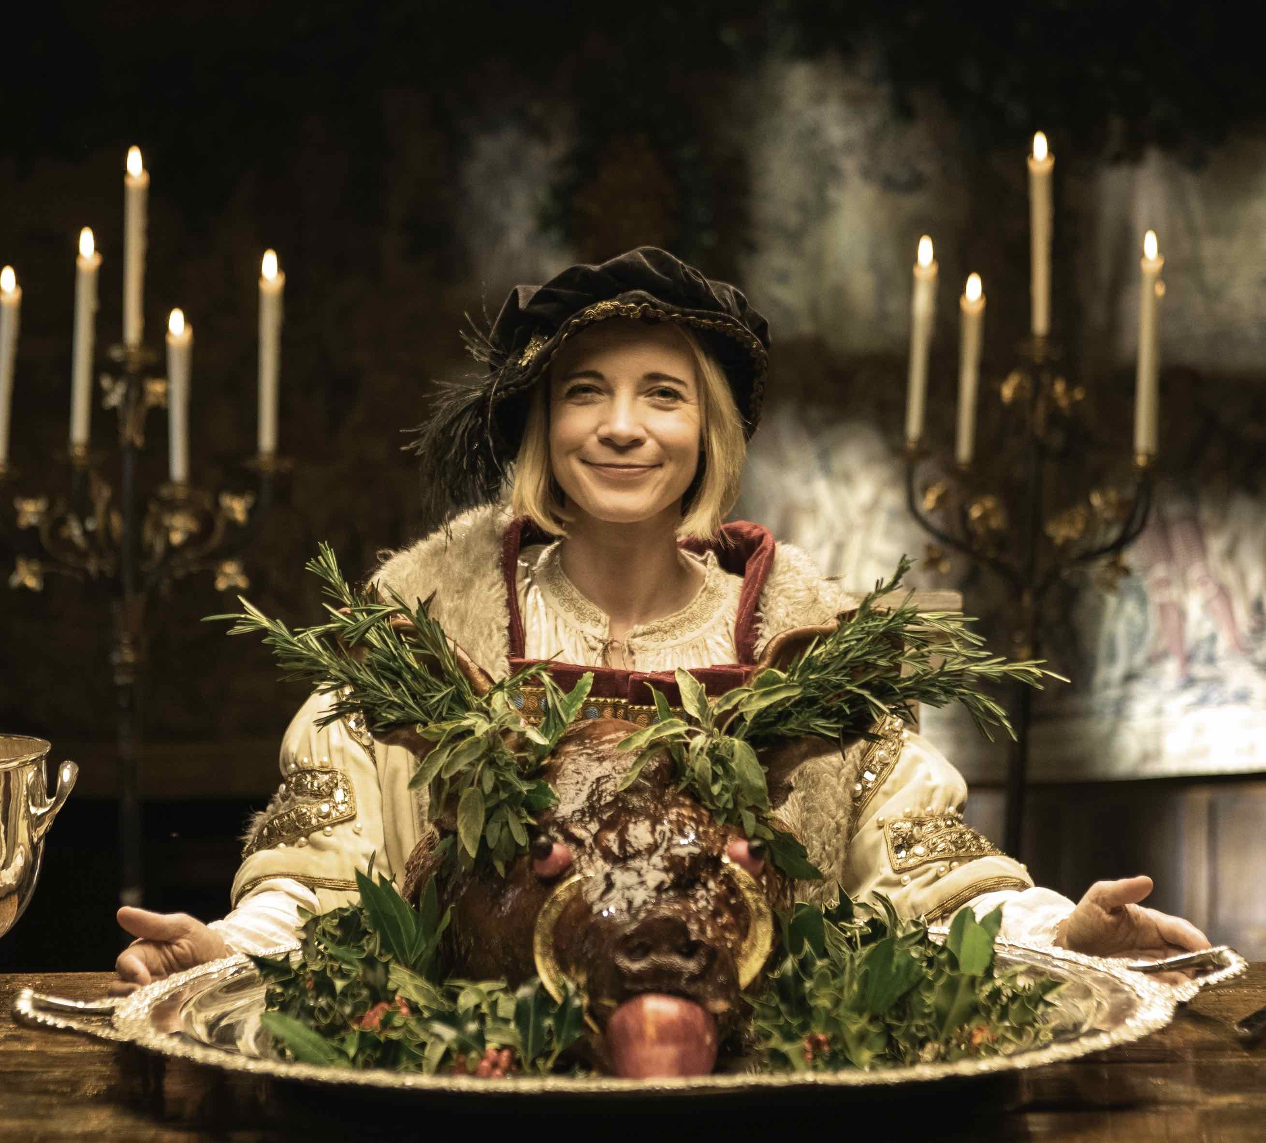
Credit: © Copyright Burning Bright Productions

The Tudor celebration of Christmas was an extravagant 12-day period of food, music, dance and tradition that began on December 25th and concluded on January 5th, the eve of Epiphany, or Twelfth Night. Through interviews with historians and newly accessible archival materials, Lucy reconstructs the particular activities performed each day, revealing that the King and his subjects celebrated Christmas in a nationwide spectacular that brought all levels of society together for an extended holiday of indulgence and merry-making. Donning period garb and rolling up her sleeves, Lucy prepares feasts, learns to decorate in Tudor style, and does a bit of caroling while also offering up a fascinating portrait of a nation at a pivotal time in history.

Lucy experiences the specific activities — some recreated for the first time by experts especially for this film — and explores the meanings of each day, beginning with feasting on Christmas, featuring an enormous poached and seasoned boar’s head accompanied by its own choral performance. Other days are given over to sports (most of which were illegal during the rest of the year), acts of charity, drinking, games, singing and more. Gifts were exchanged on New Year’s Day and could be highly political — the wrong gift to the King could ruin a career. Some of the more unusual traditions included a day of “Misrule,” in which the social order was turned on its head as children had control over parents and “the Lord of Misrule” was allowed to make fun of the King. “Mummering,” a strange and spooky Christmas custom in which costumed neighbors dropped in for mischievous fun, is a prototype of Halloween trick or treating.

All of these traditions led up to the massive celebration that was Twelfth Night. Join Lucy as she samples some of the myriad treats enjoyed on that day and takes part in a spectacular entertainment fit for a king.

LUCY WORSLEY’S 12 DAYS OF TUDOR CHRISTMAS will stream on December 25 and be available on all station-branded PBS platforms, including PBS.org and the PBS Video App, available on iOS, Android, Roku, Apple TV, Amazon Fire TV and Chromecast. PBS station members will be available to view all episodes via Passport (contact your local PBS station for details).

LUCY WORSLEY’S 12 DAYS OF TUDOR CHRISTMAS is produced by Burning Bright Productions for BBC in association with PBS. The Executive Producer is Susanne Curran and the program is produced and directed by Peter Sweasey.

About PBS
PBS, with nearly 350 member stations, offers all Americans the opportunity to explore new ideas and new worlds through television and digital content. Each month, PBS reaches over 120 million people through television and 26 million people online, inviting them to experience the worlds of science, history, nature and public affairs; to hear diverse viewpoints; and to take front row seats to world-class drama and performances. PBS’ broad array of programs has been consistently honored by the industry’s most coveted award competitions. Teachers of children from pre-K through 12th grade turn to PBS for digital content and services that help bring classroom lessons to life. Decades of research confirms that PBS’ premier children’s media service, PBS KIDS, helps children build critical literacy, math and social-emotional skills, enabling them to find success in school and life. Delivered through member stations, PBS KIDS offers high-quality educational content on TV – including a 24/7 channel, online at pbskids.org, via an array of mobile apps and in communities across America. More information about PBS is available at www.pbs.org, one of the leading dot-org websites on the internet, or by following PBS on Twitter, Facebook or through our apps for mobile and connected devices. Specific program information and updates for press are available at pbs.org/pressroom or by following PBS Pressroom on Twitter.

– PBS –

CONTACTS:
Cara White / Mary Lugo, CaraMar, Inc.
cara.white@mac.com; lugo@negia.net

For images and additional up-to-date information on this and other PBS programs, visit PBS PressRoom at pbs.org/pressroom.

