LEONARDO DA VINCI
TCA Press Tour Panelists Bios

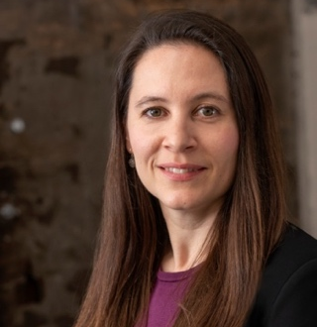
Sarah Burns is the author of “The Central Park Five: A Chronicle of a City Wilding” (Knopf, 2011) and, along with David McMahon and Ken Burns, the producer, writer and director of the documentary “The Central Park Five,” about the five Black and Latino teenagers who were wrongly convicted in the infamous Central Park Jogger rape of 1989. The film premiered at the Cannes Film Festival in 2012, was named the Best Non-Fiction film of 2012 by the New York Film Critics Circle and won a 2013 Peabody Award. She produced and directed, along with David McMahon and Ken Burns, the two-part, four-hour “Jackie Robinson,” a biography of the celebrated baseball player and civil rights icon, which she wrote with McMahon. The film aired on PBS in April 2016 and she and McMahon were nominated for an Emmy for Outstanding Writing for a Nonfiction Program and won a WGA award for Documentary Script. In 2020, Burns and McMahon produced and directed a documentary about a housing project in Atlanta called “East Lake Meadows: A Public Housing Story.” Together with McMahon and Ken Burns, Sarah produced and directed a four-part biography of Muhammad Ali, which premiered on PBS in September 2021 and was named the best television show of 2021 by Awards Daily writer David Phillips. She and McMahon were nominated for a WGA award for Documentary Script. Her next project is a two-part documentary biography of Leonardo da Vinci, which will air on PBS in November 2024. Sarah was born and raised in Walpole, New Hampshire. She graduated from Yale University with a degree in American Studies, and now lives in Brooklyn, New York with her husband, David McMahon, and their children.
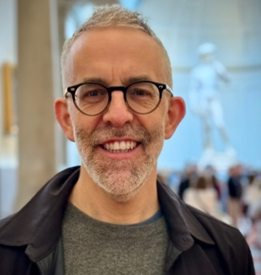
David McMahon has been making award-winning documentary films for more than a decade. With Ken Burns and Sarah Burns, he wrote, directed, and produced “The Central Park Five,” a two-hour film about the five teenagers who were wrongly convicted in the Central Park Jogger case of 1989, which won a Peabody Award and Best Non-Fiction Film of 2012 from The New York Film Critics Circle. In 2016, he again teamed up with Ken Burns and Sarah Burns to direct and produce “Jackie Robinson,” a two-part, four-hour biography of the baseball and civil rights icon, for which he and Sarah Burns were nominated for an Emmy Award for Outstanding Writing for a Non-Fiction program and won a WGA Award for documentary script. In 2020, he and Sarah Burns directed and produced “East Lake Meadows: A Public Housing Story,” a two-hour film about a housing project in Atlanta, which premiered on PBS that spring. In 2021, Together with Ken Burns and Sarah Burns, he produced and directed a four-part series on Muhammad Ali, which was named the best television show of the year by Awards Daily writer David Phillips. He and Sarah Burns were nominated for a WGA award for the script. He is currently at work on a two-part, four-hour film on Leonardo da Vinci, which will air nationally on PBS in November 2024. Raised in Clarence, New York, and a graduate of the University of Michigan, McMahon lives in Brooklyn, New York, with his wife, Sarah Burns, and their two children.

