Nonesuch Releases Caroline Shaw's Original Score for LEONARDO da VINCI,
a New Film from Ken Burns, on October 25; Album Track “Intentions of the Mind” out Today

Original music composed by Shaw & performed by
Attacca Quartet, Sō Percussion, Roomful of Teeth & John Patitucci

New York’s The Town Hall to host celebration of documentary,
with live musical performances & film excerpts, on October 29

Two-part film, directed by Ken Burns, Sarah Burns & David McMahon,
and written by McMahon & Sarah Burns, airs on PBS November 18 & 19

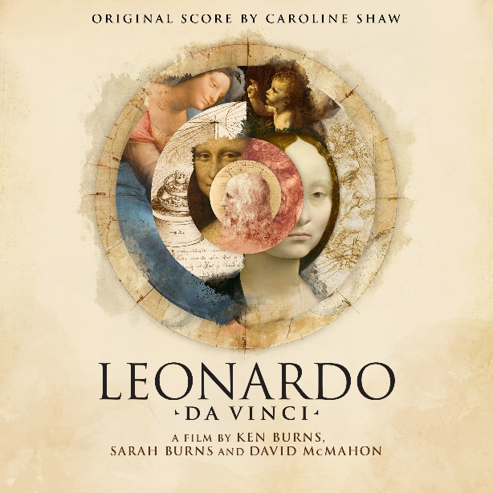

The original score for Ken Burns’s new two-part documentary, LEONARDO da VINCI, with new compositions by Caroline Shaw, is available via Nonesuch Records on October 25, 2024; the documentary airs on November 18 and 19 at 8pm ET (check local listings) on PBS, PBS.org, and the PBS App. The album features performances by the composer’s longtime collaborators Attacca Quartet, Sō Percussion, and Roomful of Teeth as well as John Patitucci. Shaw wrote and recorded new music for LEONARDO da VINCI, marking the first time a Ken Burns film has featured an entirely original score. The album track “Intentions of the Mind,” along with a music video, are available now.

In celebration of LEONARDO da VINCI, New York City’s historic venue The Town Hall hosts an evening, presented by Bank of America, of performances from Shaw’s score by Attacca Quartet, Sō Percussion, and Roomful of Teeth on October 29. The filmmakers will also preview excerpts from the four-hour film. More information is available here.

LEONARDO da VINCI is directed by Ken Burns, Sarah Burns, and David McMahon. The film, which explores the life and work of the fifteenth century polymath Leonardo da Vinci, is Burns’s first non-American subject. It also marks a significant change in the team’s filmmaking style, which includes using split screens with images, video, and sound from different periods to further contextualize Leonardo’s art and scientific explorations. LEONARDO da VINCI looks at how the artist influenced and inspired future generations, and it finds in his soaring imagination and profound intellect the foundation for a conversation we are still having today: what is our relationship with nature and what does it mean to be human?

“No single person can speak to our collective effort to understand the world and ourselves,” said Ken Burns. “But Leonardo had a unique genius for inquiry, aided by his extraordinary skills as an artist and scientist, that helps us better understand the natural world that we are part of and to appreciate more fully what it means to be alive and human.”

“To help give depth and dimension to Leonardo’s inner life, and to carry our viewers on his personal journey, we enlisted the composer Caroline Shaw,” McMahon says in the album’s liner note. “Caroline’s existing body of music—joyful, daring, at times transcendent, and wholly unique—seemed to speak directly to Leonardo, a seeking soul who, 500 years after his death, can come across as strikingly modern. A fully original score, we believed, would add crucial connective tissue to areas where the record of Leonardo’s life is thin and it’s possible to briefly lose his trail. The music Caroline created is dynamic, enthralling and filled with wonder.

“This soundtrack is a testament to the inspired efforts of Jennifer Dunnington, who marshaled it into being, the brilliant musicians and vocalists who, with the help of Alex Venguer, Neal Shaw, Colton Dodd and Tim Marchiafava, made it soar, and most of all Caroline Shaw, who might be Leonardo’s soulmate from across time,” he continues. “With her help, the Leonardo who emerges is no wizard shrouded in mystery, but a prideful, obsessive, at times lonely or flustered, occasionally ecstatic, and, in the end, content man who is in ways both modern and thoroughly of his time.”

“As we set out to explore Leonardo’s life, we realized that while he was very much a man of his time, he was also interested in something more universal,” said Sarah Burns. “Leonardo was uniquely focused on finding connections throughout nature, something that strikes us as very modern today, but which of course has a long history.”

Caroline Shaw is a musician who moves among roles, genres, and mediums, trying to imagine a world of sound that has never been heard before but has always existed. She is the recipient of the 2013 Pulitzer Prize in Music, several Grammy awards, an honorary doctorate from Yale, and a Thomas J. Watson Fellowship. She has worked with a range of artists including Rosalía, Renée Fleming, and Yo-Yo Ma, and she has contributed music to films and TV series including Fleishman Is in Trouble, Bombshell, Yellowjackets, Maid, Dark, and Beyoncé’s Homecoming. In addition to three albums with Sō Percussion, Narrow Sea, Let the Soil Play Its Simple Part, and Rectangles and Circumstance, Nonesuch has released her two Grammy-winning albums Orange and Evergreen, both of which feature Attacca Quartet. “Two-Step” and “Ghost,” Shaw’s songs with Ringdown, her duo with Danni Lee Parpan, are available now on Nonesuch. Caroline Shaw is Wigmore Hall’s 2024-25 Composer in Residence.

For more information, visit publicity.nonesuch.com, or contact:
Melissa Cusick, Nonesuch Records, melissa.cusick@nonesuch.com

PBS Media Contact: LeonardoDKC@dkcnews.com

For images and additional up-to-date information on this program, visit PBS PressRoom at https://pressroom.pbs.org/programs/l/leonardo-da-vinci or http://pbs.org/leonardo.

# # # #

