LAST OF THE BREED
Premieres December 2016 on PBS

– Willie Nelson, Merle Haggard and Ray Price Perform Their Greatest Hits –

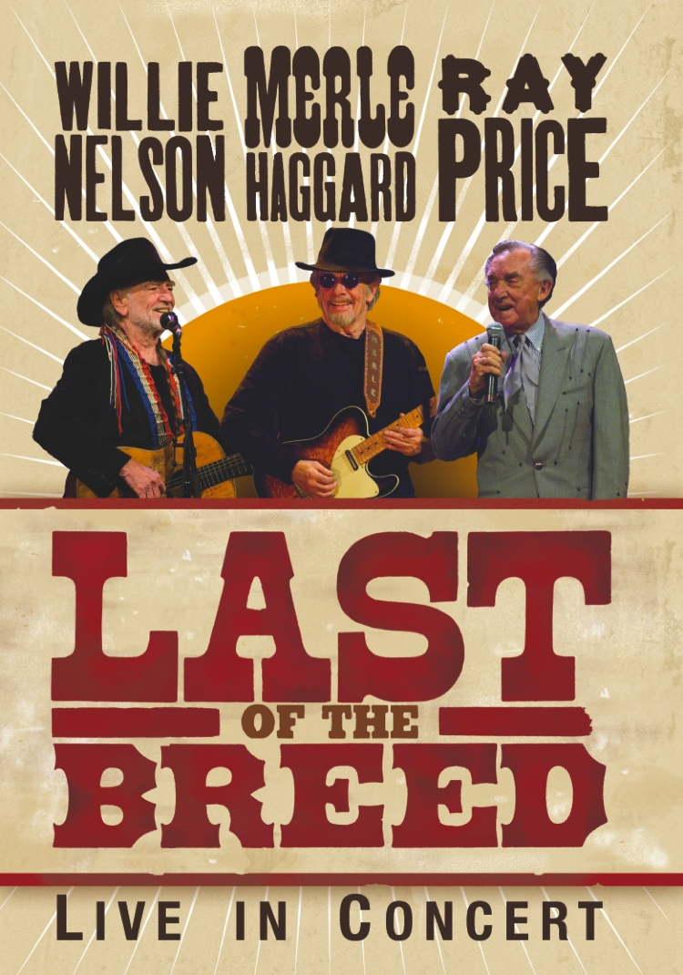
The treasure trove of honky-tonk hits and Texas swing tunes that turned the album Last of the Breed — by the legendary Willie Nelson, Merle Haggard and Ray Price — into a major-selling hit airs as a once-in-a-lifetime concert event. LAST OF THE BREED is part of special programming premiering on PBS stations beginning November 26, 2016 (check local listings).
Taped on March 25, 2007, at the Rosemont Theatre in Chicago during the final performance of their sold out tour that played to rave reviews, Nelson, Haggard and Price (backed by Grammy Award winning “Kings of Texas Swing” Asleep at the Wheel, led by Ray Benson, and Ray Price backed by his Cherokee Cowboys) deliver rousing performances of their greatest hits in the richest voices this side of the Rio Grande. Their timeless music — warm yet gritty, powerful and honest — is bound to have viewers singing along from beginning to end.
LAST OF THE BREED features the greatest hits of these Country Music Hall of Fame inductees, including “Okie From Muskogee,” “Pancho and Lefty,” “For the Good Times,” “Night Life,” “Crazy,” “Mama Tried,” “Always on My Mind,” “On the Road Again” and many others.
LAST OF THE BREED includes:
- “San Antonio Rose” − Ray Price
- “Make the World Go Away” − Ray Price
- “For the Good Times” − Ray Price
- “Route 66” − Asleep at the Wheel
- “Take Me Back to Tulsa” − Merle Haggard
- “That’s the Way Love Goes” − Merle Haggard
- “Silver Wings” − Merle Haggard
- “Sing Me Back Home” − Merle Haggard
- “Okie From Muskogee” − Merle Haggard and Willie Nelson
- “Pancho and Lefty” − Willie Nelson and Merle Haggard
- “Ramblin’ Fever” − Willie Nelson andMerle Haggard
- “Night Life” − Ray Price
- “Crazy” − Willie Nelson, Merle Haggard and Ray Price
- “On the Road Again” − Willie Nelson
- “Always on My Mind” − Willie Nelson
- “Mama Tried” − Merle Haggard
- “Whiskey River” − Willie Nelson
Underwriters: Public Television Viewers and PBS. Producer: Ambassador Entertainment Inc. Executive producer: Mark Rothbaum and Albert Spevak. Producer: Albert Spevak. Director: Lawrence Jordan.
– PBS –

CONTACTS: Cara White, CaraMar Publicity, 843-881-1480; cara.white@mac.com

For images and additional up-to-date information on this and other PBS programs, visit PBS PressRoom at pbs.org/pressroom.

