LAND GIRLS SEASON 1
Premieres on PBS Stations Beginning November 27

BBC Drama Follows Four Members of the Women’s Land Army
During World War II

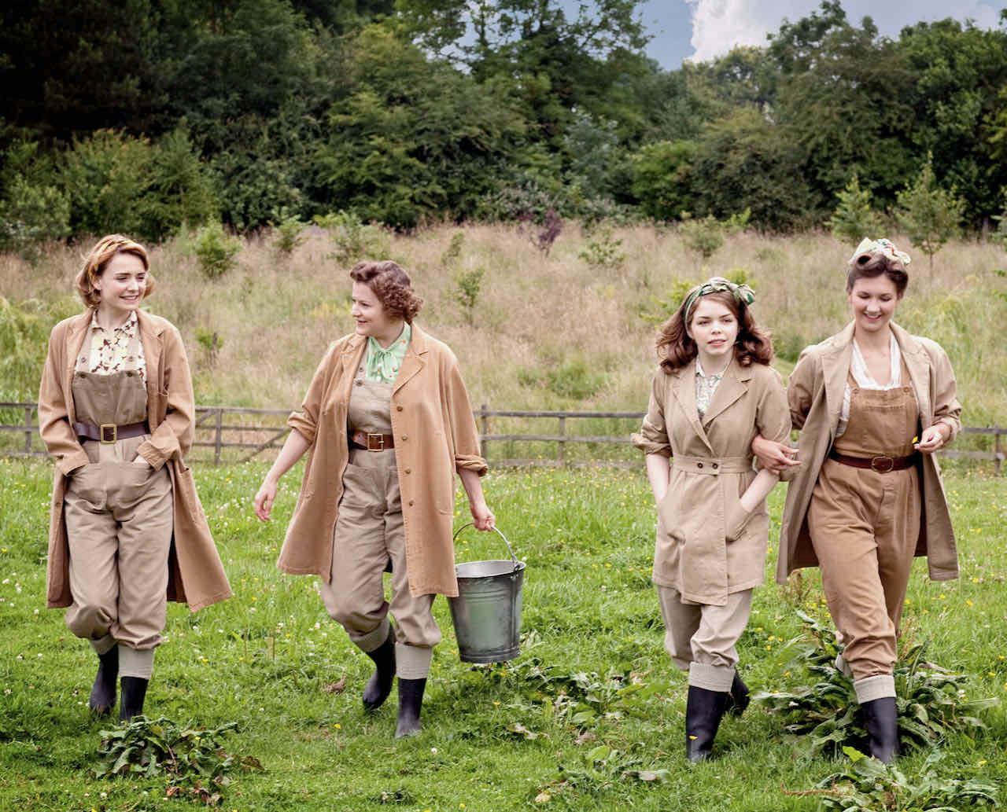
Credit: Courtesy of the BBC

Follow the lives, loves, highs and lows of four members of the Women's Land Army who are working at the Hoxley Estate during World War II in this BBC drama. As men fought on the battlefields, women from all walks of life worked the farms that fed the nation, doing their part to keep the home front running. Joyce, Nancy, Annie and Bea join the Land Army officially to help Britain’s war effort, but privately each has her own reasons for doing so. LAND GIRLS SEASON 1 is part of special programming premiering on PBS stations beginning Saturday, November 27, 2021 (check local listings).

PBS special programming invites viewers to experience the worlds of science, history, nature and public affairs; hear diverse viewpoints; and take front-row seats to world-class drama and performances. Viewer contributions are an important source of funding, making PBS programs possible. PBS and public television stations offer all Americans from every walk of life the opportunity to explore new ideas and new worlds through television and online content.

Underwriters: Public Television Viewers and PBS

- PBS –

CONTACT: Cara White, CaraMar, Inc., cara.white@mac.com

For images and additional up-to-date information on this and other PBS programs, visit PBS PressRoom at pbs.org/pressroom.

