KEN BURNS: MUHAMMAD ALI
Premieres on PBS Stations Beginning November 27

Behind-the-Scenes of the Epic Documentary Series with Host Keith David

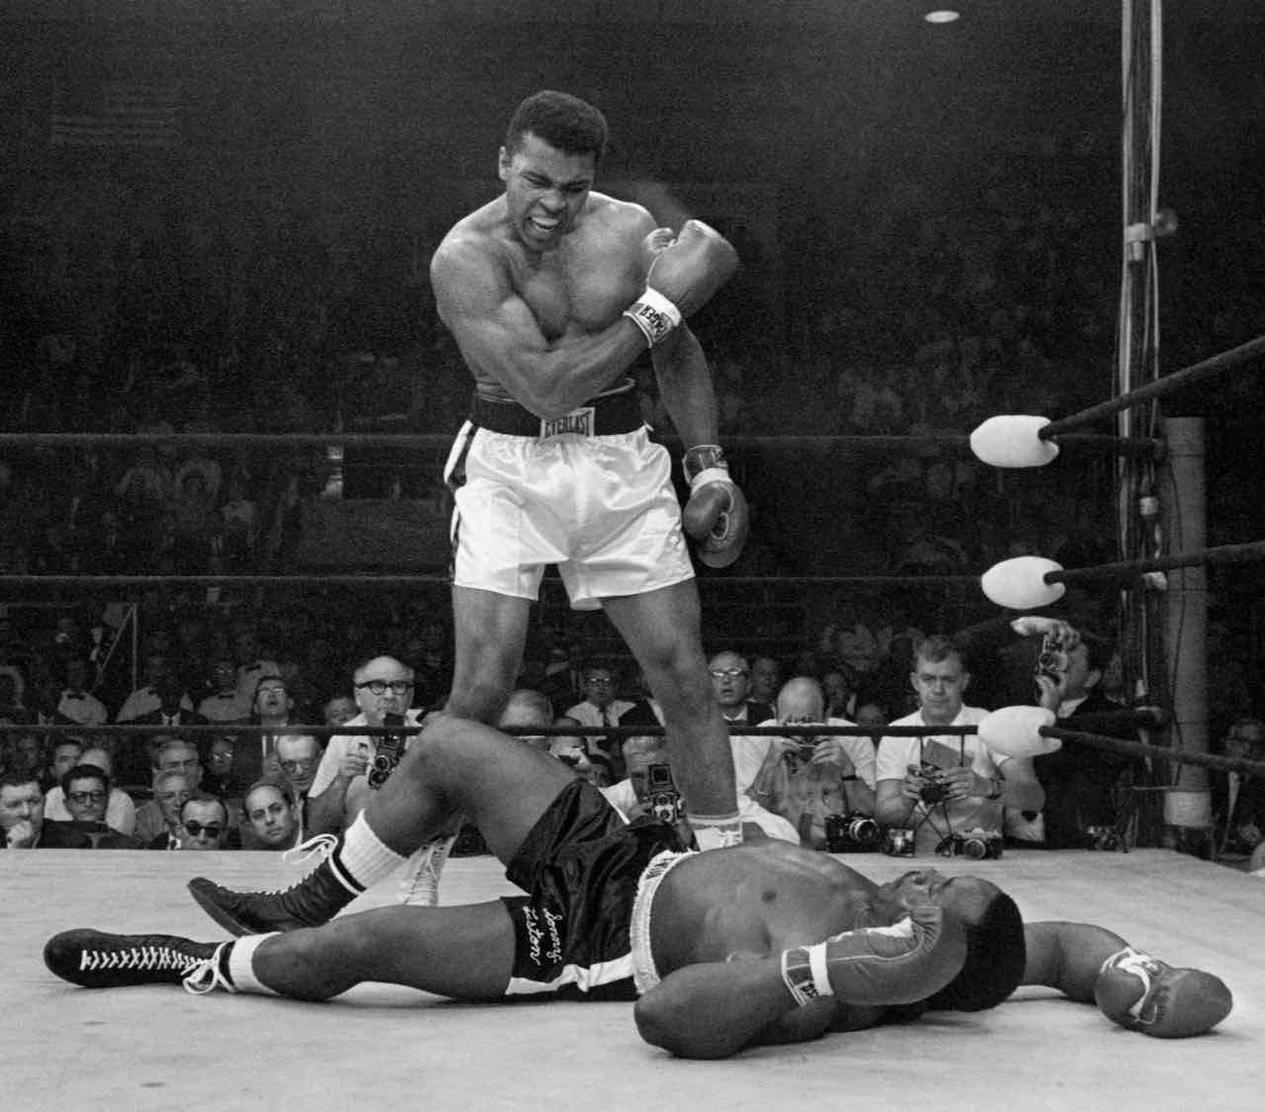
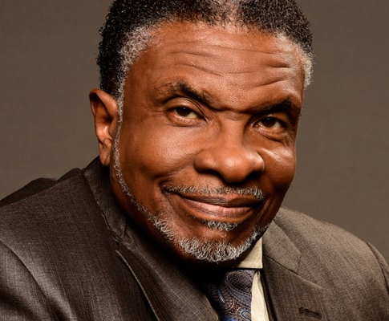
Top: Muhammad Ali stands over fallen Sonny Liston, shouting and gesturing shortly after dropping Liston with a short hard right to the jaw in Lewiston, Maine. May 25, 1965. Credit: John Rooney/AP Images
Bottom: Host Keith David.
Credit: Courtesy of Inky Dinky Worldwide CT LLC

KEN BURNS: MUHAMMAD ALI documents the making of the four-part series from filmmakers Ken Burns, Sarah Burns and David McMahon. Hosted by Keith David, three-time Emmy Award winner for his voice-over narration for previous Ken Burns projects JACKIE ROBINSON, THE WAR and UNFORGIVABLE BLACKNESS, the program features new and exclusive interviews with Ken Burns and the team that created the eight-hour epic series. Weaving together the most dramatic and emotional moments from Muhammad Ali, the program explores the making of the documentary series that follows the life of one of the most consequential men of the 20th century. KEN BURNS: MUHAMMAD ALI is part of special programming premiering on PBS stations beginning Saturday, November 27, 2021 (check local listings).

The three-time heavyweight boxing champion Muhammad Ali captivated billions of billions of fans with his combination of speed, agility and power in the ring, and his charm, wit, and outspokenness outside of it. At the height of his fame, Ali challenged Americans’ racial prejudices, religious biases, and notions about what roles celebrities and athletes play in our society, and inspired people all over the world with his message of pride and self-affirmation.

Drawing from an extraordinary trove of archival footage and photographs, contemporary music, and the insights and memories of eyewitnesses—including family and friends, journalists, boxers, and historians, among others—Burns, Burns and McMahon created a sweeping portrait of an American icon. The series details the story of the athlete who called himself—and was considered by many to be—”the greatest of all time.”

About Keith David

Keith David is a classically trained actor, multiple Emmy Award winner and Tony Award nominee. In September 2021, Keith narrated Ken Burns’ MUHAMMAD ALI, a documentary series about the life of the legendary boxer, which premiered on PBS. In October, Amazon / Blumhouse releases Black As Night, in which he has a starring role. Keith is currently shooting the limited series From Scratch (Netflix) with Zoe Saldana. This fall Keith commences rehearsals for the new Broadway play Thoughts of a Colored Man, which opens on October 31 at the John Golden theater.
Born and raised in New York City, Keith is a graduate of the New York High School of the Performing Arts and the Juilliard School. His expansive film credits include 21 Bridges, Night School, Disney's The Princess and the Frog, Requiem for a Dream, Men at Work, They Live, Crash, There's Something About Mary, The Thing, Platoon and many others. Keith completed five seasons starring in Greenleaf for Oprah Winfrey's OWN network. Other TV credits include NCIS: New Orleans, Blackish, MacGyver, Fresh Off the Boat, Community, Enlisted and Mister Rogers Neighborhood. His voice over work has earned him three Emmys for narrating Ken Burns' Jackie Robinson, The War and Unforgivable Blackness –The Rise and Fall of Jack Johnson. Some of his other voice acting credits include Adventure Time, Bojack Horseman, Rick & Morty, Spawn and Gargoyles. On Broadway, he starred in Seven Guitars and Jelly's Last Jam (Tony nomination). As a singer Keith has toured for the past several years with Too Marvelous For Words, in which he recreates Nat King Cole. Keith is currently creating a show about legendary blues singer Joe Williams.
PBS special programming invites viewers to experience the worlds of science, history, nature and public affairs; hear diverse viewpoints; and take front-row seats to world-class drama and performances. Viewer contributions are an important source of funding, making PBS programs possible. PBS and public television stations offer all Americans from every walk of life the opportunity to explore new ideas and new worlds through television and online content.

Underwriters: Public Television Viewers and PBS
Production Company: Inky Dinky Worldwide CT LLC
Producer and Director: Bob Marty

- PBS –

For images and additional up-to-date information on this and other PBS programs, visit PBS PressRoom at pbs.org/pressroom.

