From Pastor’s Daughter to Influential World Leader,
Angela Merkel Profiled on IN THEIR OWN WORDS
Tuesday, December 28 on PBS

New Biographical Portrait Reveals a Fascinating Story of Courage, Determination and Leadership

ARLINGTON, VA – IN THEIR OWN WORDS continues their series of primetime specials that explore the lives and impact of some of the most intriguing figures in recent history. Combining exclusive interviews with archival footage and each subject’s own words to help tell the story, IN THEIR OWN WORDS profiles Angela Merkel, who will step down this year after 16 years as Germany’s chancellor. One of the world’s most respected leaders, Merkel took on the male establishment to become Germany’s first female chancellor. With a sharp and savvy mind, she overcame fierce opposition, a vicious press and rampant sexism to lead Germany and Europe with a steady focus on peace and freedom. Featuring interviews with Hillary Clinton, George W. Bush and many others, “Angela Merkel” premieres Tuesday, December 28, 8:00-9:00 pm. ET (check local listings) on PBS, PBS.org and the PBS Video app.
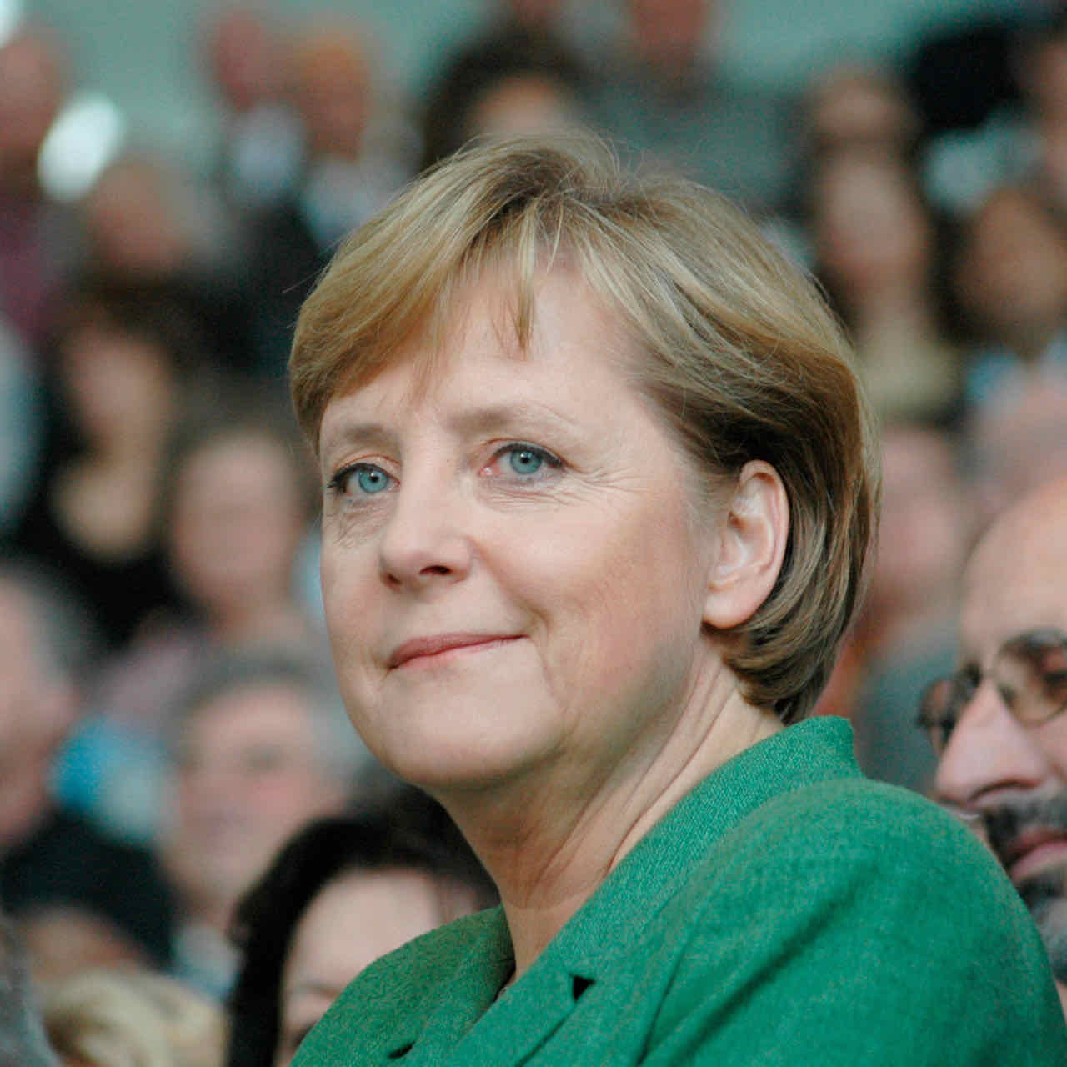
Credit: 360b / ALAMY Stock Photo

One of the world’s most enigmatic leaders, Angela Merkel’s life story reveals the woman behind the veil. Born in 1954 in Hamburg, West Germany, her father, a Lutheran pastor, was asked to serve in East Germany, and the family moved there when Merkel was an infant. A surveillance state under Soviet control, East Germany was ruled by the notorious Stasi, secret police who encouraged neighbor to inform upon neighbor. Merkel learned from her mother at an early age not to speak about her family in public, a lesson which stayed with her for the rest of her life.

In 1961, fearing that too many citizens were fleeing to the West, the government built a wall dividing Berlin, leaving East Germans—including Merkel and her family—suddenly cut off from freedom and opportunity. “There was one thing that this wall could not do during all those years,” said Merkel. “It couldn’t impose limits on my inner thoughts—my personality, my imagination, my dreams and desires.”

A brilliant student, Merkel chose to focus on physics because “there the truth isn’t so easily bent.” Awarded her doctorate in 1986, she went to work at the East Germany Academy of Sciences. But her life changed completely when the Berlin Wall came down in 1989.

Merkel soon realized that she wanted to help build a new Germany and joined one of the newly emerging political parties, which was affiliated with the Christian Democratic Party, the party of Helmut Kohl. After the treaties were signed between East and West Germany, Kohl formed a unity government, selecting a cabinet comprised of members from the East and West, one of whom was Merkel. Called “das Mädchen”—the girl—by Kohl, she was given a token position as a minister for women and children.

“She’s constantly underestimated, which in a way becomes like her superpower,” said historian Jennifer Jenkins. “She’s like a master chess player. She’s shrewd and strategic. She gives this impression of being very quiet, but there’s a roaring engine in there.”

Slowly and deliberately, Merkel began climbing the German political ladder. By 1998, she was the secretary of the Christian Democratic Union. When a scandal over illegal donations, slush funds and covert bank accounts became a crisis in 1999, Merkel publicly blamed Kohl for damaging the party.

“She, in effect, committed patricide,” said author and journalist Kati Marton. “The boldest political act was committed by Merkel when she turned on her mentor Helmut Kohl. And she positioned herself as the heir to the CDU.”

In 2005, Merkel became Chancellor of Germany, the first woman ever to hold that position. Interviews with George W. Bush and Hillary Clinton explore Merkel’s relationship with the United States and presidents Bush and Obama.

Fiercely private, Merkel has been married twice, although both husbands have shunned the limelight. “Angela Merkel never invited people to her home,” said Merkel biographer Stefan Kornelius. “She never lets anybody in her private life. What kind of furniture she has, whether she has friends, whether she has pets—nobody knows.”

IN THEIR OWN WORDS delves into some of the most significant crises that Merkel has faced, including the Greek debt crisis and the migrant crisis of 2015. When other countries closed their borders, she took a stand that Germany, the strongest economy in Europe, had a special responsibility to the tide of humanity fleeing the Syrian civil war and instability in Iraq, Afghanistan and Libya. But Merkel paid the price for her decision, becoming the focal point of hate from far right extremists and witnessing the rise of xenophobia and racism in Germany.

At the end of 2021, Merkel will step down as Chancellor. She has worked with five British prime ministers, four French presidents, seven Italian prime ministers and four U.S. presidents. “Nobody laughs anymore if a girl says she wants to be chancellor,” said Merkel.

IN THEIR OWN WORDS will stream simultaneously with broadcast and be available on all station-branded PBS platforms, including PBS.org and the PBS Video app, available on iOS, Android, Roku, Apple TV, Amazon Fire TV, Android TV, Samsung Smart TV and Chromecast.
A co-venture of Dalaklis Media and Prospero Media, IN THEIR OWN WORDS is produced by Lower Canada Productions Inc., in association with PBS, documentary Channel, Rive Gauche Television and with the participation of Rogers Cable Network Fund. Executive Producers are Chuck Dalaklis, Martin Katz, Matt Hanna and Karen Wookey. Bill Margol is executive in charge for PBS. Rive Gauche Television, an Aftershock Media Company, is the international distributor of the series.
About PBS
PBS, with more than 330 member stations, offers all Americans the opportunity to explore new ideas and new worlds through television and digital content. Each month, PBS reaches over 120 million people through television and 26 million people online, inviting them to experience the worlds of science, history, nature and public affairs; to hear diverse viewpoints; and to take front row seats to world-class drama and performances. PBS’ broad array of programs has been consistently honored by the industry’s most coveted award competitions. Teachers of children from pre-K through 12th grade turn to PBS for digital content and services that help bring classroom lessons to life. Decades of research confirms that PBS’ premier children’s media service, PBS KIDS, helps children build critical literacy, math and social-emotional skills, enabling them to find success in school and life. Delivered through member stations, PBS KIDS offers high-quality educational content on TV – including a 24/7 channel, online at pbskids.org, via an array of mobile apps and in communities across America. More information about PBS is available at www.pbs.org, one of the leading dot-org websites on the internet, or by following PBS on Twitter, Facebook or through our apps for mobile and connected devices. Specific program information and updates for press are available at pbs.org/pressroom or by following PBS Communications on Twitter.

– PBS –
CONTACTS:

Becky Scullin, PBS; brscullin@pbs.org

Cara White / Mary Lugo
843-881-1480; 770-851-8190
CaraMar, Inc.
cara.white@mac.com; lugo@negia.net

For images and additional up-to-date information on this and other PBS programs, visit PBS PressRoom at pbs.org/pressroom.

