IN PURSUIT: LESSONS OF AMERICAN LEADERSHIP
Premieres Tuesday, October 27, 2026 on PBS

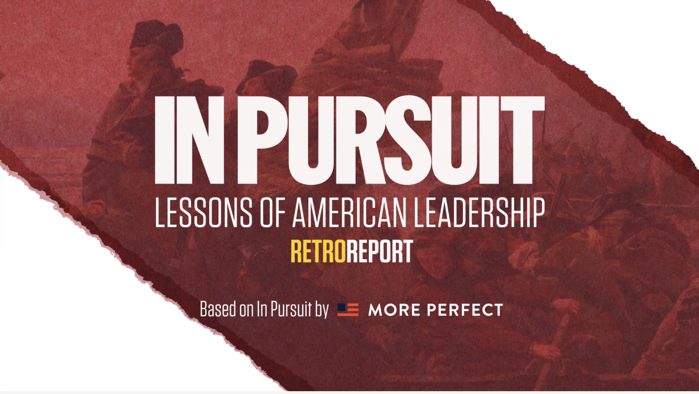
Photo credit: © Retro Report

New Documentary Special and Digital Series Brings the Leadership Lessons of American Presidents and First Ladies to Life, Featuring Insights from Chief Justice John Roberts, Ken Burns, Sharon McMahon, Lonnie Bunch, Judy Woodruff, General Stanley McChrystal, and More

ARLINGTON, VA; August 3, 2026 – PBS announced that IN PURSUIT: LESSONS OF AMERICAN LEADERSHIP, a new documentary special produced by Retro Report based on In Pursuit by More Perfect, will premiere Tuesday, October 27, 2026, at 10:00 p.m. ET (check local listings) on PBS, PBS.org, and the PBS app.

Based on More Perfect’s groundbreaking In Pursuit initiative — a curated series of essays by leading American public figures and scholars distilling one leadership lesson from each American president and several first ladies — the film weaves together new interviews and archival material with documentary storytelling to explore what we can learn from the past to inform a more perfect union. IN PURSUIT is part of PBS America @ 250, a multiyear celebration of U.S. history, culture, and programming marking America’s Semiquincentennial.

The In Pursuit essay series — published weekly on Substack throughout 2026 — features contributions from three former Presidents, three former First Ladies, the Chief Justice of the Supreme Court, and seven Pulitzer Prize winners, including President Barack Obama on Abraham Lincoln, President George W. Bush on George Washington, President Bill Clinton on Theodore Roosevelt, Michelle Obama on Jacqueline Kennedy, Hillary Clinton on Eleanor Roosevelt, Laura Bush on Lady Bird Johnson, and Ken Burns and Geoffrey Ward on Franklin Delano Roosevelt. Drawing from these essays and original interviews with the authors, the Retro Report special brings their reflections on presidential leadership, character, and democratic ideals to a national television audience.
“Public media plays an important role in helping audiences better understand the stories that have shaped our nation,” said Margaret Ebrahim, Senior Director, Programming & Development, at PBS. “IN PURSUIT: LESSONS OF AMERICAN LEADERSHIP brings history to life through the voices of respected leaders, scholars, and historians, inviting viewers to reflect on the leadership that continues to shape our country.”

“At this moment of reflection in our nation’s history, we’re honored to be introducing these dynamic stories of leadership that have shaped our democracy to a television and digital audience,” said Kyra Darnton, Executive Producer of Retro Report’s IN PURSUIT: LESSONS OF AMERICAN LEADERSHIP.

“Presidents and First Ladies provide an accessible window into American history,” said Colleen Shogan, CEO of In Pursuit and former Archivist of the United States. “This film brings those lessons to life in a way that is both entertaining and deeply relevant. As we celebrate our 250th anniversary, we hope it sparks a national conversation about what we can learn from the past to write the history of America’s future.”

“We call it the ‘American Experiment,’ but we could do far more to learn from our past to improve our country’s future,” said John Bridgeland, Founder and CEO of More Perfect. “These essays and this film share powerful lessons relevant to leadership, democracy, and character, and can serve as guides to a more perfect union.”

The special and digital series feature segments inspired by the essays and interviews of some of the nation’s most respected voices, including: retired General Stanley McChrystal reflects on Ulysses S. Grant as a model of leadership grounded in service rather than personal ambition. Secretary of the Smithsonian Lonnie Bunch considers Martin Van Buren’s role in building the modern American political system. And documentary filmmaker Ken Burns reflects on Franklin Roosevelt’s empathetic leadership during the Great Depression and World War II.

Additional insights feature Chief Justice John Roberts on William Howard Taft, Judy Woodruff on Rosalynn Carter, Douglas Brinkley on Barack Obama, David Brooks on Ronald Reagan, Anita McBride on Bess Truman, Sean Wilentz on Bill Clinton, and Lindsay Chervinsky on John Quincy Adams.

In addition to the broadcast special and digital series, Retro Report has developed free educational resources tied to the In Pursuit project, available at retroreport.org, designed to bring civic learning into classrooms nationwide. The In Pursuit essay series is accompanied by a companion podcast, “In Pursuit with Colleen Shogan,” produced by PRX and available on all major podcast platforms.

IN PURSUIT: LESSONS OF AMERICAN LEADERSHIP will stream simultaneously with broadcast and be available on all station-branded PBS platforms, including PBS.org and the PBS app, which is available on iOS, Apple TV, Android mobile and tablets, Android/Google TV, Roku, Amazon Fire TV and tablets, Comcast, Samsung Smart TV, VIZIO and LG Smart TVs.

IN PURSUIT: LESSONS OF AMERICAN LEADERSHIP is a Retro Report production for PBS, based on In Pursuit by More Perfect. The Director is Bonnie Bertram. Executive Producers are Kyra Darnton and Chris Buck. Executive in Charge for PBS is Margaret Ebrahim.

Funding for the special is provided by The Arthur Vining Davis Foundations.

About Retro Report
Retro Report is an Emmy Award-winning nonprofit newsroom dedicated to producing documentary journalism and educational resources. Retro Report has produced two prime-time television series for PBS, including the IDA award winning “Citizen Nation,” and has been recognized with 15 Emmy Award nominations, 14 Edward R. Murrow Awards, 12 Webbys, a Gerald Loeb Award and others. Feature-length documentaries include “Enemies of the People,” “How Saba Kept Singing” and, for FRONTLINE, “Baby Brokers,” “Crisis on Campus,” “Facing Eviction,” “Massacre in El Salvador,” “Forever Prison,” and “American Reckoning,” which was nominated for a 2023 Peabody Award. Retro Report has created more than 300 short documentaries in partnership with The New York Times, The New Yorker, PBS NewsHour, Independent Lens, Scientific American and many others. Retro Report’s free educational resources reach more than 3 million students each month

About More Perfect
More Perfect is a bipartisan alliance of 44 Presidential Centers, National Archives Foundation, American Academy of Arts and Sciences, Karsh Institute for Democracy at the University of Virginia, and more than 100 organizations working together to advance five foundational Democracy Goals: 1) Universal Civic Learning; 2) Expanding National Service & Volunteering; 3) Bridging Divides & Building Trust; 4) Trusted Elections & More Representative and Responsive Governance; and 5) Access to Trusted News & Information.

About In Pursuit
In Pursuit is led by CEO Colleen Shogan, former Archivist of the United States & Senior Advisor to More Perfect & Senior Fellow in Civics at Stand Together; and Co-Chaired by John Bridgeland, More Perfect Founder & CEO and former Director of the White House Domestic Policy Council under President George W. Bush; Anita McBride, Director, First Ladies Initiative at American University and former Chief of Staff to First Lady Laura Bush, and Mark Updegrove, President & CEO of the LBJ Foundation and Presidential Historian for ABC News; with Vice Chair Andrew Mangino, an award-winning social entrepreneur.

About PBS
PBS, with more than 330 member stations, offers all Americans the opportunity to explore new ideas and new worlds through television and digital content. Each month, PBS reaches over 36 million adults on linear primetime television, more than 16 million users on PBS-owned streaming platforms, 53 million viewers on YouTube, and 60 million people view PBS content on social media, inviting them to experience the worlds of science, history, nature, and public affairs and to take front-row seats to world-class drama and performances. PBS’s broad array of programs has been consistently honored by the industry’s most coveted award competitions. Teachers of children from pre-K through 12th grade turn to PBS LearningMedia for digital content and services that help bring classroom lessons to life. As the number one educational media brand, PBS KIDS helps children 2-8 build critical skills, enabling them to find success in school and life. Delivered through member stations, PBS KIDS offers high-quality content on TV — including a PBS KIDS channel — and streaming free on pbskids.org and the PBS KIDS Video app, games on the PBS KIDS Games app, and in communities across America. More information about PBS is available at PBS.org, one of the leading dot-org websites on the internet, Facebook, Instagram, or through our apps for mobile and connected devices. Specific program information and updates for press are available at pbs.org/pressroom or by following PBS Communications on X.

Media Contacts
PBS: Meredith Tiger, mjtiger@pbs.org
Retro Report: Sianne Garlick, sgarlick@retroreport.com
DKC: DKCMorePerfect@dkcnews.com

###

For images and additional up-to-date information on this and other PBS programs, visit PBS PressRoom at pbs.org/pressroom.

