IN A DIFFERENT KEY
PREMIERES DECEMBER 13 ON PBS STATIONS NATIONWIDE

A True Story of Love, Difference and the Fight to Belong

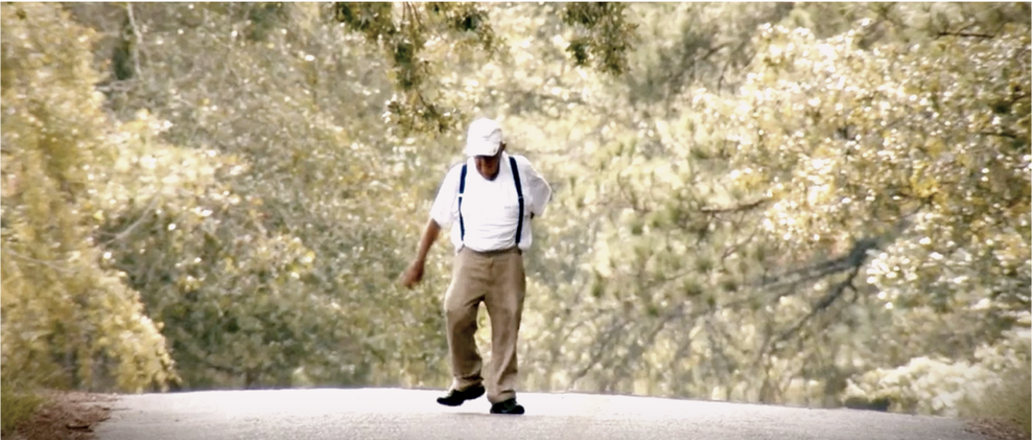

Boston, MA (October 13, 2022) – IN A DIFFERENT KEY, a true story of love, difference and the fight to belong, premieres on PBS stations nationwide beginning on December 13 at 9pm EST (check local listings), presented by Boston public media producer GBH. Based on the Pulitzer Prize-nominated book of the same name by journalists Caren Zucker and John Donvan – the film’s Executive Producers – the film follows the mother of an autistic son as she finds and then befriends the first child ever diagnosed with autism – Donald Triplett, who still lives in the small Mississippi town where he was born nearly 90 years ago.

Today, the rate of diagnosed Autistic Spectrum Disorder (ASD) has reached the level of 1 in 44 children. In a question relevant to many, co-director Caren Zucker seeks answers to the unknowable: will the non-autistic majority embrace and protect her child when she is no longer here. “Really, it’s an untold story of an unrecognized civil rights movement,” says Zucker, “but it’s also a love story, where the arc of justice is really bending in the right direction – just not fast enough for mothers like me.”

Donvan’s and Zucker’s film is a fascinating and illuminating journey into the lives of individuals past and present, who have experienced the best and the worst of society’s response to people seen as “different.” IN A DIFFERENT KEY starts with the story of Donald, who was identified as “Case 1” among the earliest published descriptions of autism. There is the heartwarming discovery that Donald’s small-town community has accepted him all his life. In the words of one member of the community, “He’s our guy.”

Says co-director John Donvan, “We hope the film touches audiences that don’t necessarily have that direct connection to autism. Every community can be part of the solution for supporting people on the spectrum, including where they work, live, go to school and beyond.”

However, the filmmakers also document abuse and rejection, exacerbated by misunderstanding, fear, bullying and racism. Standing up to these forces, pushing back against them, has been a decades-long mission for a legion of people – people on the spectrum, their families and their allies.

“The film reveals the complexity and breadth of the autism spectrum,” says John Bredar, VP of GBH National Programming. “And it does this in such a personal way that folks who are not in the autism community will really get it.”

With original music by Wynton Marsalis, IN A DIFFERENT KEY is poised to open eyes, minds and hearts across the country, while educating about the incredible highs and lows of neurodiversity and the importance of supportive communities.

WATCH THE OFFICIAL TRAILER HERE
IN A DIFFERENT KEY is produced by GBH Boston and Co-Directors Caren Zucker and John Donvan. Composer: Wynton Marsalis; Editor, Co-Producer: Ray Conley; Director of Photography: Terry Stewart. Funding for IN A DIFFERENT KEY is provided by Liberty Mutual Insurance.
https://www.pbs.org/show/different-key/

Facebook

PHOTOS HERE

PRESS CONTACTS:
Erin Haworth, High10 Media
erin@high10media.com

Rachael Myer Curley, DRA Collective
rachael@dracollective.com

About GBH
GBH is the leading multiplatform creator for public media in America. As the largest producer of content for PBS and partner to NPR and PRX, GBH delivers compelling experiences, stories and information to audiences wherever they are. Headquartered in Boston, GBH has been recognized with hundreds of the nation’s premier broadcast, digital and journalism awards. Find more information at gbh.org.

