IL VOLO – TRIBUTE TO ENNIO MORRICONE
Premieres on PBS Stations Beginning November 27

The Operatic Trio’s Concert Honors the Celebrated Italian Film Composer

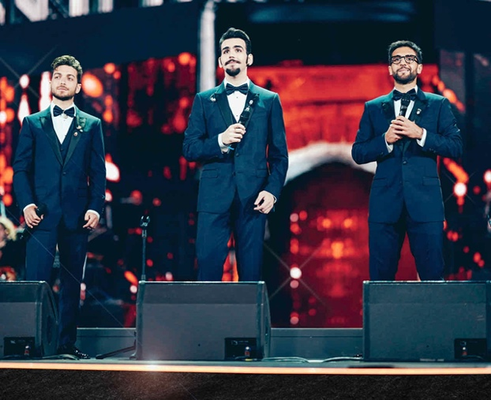
Credit: Simone Cecchetti

Set in the medieval town made famous by Shakespeare’s Romeo and Juliet, Italian performers Gianluca Ginoble, Piero Barone and Ignazio Boschetto serenade a live audience in an extraordinary tribute concert to legendary composer Ennio Morricone. Filmed in June 2021 in the Arena Di Verona in Verona, Italy, IL VOLO – TRIBUTE TO ENNIO MORRICONE showcases classical arrangements from the prolific film composer and fan favorites from the operatic trio’s most popular albums. With support from the Morricone family and accompanied by incredible theatrical and musical performers, the artists celebrate the Maestro alongside a full choir and orchestra, guest conducted by Ennio Morricone’s son. IL VOLO – TRIBUTE TO ENNIO MORRICONE is part of special programming premiering on PBS stations beginning Saturday, November 27, 2021 (check local listings).

Since sharing a stage together more than a decade ago, Il Volo often credits the Oscar, Grammy, and Golden Globe-winning composer as one of Italy’s greatest treasures. After Morricone’s death, Il Volo dedicated a performance to the Maestro in March 2021, singing “Your Love,” his famous melody from Once Upon A Time in The West.

Capturing the world’s attention as young artists on an Italian talent show, Piero, Gianluca and Ignazio have been beloved by PBS viewers since their first special, Il Volo Takes Flight, in 2011. In the years that followed, the group has produced at least six albums, received acclaim and numerous award nominations, and performed around the world at some of the most prestigious venues.

PBS special programming invites viewers to experience the worlds of science, history, nature and public affairs; hear diverse viewpoints; and take front-row seats to world-class drama and performances. Viewer contributions are an important source of funding, making PBS programs possible. PBS and public television stations offer all Americans from every walk of life the opportunity to explore new ideas and new worlds through television and online content.

Underwriters: Public Television Viewers and PBS
Production Company: Detroit Educational Television Foundation

- PBS –

Contact: Cara White, CaraMar, Inc., cara.white@mac.com

For images and additional up-to-date information on this and other PBS programs, visit PBS PressRoom at pbs.org/pressroom.

