Escape to HOTEL PORTOFINO for Another Season of Romance, Mystery, and Luxury, Premiering July 28 on PBS

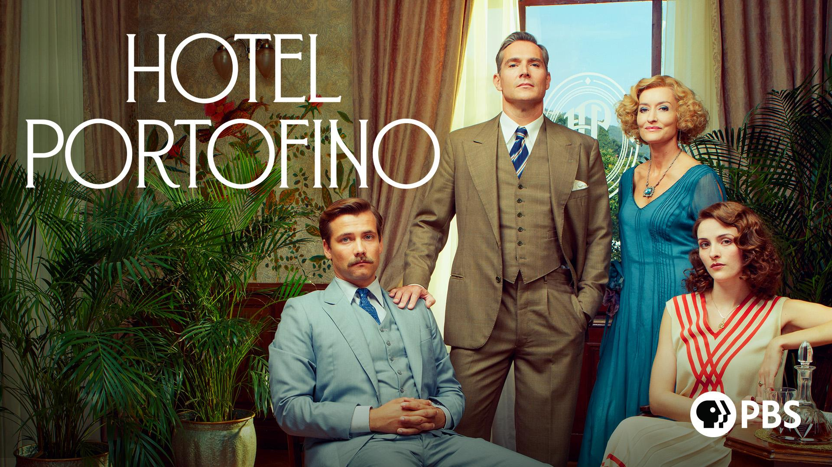

Natascha McElhone-Led Period Drama Returns Exclusively on all PBS Platforms

ARLINGTON, VA, July 8, 2024 – The glamorous period drama series HOTEL PORTOFINO returns for a third season on Sunday, July 28 at 8 p.m. ET across all PBS platforms in the U.S. (check local listings). Natascha McElhone (“Californication,” “The Crown”) stars in the heady, period drama about a British family who run a hotel for upper-class travelers on the magical Italian Riviera during the glamourous “Roaring 20s” but also under the dark cloud of Fascist Italy.

HOTEL PORTOFINO will stream on all station-branded PBS platforms, including PBS.org, and the PBS App, available on iOS, Android, Roku streaming devices, Apple TV, Android TV, Amazon Fire TV, Samsung Smart TV, Chromecast, and VIZIO. HOTEL PORTOFINO will also be available to stream on PBS Passport and the PBS Masterpiece Prime Video Channel.

Season 3 finds Bella (McElhone) preparing for the arrival of her father and sister when her husband Cecil returns unannounced, intending to divorce Bella and leave her to face the public scrutiny of being a divorced woman in 1929. Bella must decide what her future holds as well as balance tensions with her estranged sister, Amelia; flirtations with local Italian architect, Marco; the shocking return of her damaged son, Lucian; and avoiding local fascist leader, Danioni. Life gets even more complicated for Bella and Cecil when the Wall Street Crash jeopardizes their financial future. Dark secrets are exposed, old flames rekindled, and revenge plans are plotted during another adventure on the sun-soaked Italian Riviera.

Additional returning cast members include Mark Umbers (“Home Fires”), Oliver Dench (“Pandora”), Olivia Morris (“RRR”), Pasquale Esposito (“Ripley”), Louisa Binder, Elizabeth Carling, Carolina Gonnelli, Lily Frazer, Louis Healy, Adam James, Giorgio Marchesi, and Daniele Pecci.

Episode 1 - “Entitled”
While avoiding Danioni and preparing for the arrival of her father and sister, Bella is thrown when Cecil returns. Alice bumps into Carlo who is with another woman, and Constance meets a new, charming local, Vito.

Episode 2 - “Proposals”
Bella receives a surprising proposal from Marco; Constance confides in Vito about Tommy; and Alice faces rejection from Carlo. As tensions simmer, a notable arrival disrupts Betty's party, bringing unexpected company with them.

Episode 3 - “Realizations”
As tensions rise between Lucian and Constance, she finds solace in her growing connection with Vito. Bella faces pressure from George to secure the hotel's investment, while the looming Wall Street Crash casts a shadow over the family's future.

Episode 4 - “Experiments”
After the fallout of the Wall Street Crash, Bella grapples with launching her new business endeavor, while Cecil finds himself confronted by a familiar adversary. While Alice confronts her fear of horses, Lucian belatedly realizes his feelings for Constance, but his revelation comes at an inopportune moment.

Episode 5 - “Revelations”
As the news of Nish's death rocks Lucian and Virat, Alice’s feelings towards Carlo are thrown into question when she discovers he’s been testing her. Meanwhile, Bella confides in Amelia about her relationship with Marco, unaware of the looming threat Danioni poses to Marco.

Episode 6 - “Masquerades”
As Marco evades the Blackshirts, Bella pursues a grant to support her budding business. Tensions escalate at Claudine's party when Jack betrays Cecil, and a sudden and violent confrontation erupts, changing the course of events dramatically.

HOTEL PORTOFINO was written and created by Matt Baker; season three was directed by Jon Jones. The series is an Eagle Eye Production in association with Beta Film and is executive produced by Eagle Eye’s Jo McGrath and Walter Iuzzolino and Carolina Giammetta.

For more information on Season 3 of HOTEL PORTOFINO, please visit the PBS PressRoom.

About PBS
PBS, with more than 330 member stations, offers all Americans the opportunity to explore new ideas and new worlds through television and digital content. Each month, PBS reaches over 36 million adults on linear primetime television, more than 16 million users on PBS-owned streaming platforms, 53 million viewers on YouTube, and 60 million people view PBS content on social media, inviting them to experience the worlds of science, history, nature, and public affairs and to take front-row seats to world-class drama and performances. PBS’s broad array of programs has been consistently honored by the industry’s most coveted award competitions. Teachers of children from pre-K through 12th grade turn to PBS LearningMedia for digital content and services that help bring classroom lessons to life. As the number one educational media brand, PBS KIDS helps children 2-8 build critical skills, enabling them to find success in school and life. Delivered through member stations, PBS KIDS offers high-quality content on TV — including a PBS KIDS channel — and streaming free on pbskids.org and the PBS KIDS Video app, games on the PBS KIDS Games app, and in communities across America. More information about PBS is available at PBS.org, one of the leading dot-org websites on the internet, Facebook, Instagram, or through our apps for mobile and connected devices. Specific program information and updates for press are available at pbs.org/pressroom or by following PBS Communications on X.

About PBS Masterpiece Prime Video Channel
PBS MASTERPIECE Prime Video Channel features world-class dramas, including adaptations of beloved literary classics, mysteries filled with eclectic characters and provocative contemporary works. Subscribers can stream their favorite MASTERPIECE series, including All Creatures Great and Small, Miss Scarlet & the Duke, Sanditon and The Long Song, as well as international dramas like Professor T and Seaside Hotel from Walter Presents.
Follow the PBS Masterpiece Prime Video Channel on Facebook.
About PBS DISTRIBUTION
PBS Distribution is a leading distributor of public media content around the world, entertaining audiences across platforms and formats. The company, a joint venture of PBS and GBH Boston, provides premium content through multiple digital channels and video services. PBS Distribution operates six subscription streaming channels — PBS Masterpiece (US and CA),

PBS KIDS, PBS Living, PBS Documentaries and PBS America (U.K.) as well as numerous Free Ad-supported Streaming TV (FAST) Channels in the U.S and U.K. In addition, the company reaches viewers through Transactional Video-on-Demand (TVOD), Subscription Video-on-Demand (SVOD) licensing, Advertising-based Video on Demand (AVOD), DVD and Blu-ray, theatrical releases, educational platforms, non-theatrical and inflight sales, and serves broadcasters and producers providing program sales and co-production financing.
PBS Distribution offers consumers and educators the highest quality factual, scripted, and children’s programming including films from Ken Burns, hit series from MASTERPIECE and foreign language dramas from Walter Presents, entertaining and educational PBS KIDS series, and award-winning documentaries from NOVA, FRONTLINE, AMERICAN MASTERS, NATURE, AMERICAN EXPERIENCE, and many independent producers. For over 10 years, the company has extended the reach of programming beyond broadcast while generating revenue for the public television system, stations, and producers.
Follow PBS Distribution on Facebook.

About EAGLE EYE DRAMA
Eagle Eye Drama was formed by Walter Iuzzolino, Jo McGrath, and Jason Thorp, the same three founders and creative team behind the global drama company Walter Presents. The company produces dramas and animations, based on adaptations and original ideas. In 2022, they launched two new companies under the Eagle Eye umbrella, Belgian-based Happy Duck

Films and animation-focused Eaglet Films.
Follow Eagle Eye Drama on Facebook, Twitter, and Instagram.

###

Media Contacts:
Caitlin Jaynes, Ali Smith, MPRM Communications
cjaynes@mprm.com
asmith@mprm.com

Chelsie Pope, PBS
cepope@pbs.org

For images and additional up-to-date information on this and other PBS programs, visit PBS PressRoom at pbs.org/pressroom.

