Winter TCA Press Tour 2024
HOPE IN THE WATER Panel Bios

Andrew Zimmern,
Executive Producer, Intuitive Content
Twitter: @andrewzimmern
Instagram: @chefaz
Andrew Zimmern is an Emmy-winning and four-time James Beard Award-winning TV personality, chef, writer, and social justice advocate. As the creator, executive producer and host of the “Bizarre Foods” franchise, “Andrew Zimmern’s Driven by Food,” MSNBC’s “What’s Eating America,” Magnolia Network’s “Family Dinner,” and the Emmy-winning “The Zimmern List,” he has devoted his life to exploring and promoting cultural acceptance, tolerance and understanding through food. You can also find him judging “Iron Chef: Quest for an Iron Legend” on Netflix, “The Silos Baking Competition” on HBO Max, and teaching live fire cooking on Outdoor Channel’s “Andrew Zimmern’s Wild Game Kitchen.” He has written four books, including the Ippy Gold Medal award-winning “AZ and the Lost City of Ophir.” Andrew is the founder and chairman of Intuitive Content, named one of the top 100 production companies in the world by Realscreen, and Passport Hospitality, a restaurant and food service development company. He is passionate about his philanthropic endeavors and sits on the boards of Services for the UnderServed, EXPLR Media, Soigne Hospitality and Beans is How. He is on the advisory boards of the Charlize Theron Africa Outreach Project, serves on City Harvest’s Food Council, is the International Rescue Committee’s Voice for Nutrition, a Global Goodwill Ambassador for the United Nations World Food Programme as well as The Nature Conservancy. Andrew is a founding member of the Coalition for Sustainable Aquaculture and the Independent Restaurant Coalition. He resides in Minneapolis.

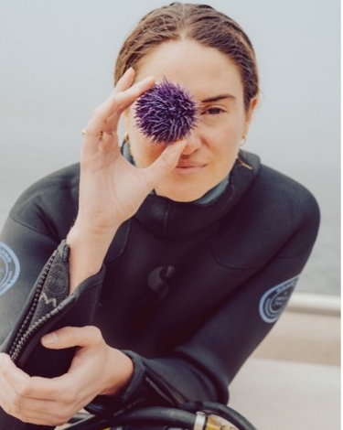
Shailene Woodley
Explorer
Twitter: @shailenewoodley
Instagram: @shailenewoodley

Shailene Woodley is an Emmy and Golden Globe nominated actress known for her roles in “Big Little Lies”, “The Descendants,” the “Divergent” film series, and the critically acclaimed “The Fault in Our Stars.” Most recently, she can be seen in Michael Mann’s “Ferrari” and Craig Gillespie’s “Dumb Money.” An inspiring actor and activist, Woodley grew up near the California coast and has witnessed firsthand how “zombie” purple urchins have taken over and destroyed kelp forests. She goes underwater with urchin divers who collect the barren urchins and then deliver them to a farm where their buttery roe is grown and harvested – turning an ecological imbalance into a saleable commodity and helping to save the kelp at the same time.

Baratunde Thurston
Explorer
Twitter: @baratunde
Instagram: @baratunde

Baratunde Thurston tells a better story of us, weaving together threads of race, technology, democracy, and climate through his work as an Emmy-nominated host, producer, writer, and public speaker. He is the host and exeutive producer of the PBS television series AMERICA OUTDOORS WITH BARATUNDE THURSTON, creator and host of “How to Citizen with Baratunde,” which Apple named one of its favorite podcasts of 2020, and a founding partner of the new media startup, Puck. His comedic memoir, “How To Be Black,” is a New York Times best-seller. In 2019, he delivered what MSNBC’s Brian Williams called “one of the greatest TED talks of all time.” Baratunde is unique in his ability to integrate and synthesize different and difficult topics in a style that’s intelligent, compassionate, and humorous. Baratunde serves on the boards of Civics Unplugged and the Brooklyn Public Library and lives in Los Angeles, California.

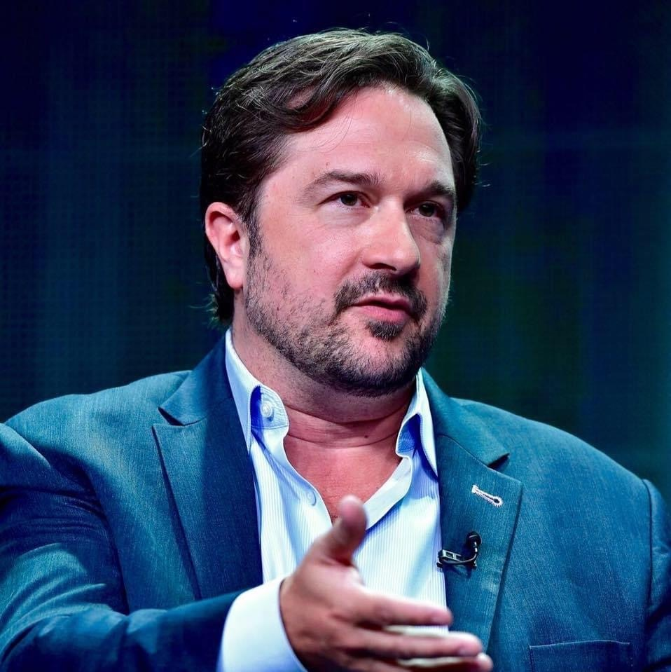
Bill Gardner
Editorial Executive for HOPE IN THE WATER
Twitter: @pbs
Instagram: @pbs
Bill Gardner oversees PBS content strategy, development and production across platforms and formats in the genres of history, science, natural history, and arts & culture. As vice president, multiplatform programming & head of development, he and his team worked closely with popular, flagship PBS strands such as NATURE, NOVA, AMERICAN MASTERS, and GREAT PERFORMAMCES, and managed a large portfolio of series and premier documentaries in collaboration with PBS stations, public media organizations, and independent producers and content creators. Under his leadership, the PBS programming team focused on the development of projects featuring significant outreach, education, and digital content components, with an emphasis on the climate and the environment, and contemporary cultural history, identity, and artistic expression. He specializes in assembling blue-chip co-productions with partners across the globe, from public broadcasters to commercial networks and new media platforms to international impact organizations. He helped launch and lead the PBS-BBC co-production partnership, which provided dozens of hours of premium multiplatform factual content to the PBS schedule each year such as “Spy in the Wild,” “The Planets,” and “The Green Planet” in the science and natural history genres and “Basquiat: Rage to Riches,” “8 Days,” and “Civilizations” in the history, arts & culture space.

Gardner holds a master’s degree in cultural anthropology and has taught university courses in Arkansas and Marrakech, Morocco. He serves on several advisory boards and is presently Board Chair of the Jackson Wild Film Festival and Summit, where he helped launched the Jackson Wild Collective, a global database of local and indigenous filmmakers dedicated to diversifying the wildlife media community.

– PBS –

